Phillip Pi’s UI QA Redline Results for Spark’s Search v5 (No Modifiers; Copy 2) in an Updated 64-bit W7 EE SP1’s IE11 Web Browser.
Notes: https://web.ciscospark.com & Edward McMullin’s https://app.zeplin.io/project.html#pid=55b10945f42dda4d1800a1ab&sid=56a0fc6f2ab86795737c79ae (last updated on 1/21/2016; P(ixel/x), not P(oin)t -- "PT and PX are the same measurements from sketch , zeplin just forces it into either PT or PX depending on the project selected. xOS will do PT , Web will do PX Since they were designed in PX from sketch (and only PX) they are therefore px in zeplin" –his emails on 2/5/2016 before 3 AM) redlines from 2/2/2016 to 3/11/2016. Both OS’ (D/P)PI (96) & IE’s zoom were @ 100% (smaller). All softwares had the (new/lat)est updates. All dates and times were based on USA & its pacific standard time (PST) zone.
Zeplin’s Search Redline Screen #1 (collapsed left side’s navigation menu). Its screen #4’s expanded left side’s navigation menu also showed similar results. Below screen (shot/capture)s were with screen #1 and Spark’s left side navigation menu expanded. V4354 - SDK v0.5.48 on 2/2/2016:
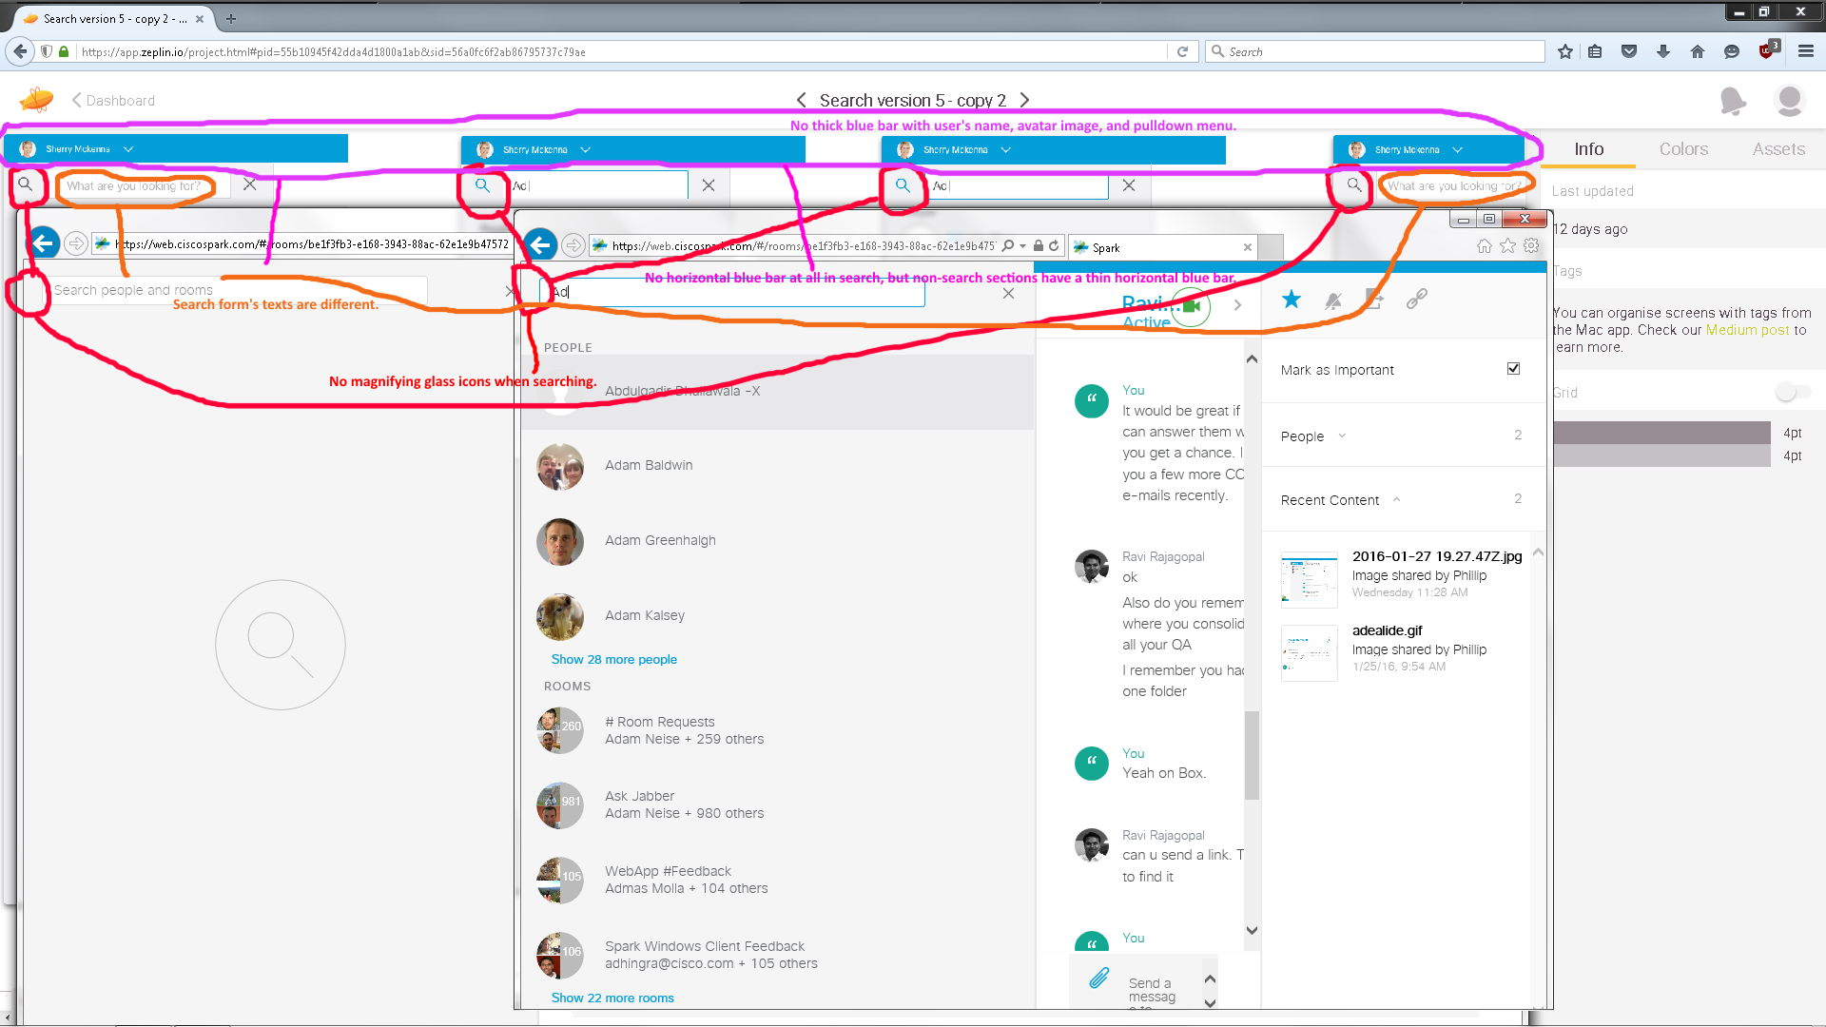
Issues From Above Image:
- IE (& other web browsers including Mac OS X’s app) didn’t show Spark’s thick horizontal blue bar with my logged in account name and pulldown arrow menu option like in Windows desktop client. Renaldo Williams’ 2/3/2016 10:27 AM PST (USA) email (CCed Ravi Rajagopal & Edward McMullin) said: “Yes its by design. The web doesn’t show avatar and 40pt thick bar at the top. Also, even if it was the plan, I would not recommend having a blue bar with a height of 40pt at top of webpage, unless there is a clear rational behind it. It is really distracting from a visual perspective with lots of blank space. It would be warranted if there were more links or buttons within that blue space.”
- Missing magnifying glass icons when searching in IE.
- Search form boxes’ texts are different (IE’s “Search people and rooms” and redlines’ “What are you looking for?”).

V4380 - SDK v0.5.48 on 2/5/2016:
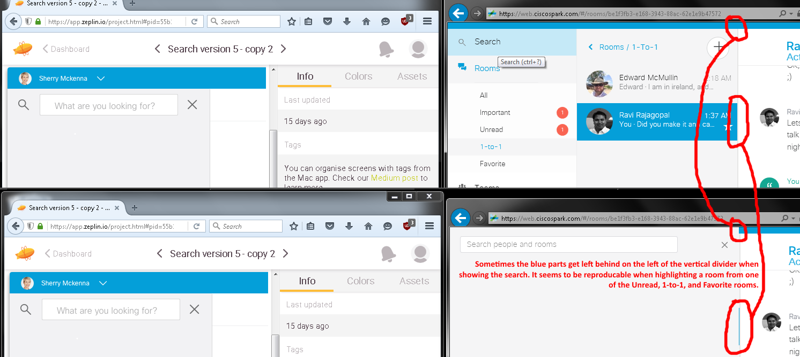
Issues From Above Images: Blue parts get left behind on the vertical divider’s left side when showing the search. They usually appear from one of the Unread, 1-to-1 (an example shown above), and Favorite rooms.

Zeplin’s Redline Screen #1 (Collapsed Left Side Navigation Menu). V4582 - SDK v0.5.52 (3/2/2016):
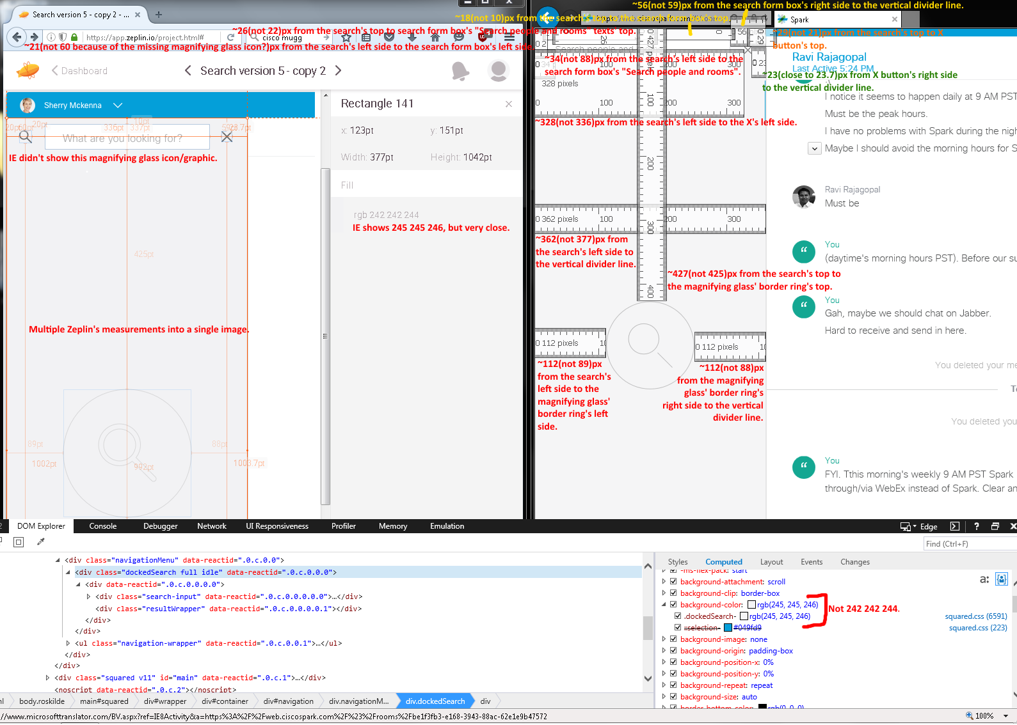
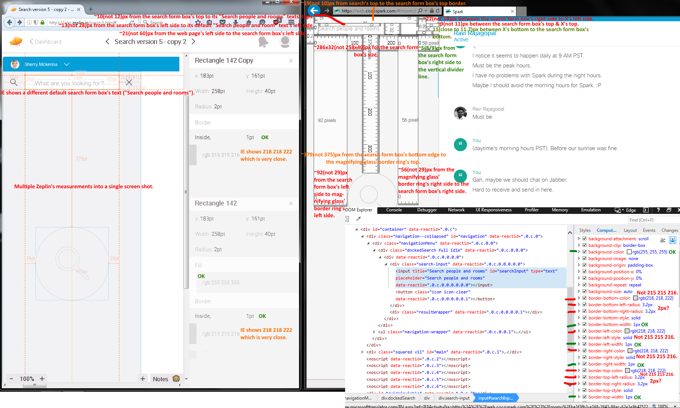
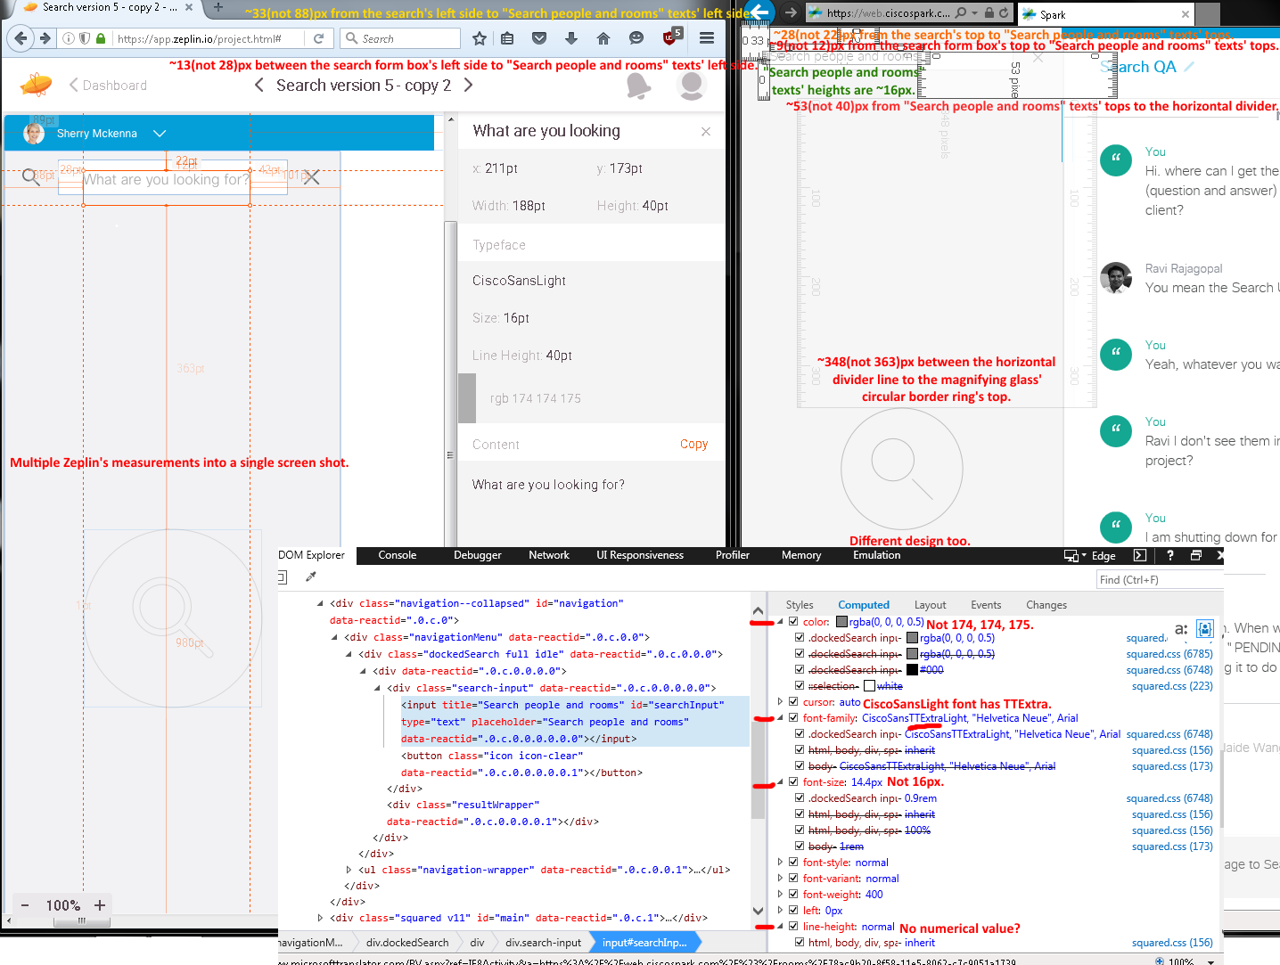
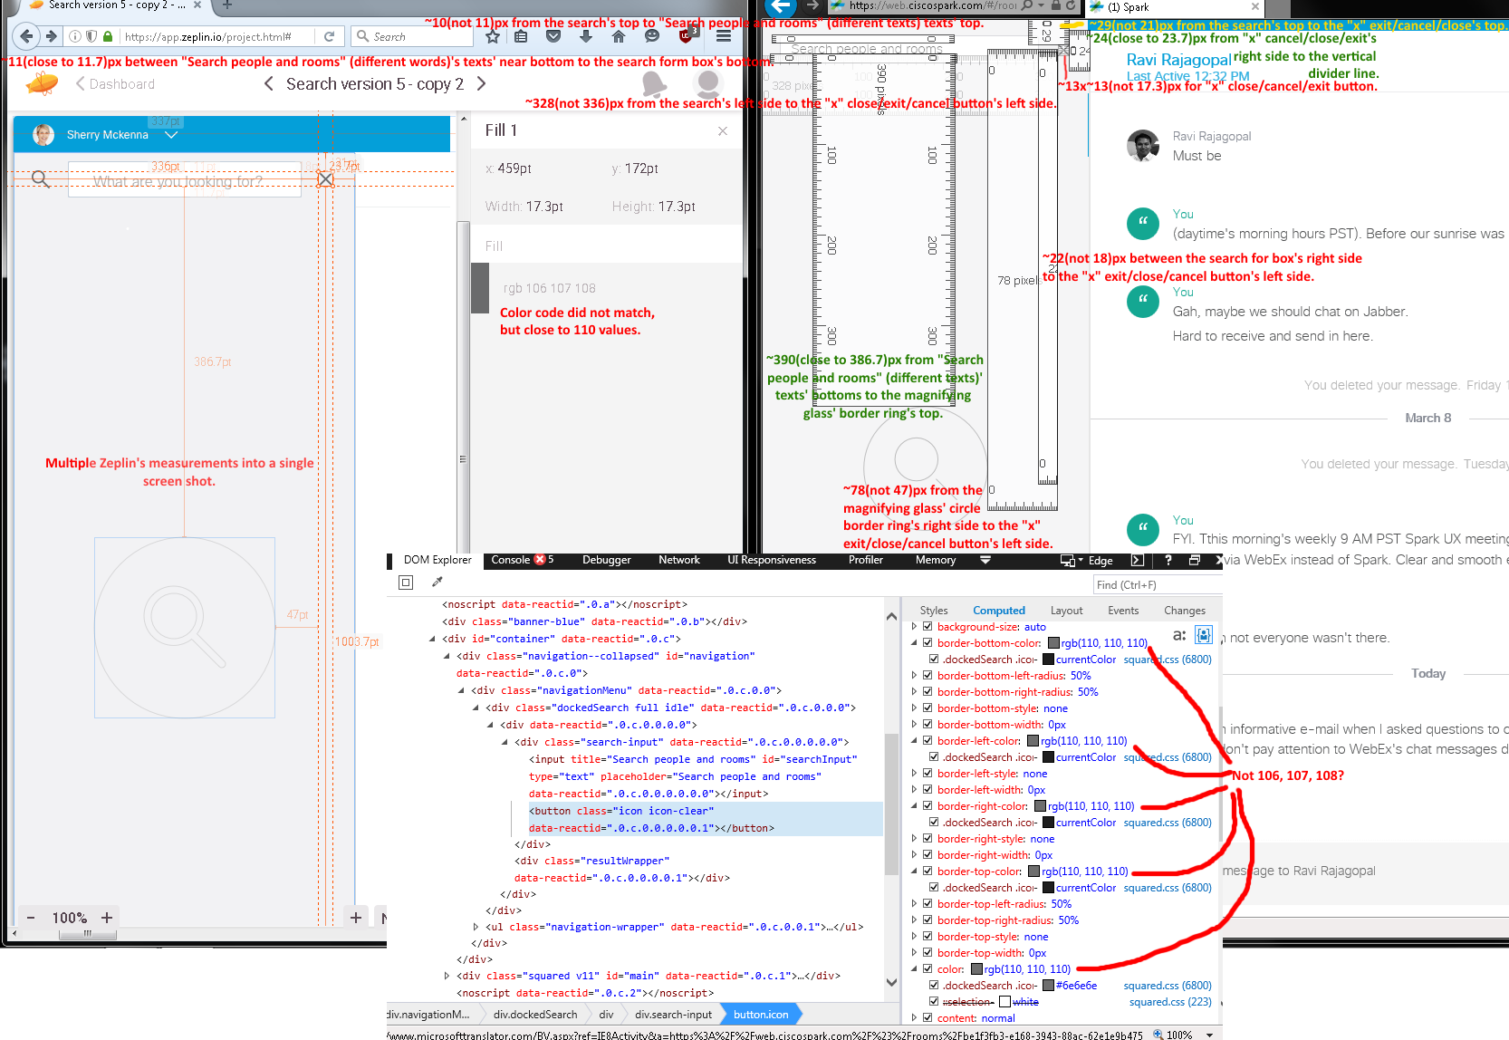

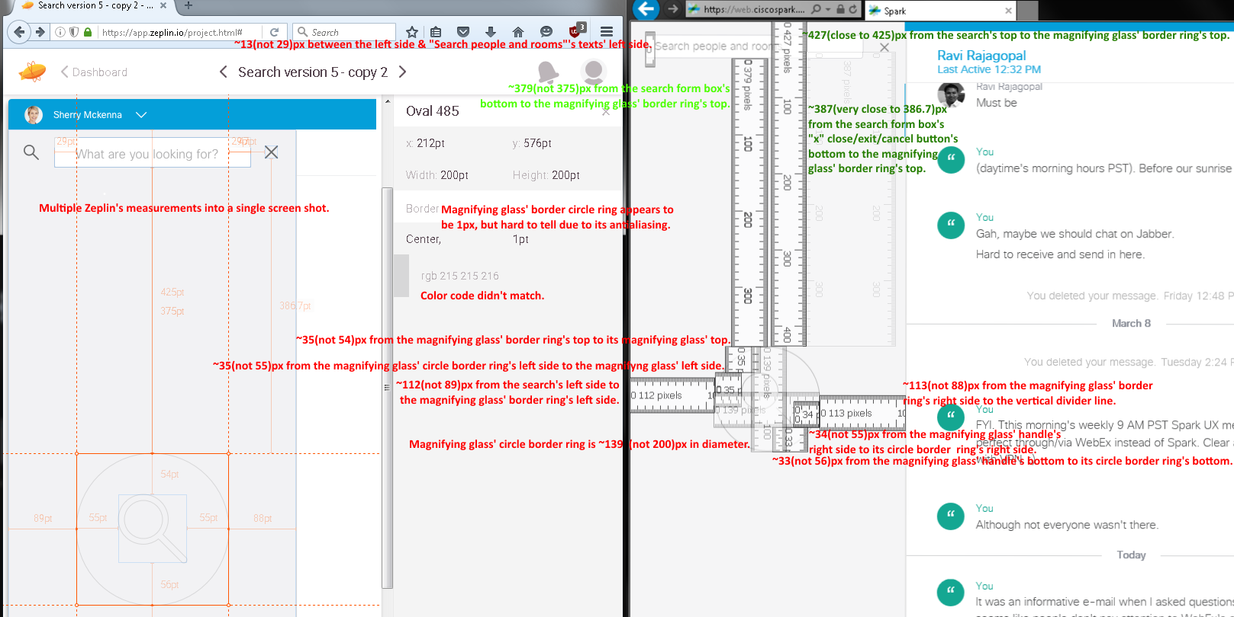

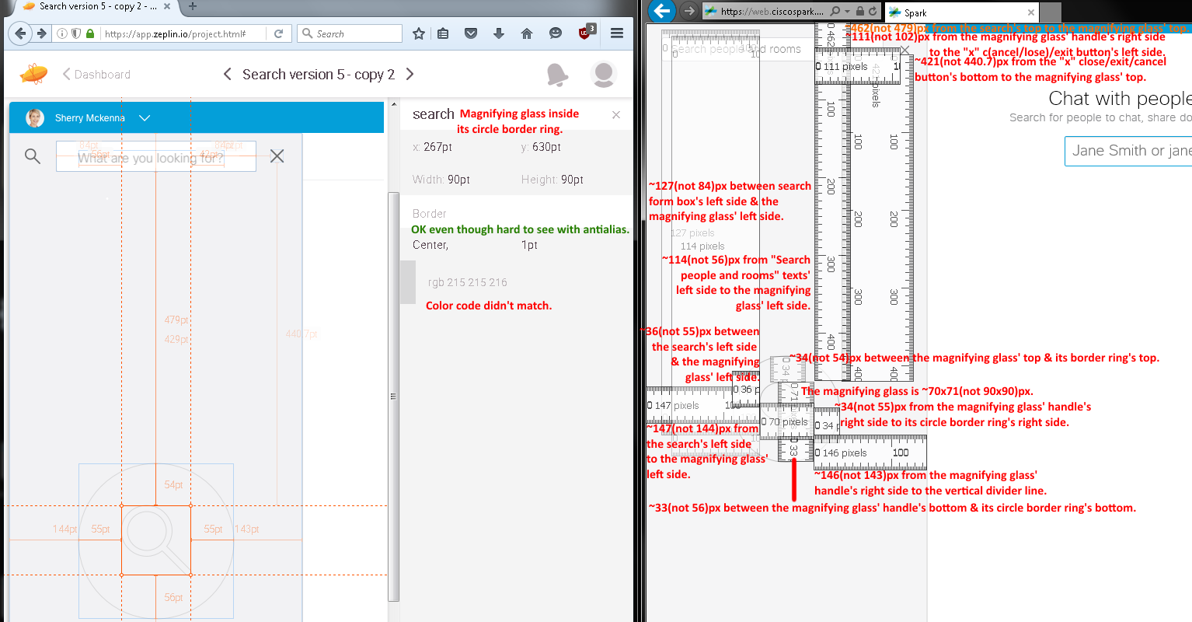
Issues from the above six collapsed left menu’s navigation screen (capture/shot)s in v4582 - SDK v0.5.52 (3/2/2016):
- Incorrect measurements and color codes.
- Missing horizontal thick blue bar and tiny magnifying glass icon/graphic.
- Search form box, texts, X cancel icon, and huge magnifying glass graphic looked different.

Zeplin’s Search Redline Screen #2:
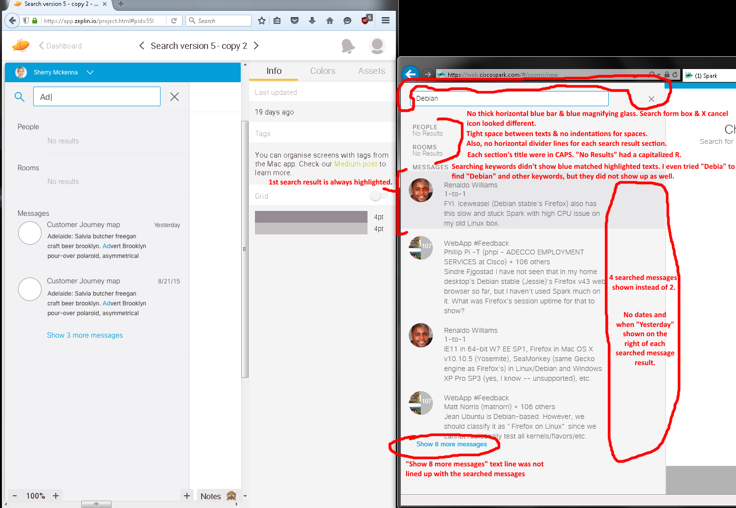

Issues from the above expanded left menu’s navigation image in v4380 - SDK v0.5.48 (2/5/2016):
- Incorrect spacings, alignments, and formattings (e.g., capitalizations).
- No blue highlighted keywords shown when found in messages. Even search partial keywords show no results at all like “Debia” (no Debian hits).
- No horizontal thick blue bar, blue magnifying glass icon/graphic, and thin horizontal section divider lines.
- Searched results always had the first result hit highlighted.
- Search form box and X cancel icon looked different.
- Searched results always showed four hits instead of two.

Note: Huge images did not fit with their issue lists, so using the two screen (shot/capture)s’ issue lists in this document page to avoid wasting two document pages.

Issues for the next two images (collapsed and expanded Spark’s left side navigation menu layouts): Incorrect color codes and dimension sizes.
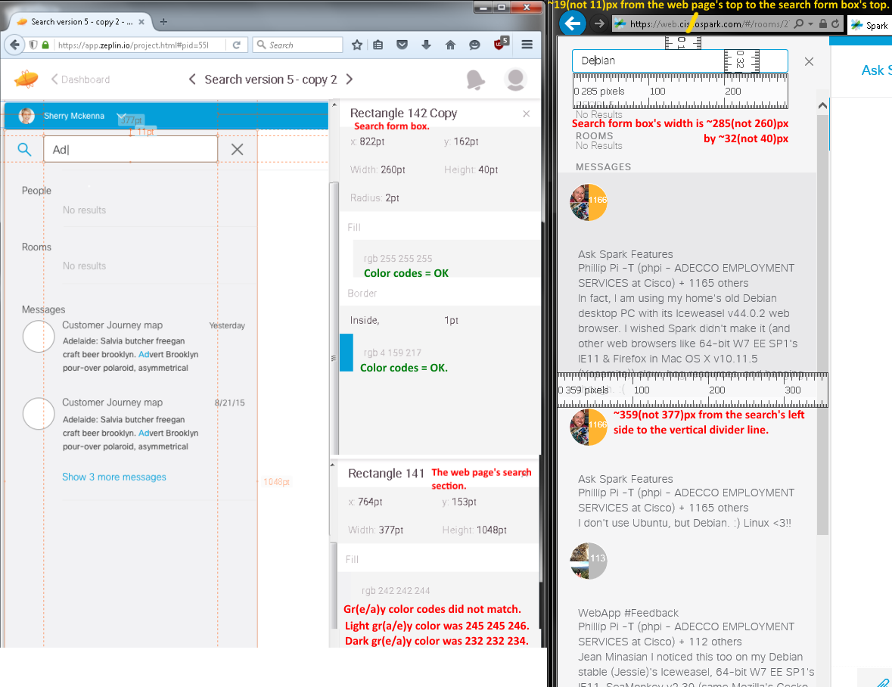
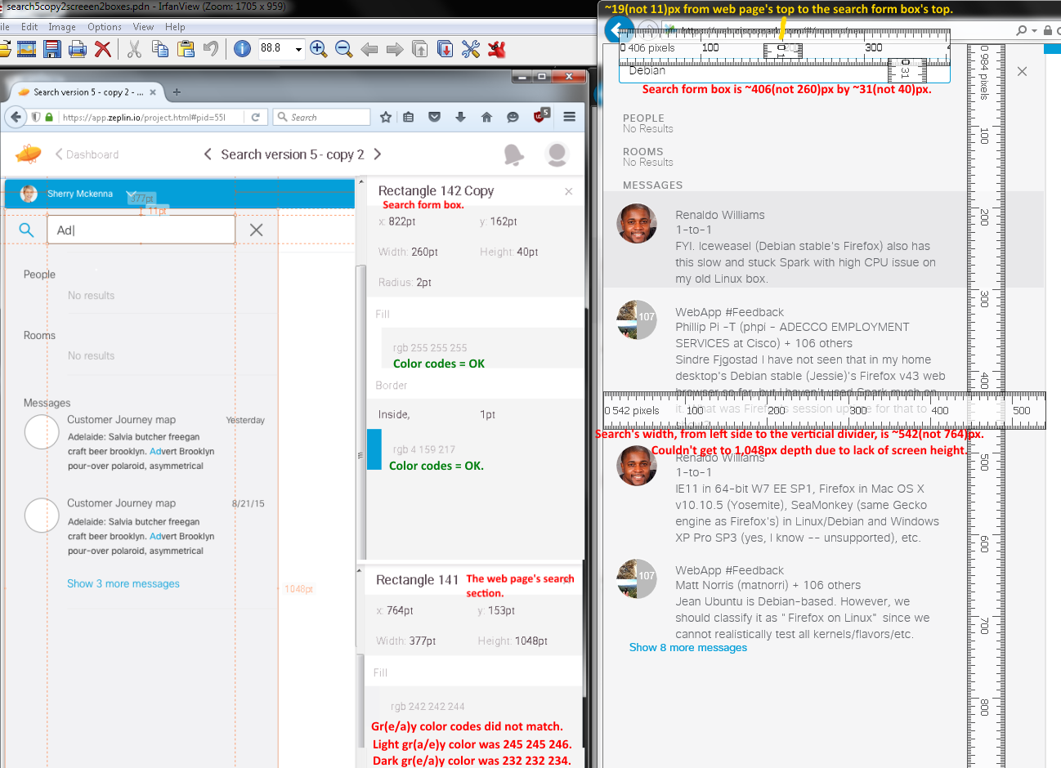

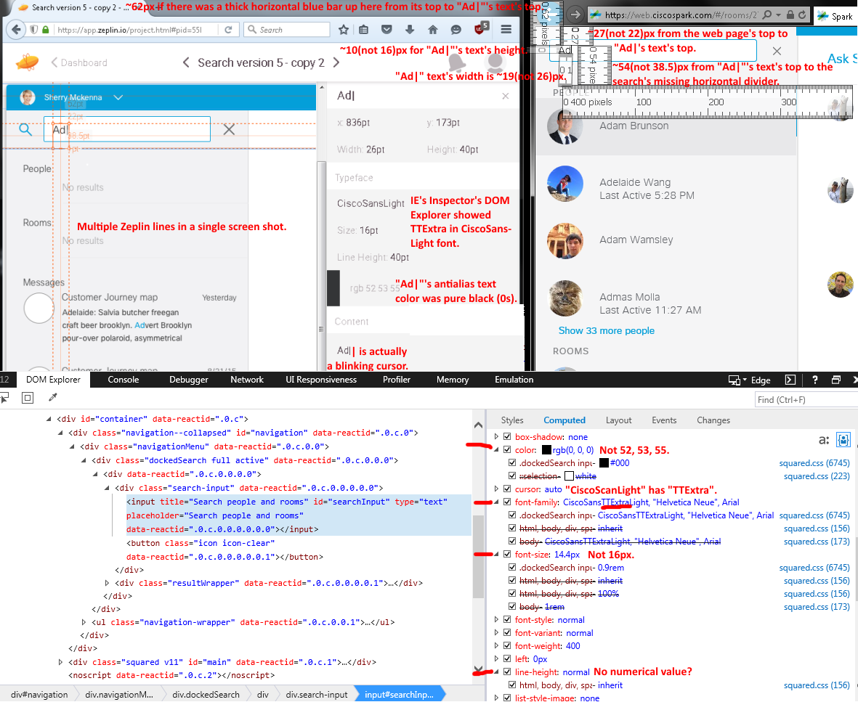
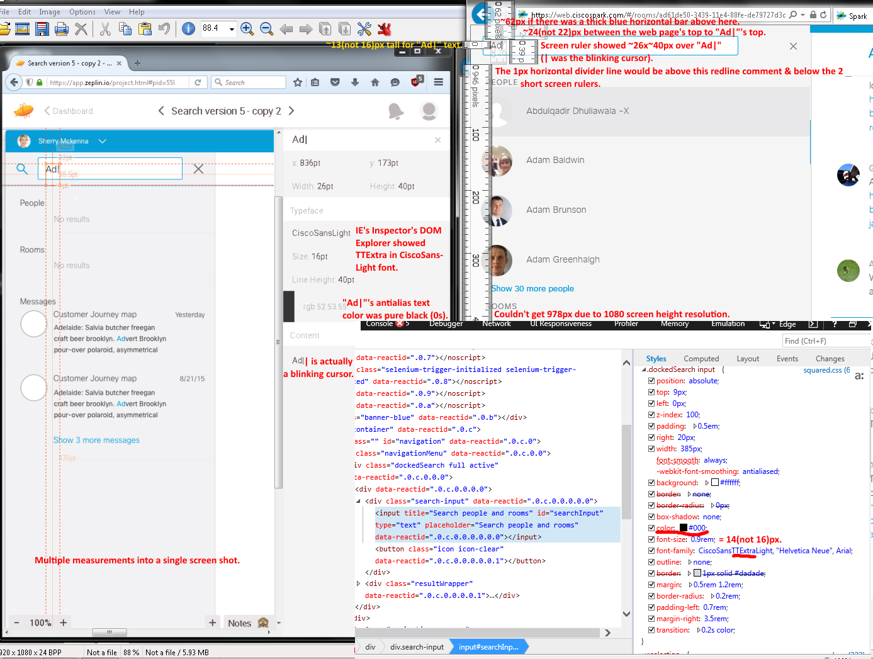
Issues from the two above navigation images (collapsed (V4476 - SDK v0.5.52 (2/25/2016)) and expanded left menu (v4380 - SDK v0.5.48 (2/5/2016))):
- Incorrect color codes, sizes, and CiscoSansLight font type face(?).
- Missing search’s horizontal 1 pixel divider and thick 42 pixels lines.

Note: Huge images did not fit with their issue lists, so using the two screen (shot/capture)s’ issue lists in this document page to avoid wasting two document pages.

Issues for the next two images and from expanded left side navigation menu (2/10/2016 afternoon & evening (Forgot to note the versions, but Renaldo Williams said they were posted on 2/9/2016 8:56:08 AM. As of 2/11/2016 4:52 AM & 3:18 PM, they were v4419 - SDK v0.5.52)) and collapsed left side menu navigation menu (V4476 - SDK v0.5.52 (2/25/2016)) [above]:
- Incorrect sizes, color codes, font, and capitalizations.
- Missing search’s horizontal divider line in the search section.
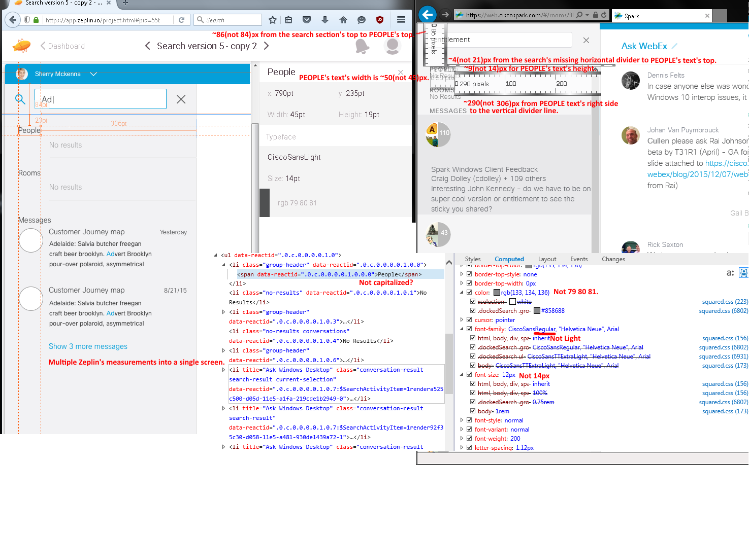
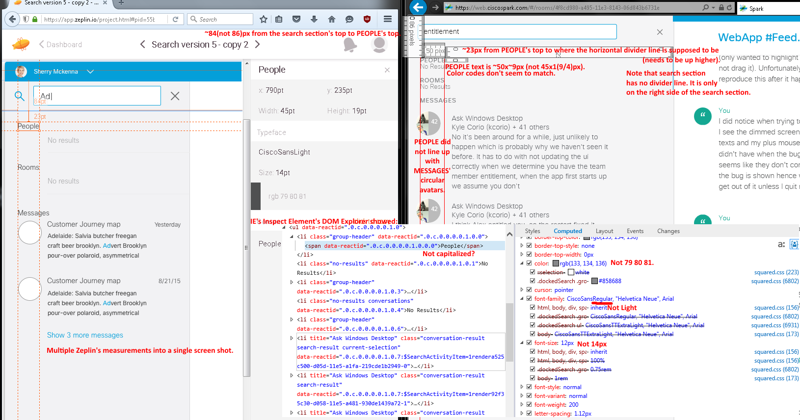

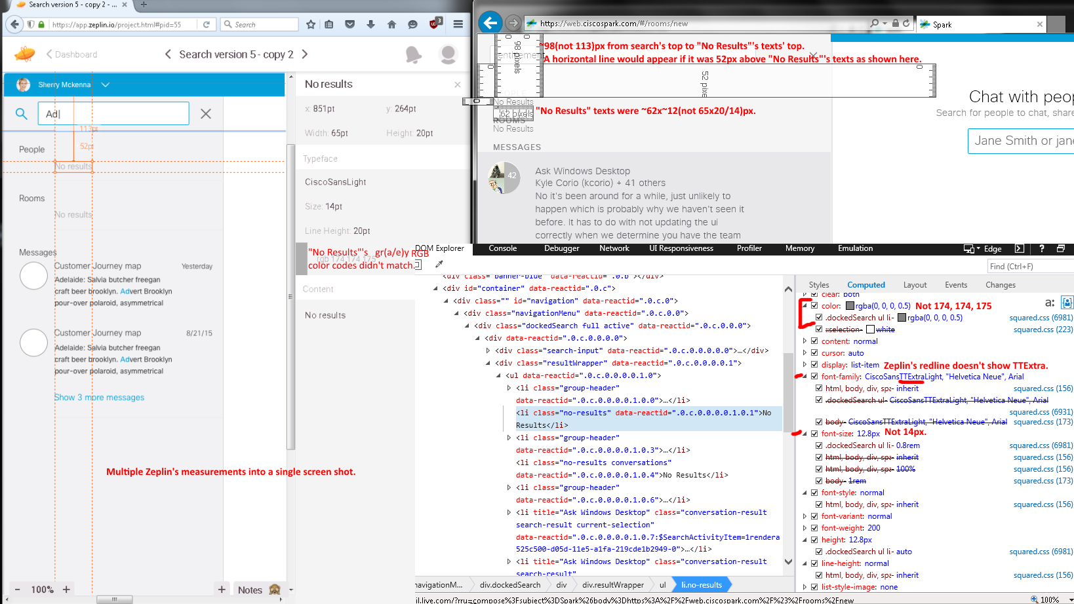
Issues from the expanded (collapsed showed the similar results in V4476 - SDK v0.5.52 (2/25/2016)) left side navigation menu (2/10/2016 afternoon & evening (Forgot to note the versions, but Renaldo Williams said they were posted on 2/9/2016 8:56:08 AM. As of 2/11/2016 4:52 AM & 3:18 PM, they were v4419 - SDK v0.5.52)) [above]:
- Wrong sizes, font color codes, and CiscoSansLight font type face(?).
- Missing search’s horizontal divider line and messages’ dates.

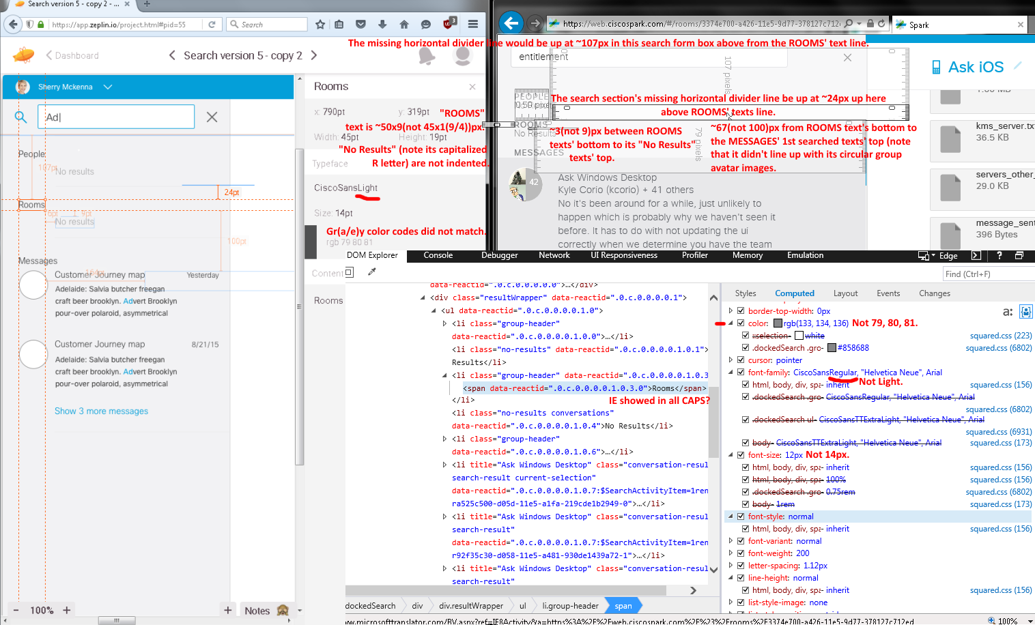
Issues from the above expanded (2/10/2016 afternoon & evening (Forgot to note the versions, but Renaldo Williams said they were posted on 2/9/2016 8:56:08 AM. As of 2/11/2016 4:52 AM & 3:18 PM, they were v4419 - SDK v0.5.52)) and below collapsed (V4476 - SDK v0.5.52 (2/25/2016) left side navigation menu images [above]:
- Wrong sizes, font color codes, text capitalizations, alignments, and CiscoSans font type face(?).
- Missing search’s horizontal divider lines and messages’ dates.
- With collapsed left side menu navigation, MESSAGES’ search results show their misplaced texts below their circular avatar images as shown below:

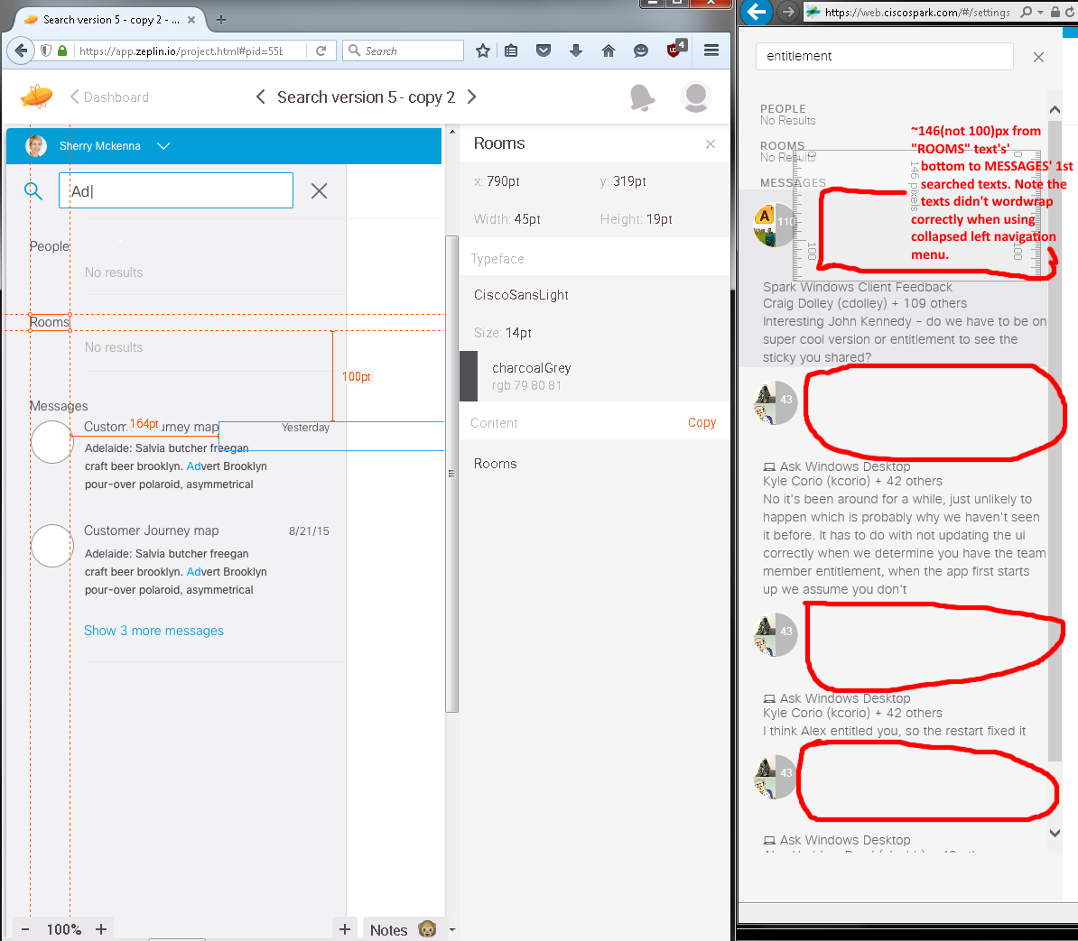
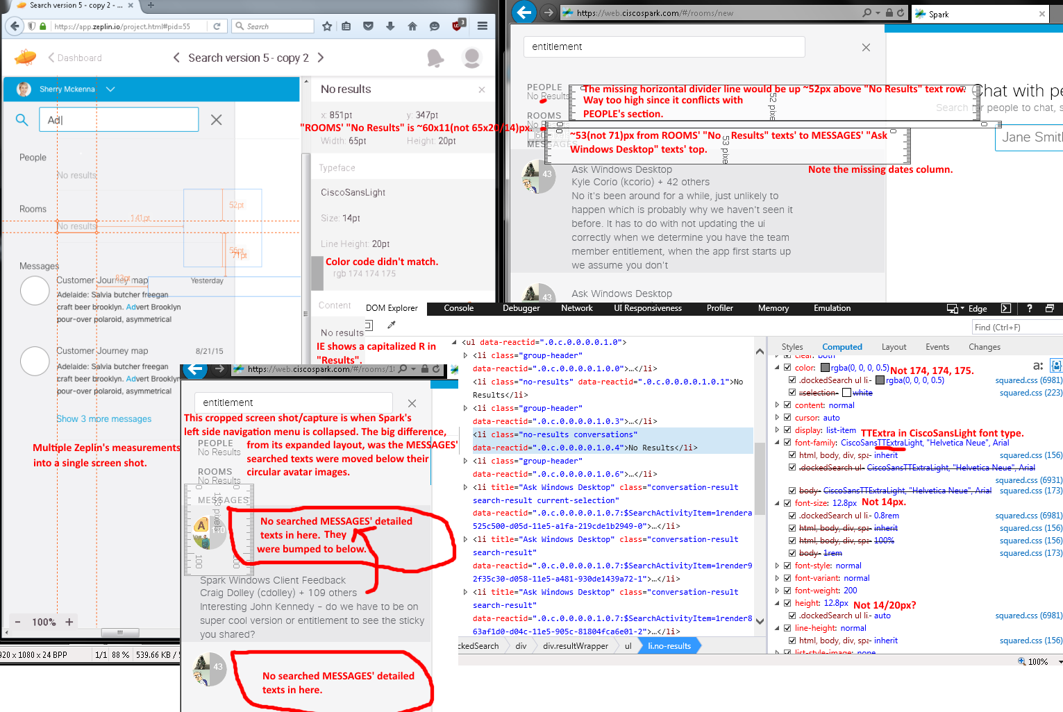
Issues from the expanded (2/10/2016 afternoon & evening (Forgot to note the versions, but Renaldo Williams said they were posted on 2/9/2016 8:56:08 AM. As of 2/11/2016 4:52 AM & 3:18 PM, they were v4419 - SDK v0.5.52)) and collapsed (V4476 - SDK v0.5.52 (2/25/2016); cropped image to show only the differences)) left side navigation menu layouts image (above):
- Wrong sizes, font color codes, text capitalizations, alignments, and CiscoSansLight font type face(?).
- Missing search’s horizontal divider lines and messages’ dates.
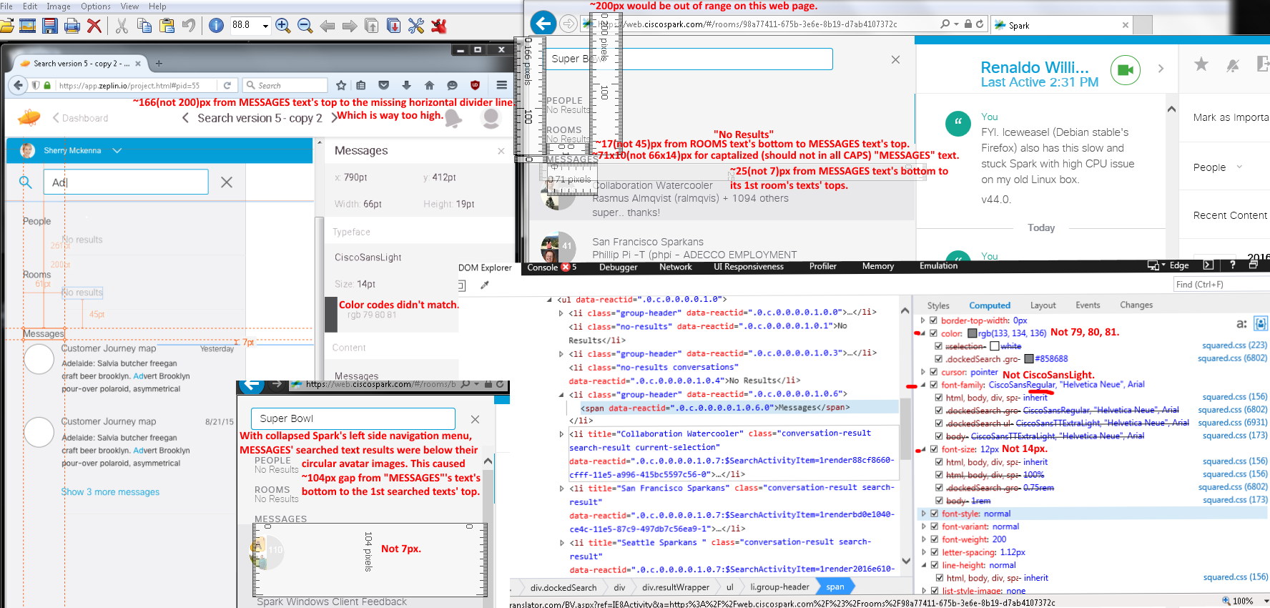
Issues from the above expanded (2/10/2016 afternoon & evening (Forgot to note the versions, but Renaldo Williams said they were posted on 2/9/2016 8:56:08 AM. As of 2/11/2016 4:52 AM & 3:18 PM, they were v4419 - SDK v0.5.52)) and collapsed (v4476 - SDK v0.5.52 (2/25/2016); cropped image to show only the differences)) left side navigation menu layouts image (above):
- Incorrect sizes, font color codes, text capitalizations, alignments, and CiscoSans font type face(?).
- Missing search’s horizontal divider lines, indentations for search results’ “No Results”, and searched messages’ dates.

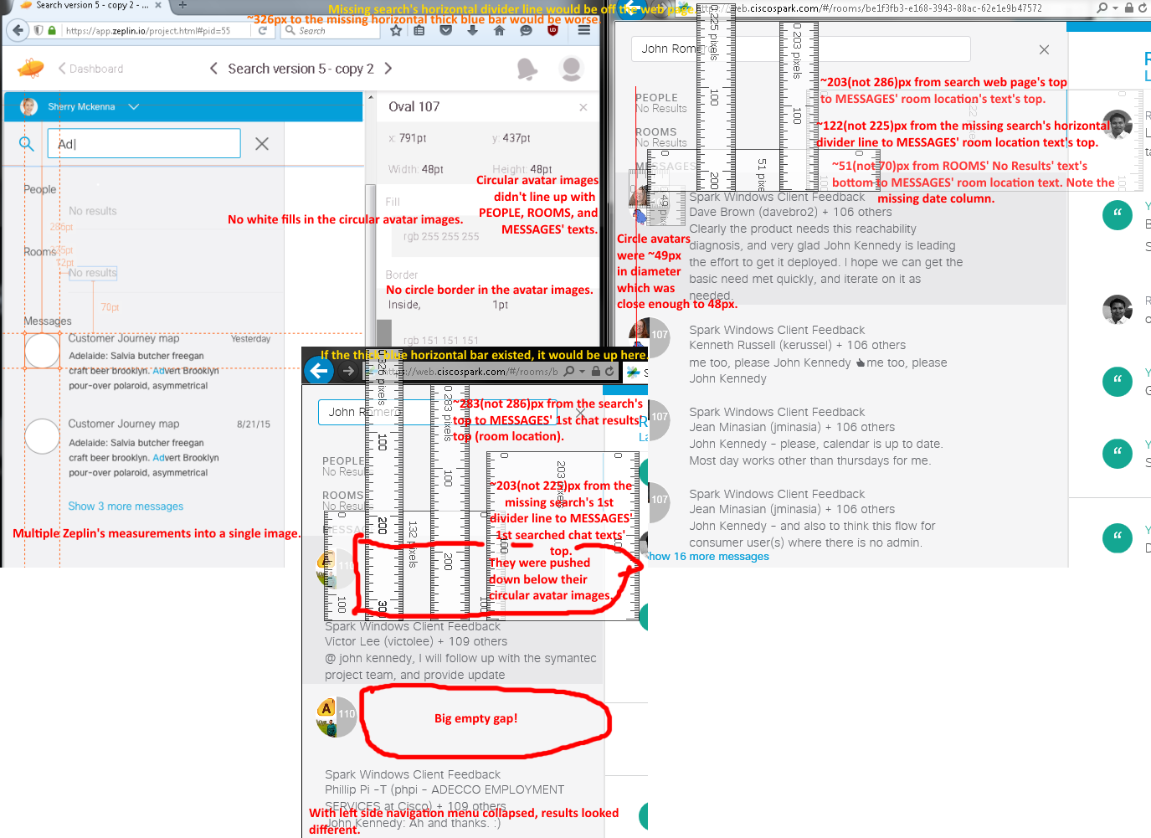
Issues from the above expanded (2/10/2016 afternoon & evening (Forgot to note the versions, but Renaldo Williams said they were posted on 2/9/2016 8:56:08 AM. As of 2/11/2016 4:52 AM & 3:18 PM, they were v4419 - SDK v0.5.52)) and collapsed (v4540 - SDK v0.5.52 (3/2/2016); cropped to show only the differences)) left side navigation menu layouts image (above):
- Incorrect measurements, alignments, and formattings.
- No white fills and gr(a/e)y circle border for the circular avatar images.
- Darker gr(e/a)y row highlight on the search’s first hit.

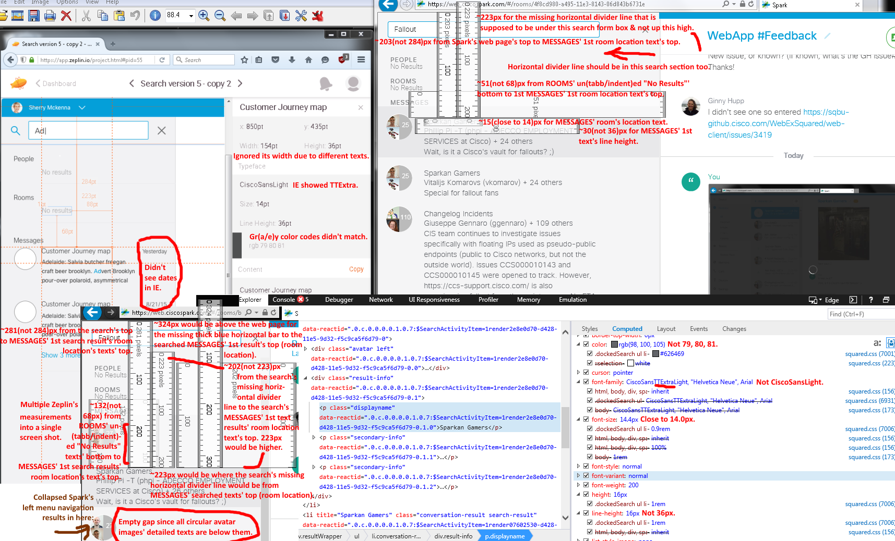
Issues from the above expanded (2/10/2016 afternoon & evening (Forgot to note the versions, but Renaldo Williams said they were posted on 2/9/2016 8:56:08 AM. As of 2/11/2016 4:52 AM & 3:18 PM, they were v4419 - SDK v0.5.52)) and collapsed (v4540 - SDK v0.5.52 (3/2/2016; cropped image) left side navigation menu layouts image (above):
- Incorrect sizes, alignments, color codes, font type face, and capitalization formattings.
- Darker gr(a/e)y row highlight on the search’s first hit.
- Missing MESSAGES’ dates (unable to check them) and search’s horizontal divider line (even if it existed, it would be in the wrong place based on its measurement) in the search section.
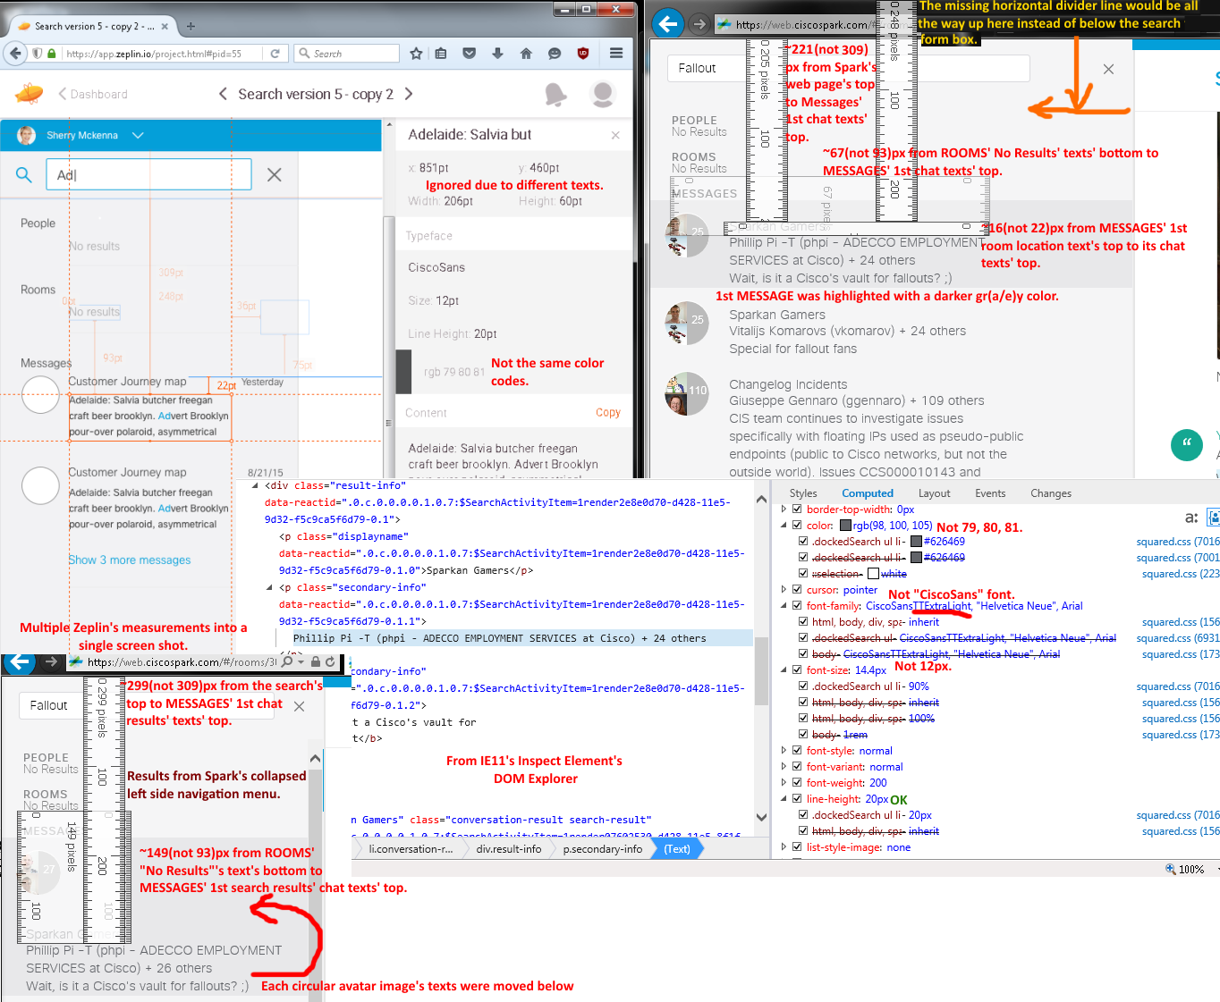
Issues from the expanded (2/10/2016 afternoon & evening (Forgot to note the versions, but Renaldo Williams said they were posted on 2/9/2016 8:56:08 AM. As of 2/11/2016 4:52 AM & 3:18 PM, they were v4419 - SDK v0.5.52)) and collapsed (v4540 - SDK v0.5.52 (3/2/2016); cropped for its differences) left side navigation menu layouts image:
1. Incorrect sizes, alignments, color codes, font type face, capitalization, and formattings.
2. Darker gr(a/e)y row highlight on the search’s first hit.
3. Missing MESSAGES’ dates (unable to check them) and search’s horizontal divider line (even if it existed, it would be in the wrong place based on its measurement) in the search section.

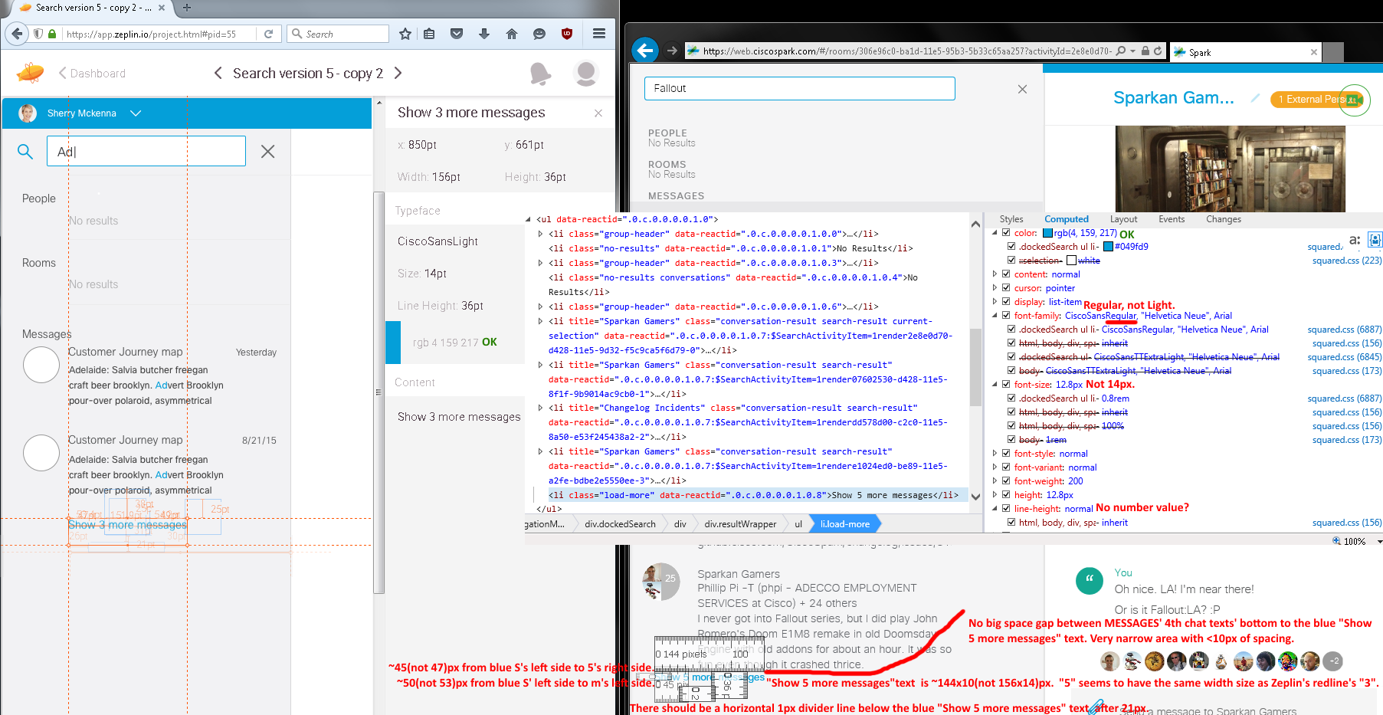
Issues from the expanded left side navigation menu (2/10/2016 afternoon & evening (Forgot to note the versions, but Renaldo Williams said they were posted on 2/9/2016 8:56:08 AM. As of 2/11/2016 4:52 AM & 3:18 PM, they were v4419 - SDK v0.5.52)) [above image]:
- Wrong sizes, alignments, font type face, and formattings (crowded with tight spaces with less than ten pixels).
- Missing 1px horizontal divider line below the blue “Show X more messages” line in the search section.

Zeplin’s Search Redline Screen #3 (with its expanded left navigation menu):
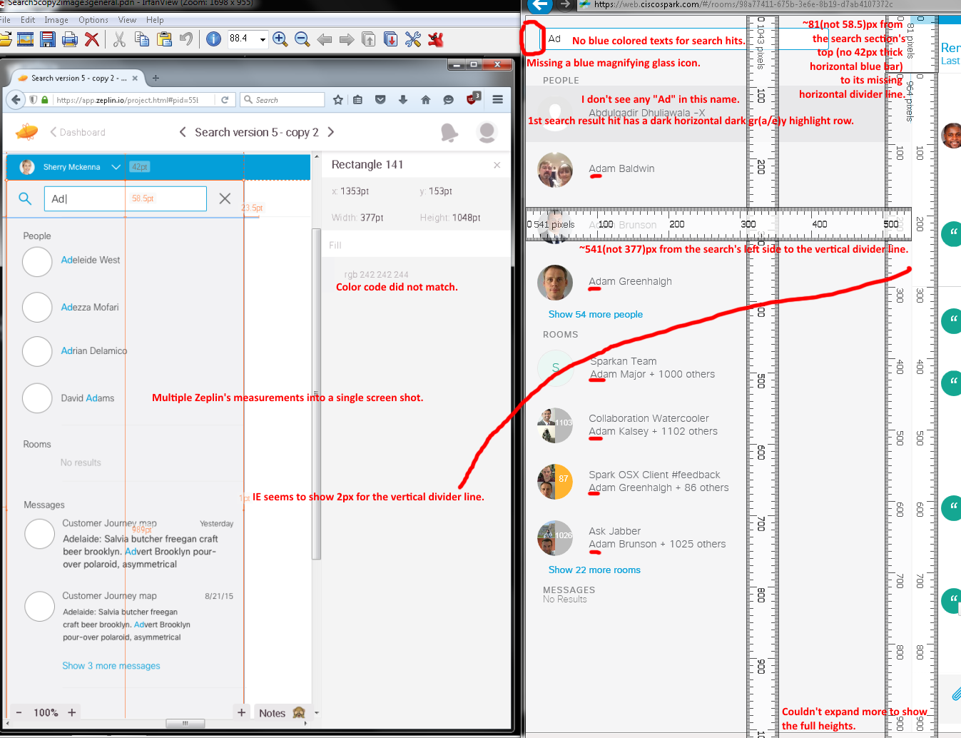
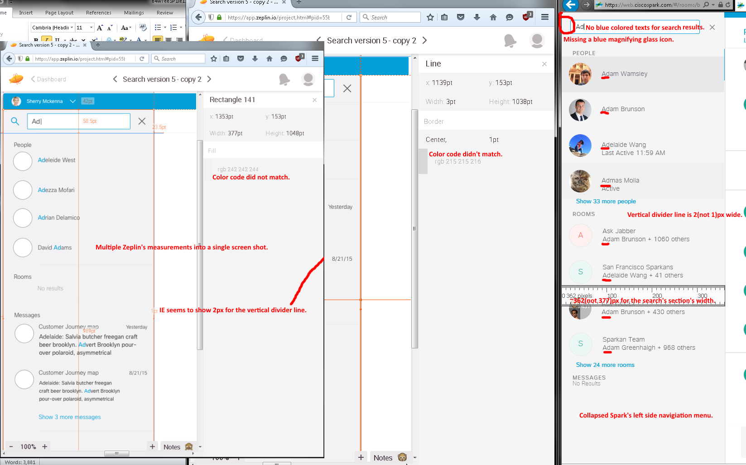
Issues from the expanded (2/10/2016 afternoon & evening (Forgot to note the versions, but Renaldo Williams said they were posted on 2/9/2016 8:56:08 AM. As of 2/11/2016 4:52 AM & 3:18 PM, they were v4419 - SDK v0.5.52)) and v4540 - SDK v0.5.52 (3/2/2016) left side navigation menu layouts images (above):
- Incorrect measurements and color code.
- Missing horizontal divider line in the search section, horizontal thick blue bar, magnifying glass icon/graphic, and lowercased letters for “PEOPLE” text.
- First search result hit had a darker gr(e/a)y highlighted row color. Also, it showed a search hit of “Ad”, but I did not see any in "Abdulgadir Dhuliawala -X" name.
- No blue color matched text inputs (Ad as an example) in the search results.
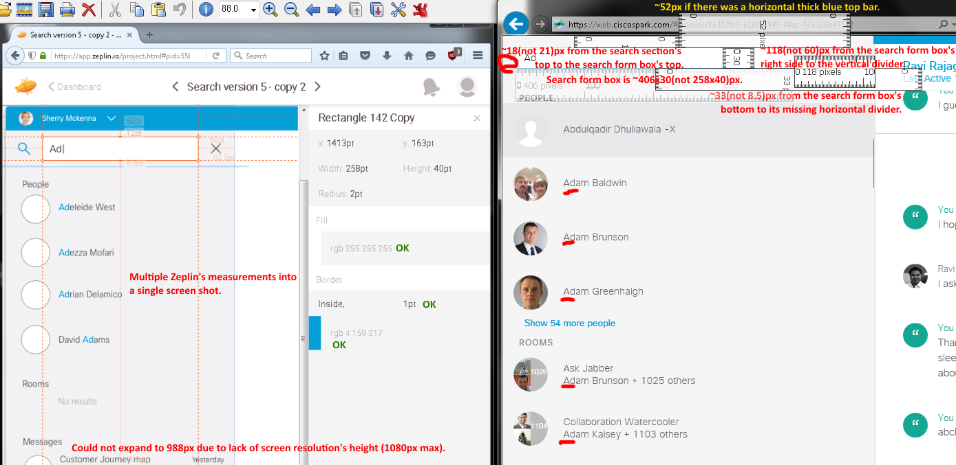
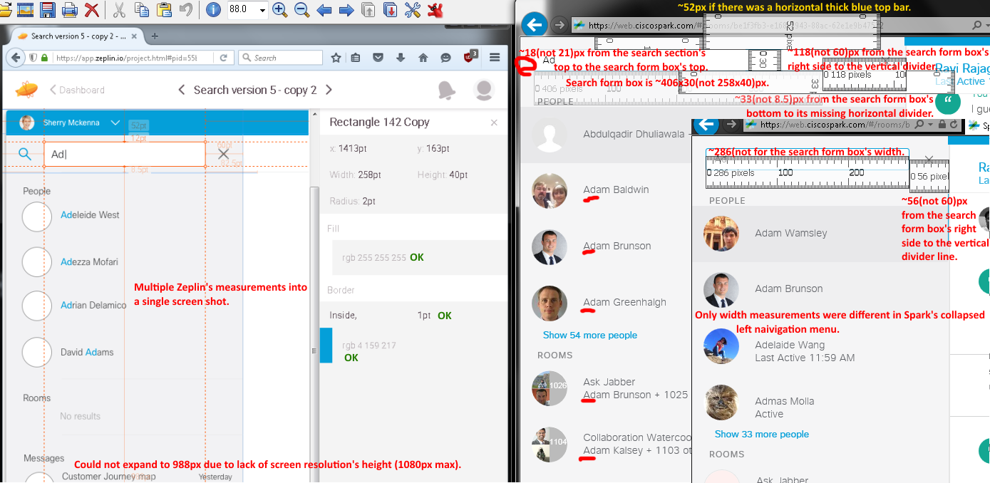
Issues from the expanded (2/10/2016 afternoon & evening (Forgot to note the versions, but Renaldo Williams said they were posted on 2/9/2016 8:56:08 AM. As of 2/11/2016 4:52 AM & 3:18 PM, they were v4419 - SDK v0.5.52)) and v4540 - SDK v0.5.52 (3/2/2016; cropped) left side navigation menu layouts images (above):
- Wrong measurements.
- Missing horizontal divider line in the search section, horizontal thick blue bar, magnifying glass icon/graphic, and lowercased letters for “PEOPLE” text.
- First search result hit had a darker gr(a/e)y highlighted row color. Also, it showed a search hit of “Ad”, but I did not see any in "Abdulgadir Dhuliawala -X" name.
- No blue color matched text inputs (Ad as an example) in the search results.

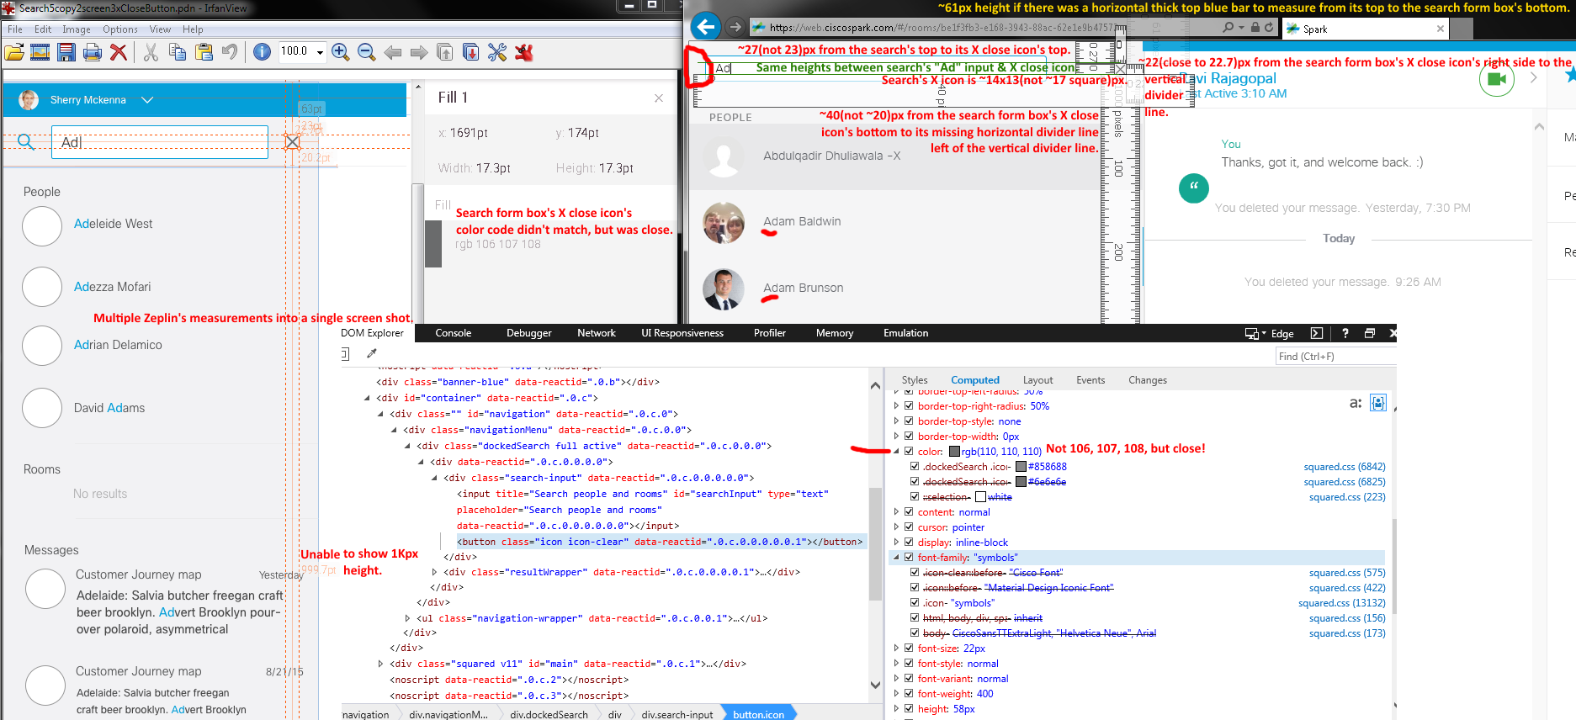
Issues from the above expanded (2/10/2016 afternoon & evening (Forgot to note the versions, but Renaldo Williams said they were posted on 2/9/2016 8:56:08 AM. As of 2/11/2016 4:52 AM & 3:18 PM, they were v4419 - SDK v0.5.52)) and v4540 - SDK v0.5.52 (3/2/2016; not shown since the results were the similiar) left side navigation menu layouts images (above):
- Incorrect sizes and color code.
- Missing horizontal divider line in the search section, horizontal thick blue bar, magnifying glass icon/graphic, and lowercased letters for “PEOPLE” text.
- First search result hit had a darker gr(a/e)y highlighted row color. Also, it showed a search hit of “Ad”, but I did not see any in "Abdulgadir Dhuliawala -X" name.
- No blue color matched text inputs (Ad as an example) in the search results.

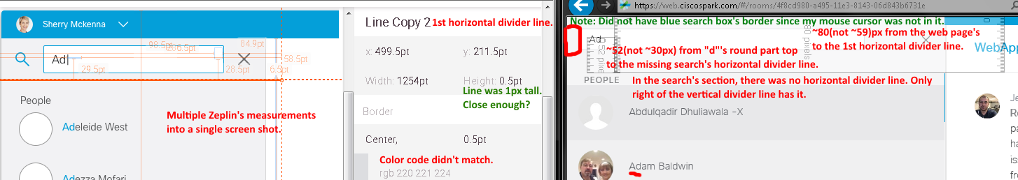
Issues from the above expanded (2/10/2016 afternoon & evening (Forgot to note the versions, but Renaldo Williams said they were posted on 2/9/2016 8:56:08 AM. As of 2/11/2016 4:52 AM & 3:18 PM, they were v4419 - SDK v0.5.52)) and v4540 - SDK v0.5.52 (3/2/2016; not shown since the results were the similiar) left side navigation menu layouts image (above):
- Wrong sizes and color code.
- Missing horizontal divider line in the search section, horizontal thick blue bar, magnifying glass icon/graphic, and lowercased letters for “PEOPLE” text.
- First search result hit had a darker gr(a/e)y highlighted row color. Also, it showed a search hit of “Ad”, but I did not see any in "Abdulgadir Dhuliawala -X" name.
- No blue color matched text inputs (Ad as an example) in the search results.

This document page only has text issues from previous and next pages with huge images that take up the whole pages.

Issues from the below expanded (2/10/2016 afternoon & evening (Forgot to note the versions, but Renaldo Williams said they were posted on 2/9/2016 8:56:08 AM. As of 2/11/2016 4:52 AM & 3:18 PM, they were v4419 - SDK v0.5.52)) and v4540 - SDK v0.5.52 (3/2/2016; cropped to show the differences) left side navigation menu layouts image (above):
- IE’s “PEOPLE” text was in caps unlike redline’s “People” text.
- Wrong sizes, color code, and CiscoSans font type face.
- Missing horizontal divider line in the search section, horizontal thick blue bar, magnifying glass icon/graphic, and lowercased letters for “PEOPLE” text.
- First search result hit had a darker gr(a/e)y highlighted row color. Also, it showed a search hit of “Ad”, but I did not see any in "Abdulgadir Dhuliawala -X" name.
- No blue color matched text inputs (Ad as an example) in the search results.
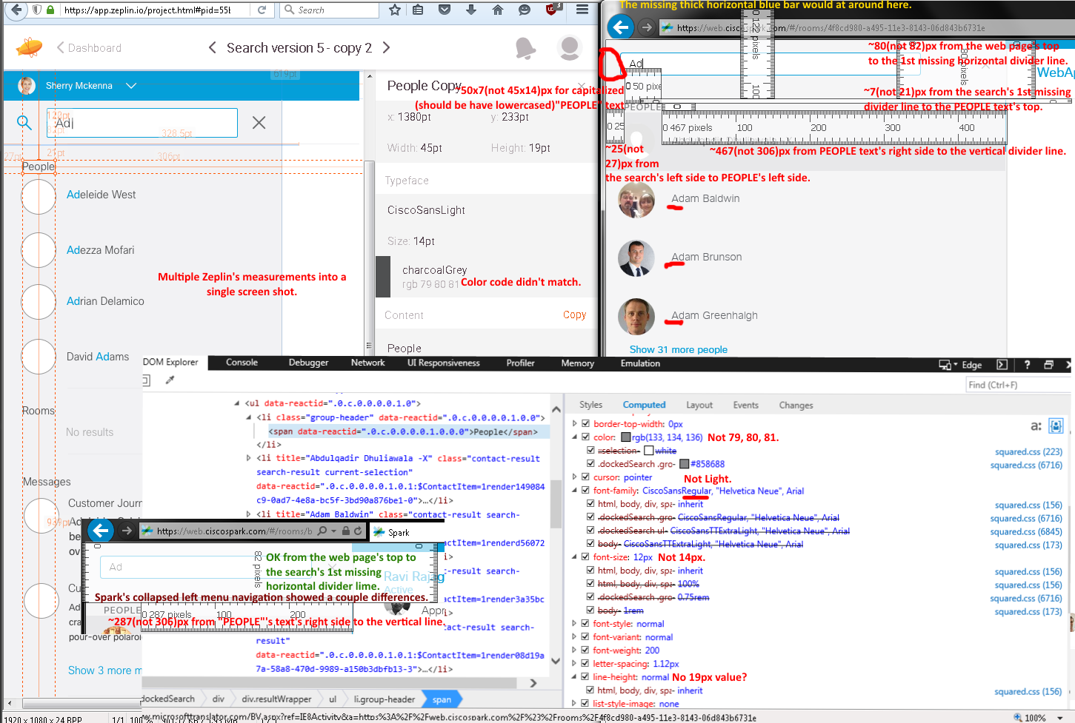

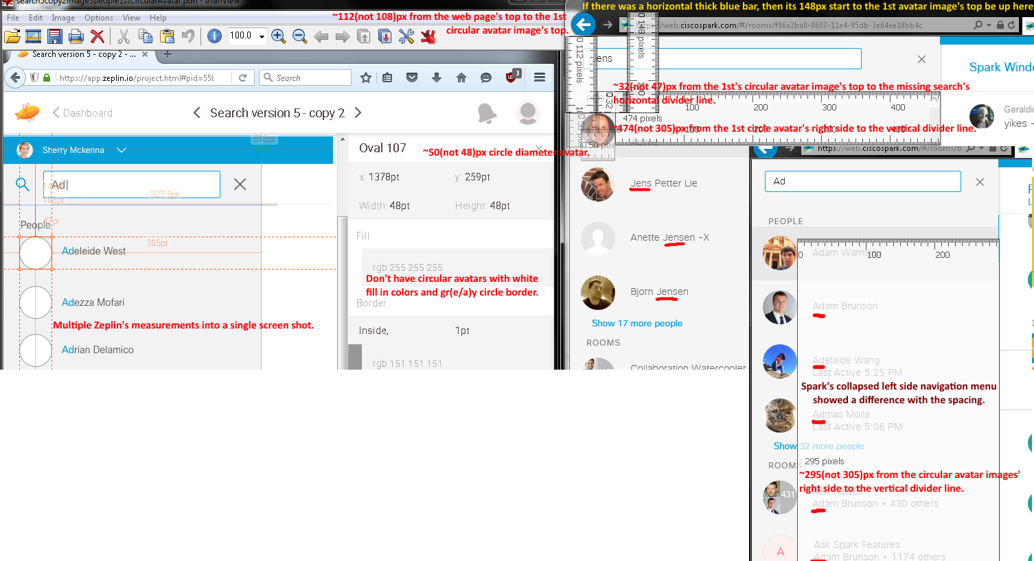
Issues from the above expanded (2/10/2016 afternoon & evening (Forgot to note the versions, but Renaldo Williams said they were posted on 2/9/2016 8:56:08 AM. As of 2/11/2016 4:52 AM & 3:18 PM, they were v4419 - SDK v0.5.52)) and v4540 - SDK v0.5.52 (3/2/2016; cropped to show the differences) left side navigation menu layouts image (above):
- Incorrect sizes.
- Missing search’s horizontal divider line, searched default white filled and gr(a/e)y bordered circular avatar images, horizontal thick blue bar, magnifying glass icon/graphic, and lowercased letters for “PEOPLE” text.
- First search result hit had a darker gr(a/e)y highlighted row color.
- No blue color matched text inputs (Jens and Ad examples) in the search results.

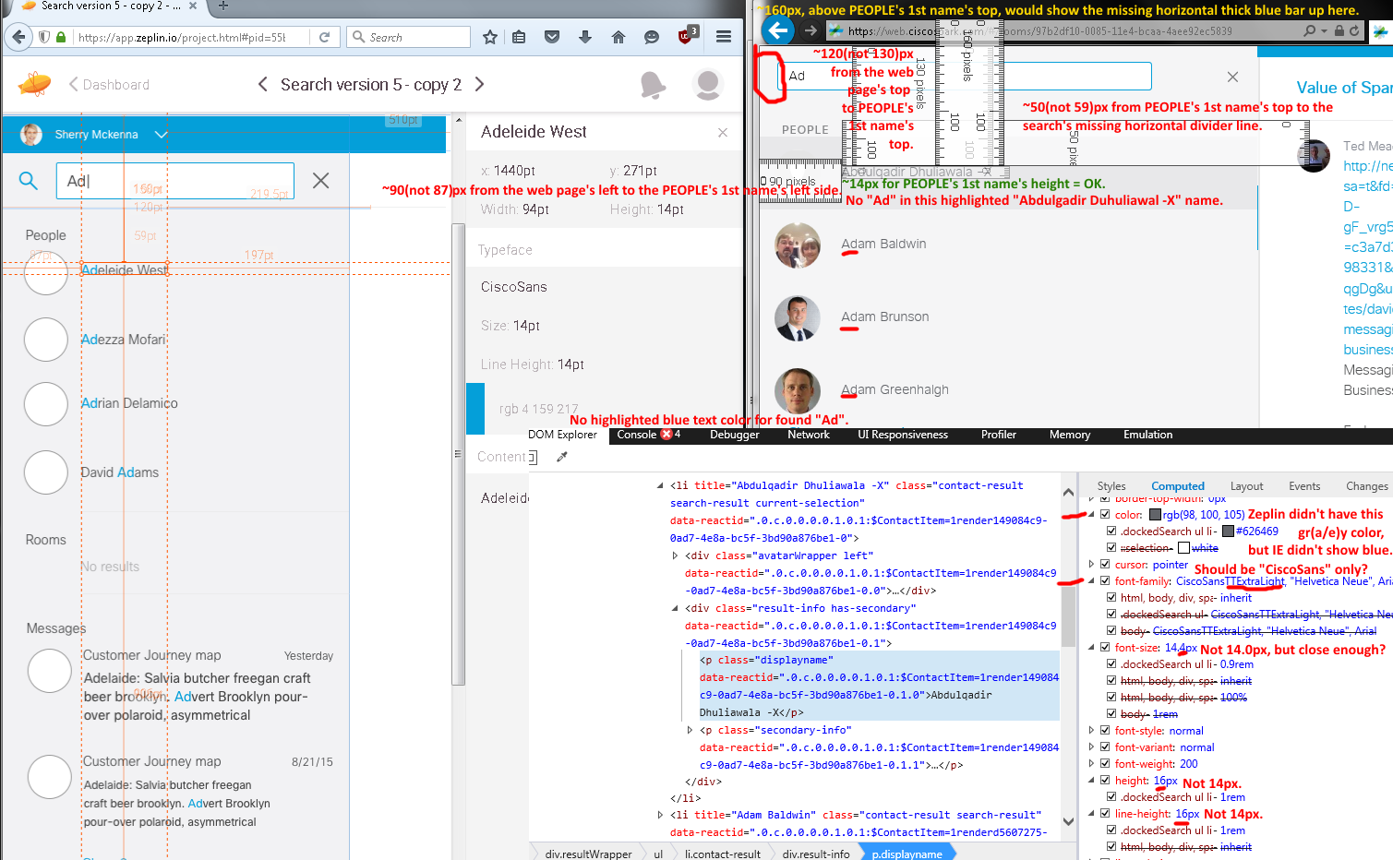
Issues from the above expanded (2/10/2016 afternoon & evening (Forgot to note the versions, but Renaldo Williams said they were posted on 2/9/2016 8:56:08 AM. As of 2/11/2016 4:52 AM & 3:18 PM, they were v4419 - SDK v0.5.52)) and v4540 - SDK v0.5.52 (3/2/2016; image not shown since the results were similiar) left side navigation menu layouts image (above):
- Mismatched sizes.
- Missing first search’s horizontal divider line, top horizontal thick blue bar, magnifying glass icon/graphic, and lowercased letters for “PEOPLE” text.
- First search result hit had a darker gr(a/e)y highlighted row color.
- No blue color matched text inputs (Ad as an example) in the search results.

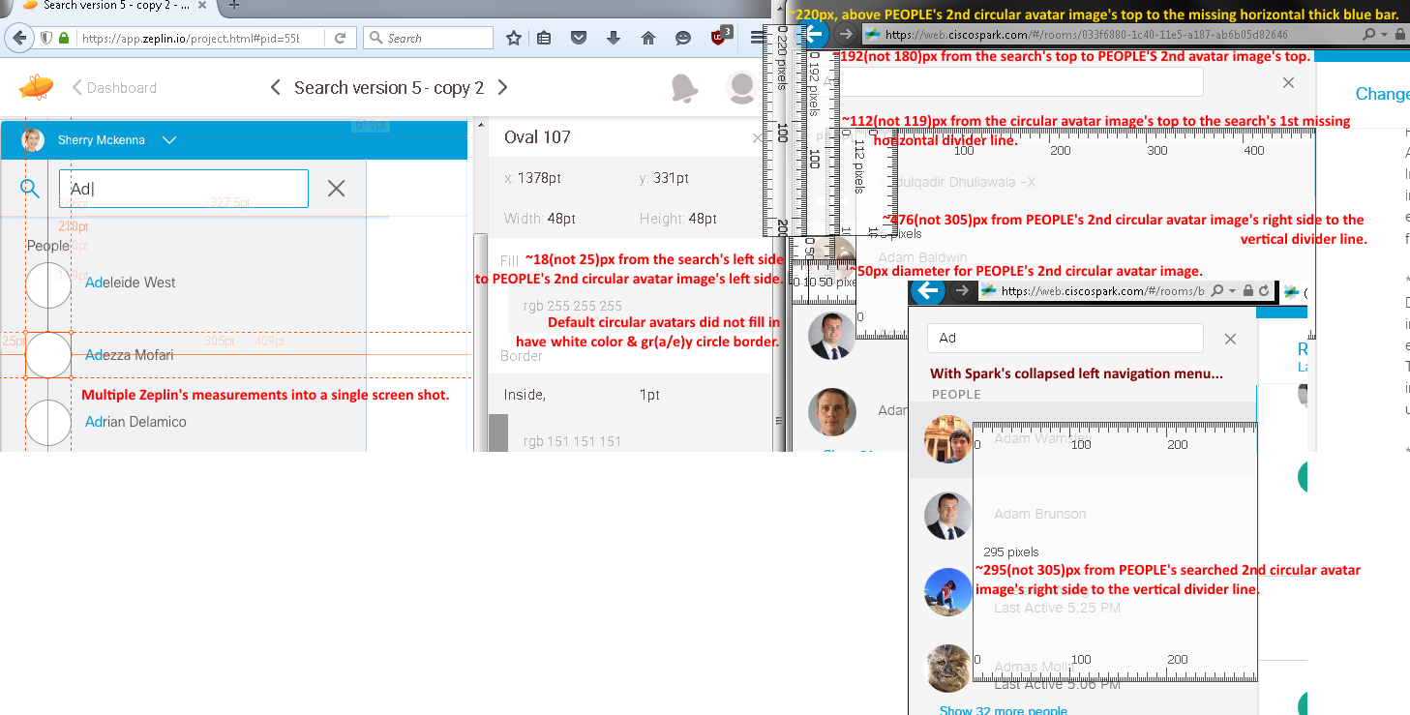
Issues from the above expanded (2/10/2016 afternoon & evening (Forgot to note the versions, but Renaldo Williams said they were posted on 2/9/2016 8:56:08 AM. As of 2/11/2016 4:52 AM & 3:18 PM, they were v4419 - SDK v0.5.52)) and v4540 - SDK v0.5.52 (3/2/2016; cropped image to show the difference) left side navigation menu layouts image (above):
- Wrong sizes.
- Missing first search’s horizontal divider line, top horizontal thick blue bar, magnifying glass icon/graphic, and lowercased letters for “PEOPLE” text.
- First search result hit had a darker gr(a/e)y highlighted row color on “Abdulqadir Dhuliawala –X” name, but it didn’t have an “Ad” search keyword.
- No blue color matched text inputs (Ad as an example) in the search results.
- Default plain circular avatar images did not have filled in white color with gr(e/a)y circle borders.

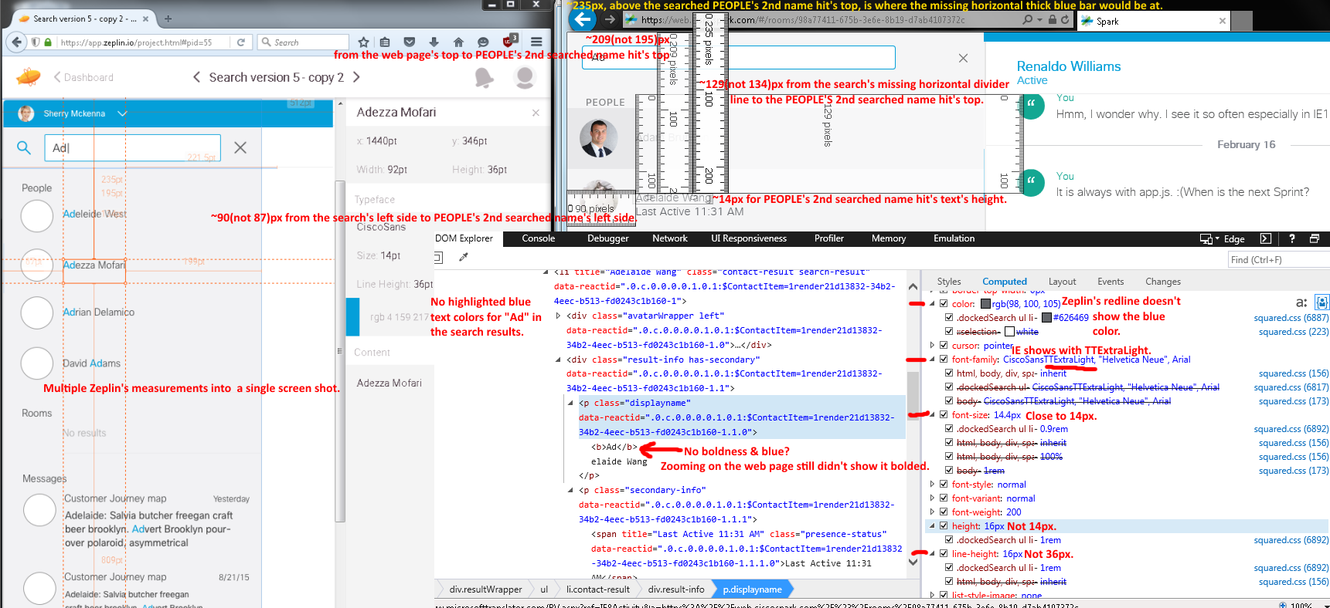
Issues from the above expanded (v4463 - SDK v0.5.52 on 2/19/2016) and collapsed (v4540 - SDK v0.5.52 (3/2/2016); not shown since its results were similiar) left side navigation menu image (above):
- Incorrect sizes.
- Missing first search’s horizontal divider line, top horizontal thick blue bar, magnifying glass icon/graphic, and lowercased letters for “PEOPLE” text.
- First search result hit had a darker gr(a/e)y highlighted row color.
- No bold and blue color matched text inputs (Ad as an example) in the search results.
- Zeplin’s redline didn’t have the RGB color code for the gr(e/a)y font color for PEOPLE’s names’ texts (e.g., Adelaide Wang). It only had the RGB color code for blue color which did not show in IE.

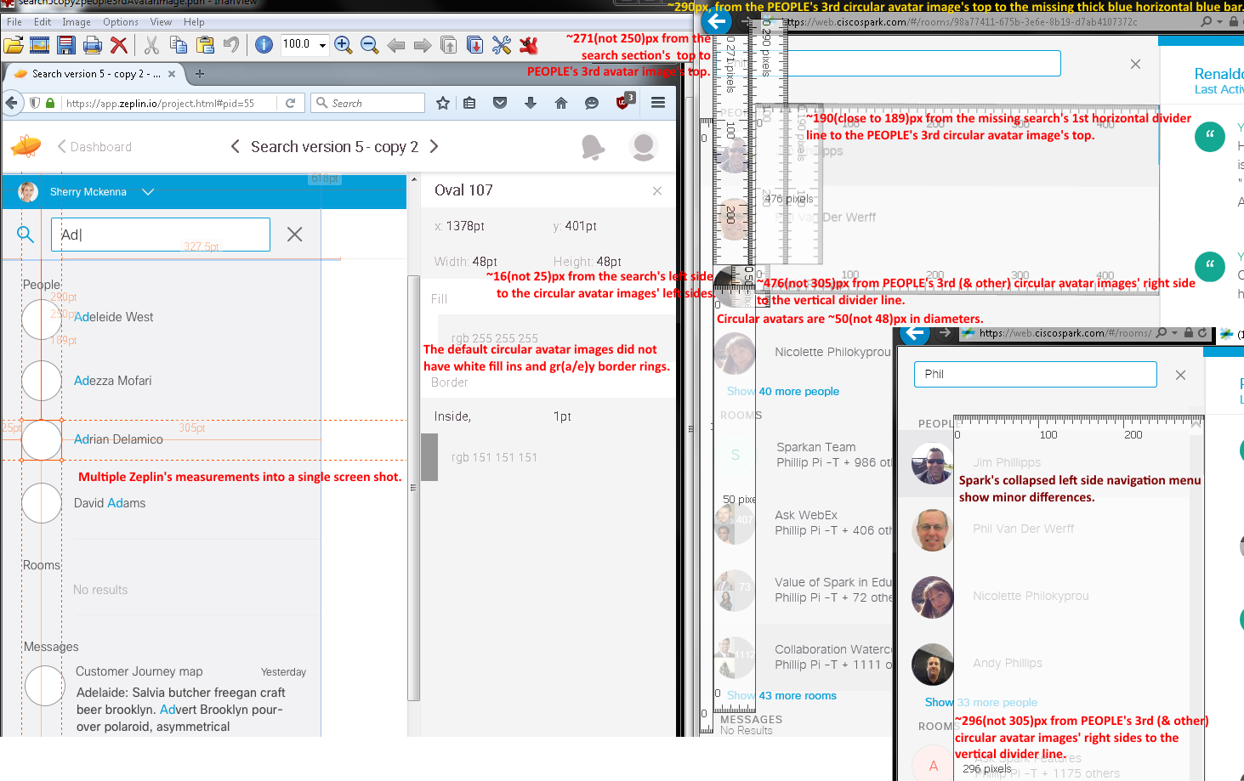
Issues from the above expanded (v4463 - SDK v0.5.52 on 2/19/2016) and collapsed (v4540 - SDK v0.5.52 (3/2/2016); cropped) left side navigation menu images (above):
- Mismatched sizes.
- Missing first search’s horizontal divider line, top horizontal thick blue bar, magnifying glass icon/graphic, and lowercased letters for “PEOPLE” text.
- First search result hit had a darker gr(e/a)y highlighted row color.
- No bold and blue color matched text inputs (Phil as an example) in their search results.
- Zeplin’s redline’s generic default circular avatar images were filled in white color and gr(a/e)y circle borders.

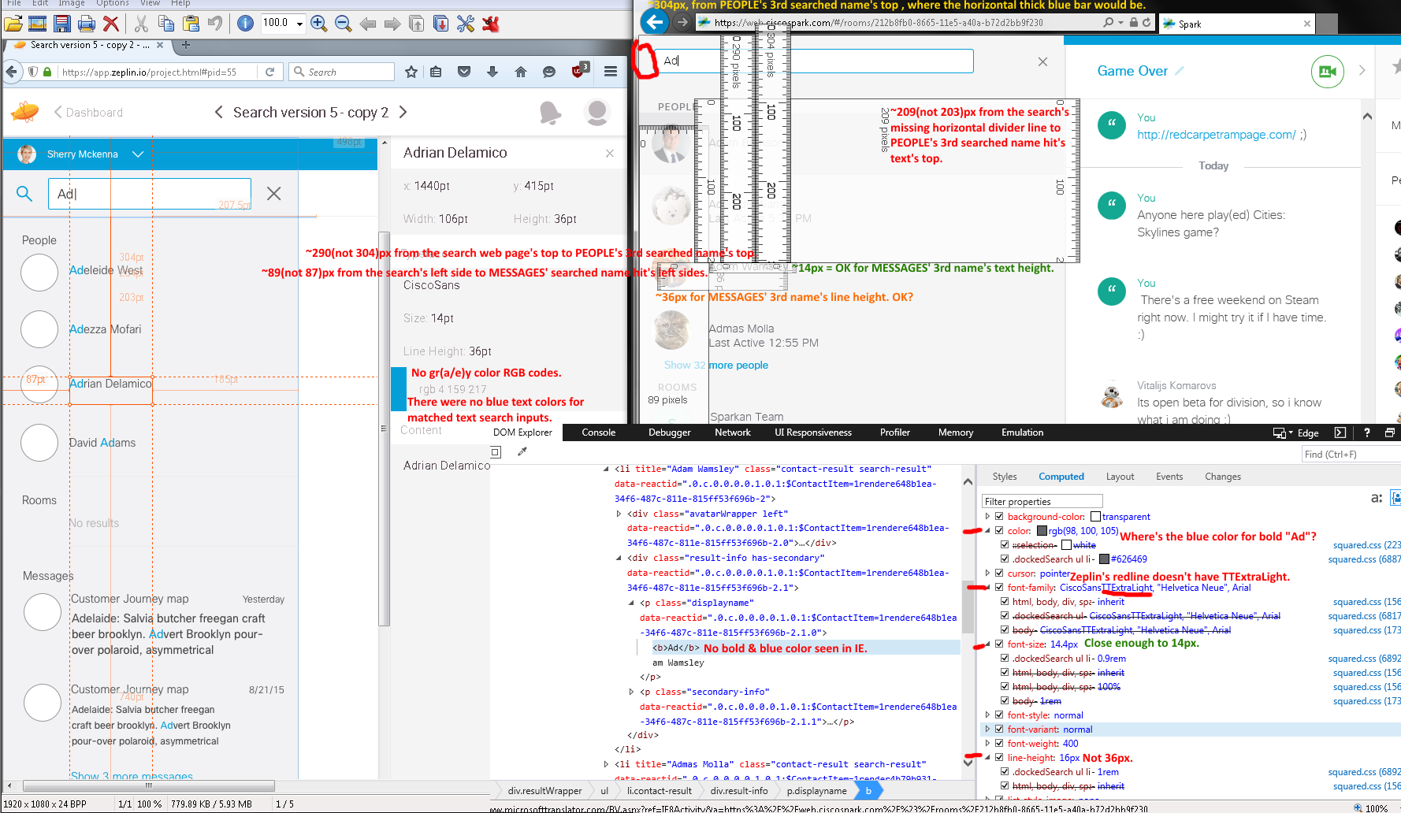
Above issues from the expanded (v4463 - SDK v0.5.52 on 2/19/2016) and collapsed (v4540 - SDK v0.5.52 (3/2/2016); not shown since its results look similar) left side navigation menu (above image):
- Wrong sizes, color codes, and maybe CiscoSans font type face.
- Missing first search’s horizontal divider line, top horizontal thick blue bar, magnifying glass icon/graphic, and lowercased letters for “PEOPLE” text.
- First search result hit had a darker gr(e/a)y highlighted row color.
- No bold and blue color matched text inputs (Ad as an example) in the search results.
- Zeplin’s redline didn’t show the gr(a/e)y color code for PEOPLE’s searched result hits.

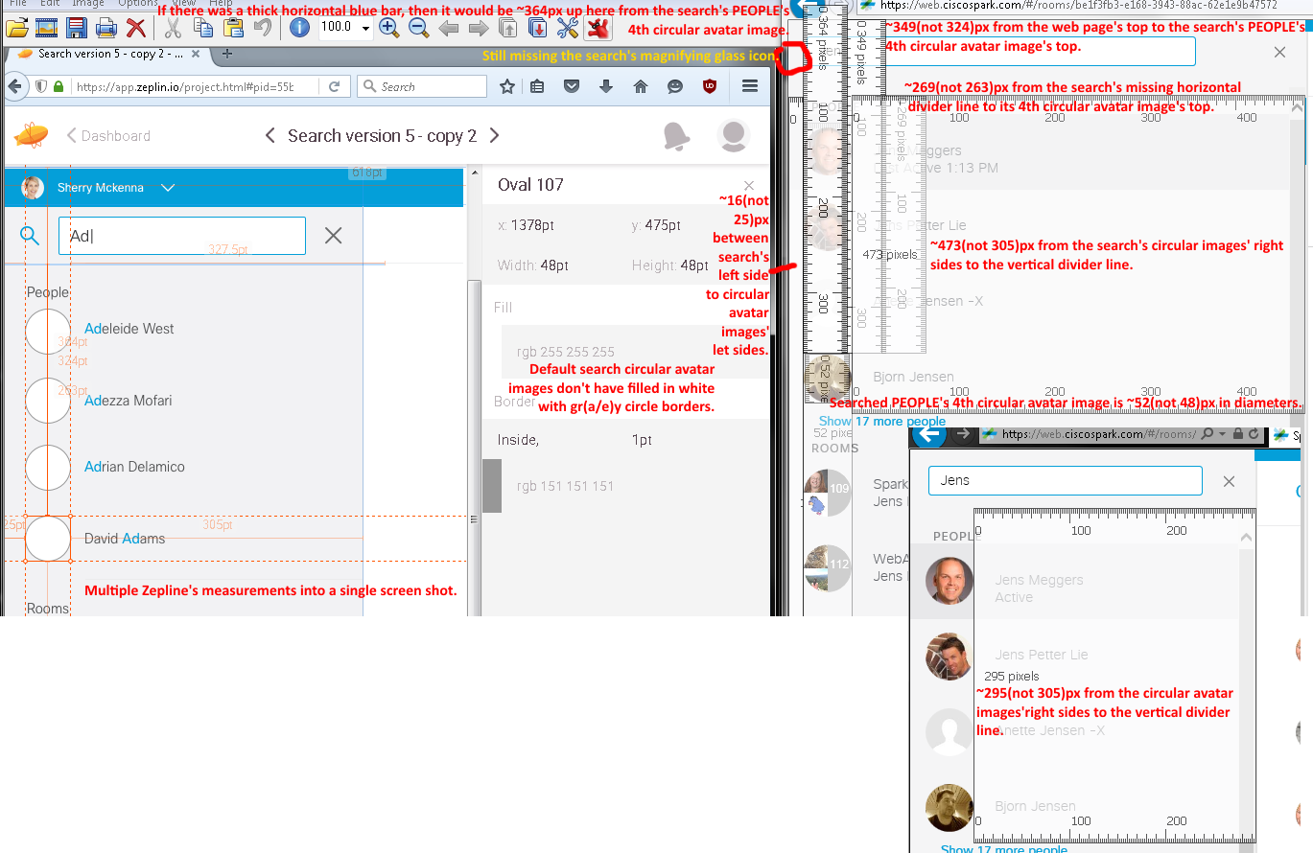
Below issues from the expanded (v4463 - SDK v0.5.52 on 2/19/2016) and collapsed (v4540 - SDK v0.5.52 (3/2/2016)) left side navigation menu:
- Incorrect sizes.
- Default generic circular avatar images did not have filled in white color with gr(e/a)y circle borders.
- Missing first search’s horizontal divider line, top horizontal thick blue bar, magnifying glass icon/graphic, and lowercased letters for “PEOPLE” text.
- First search result hit had a darker gr(e/a)y highlighted row color.
- No bold and blue color matched text inputs (Jens as an example) in the search results.
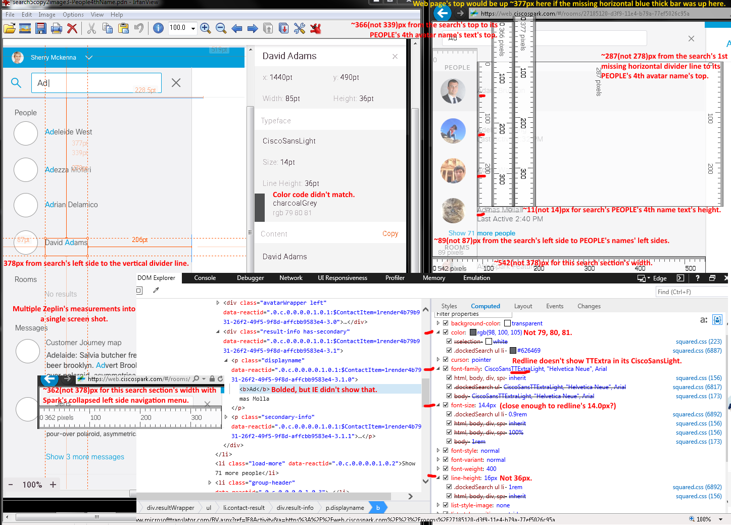

Issues from the above screen capture/shot with the expanded (v4463 - SDK v0.5.52 on 2/19/2016) and collapsed (v4540 - SDK v0.5.52 (3/2/2016); cropped to show the differences) left side navigation menu layouts:
- Mismatched sizes, color code, and CiscoSansLight font type face.
- Missing first search’s horizontal divider line, top horizontal thick blue bar, magnifying glass icon/graphic, and lowercased letters for “PEOPLE” text.
- First search result hit had a darker gr(e/a)y highlighted row color.
- No bold and blue color matched text inputs (Ad as an example) in the search results.

Note: Huge images did not fit with their issue lists, so using the two screen (shot/capture)s’ issue lists in this document page to avoid wasting two document pages.

Issues from the below screen shot/capture Issues with the expanded (v4463 - SDK v0.5.52 on 2/19/2016) and collapsed (v4540 - SDK v0.5.52 (3/2/2016); cropped to show the differences) left side navigation menu layouts:
- Incorrect sizes, color code, and CiscoSans font type face.
- Missing first search’s horizontal divider line, top horizontal thick blue bar, magnifying glass icon/graphic, and lowercased letters for sections’ texts (PEOPLE and ROOMS).
- First search result hit had a darker gr(e/a)y highlighted row color.
- IE’s Inspect Element’s DOM Explorer didn’t show a line height’s numerical value to compare.
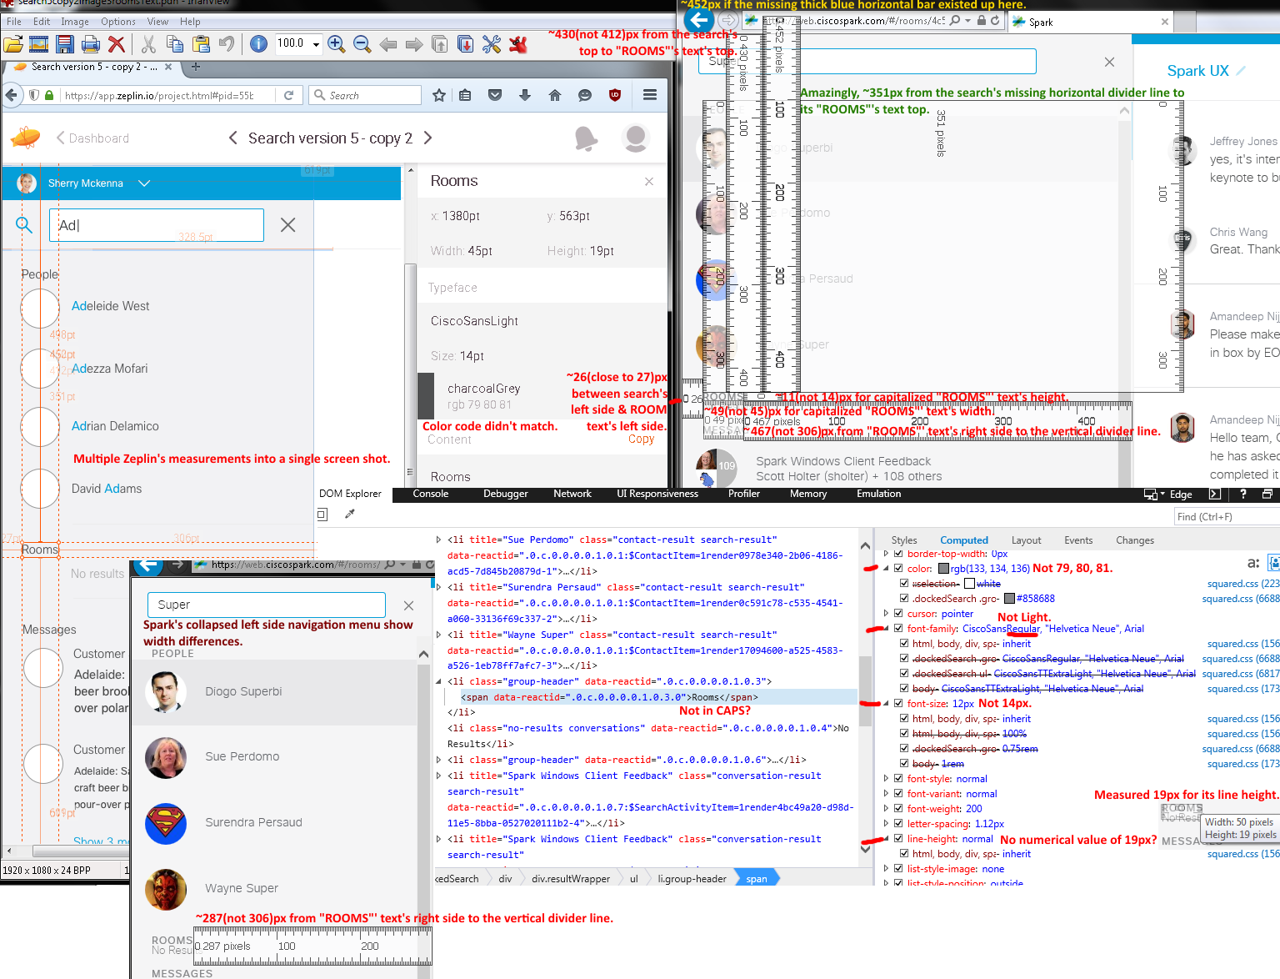
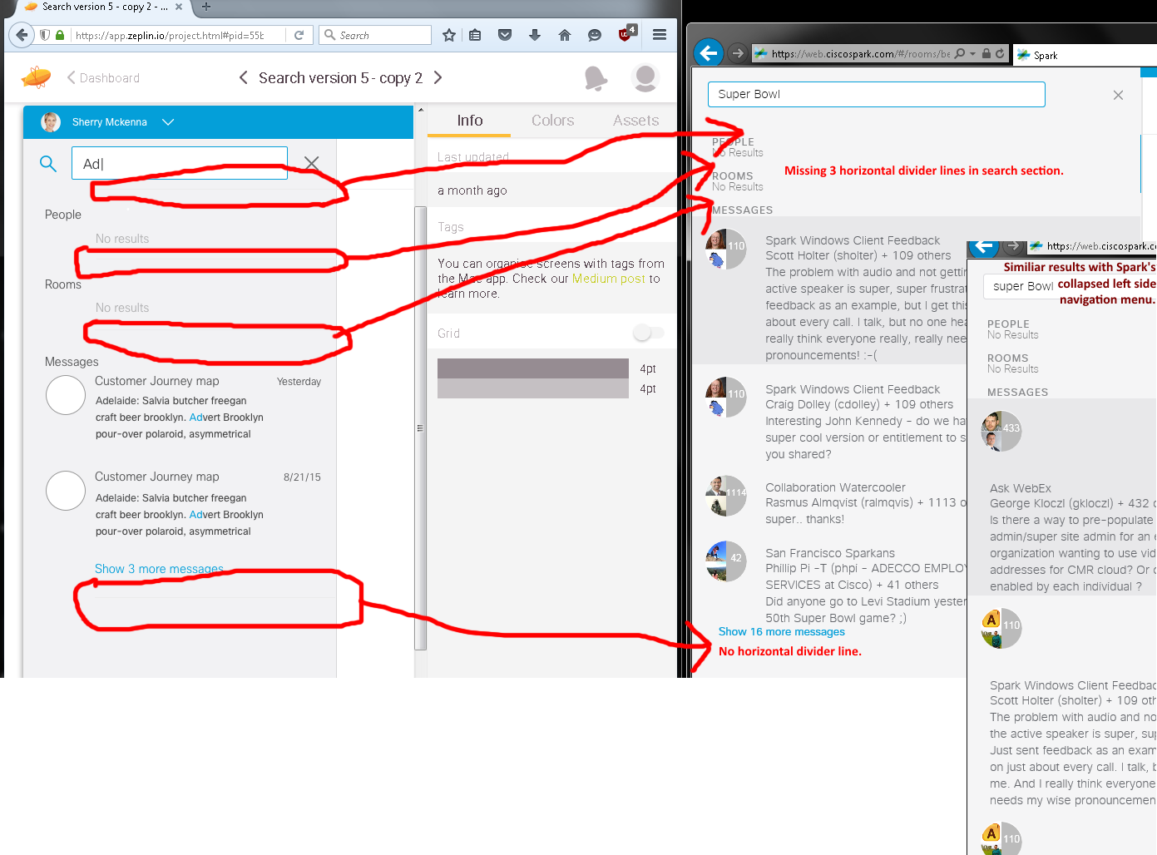
Issues from the above screen capture/shot with the expanded (v4467 - SDK v0.5.52 (2/23/2016); Zeplin’s search image #2) and collapsed (v4540 - SDK v0.5.52 (3/2/2016)): Four horizontal divider lines not seen in the search section.
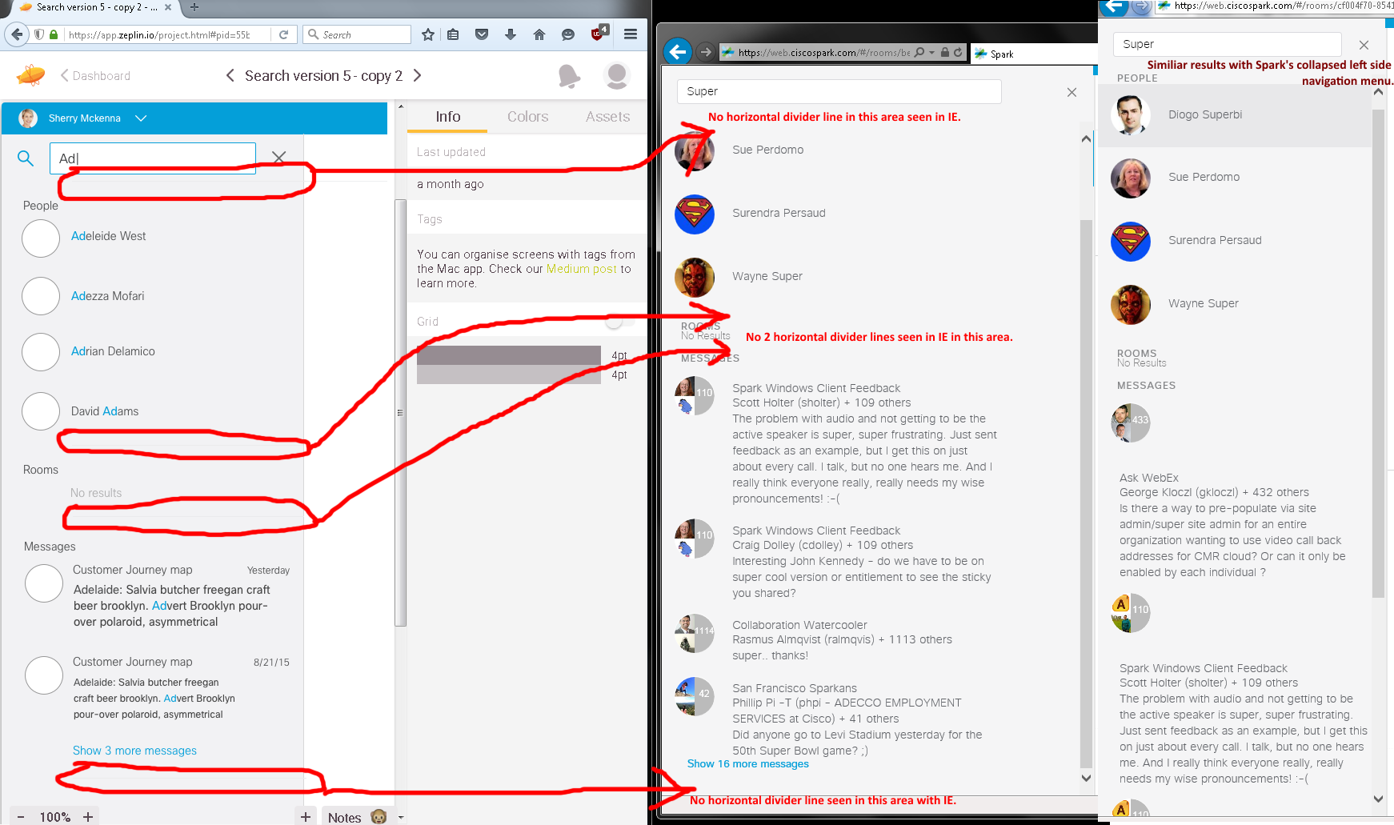
Issues from the above screen capture/shot with the expanded (v4467 - SDK v0.5.52 (2/23/2016); Zeplin’s search image #3) and collapsed (v4540 - SDK v0.5.52 (3/2/2016); cropped to show the differences) left side navigation menu: Four missing horizontal divider lines seen in the search section.

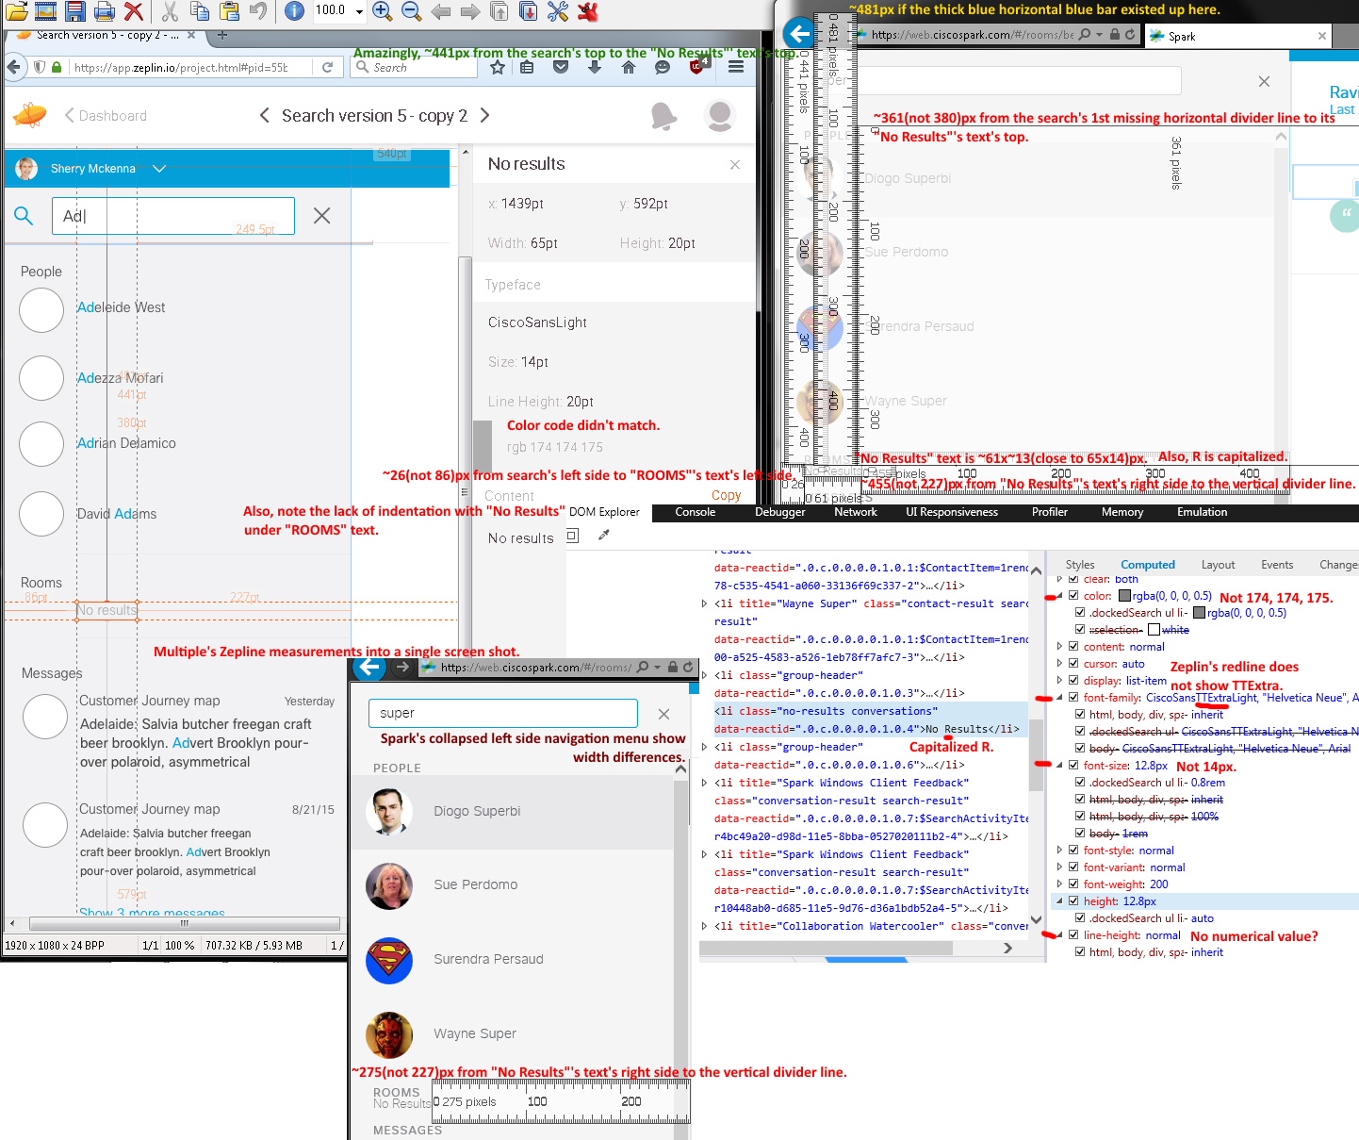
Issues from the above screen shot with the expanded (v4467 - SDK v0.5.52 (2/23/2016)) and collapsed (v4540 - SDK v0.5.52 (3/2/2016); cropped) left side navigation menu layouts:
- Incorrect sizes, color code, and CiscoSansLight font type face.
- Missing four search’s horizontal divider lines, top horizontal thick blue bar, magnifying glass icon/graphic, and lowercased letters for sections' texts (PEOPLE and ROOMS).
- “No Results” text has a capitalized R.
- First search result hit had a darker gr(e/a)y highlighted row color.
- IE’s Inspect Element’s DOM Explorer didn’t show a line height’s numerical value to compare.
- With Spark’s collapsed left side navigation menu, MESSAGES’ search results have formatting and wordwrapping issues with empty (space/gap)s due to each circular avatar image’s texts pushed below.

Note: Huge images did not fit with their issue lists, so using the two screen (shot/capture)s’ issue lists in this document page to avoid wasting two document pages.

Issues from the below screen capture/shot with expanded (v4467 - SDK v0.5.52 (2/23/2016)) and collapsed v4582 - SDK v0.5.52 (3/7/2016; cropped) left side navigation menu layouts:
- Incorrect sizes, color code, and CiscoSans font type face.
- Missing four search’s horizontal divider lines, top horizontal thick blue bar, magnifying glass icon/graphic, lowercased letters for “MESSAGES” text, and “No Results” text has a capitalized R.
- First search result hit had a darker gr(e/a)y highlighted row color.
- IE’s Inspect Element’s DOM Explorer didn’t show a line height’s numerical value to compare.
- With Spark’s collapsed left side navigation menu, MESSAGES’ search results have formatting and wordwrapping issues with empty (space/gap)s due to each circular avatar image’s texts pushed below.
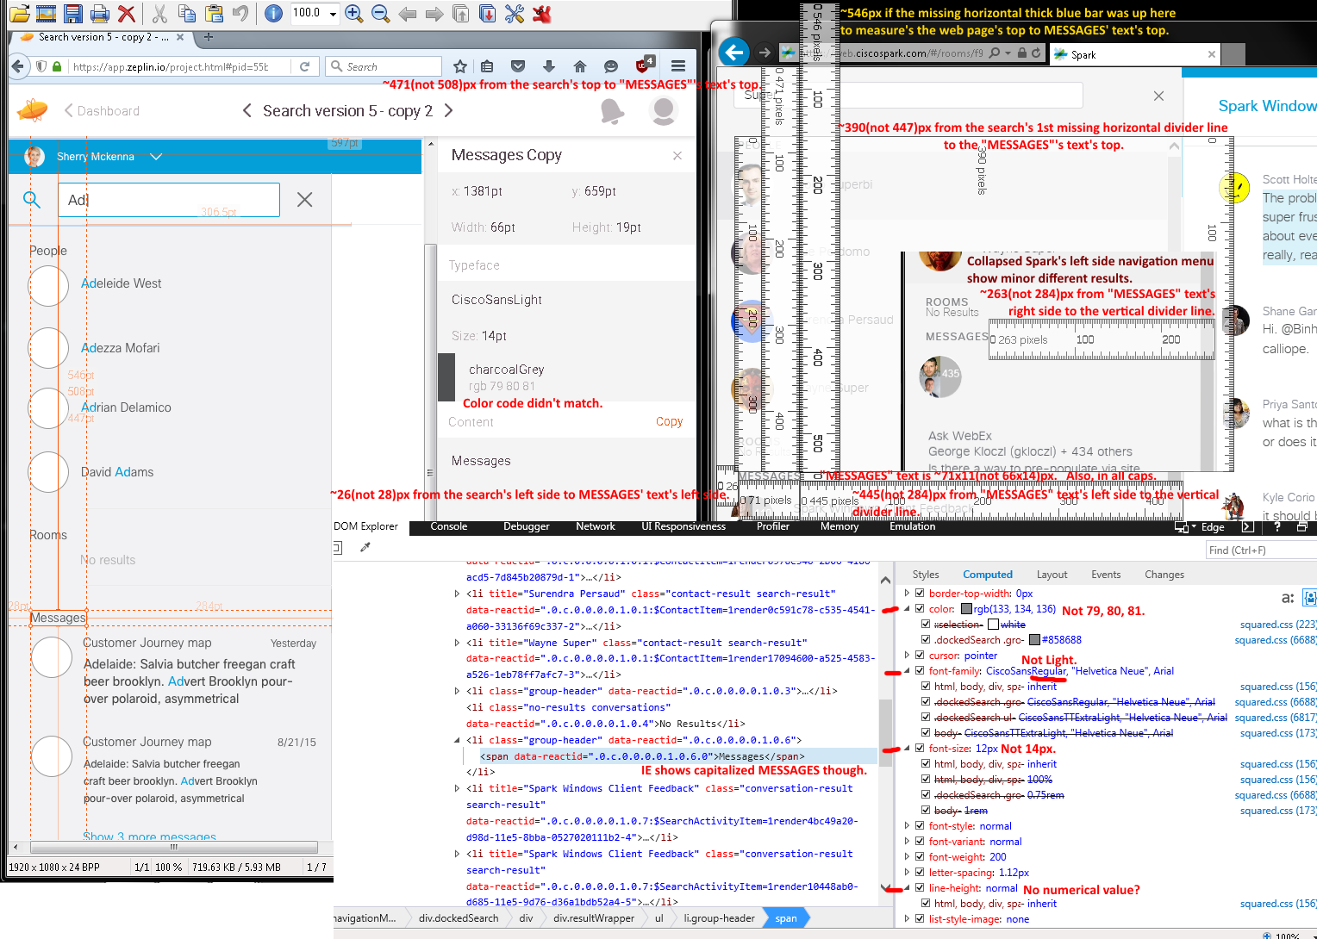

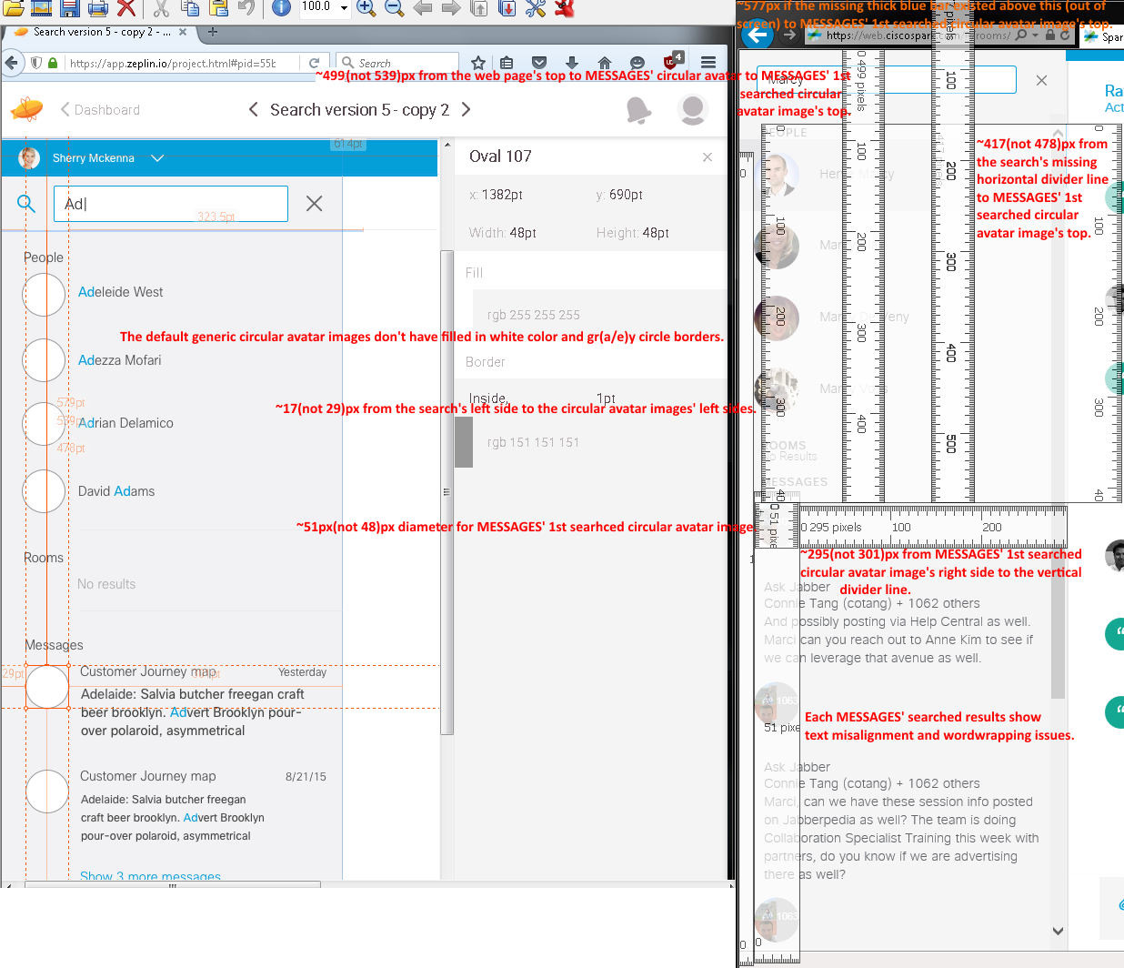
Issues from the above screen capture/shot with the collapsed (expanded layout showed similar results and not shown above) left side navigation menu (v4582 - SDK v0.5.52 (3/7/2016)) layout:
- Wrong sizes and maybe circular avatar images.
- Missing four search’s horizontal divider lines, top horizontal thick blue bar, magnifying glass icon/graphic, lowercased letters for “MESSAGES” text, and “No Results” text has a capitalized R.
- First search result hit had a darker gr(a/e)y highlighted row color.
- With Spark’s collapsed left side navigation menu, MESSAGES’ search results have formatting and wordwrapping issues with empty (space/gap)s due to each circular avatar image’s texts pushed below.

Note: Huge images did not fit with their issue lists, so using the two screen (shot/capture)s’ issue lists in this document page to avoid wasting two document pages.

Issues from the below screen shot/capture with the expanded (v4467 - SDK v0.5.52 (2/23/2016)) and collapsed (v4582 - SDK v0.5.52 (3/7/2016)) left side navigation menu:
- Incorrect measurements, CiscoSansLight font type face, and color code.
- Missing MESSAGES’ dates, four search’s horizontal divider lines, top horizontal thick blue bar, magnifying glass icon/graphic, and lowercased letters for “MESSAGES” text.
- “No Results” text has a capitalized R.
- First search result hit had a darker gr(a/e)y highlighted row color.
- With Spark’s collapsed left side navigation menu, MESSAGES’ search results have formatting and wordwrapping issues with empty (space/gap)s due to each circular avatar image’s texts pushed below.
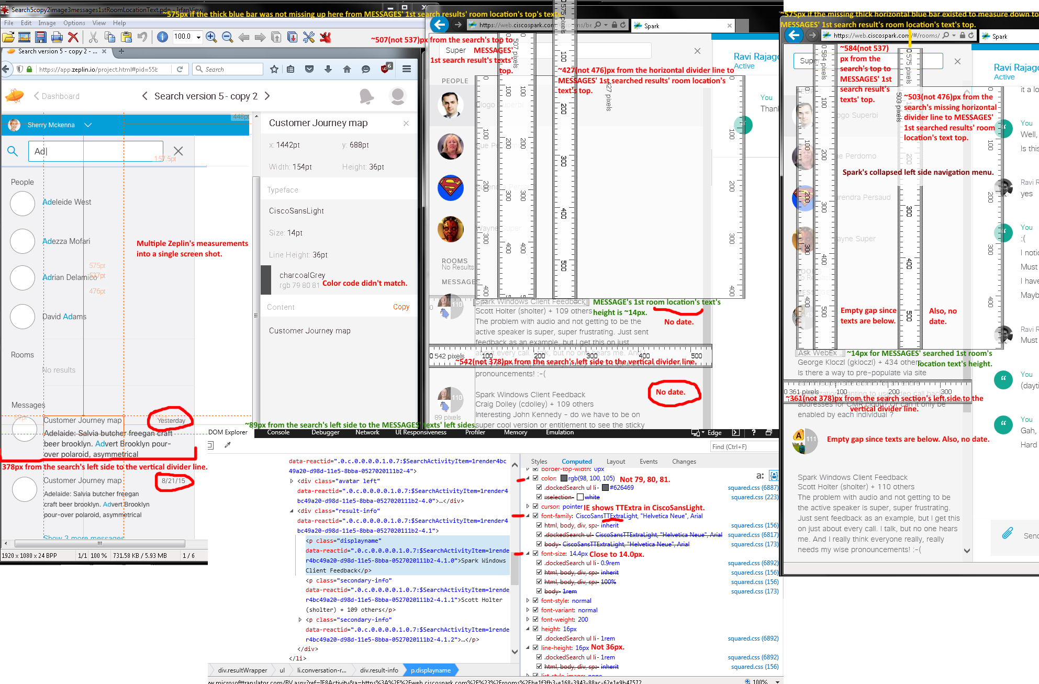

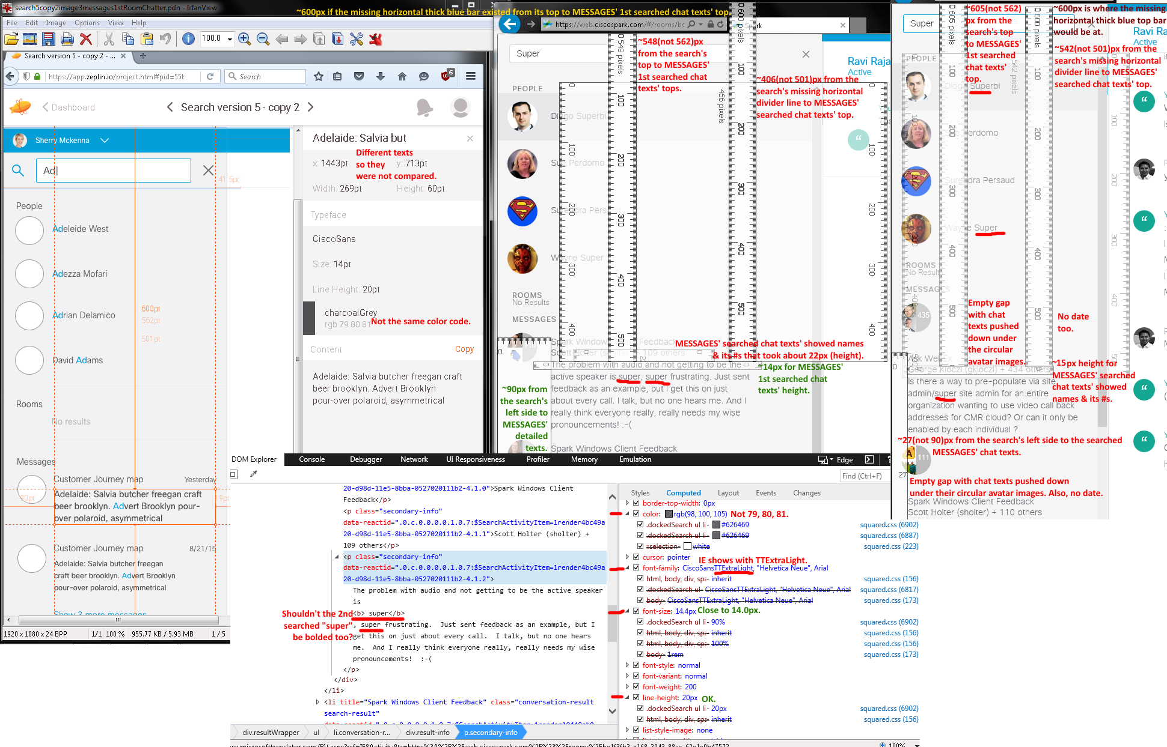

Issues from the above screen shot/capture with the expanded (v4467 - SDK v0.5.52 (2/23/2016)) and collapsed (v4582 - SDK v0.5.52 (3/7/2016) left side navigation menu layouts:
- Searched “Super” and there no bolded blue text results. However, IE’s Inspect element’s DOM Explorer showed bold HTML tags. Also, there were two “super” in my 1st search result. Shouldn’t the second “super” also be in bolded blue?
- Incorrect measurements, CiscoSans font type face?, and color code.
- Missing MESSAGES’ dates, four search’s horizontal divider lines, top horizontal thick blue bar, magnifying glass icon/graphic, and lowercased letters for texts (MESSAGES, ROOMS, and PEOPLE).
- “No Results” text has a capitalized R.
- First search result hit had a darker gr(a/e)y highlighted row color.
- With Spark’s collapsed left side navigation menu, MESSAGES’ search results have formatting and wordwrapping issues with empty (space/gap)s due to each circular avatar image’s texts pushed below.

Note: Huge images did not fit with their issue lists, so using the two screen (shot/capture)s’ issue lists in this document page to avoid wasting two document pages.

Issues from the below screen capture/shot with the expanded (v4467 - SDK v0.5.52 (2/23/2016)) and collapsed (v4582 - SDK v0.5.52 (3/7/2016) left side navigation menu layouts::
- Default generic circle avatar images do not have filled in white color with their gr(a/e)y circular borders.
- Searched “Super” and there were no bolded blue text results.
- Incorrect measurements.
- Missing MESSAGES’ dates, four search’s horizontal divider lines, top horizontal thick blue bar, magnifying glass icon/graphic, and lowercased letters for texts (MESSAGES, ROOMS, and PEOPLE).
- “No Results” text has a capitalized R.
- With Spark’s collapsed left side navigation menu, MESSAGES’ search results have formatting and wordwrapping issues with empty (space/gap)s due to each circular avatar image’s texts pushed below.
- First search result hit had a darker gr(a/e)y highlighted row color.
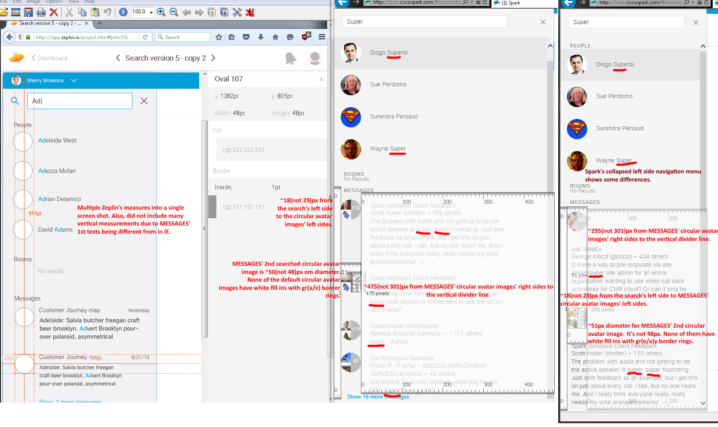

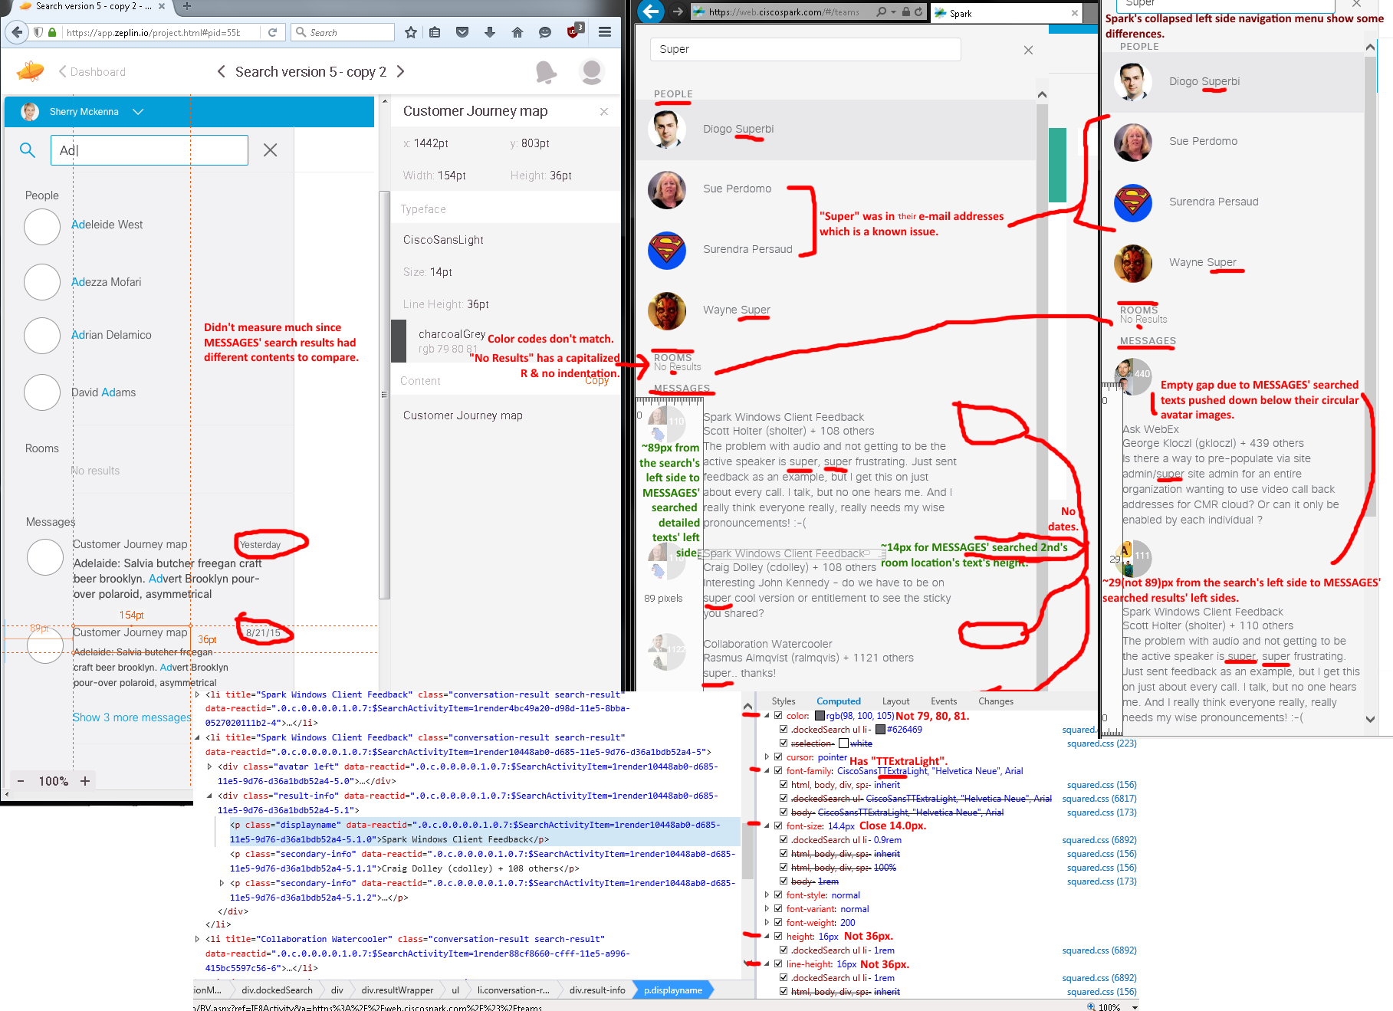
Issues from the above screen shot/capture in expanded (v4476 - SDK v0.5.52 (2/25/2016)) and collapsed (v4582 - SDK v0.5.52 (3/2/2016); cropped) left side navigation menu layouts.
- Searched “Super” and there were no bolded blue text results.
- Incorrect CiscoSansLight font type face, measurements, and color code.
- Missing MESSAGES’ dates, four search’s horizontal divider lines, top horizontal thick blue bar, magnifying glass icon/graphic, and lowercased letters for texts (MESSAGES, ROOMS, and PEOPLE).
- “No Results” text has a capitalized R.
- First search result hit had a darker gr(a/e)y highlighted row color.
- With Spark’s collapsed left side navigation menu, MESSAGES’ search results have formatting and wordwrapping issues with empty (space/gap)s due to each circular avatar image’s texts pushed below.

Note: Huge images did not fit with their issue lists, so using the two screen (shot/capture)s’ issue lists in this document page to avoid wasting two document pages.

Issues from the below screen shot/capture in expanded (v4476 - SDK v0.5.52 (2/25/2016)) and collapsed (v4582 - SDK v0.5.52 (3/2/2016); cropped) left side navigation menu layouts.
- Searched “Super” and there were no bolded blue text results even though IE11 showed bold HTML tags.
- Mismatched CiscoSans font type face, measurements, and color code.
- Missing MESSAGES’ dates, four search’s horizontal divider lines, top horizontal thick blue bar, magnifying glass icon/graphic, and lowercased letters for texts (MESSAGES, ROOMS, and PEOPLE).
- “No Results” text has a capitalized R.
- First search result hit had a darker gr(e/a)y highlighted row color.
- With Spark’s collapsed left side navigation menu, MESSAGES’ search results have formatting and wordwrapping issues with empty (space/gap)s due to each circular avatar image’s texts pushed below.
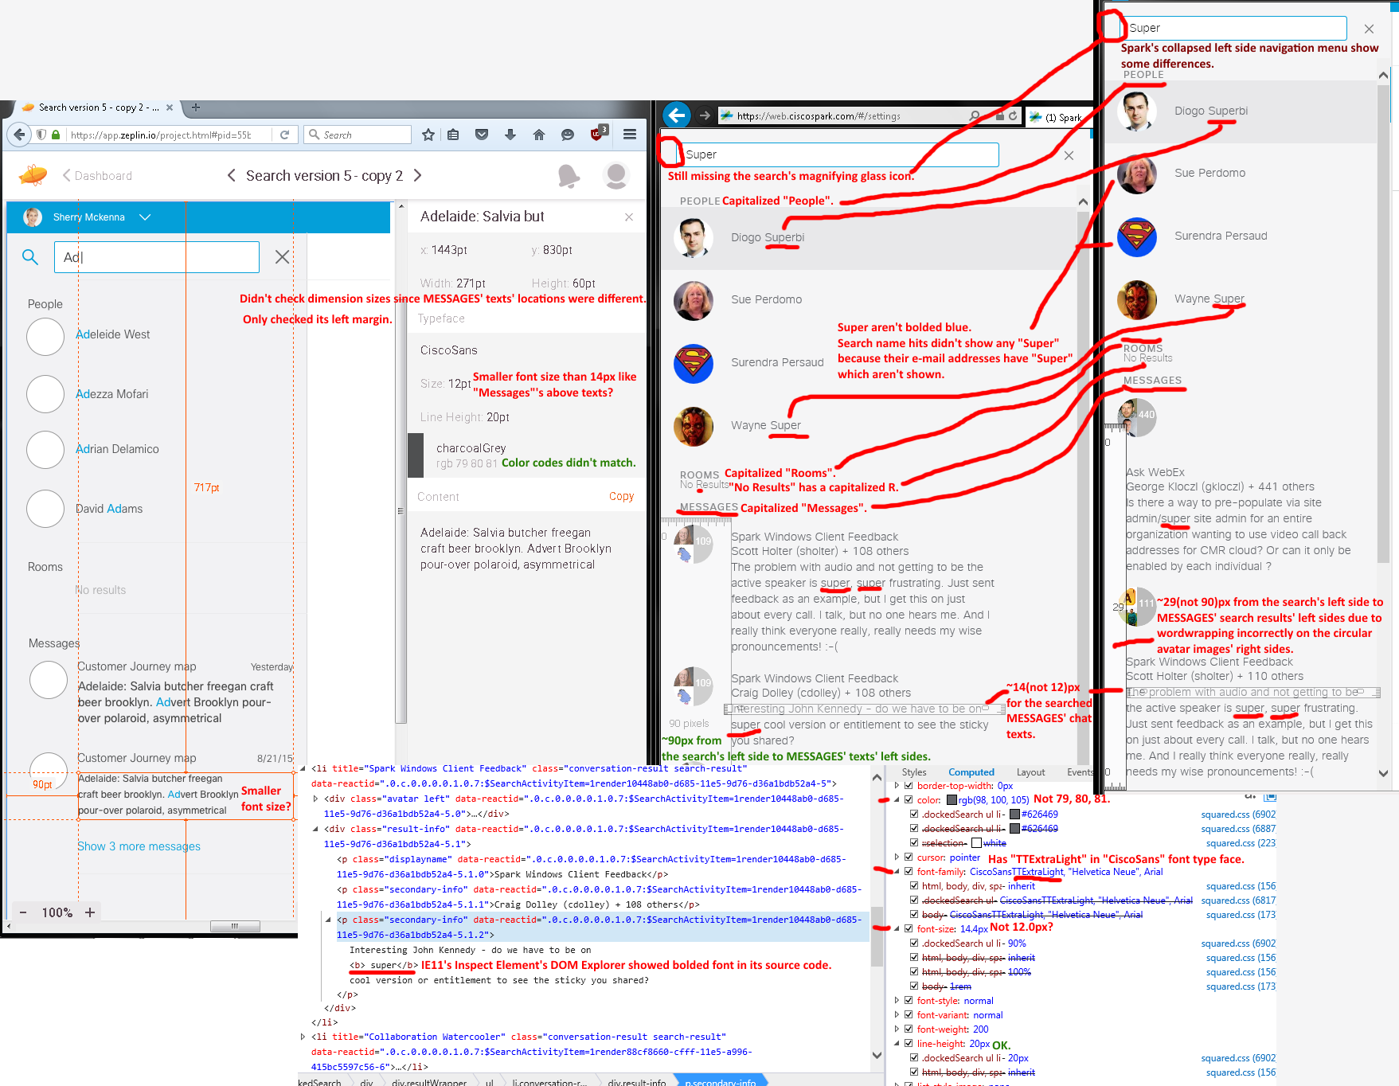
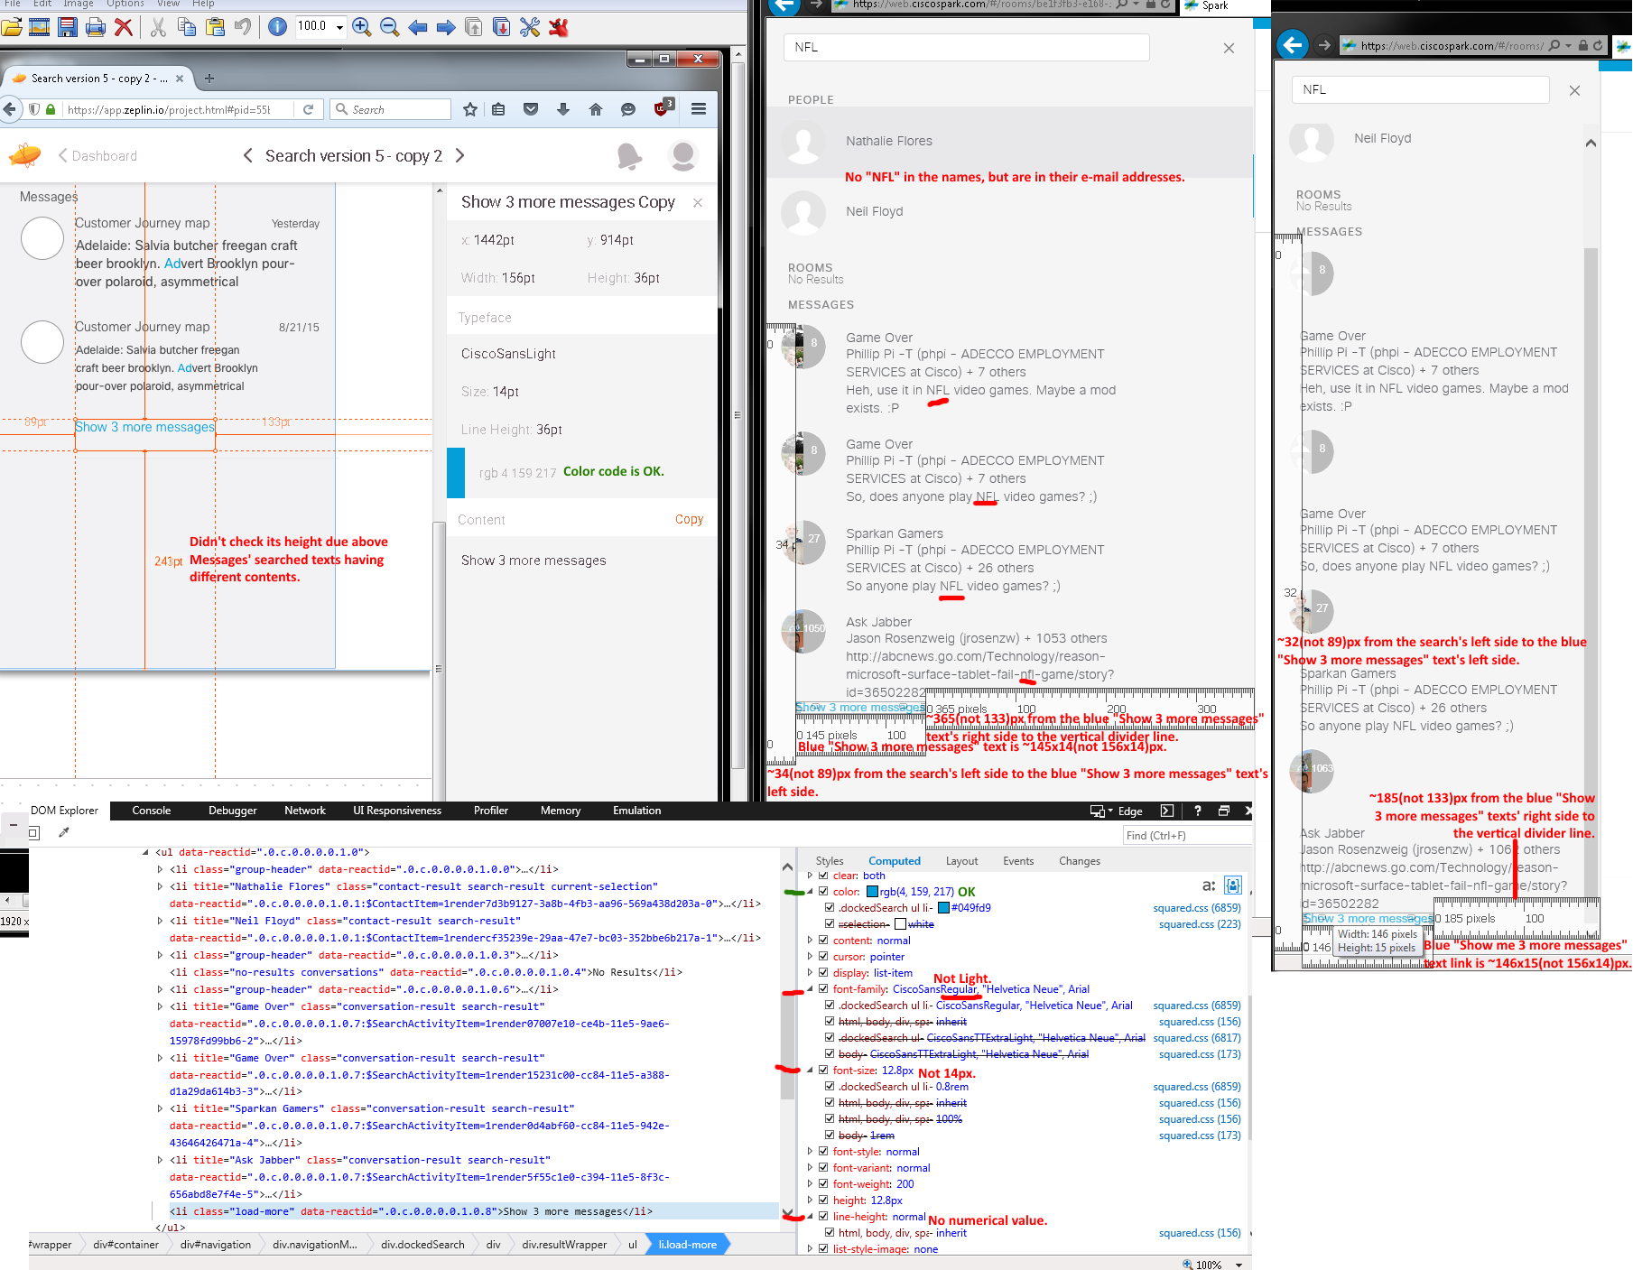
Issues from the above screen capture/shot in expanded (v4476 - SDK v0.5.52 (2/25/2016)) and collapsed (v4582 - SDK v0.5.52 (3/2/2016); cropped) left side navigation menu layouts:
- Searched “NFL” and there were no bolded blue text results.
- Mismatched CiscoSans font type face and measurements.
- Missing MESSAGES’ dates, four search’s horizontal divider lines, top horizontal thick blue bar, magnifying glass icon/graphic, and lowercased letters for texts (MESSAGES, ROOMS, and PEOPLE).
- First search result hit had a darker gr(e/a)y highlighted row color.
- With Spark’s collapsed left side navigation menu, MESSAGES’ search results have formatting and wordwrapping issues with empty (space/gap)s due to each circular avatar image’s texts pushed below.
Zeplin’s Redline Screen #4 (Spark’s Expanded Left Side Navigation Menu). V4354 - SDK v0.5.48 on 2/2/2016:
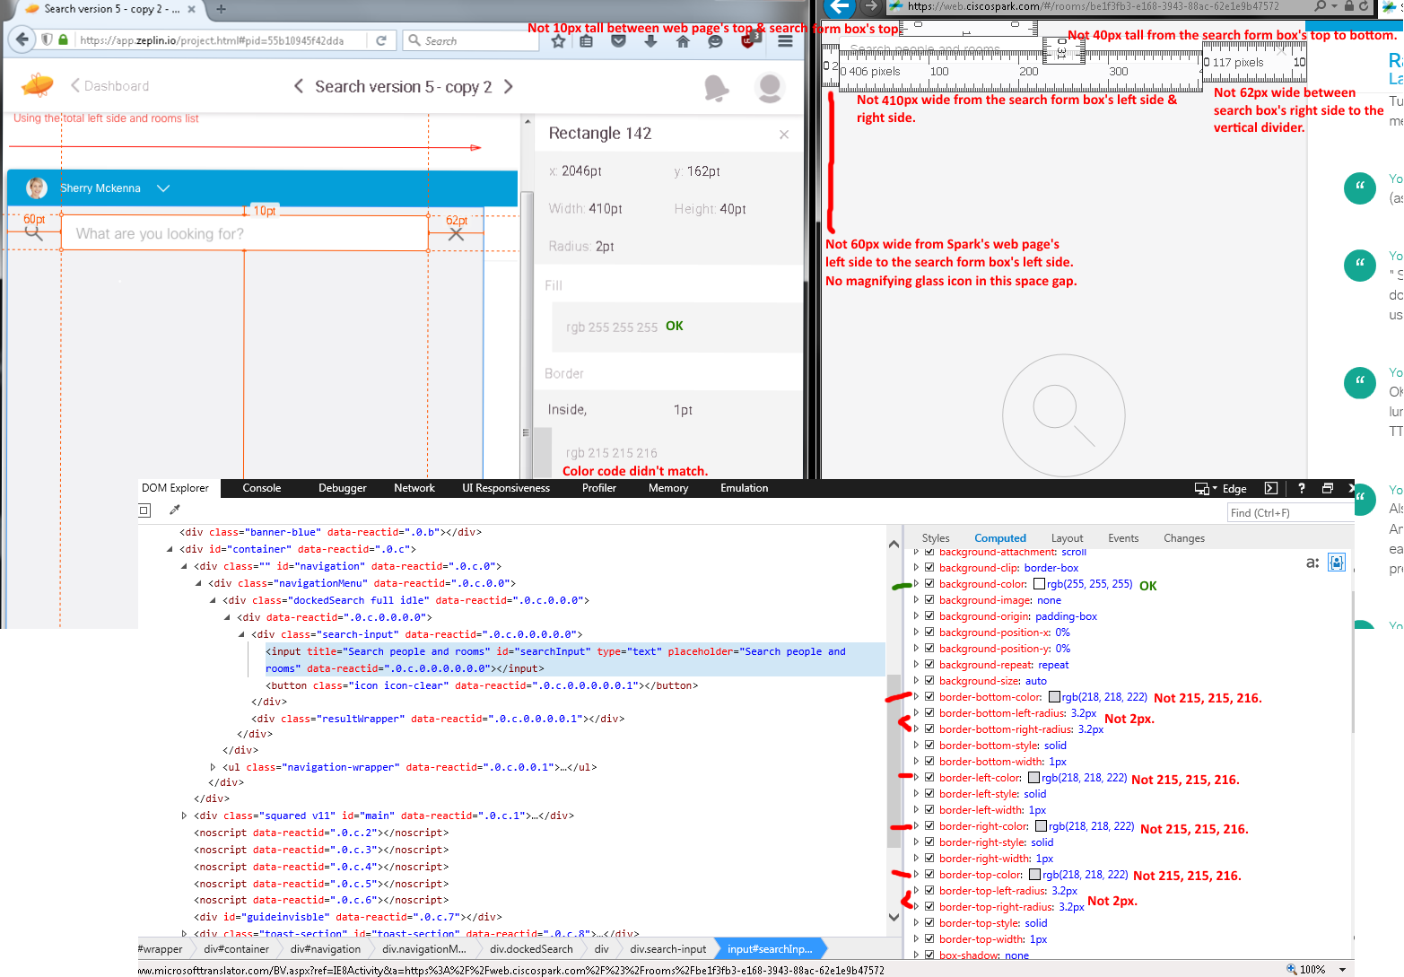
Issues: Incorrect dimension sizes and color codes.
V4380 - SDK v0.5.48 on 2/5/2016:
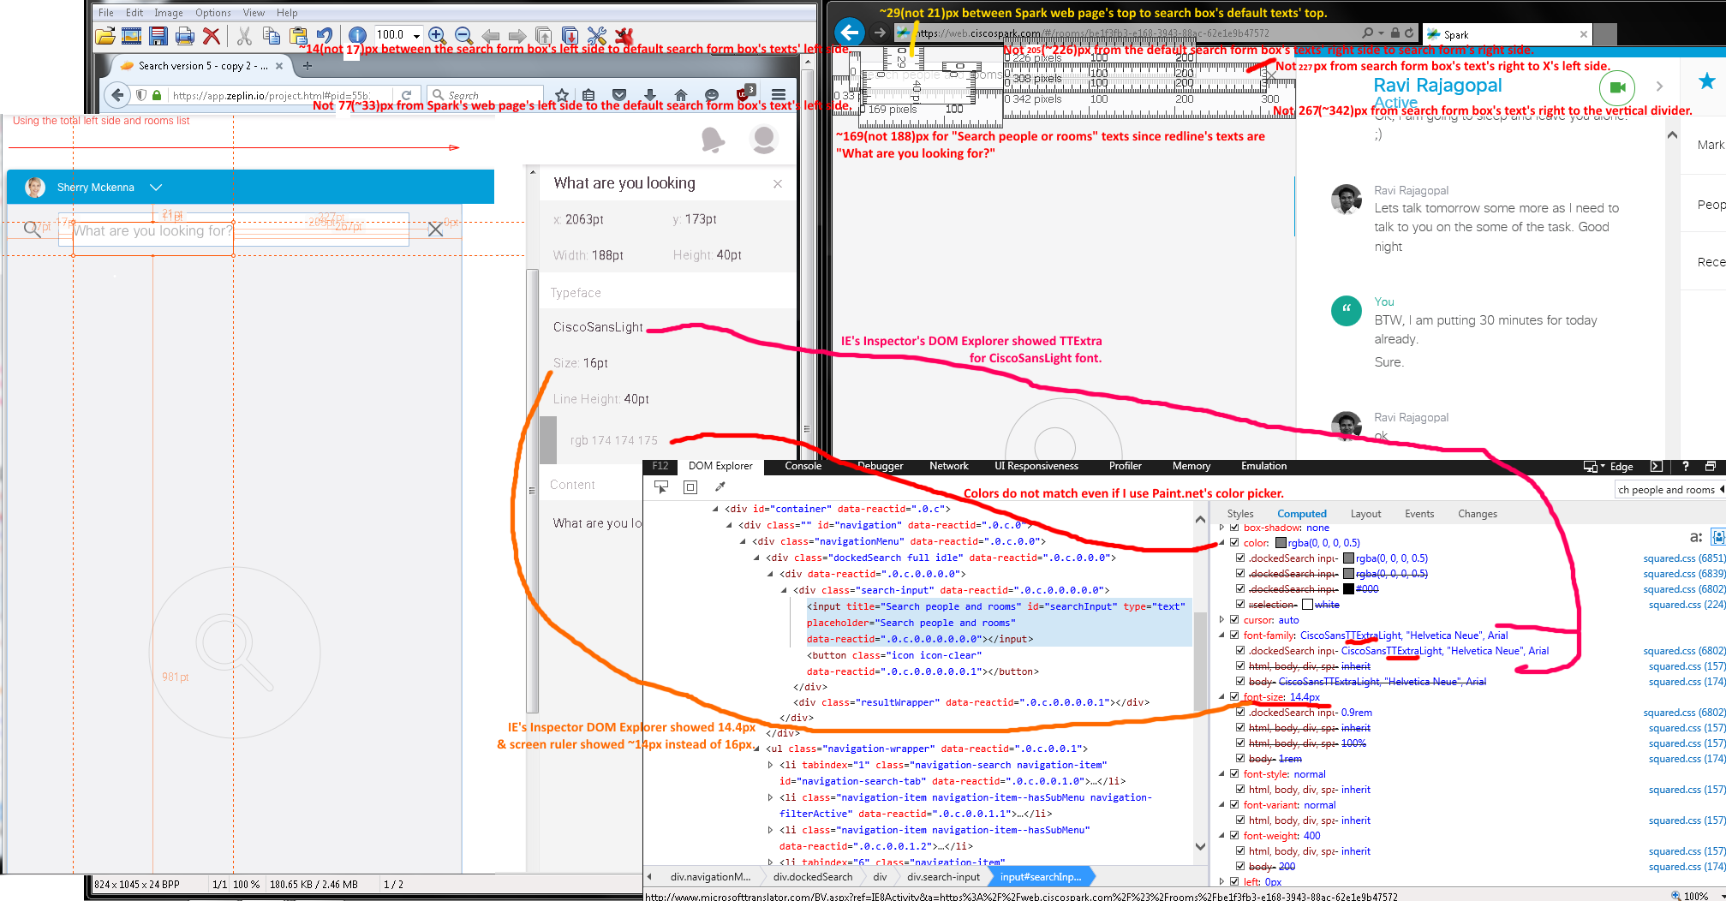
Issues: Wrong sizes, color color code, font type face, and texts.

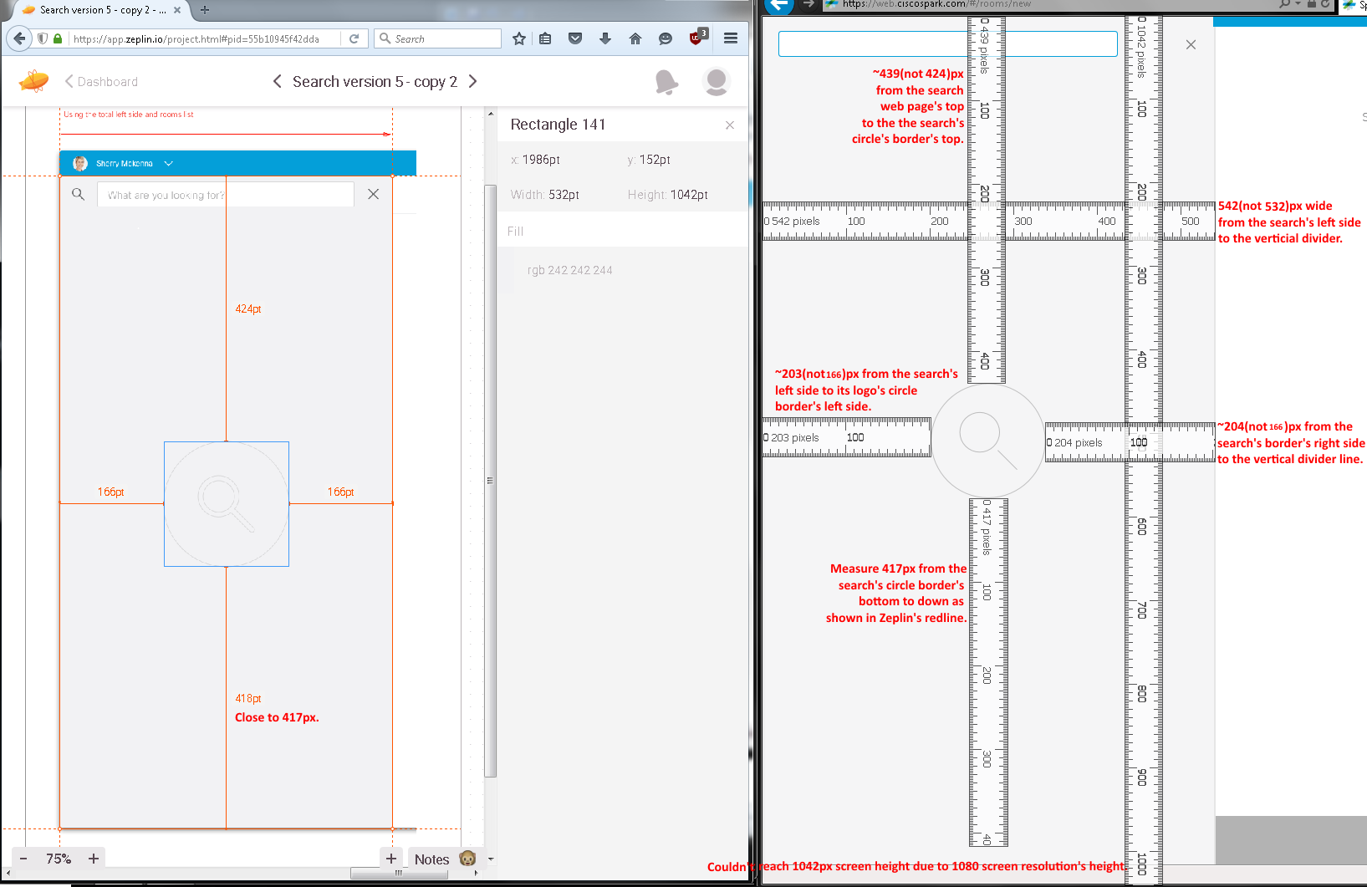
Issues: Incorrect dimension sizes.

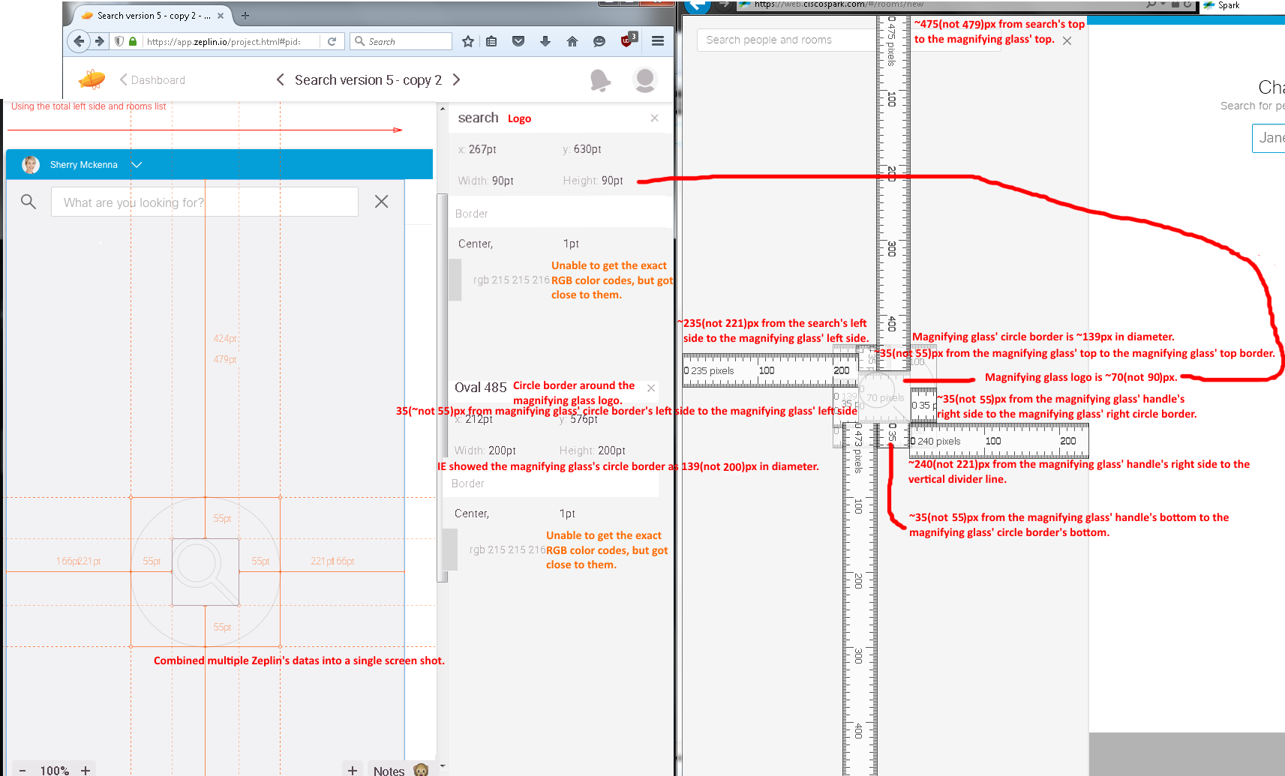
Issues:
- Wrong dimension sizes.
- Magnifying glass, with its circle ring border, graphics looked different and did not match each other.
- Incorrect RGB color codes even though were close enough due to antaliasing on the magnifying glass and its circle ring?

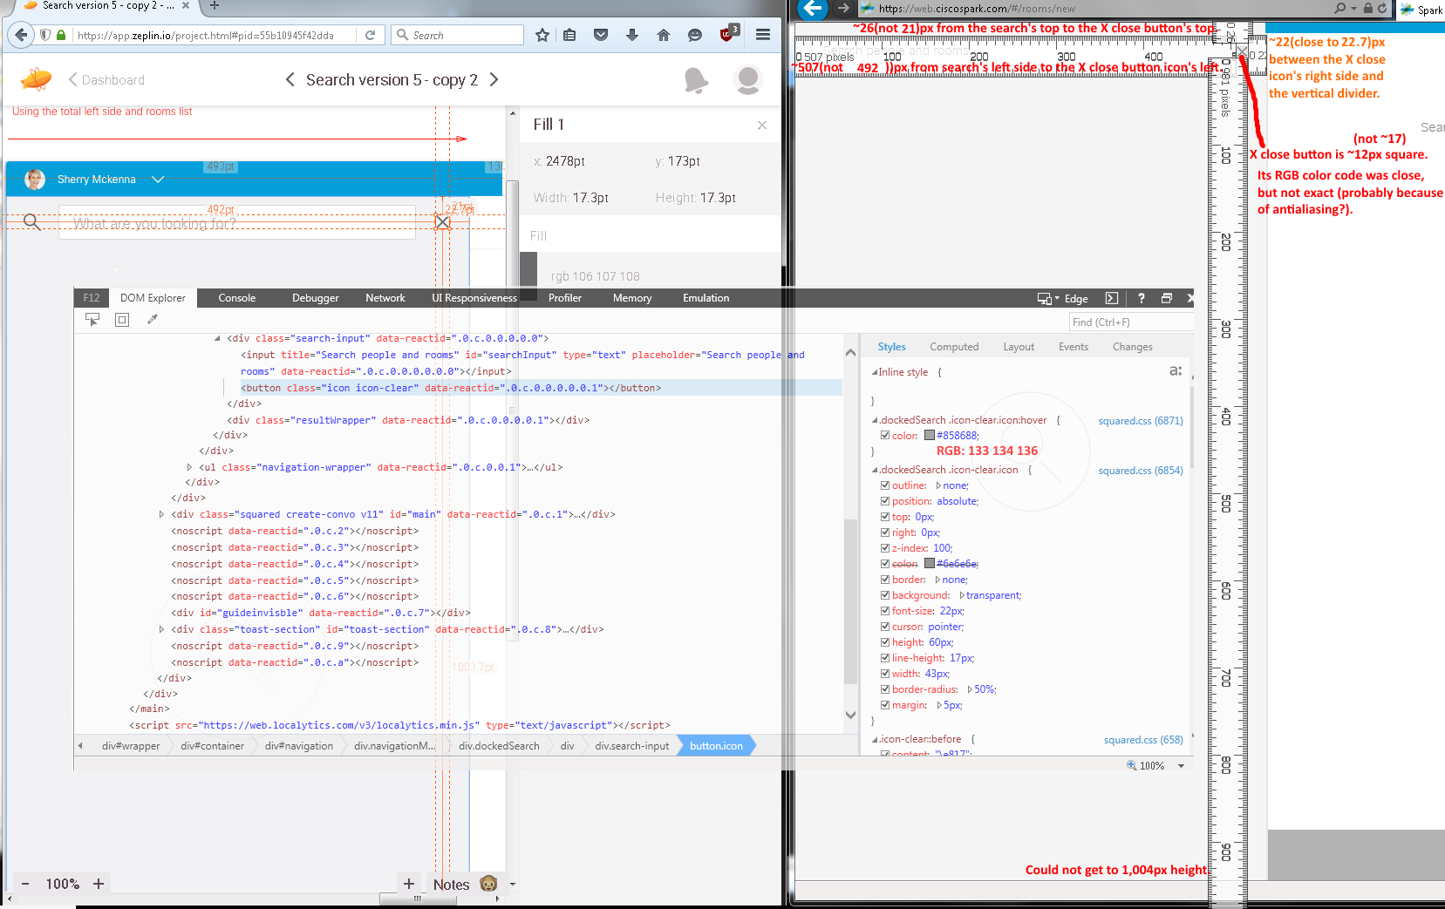
Issues:
- Incorrect dimension sizes.
- Incorrect RGB color codes even though were close enough due to antaliasing on the X close button icon with a color picker? However, IE’s Inspect Element’s DOM Explorer’s Element show completely different RGB color codes even though close.

