**Phillip Pi’s UI QA Redline Results for Spark’s “Search version 5 – redlines” in an Updated 64-bit W7 EE SP1’s IE11 Web Browser.**

Notes: <https://web.ciscospark.com> (v4582 - SDK v0.5.52 (3/2/2016)) & Edward McMullin’s <https://app.zeplin.io/project.html#pid=55b10945f42dda4d1800a1ab&sid=568e638d7426c3973d806e48> (last updated on 1/2016; P(ixel/x), not P(oin)t -- "PT and PX are the same measurements from sketch , zeplin just forces it into either PT or PX depending on the project selected. xOS will do PT , Web will do PX Since they were designed in PX from sketch (and only PX) they are therefore px in zeplin" –his emails on 2/5/2016 before 3 AM) redlines from March 2016’s 11th to 15th. Both OS’ (D/P)PI (96) & IE’s zoom were @ 100% (smaller). All softwares had the (new/lat)est updates. All dates and times were based on USA & its pacific time (PT) zone (11th was standard & after 13th was daylight [a hour ahead]). Only compared with the graphic overlays & a few Zeplin’s detailed datas with mouse clicked parts (most looked the same as its “Search version 5 - copy 2” (<https://app.zeplin.io/project.html#pid=55b10945f42dda4d1800a1ab&sid=56a0fc6f2ab86795737c79ae> & those comparisons can be found in “64w7eeSP1ie11searchQA - Search version 5 - copy 2.docx”); image #4 had some differences shown in this document).

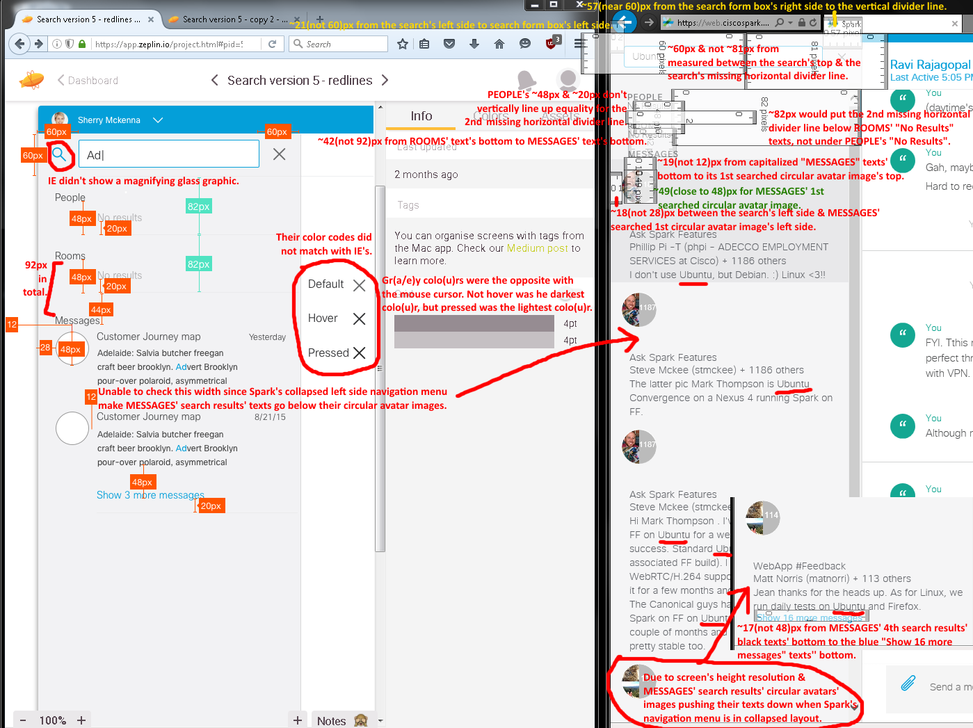**Zeplin’s Screen Image #1 (collapsed left side navigation menu):**

Left side image’s issues:

1. Wrong sizes and colo(u)r codes.

2. Gr(e/a)y “x” exit/c(lose/ancel) button’s intensity shade colo(u)rs were in reverse (pressed as lightest, mouse cursor not hovered as darkest in IE web browser).

3. MESSAGES’ searched results showed its texts wordwrapping too early after their circular avatar images. This only happens in Spark’s left side navigation menu is collapsed. Expanded layout was fine even though their measurements were still incorrect.

4. Missing horizontal divider lines in the search section.

5. Searching for “Ubuntu” show MESSAGES’ 1st results as a darker gr(a/e)y colo(u)r highlight.

6. Searched MESSAGES’ results showed four hits instead of two before showing their blue “Show # more messages” link (# = 16 as an example).

7. Missing thick 40px top blue bar, its logged in user’s circular avatar image, its upside down white ^ arrow, blue searched keyword results (e.g., Ubuntu).

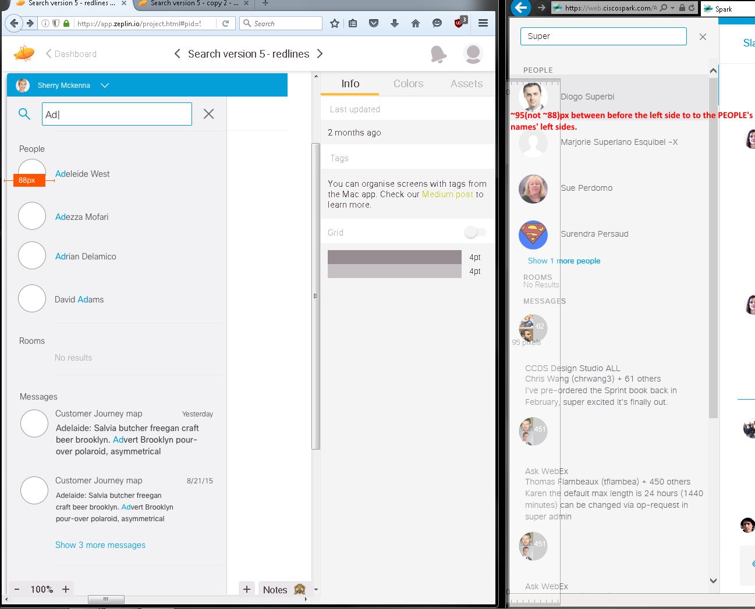**Zeplin’s Screen Image #2 (collapsed left side navigation menu):**

Left image’s issues:

1. Incorrect measurement.

2. MESSAGES’ searched results showed its texts wordwrap-ping too early after their circular avatar images. This only happens in Spark’s left side navigation menu is collapsed. Expanded layout was fine even though their measure-ments were still incorrect.

3. Missing horizontal divider lines in the search section.

4. Searching for “Super” show MESSAGES’ 1st results as a darker gr(a/e)y colo(u)r highlight.

5. Missing thick 40px top blue bar, its logged in user’s circular avatar image, its upside down white ^ arrow, blue searched keyword results (e.g., Super).

**Zeplin’s Screen Image #3 (collapsed left side navigation menu):**

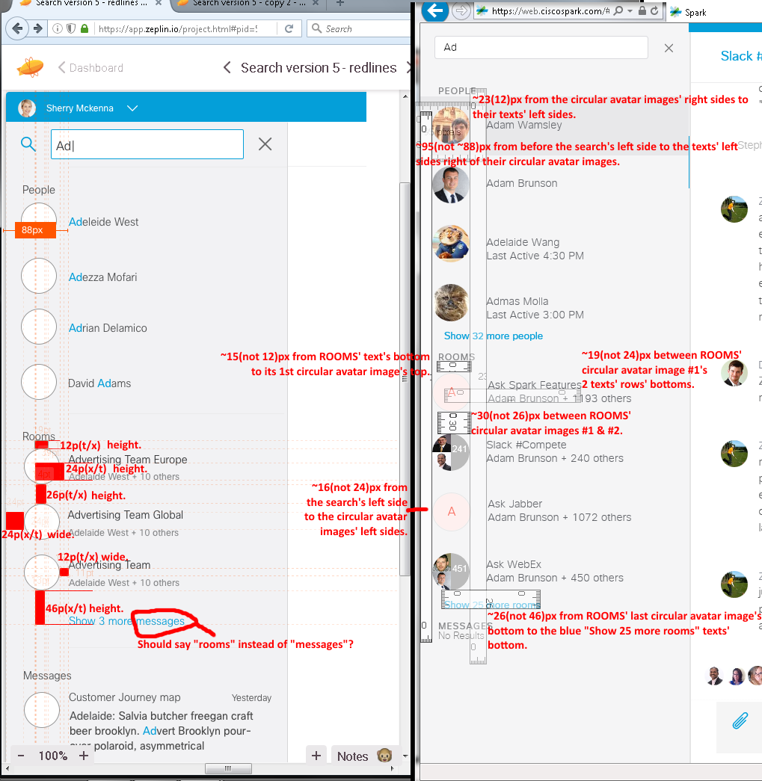Left image’s issues:

1. Wrong measurement.

2. Missing horizontal divider lines in the search section.

3. Searching for “Ad” show PEOPLE’s 1st results as a darker gr(e/a)y colo(u)r highlight.

4. Missing thick 40px top blue bar, its logged in user’s circular avatar image, its upside down white ^ arrow, blue searched keyword results (e.g., Ad).

5. Zeplin shows “Show 3 more messages” text under Rooms. I think this is suppoesd to say “rooms”.

**Zeplin’s Screen Image (a few multiple measurements into each screen shot) #4 (Spark’s expanded left side navigation menu):**

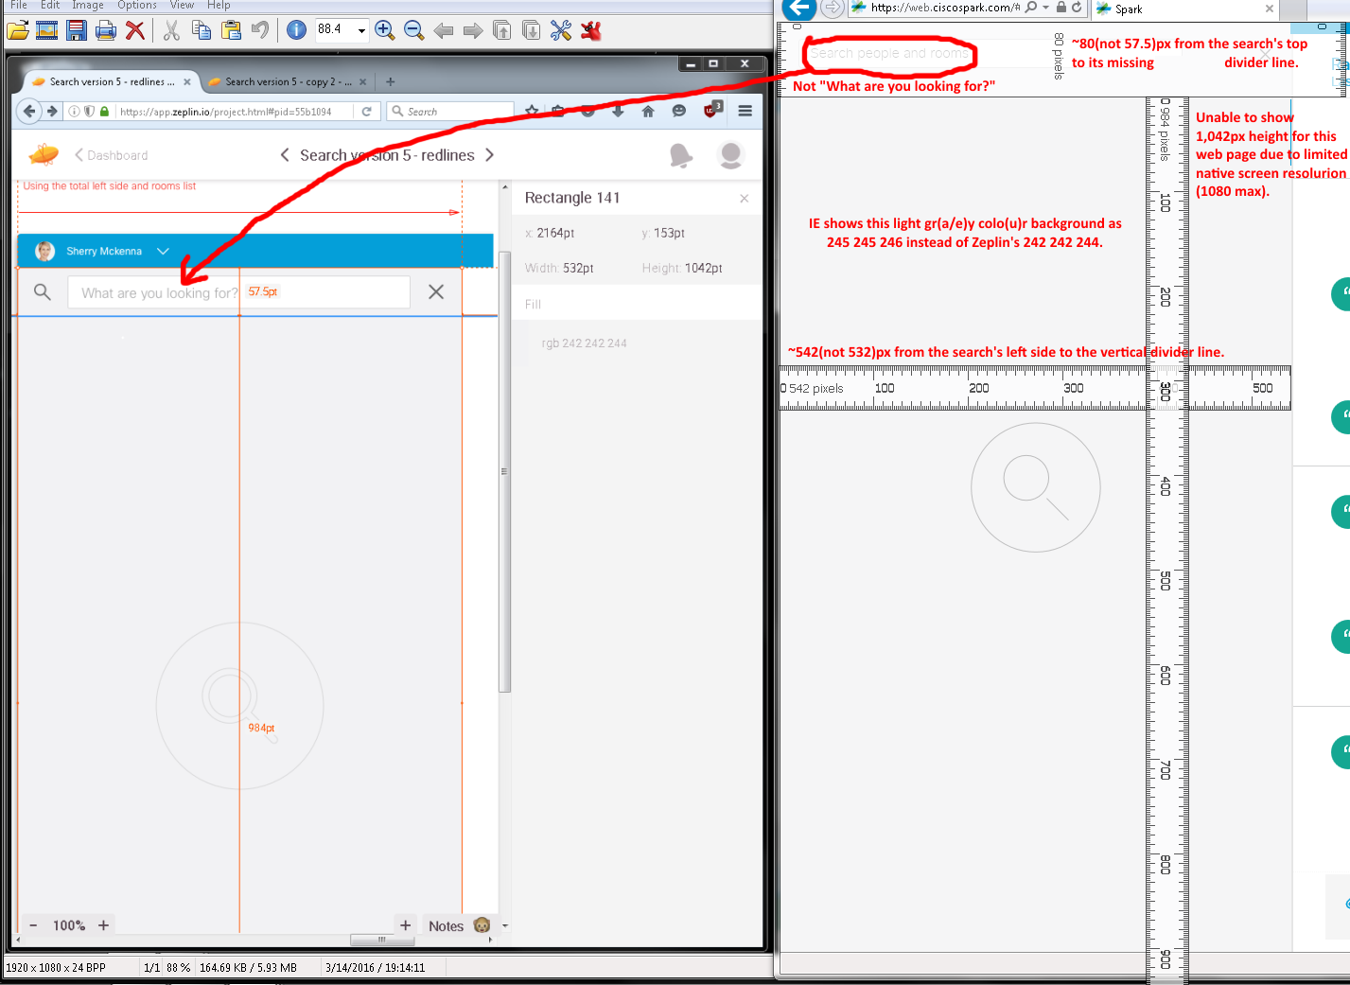

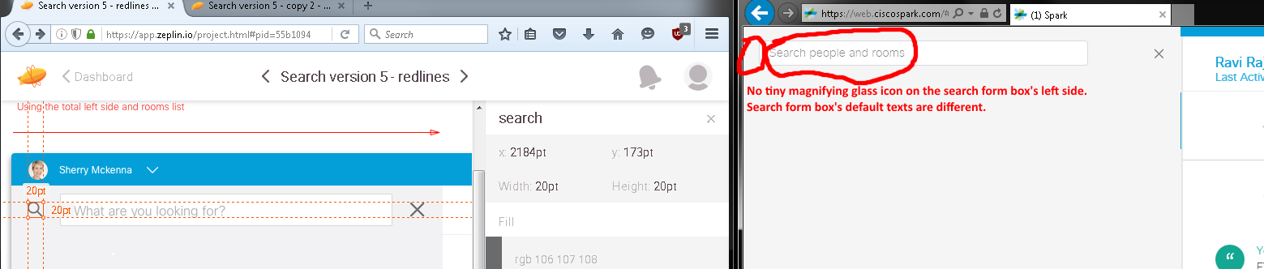

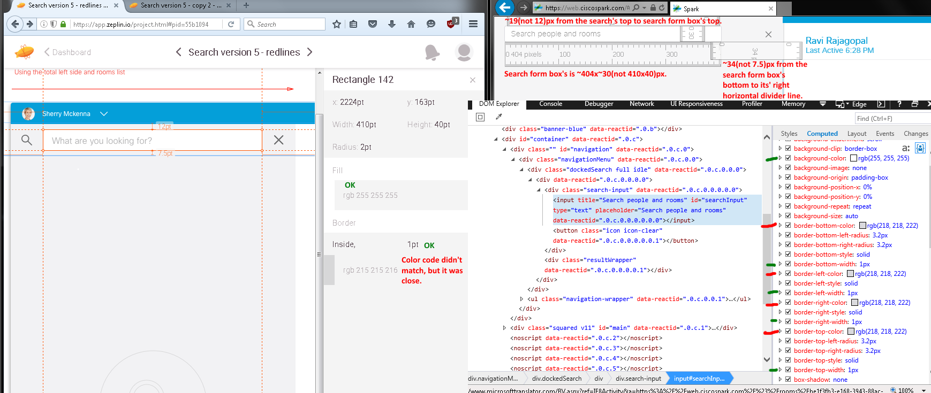

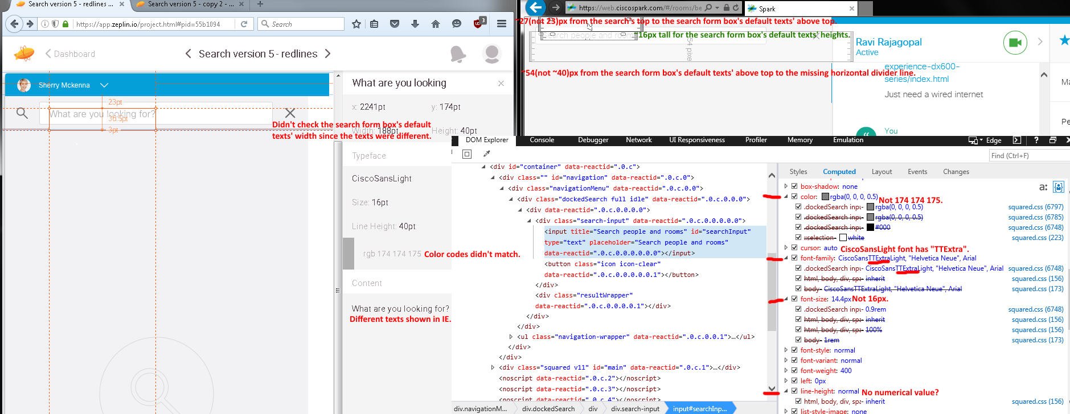

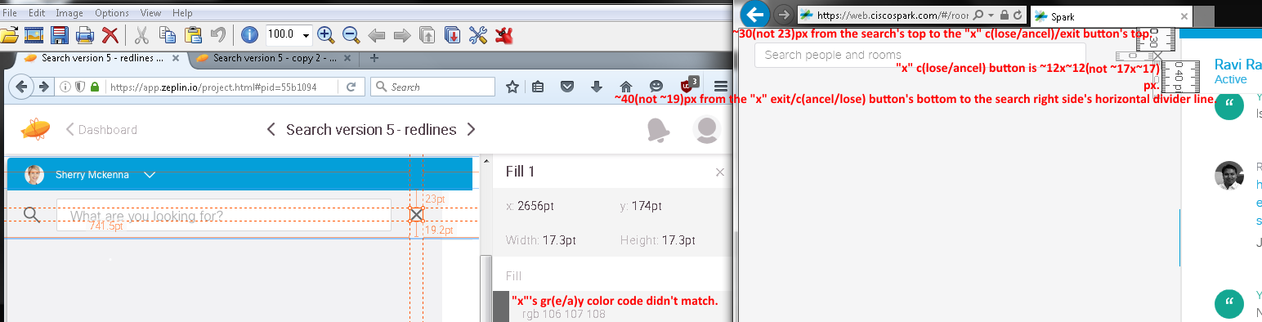

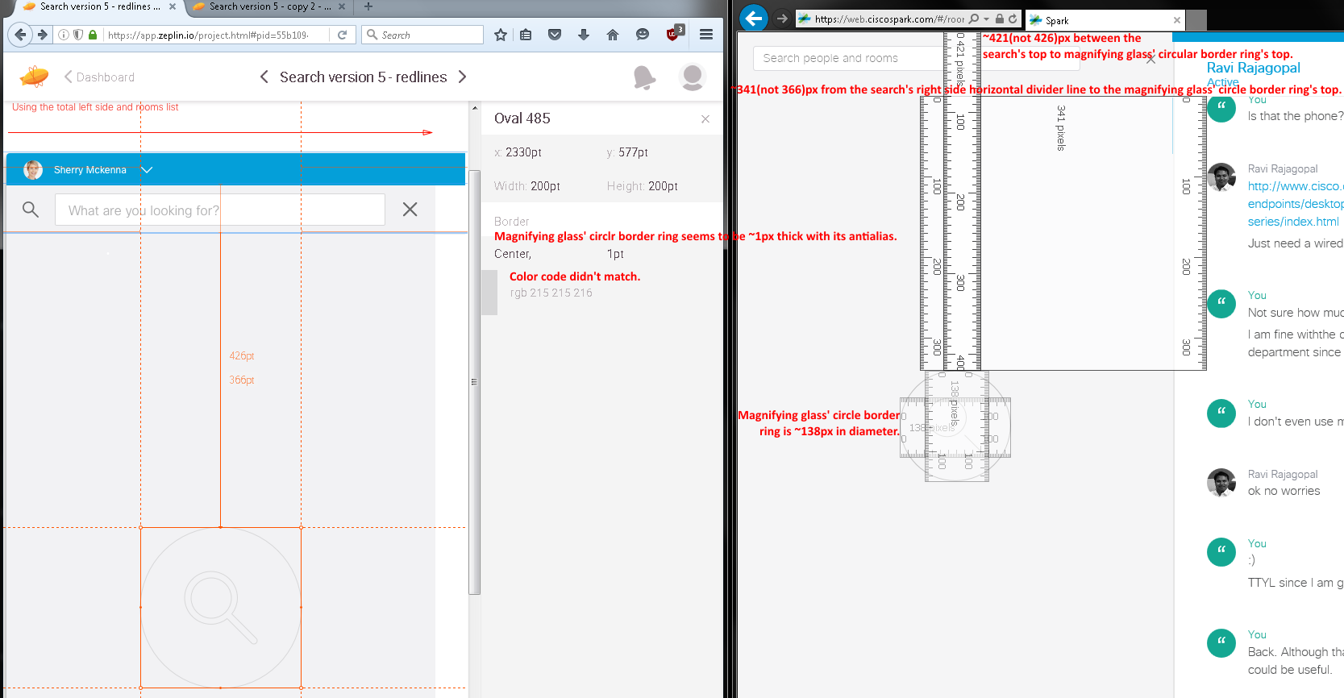

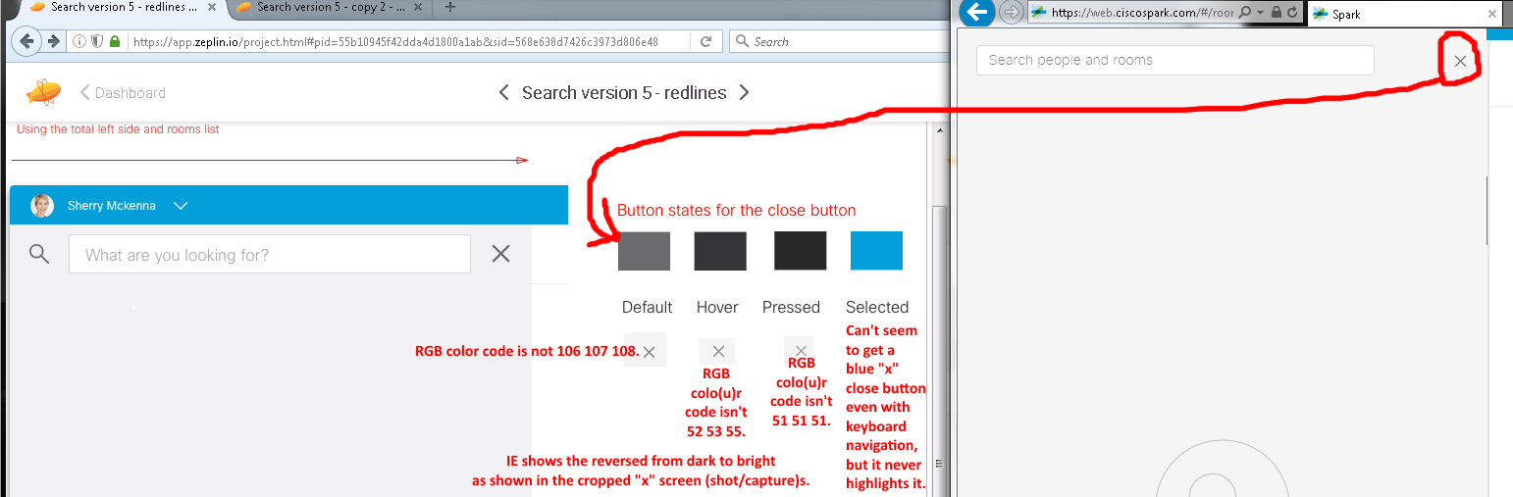

Issues from the above Zeplin’s screen image #4 (Spark’s expanded left side navigation menu) comparisons:

1. Missing top thick blue line with its user’s circular avatar image, name, and upside ^. Also, missing the tiny magnifying glass icon on the search form box’s left side.
2. Search form box shows different default texts.
3. Mismatched CiscoSansLight font typeface(?), colo(u)r codes, and sizes.