Phillip Pi’s QA UX UI Results With Windows v1.0.0.(Build #s Are Mentioned Below) Desktop Client’s Search (Search version 5 - copy 2) in Updated 64-bit W7 EE SP1 (smaller - 100% DPI).
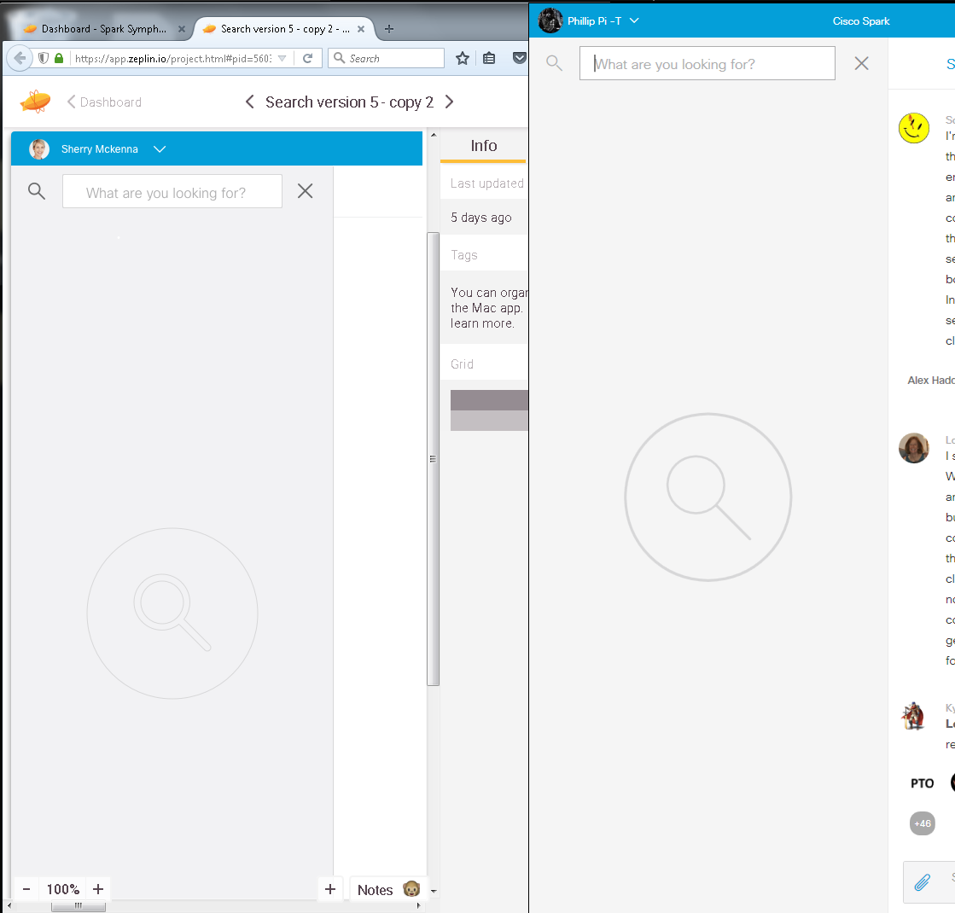Notes: All redline specifications were from web browsers’ online Zeplin’s “Spark Symphony Windows Native” project (https://app.zeplin.io/project.html#pid=56031c111ab6a3262dc395b8&dashboard)’s dashboard for its “Search version 5 - copy 2” (https://app.zeplin.io/project.html#pid=56031c111ab6a3262dc395b8&dashboard&sid=566077eaee0fadc42ae414f4)’s 12/3/2015 screens and compared between Dec. 4th to 18th, 2015 (USA’s PST). Also, Spark’s left menu was not collapsed into its icons only (should say “< Rooms / All”) before clicking on its search.
From build 3037 on 12/8/2015.
From build 2988 on 12/4/2015:
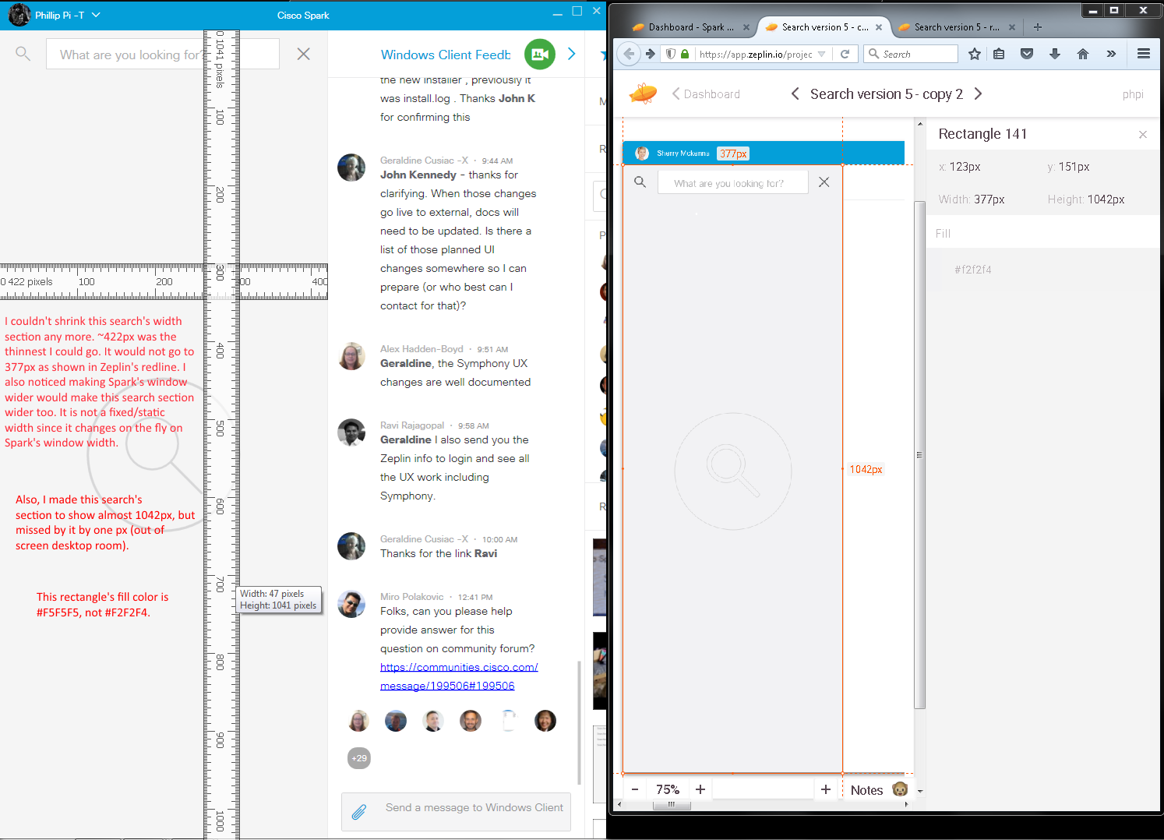
From build 3019 on 12/4/2015:
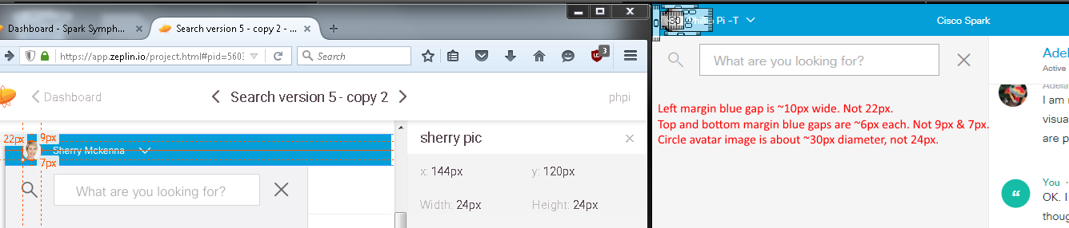
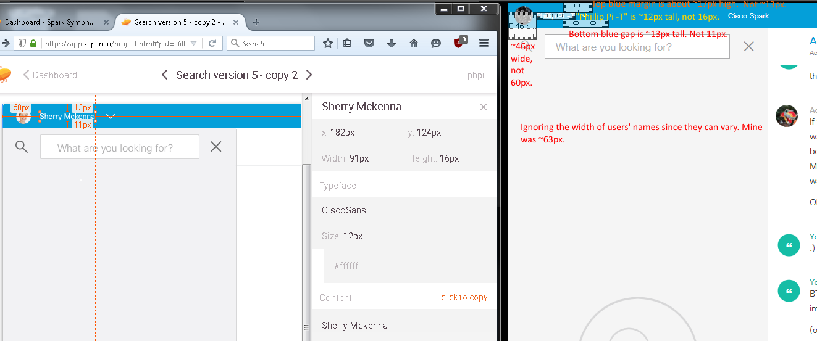

From build 3021 on 12/7/2015:
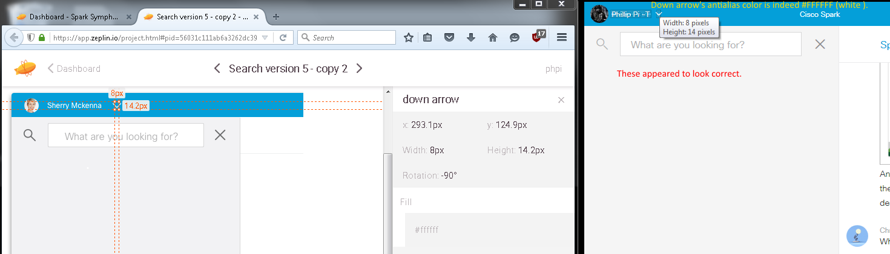
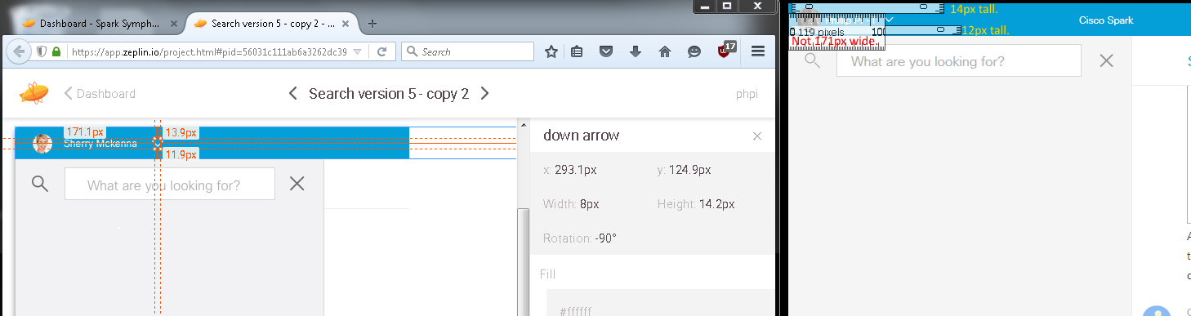
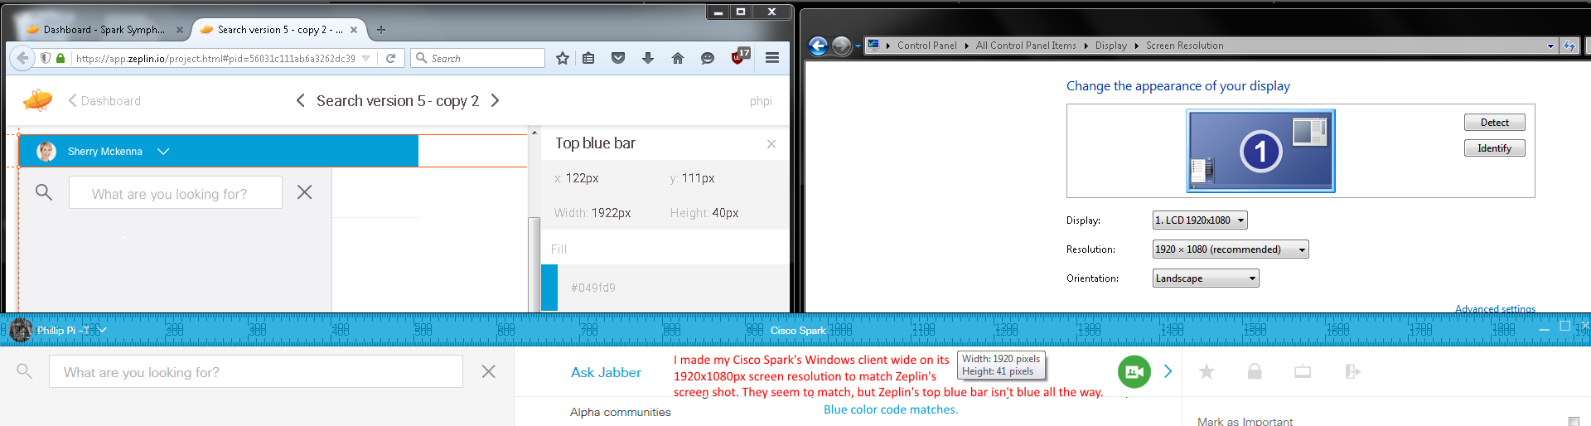
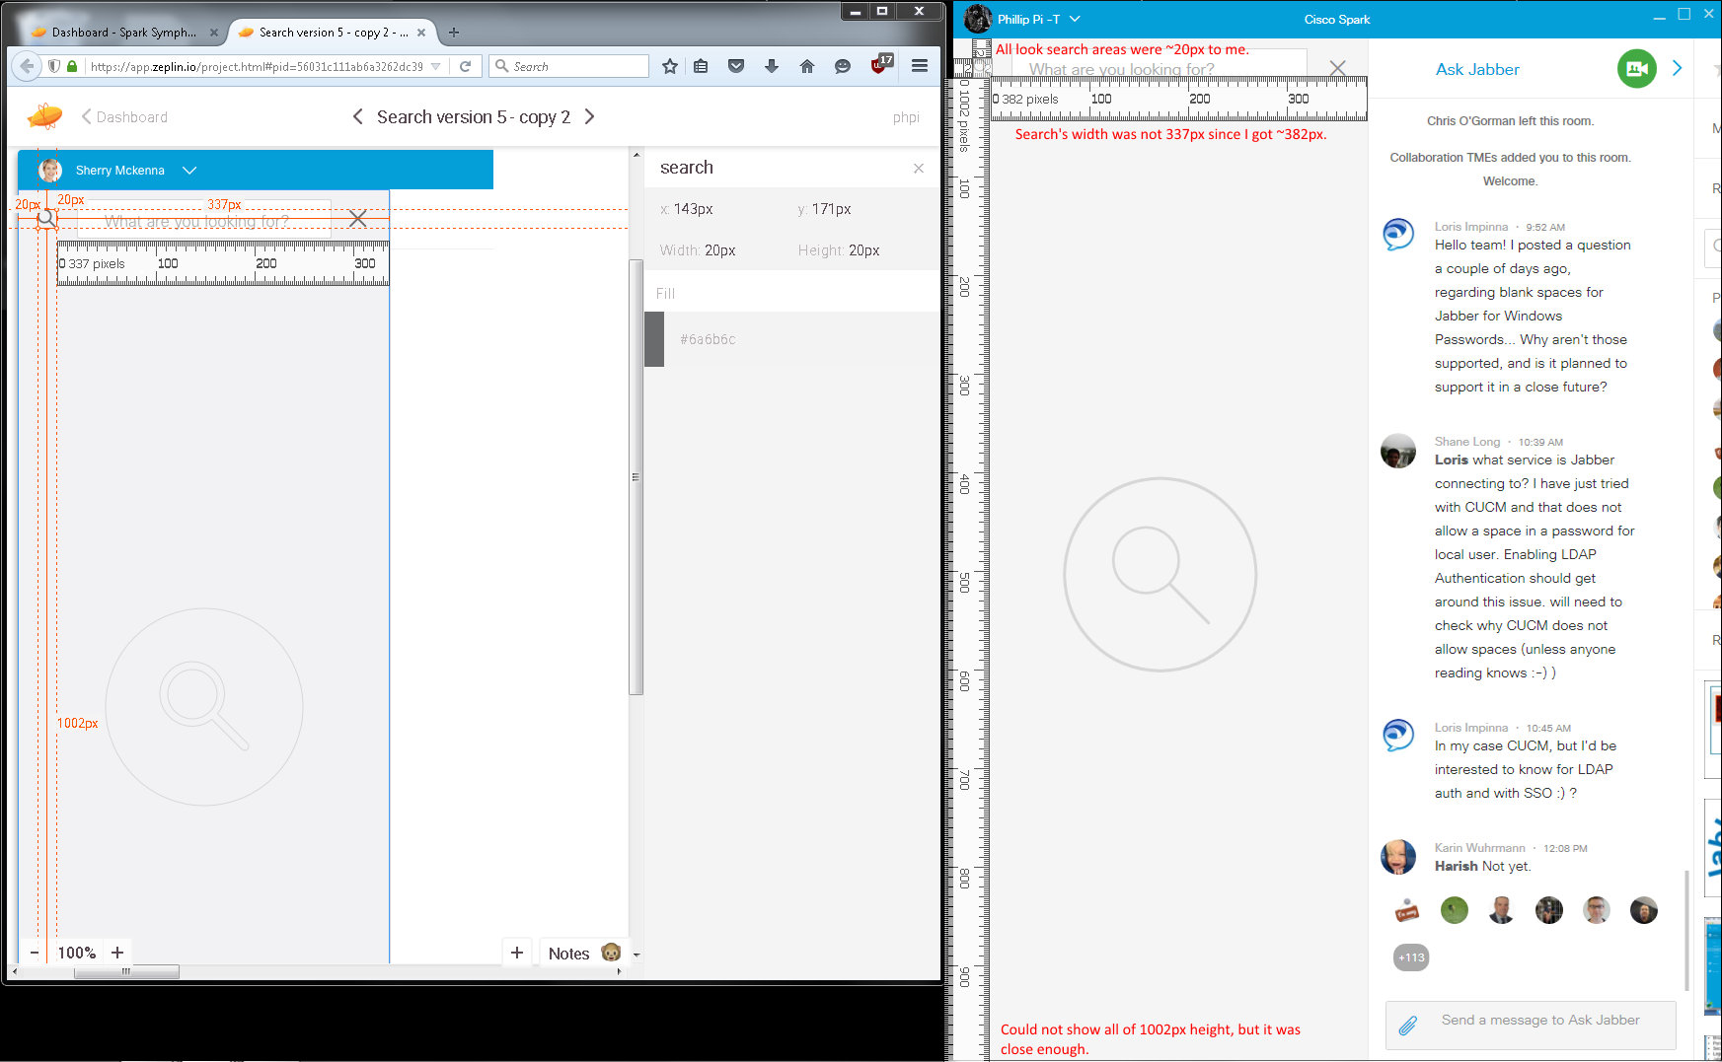
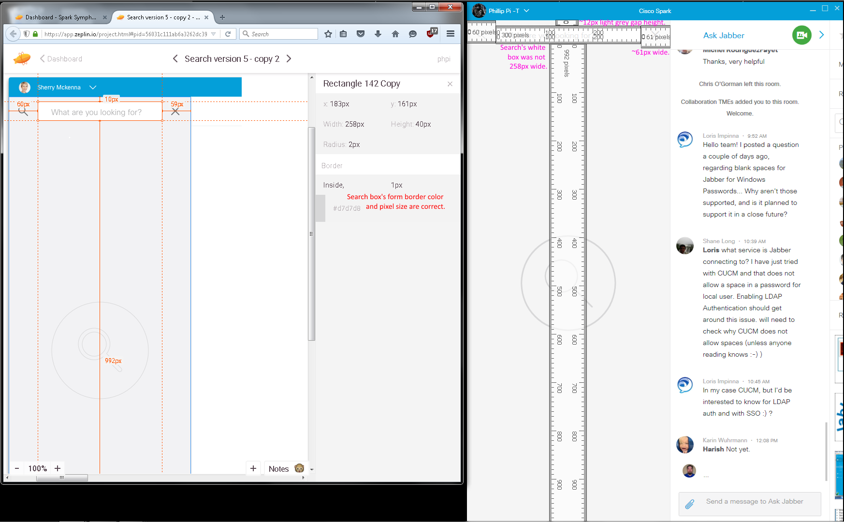
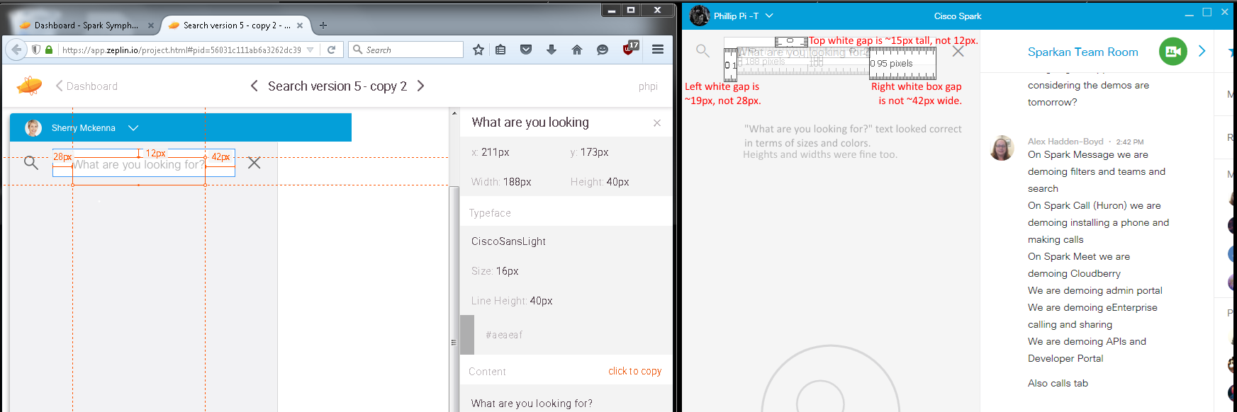
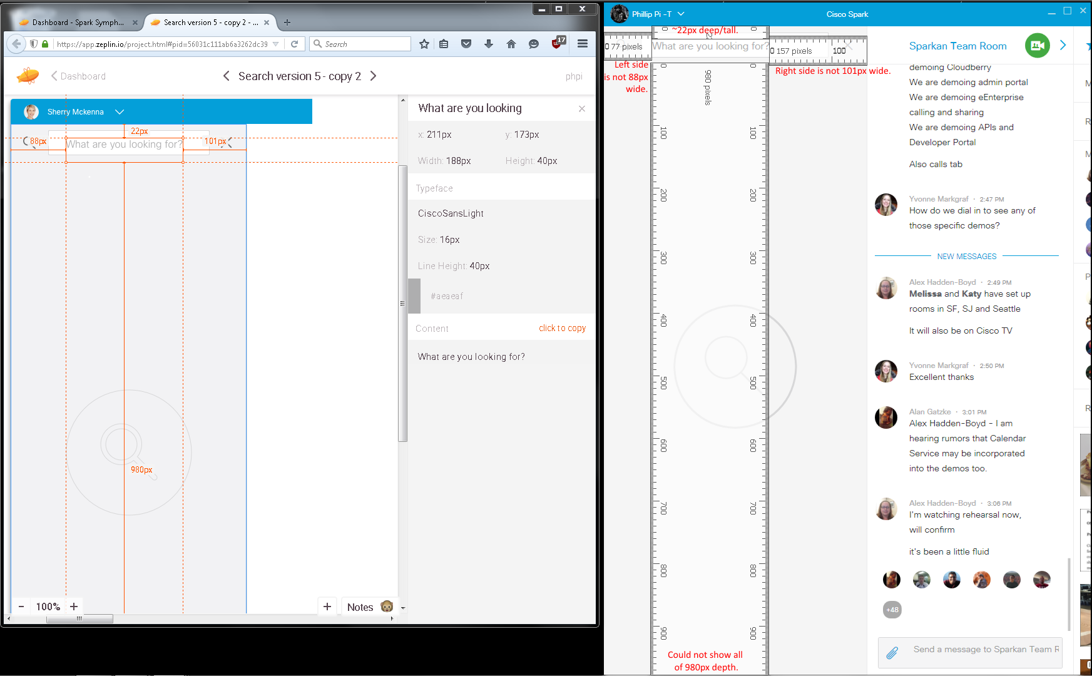

From build 3037 on 12/7/2015:
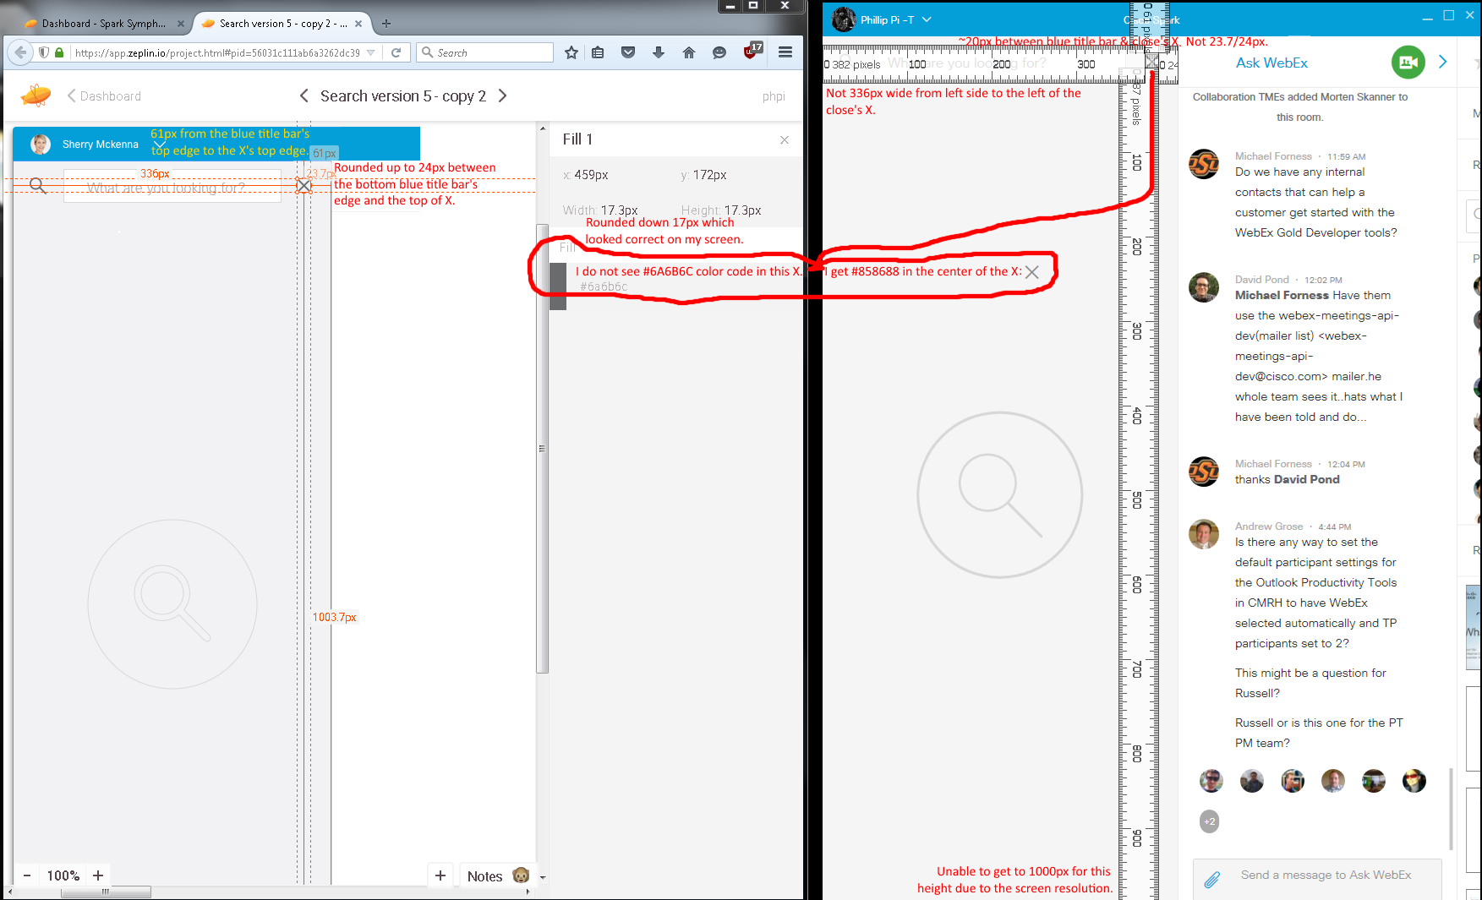
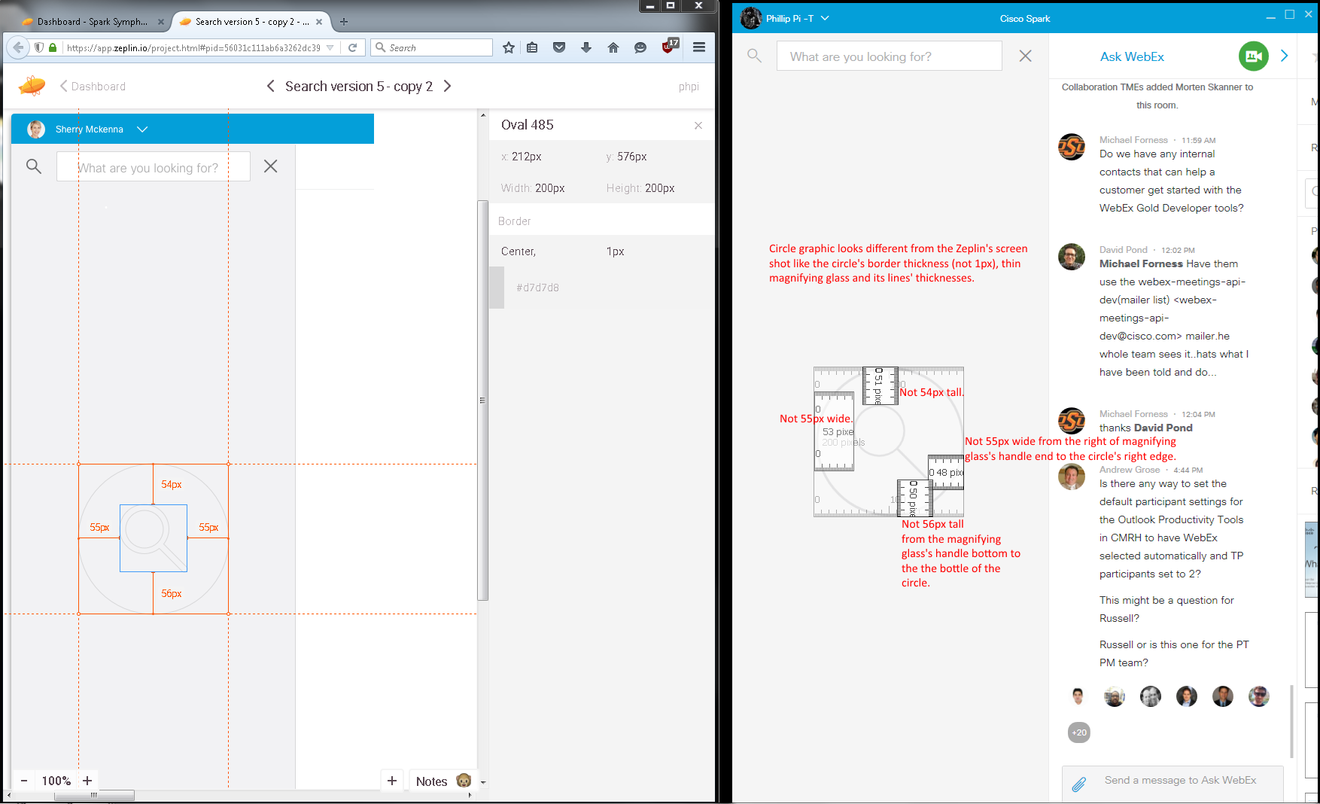
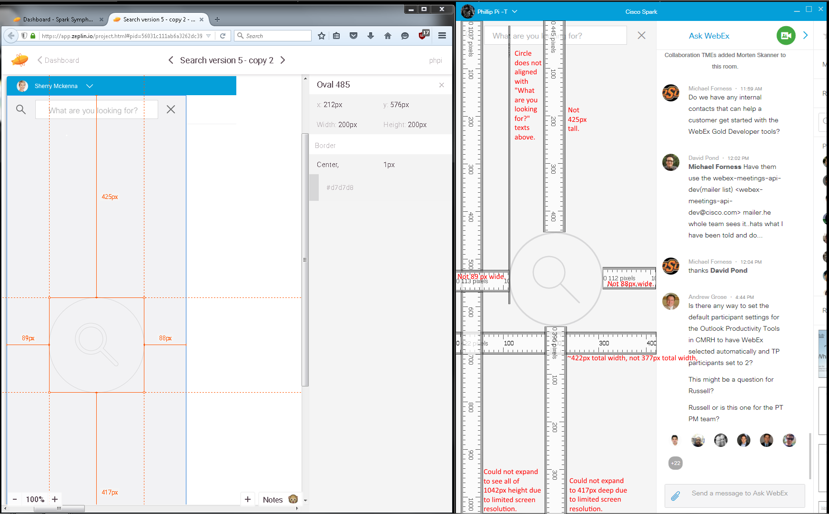
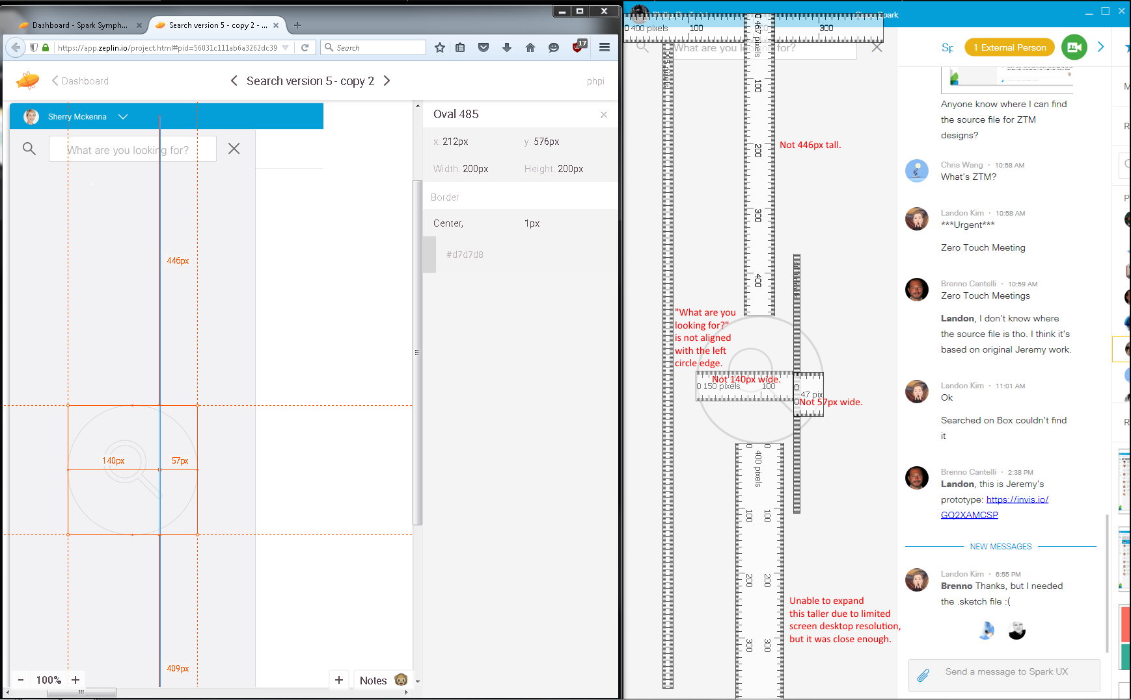
First Image’s Issues:
- Wrong color codes.
- Wrong dimension sizes.
- Wrong search (image/graphic)s.
Second Image With Inputted Keyword Searches:
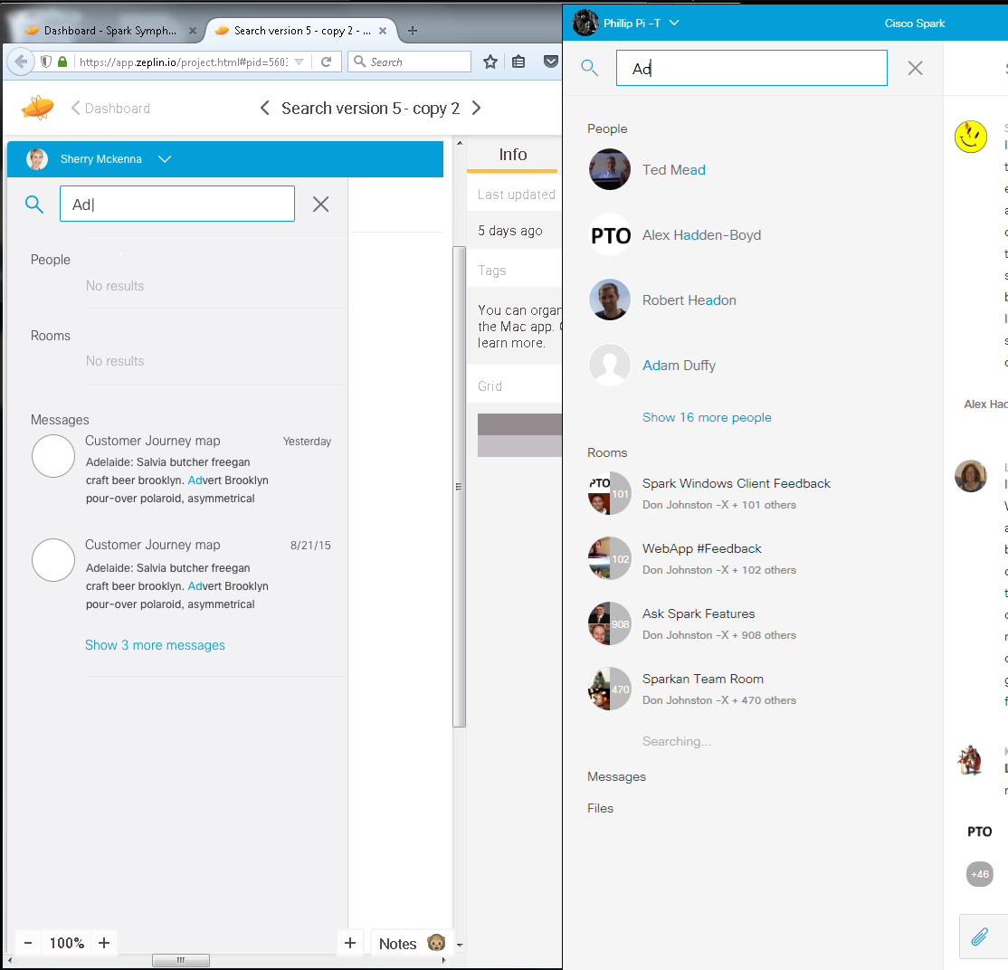
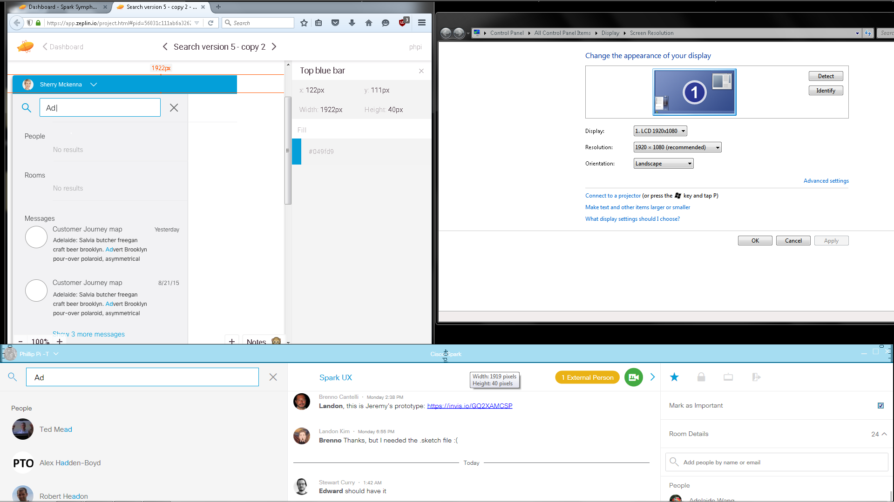
Could not stretch wider than 1920px resolution to measure, but got close enough. The top blue title bar’s sizes seems to be correct.

Below’s Zeplin’s screen shot didn’t show “Cisco Spark” texts even though it showed the texts’ attributes, like color code and sizes. They appeared to be correct when I compared and checked. Also had to search “Spark” instead of “Ad” since it didn’t show any “Ad” messages for its results:

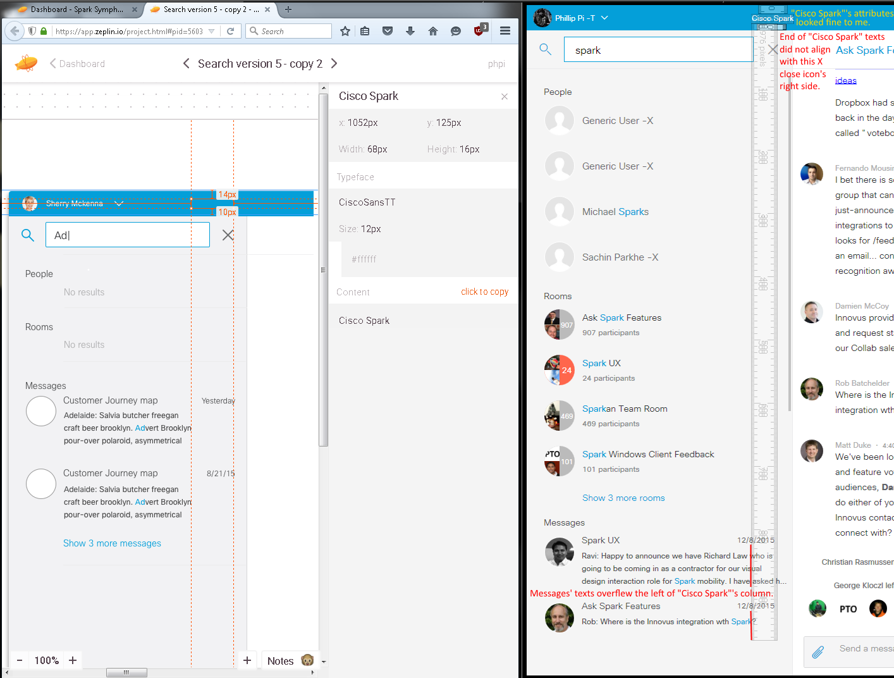
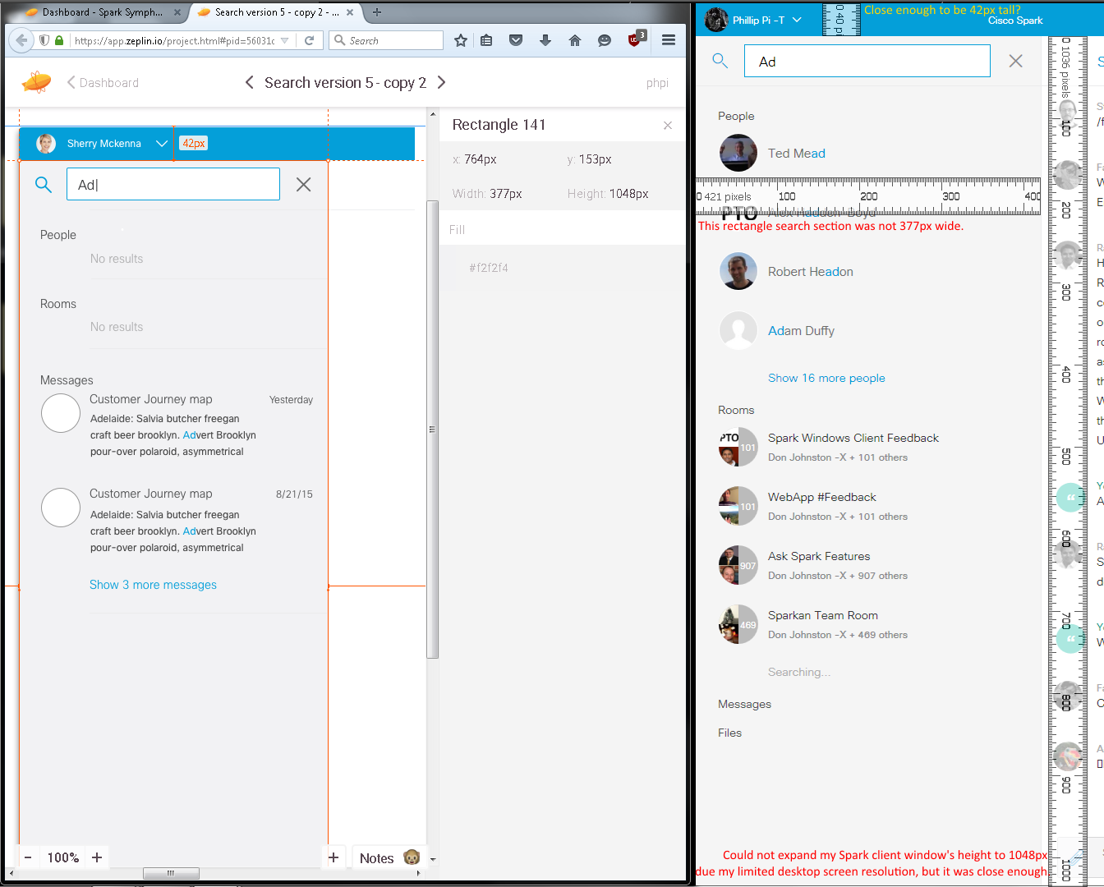
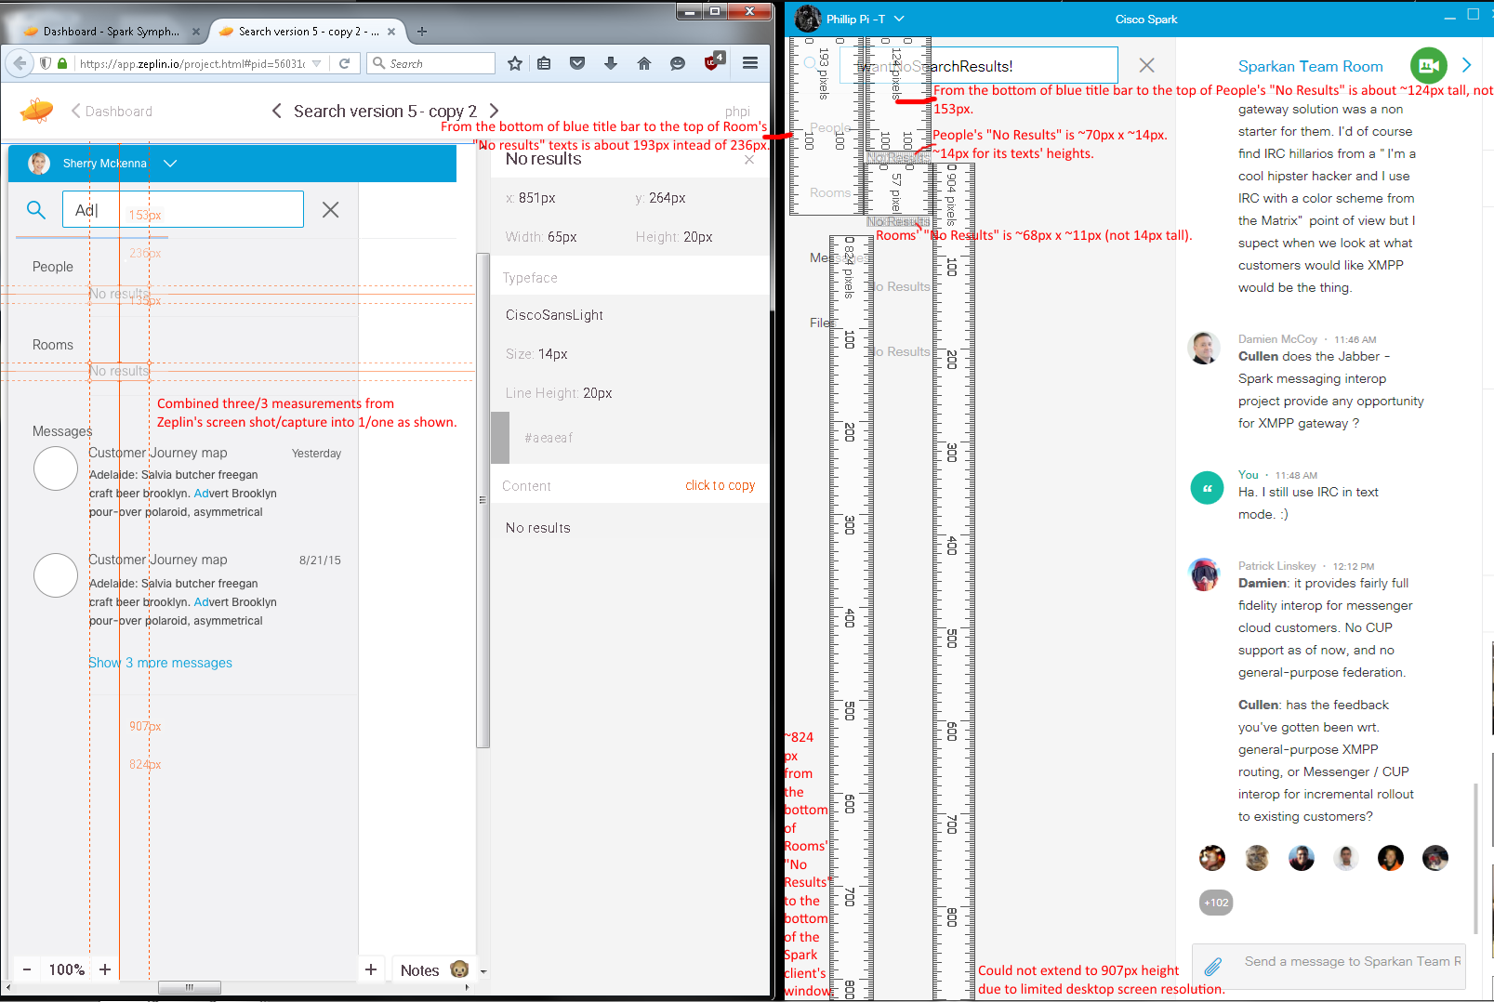
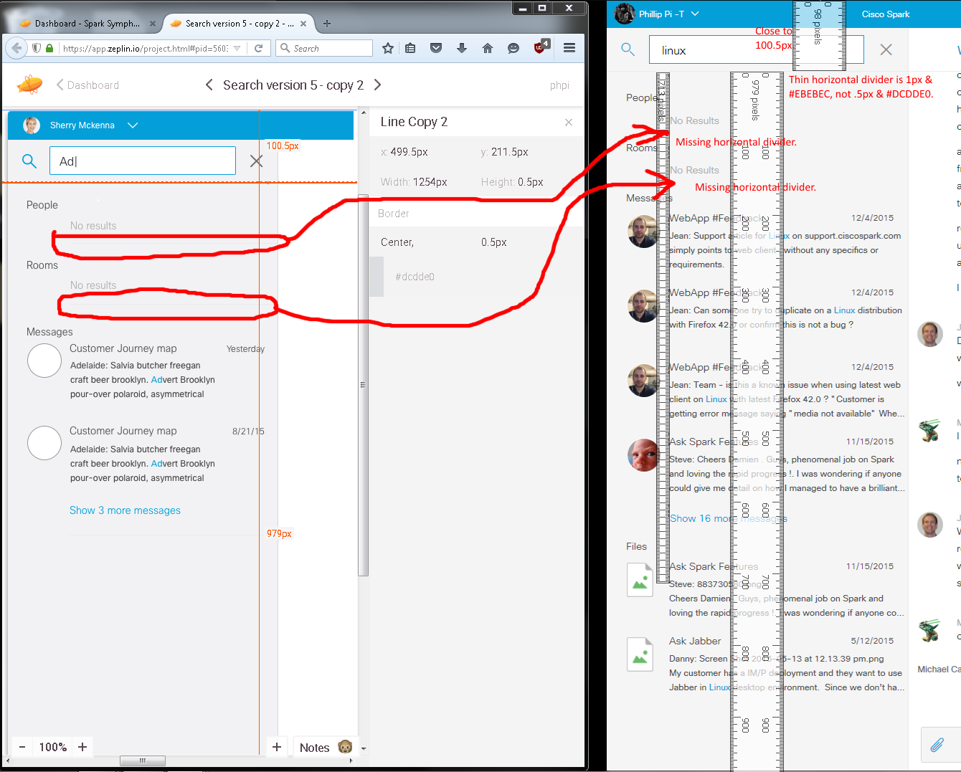
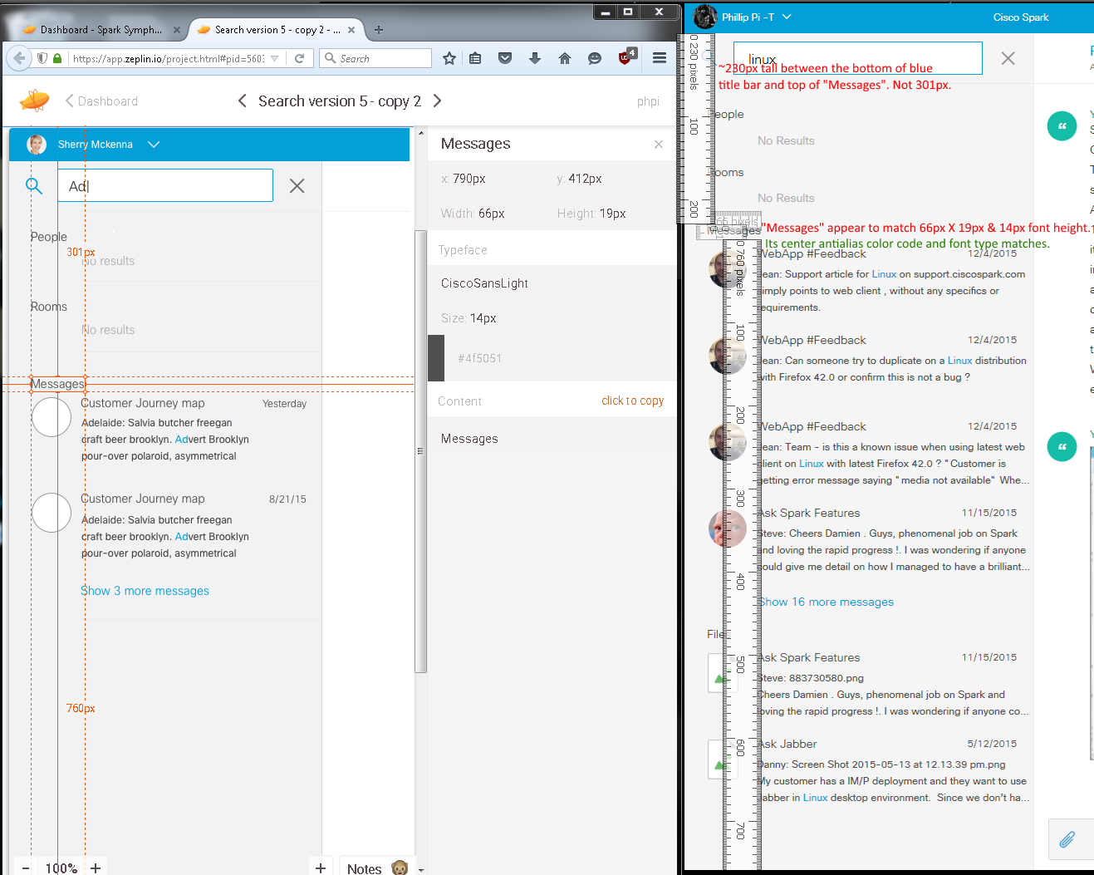From build 3074.
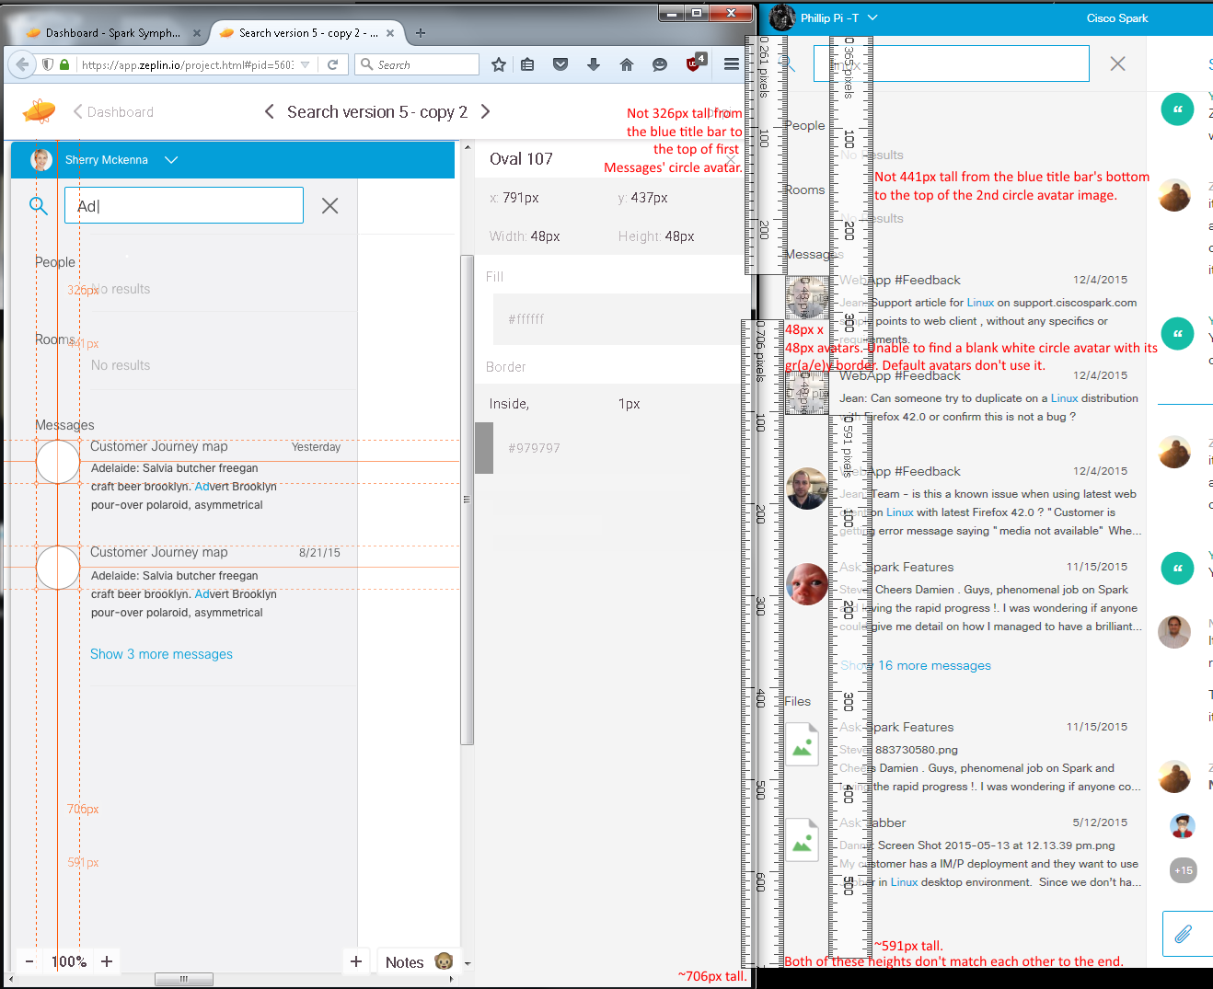
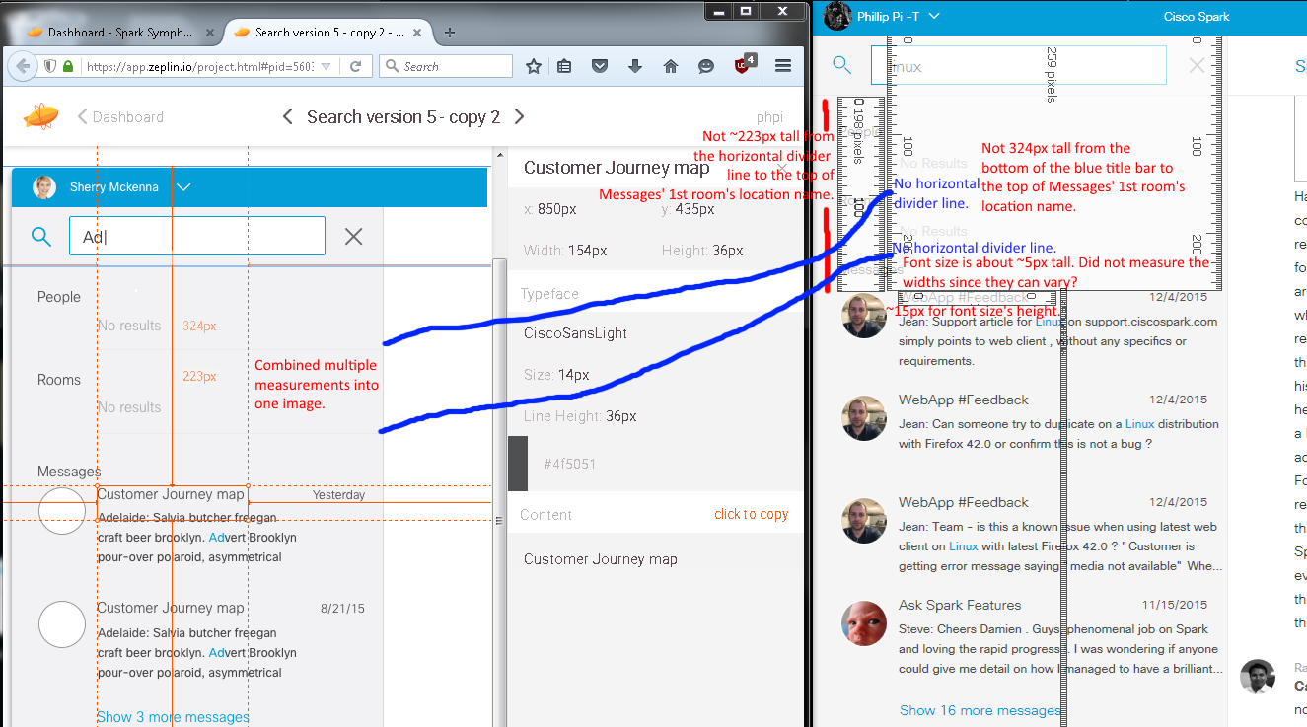
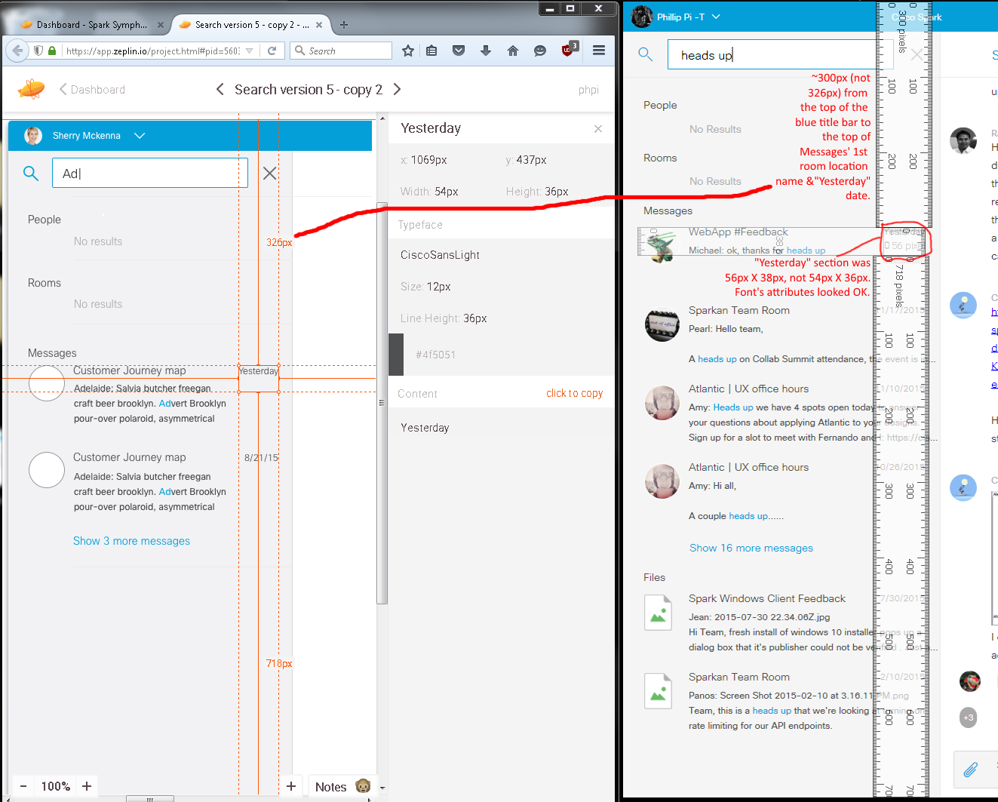
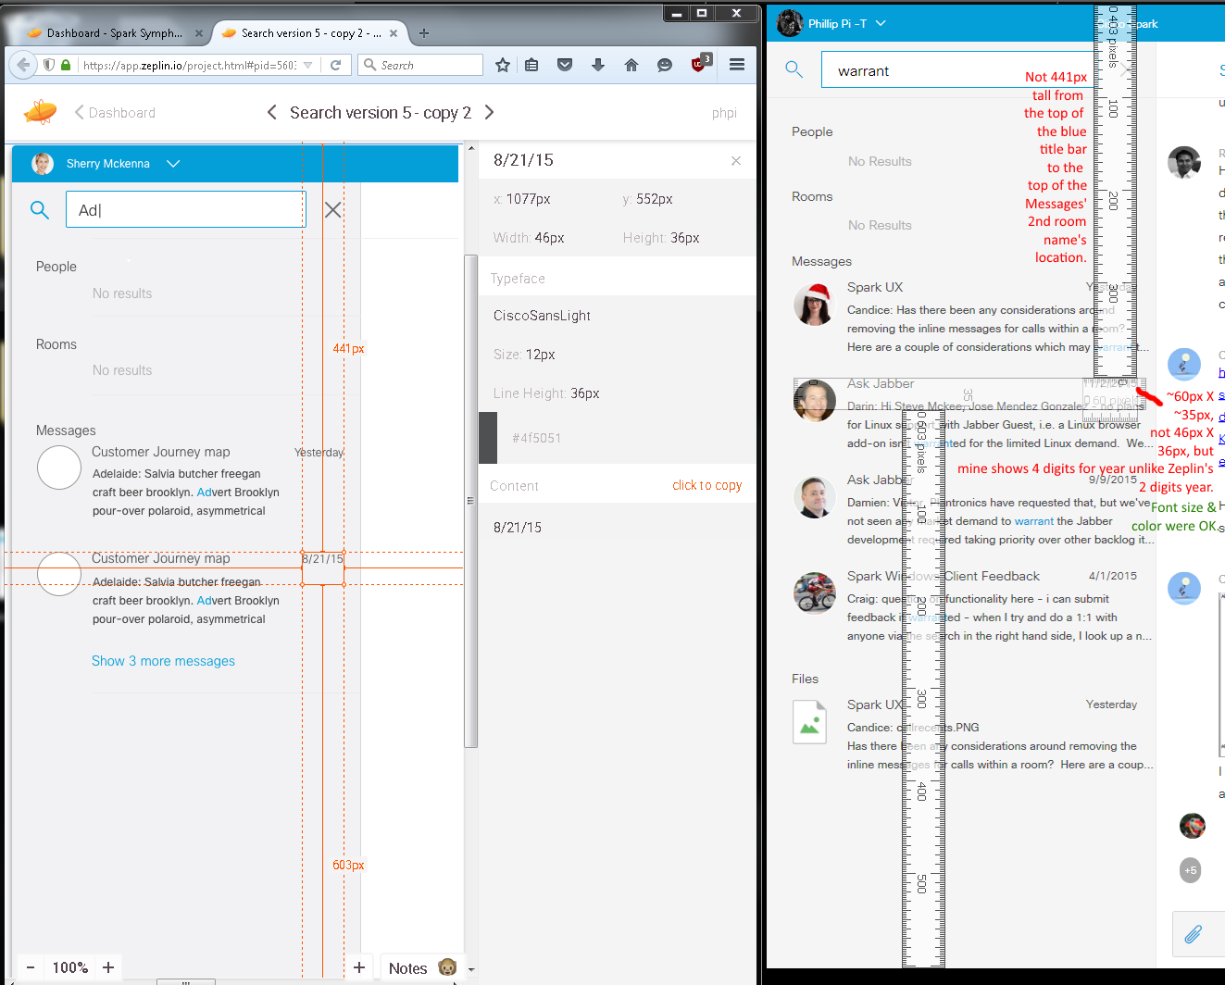
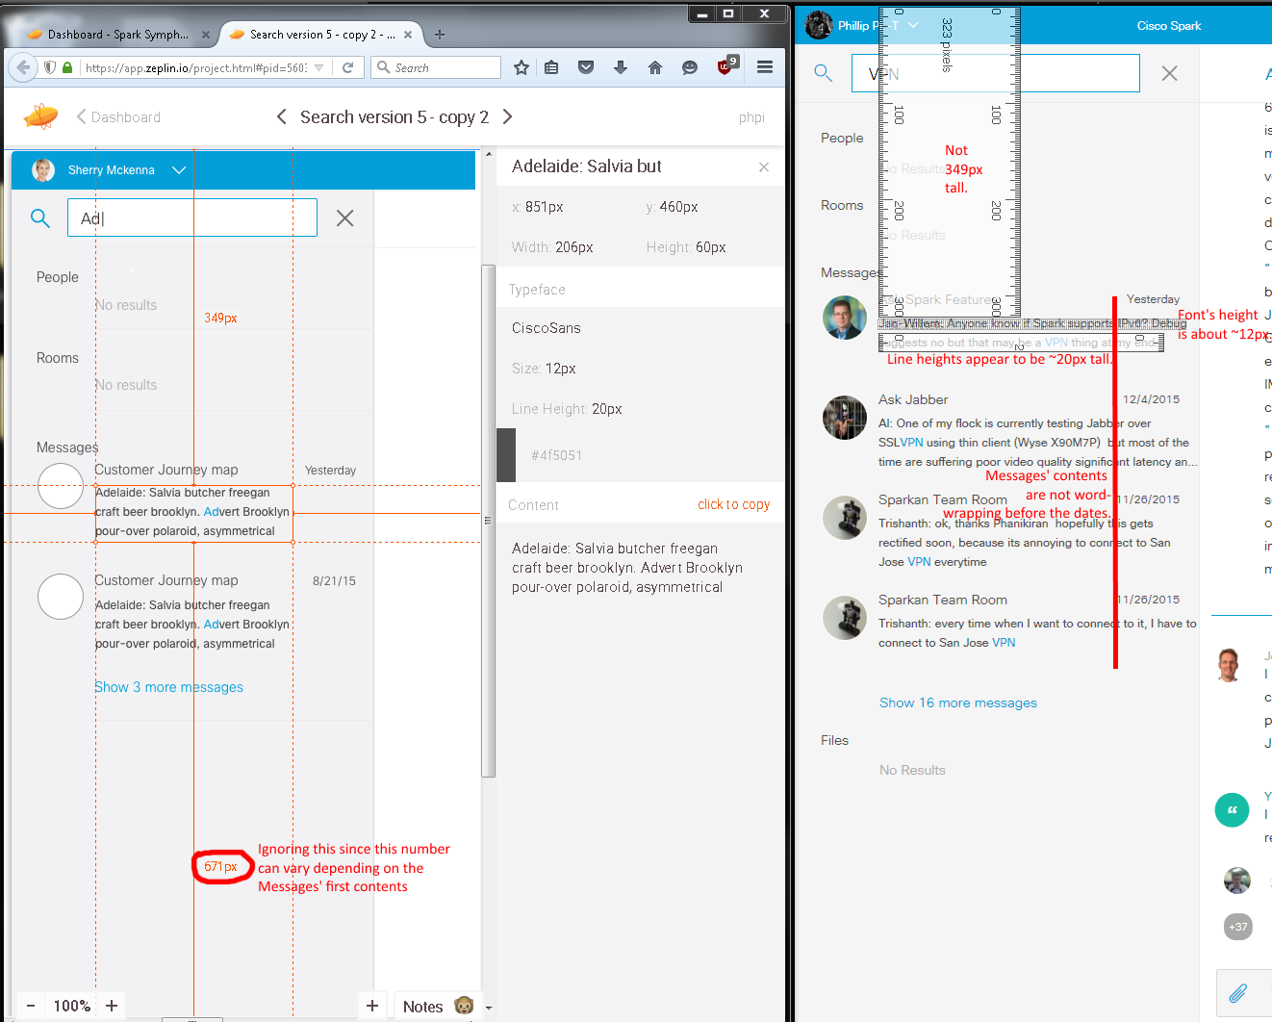From build 3096 on Dec. 10th, 2015.

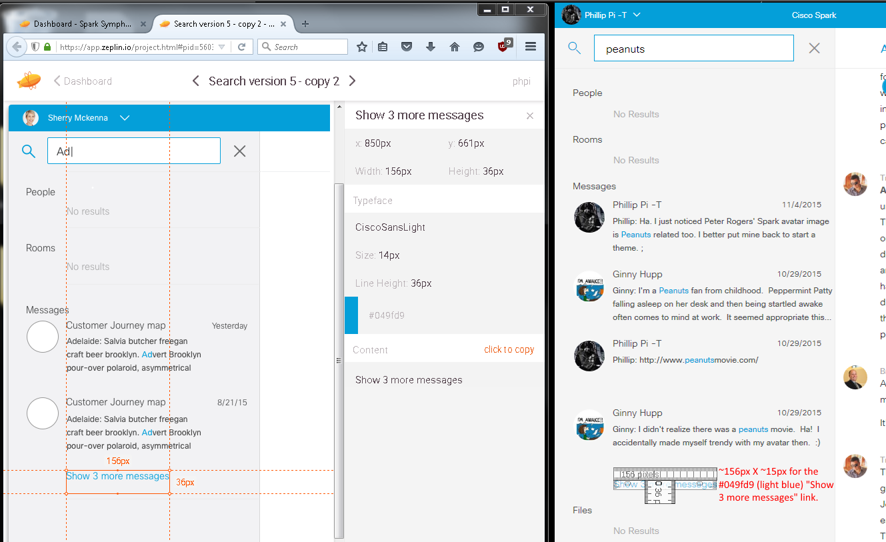
Second Image’s Issues:
- Dimension sizes.
- Misalignments.
- Messages’ text contents are not wordwrapping before the date columns.
- Wrong/Incorrect colors.
- Missing images, horizontal divider lines?, and “Files” section in Zeplin’s screen (shot/capture)s.

Third Image With Search Results:
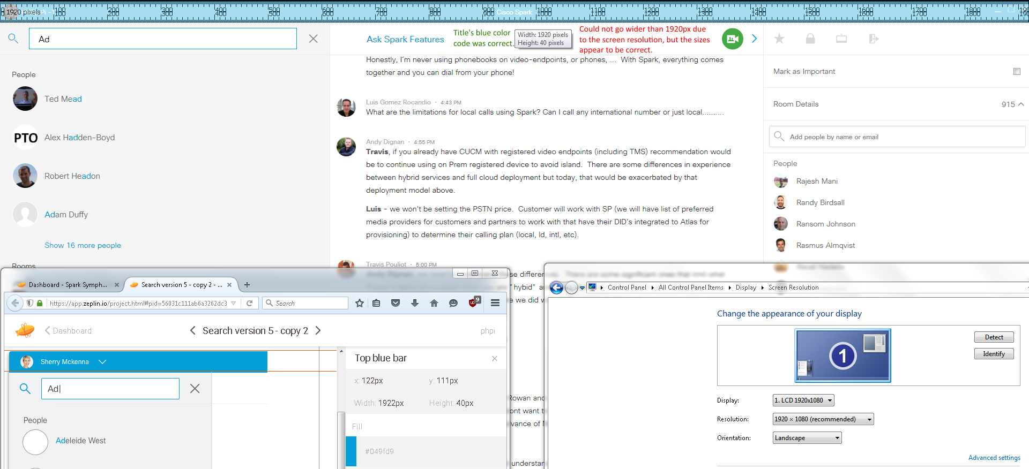
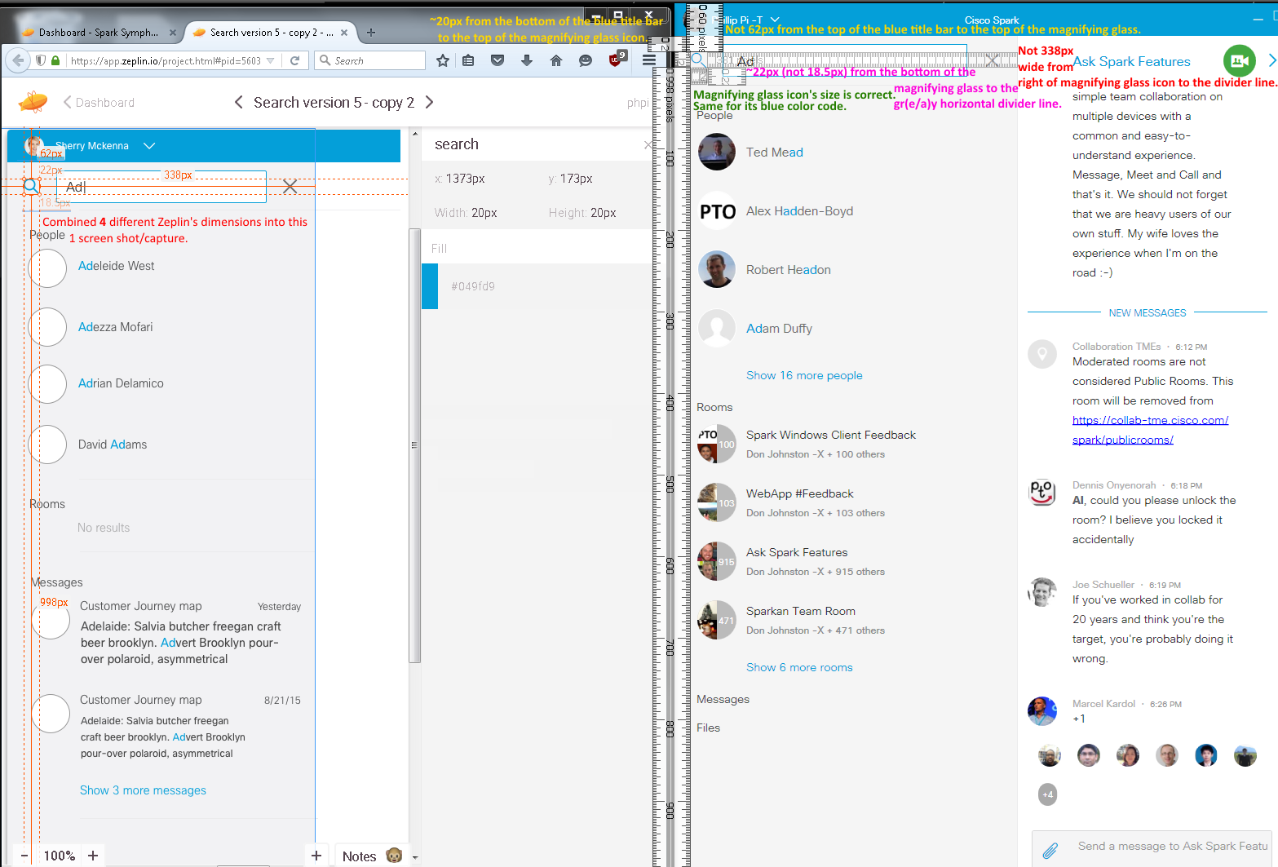
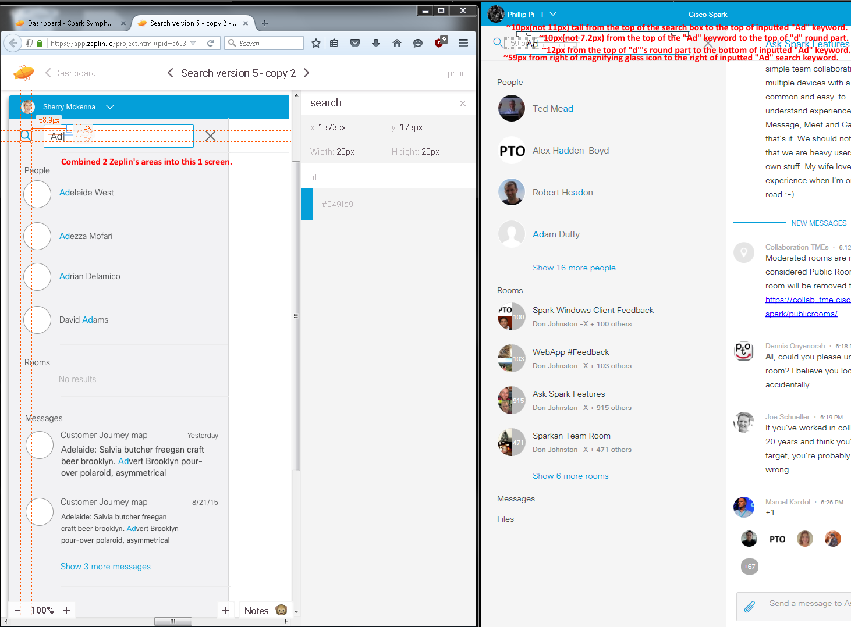
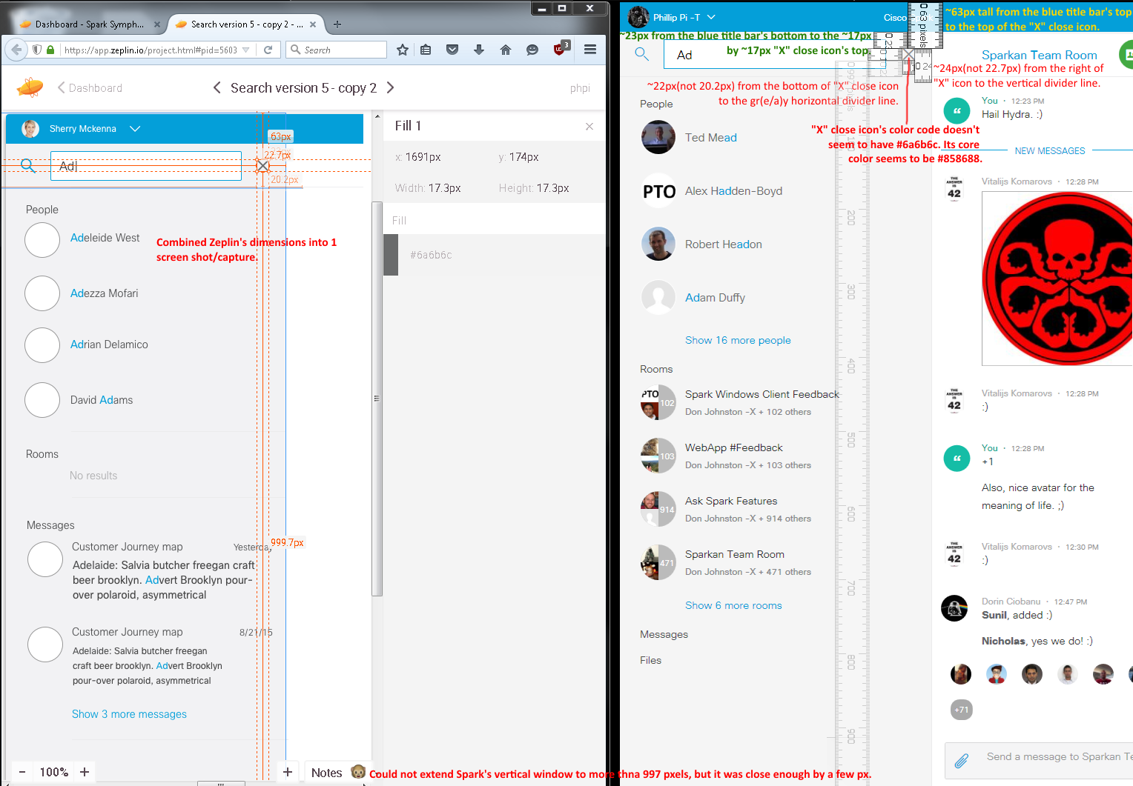
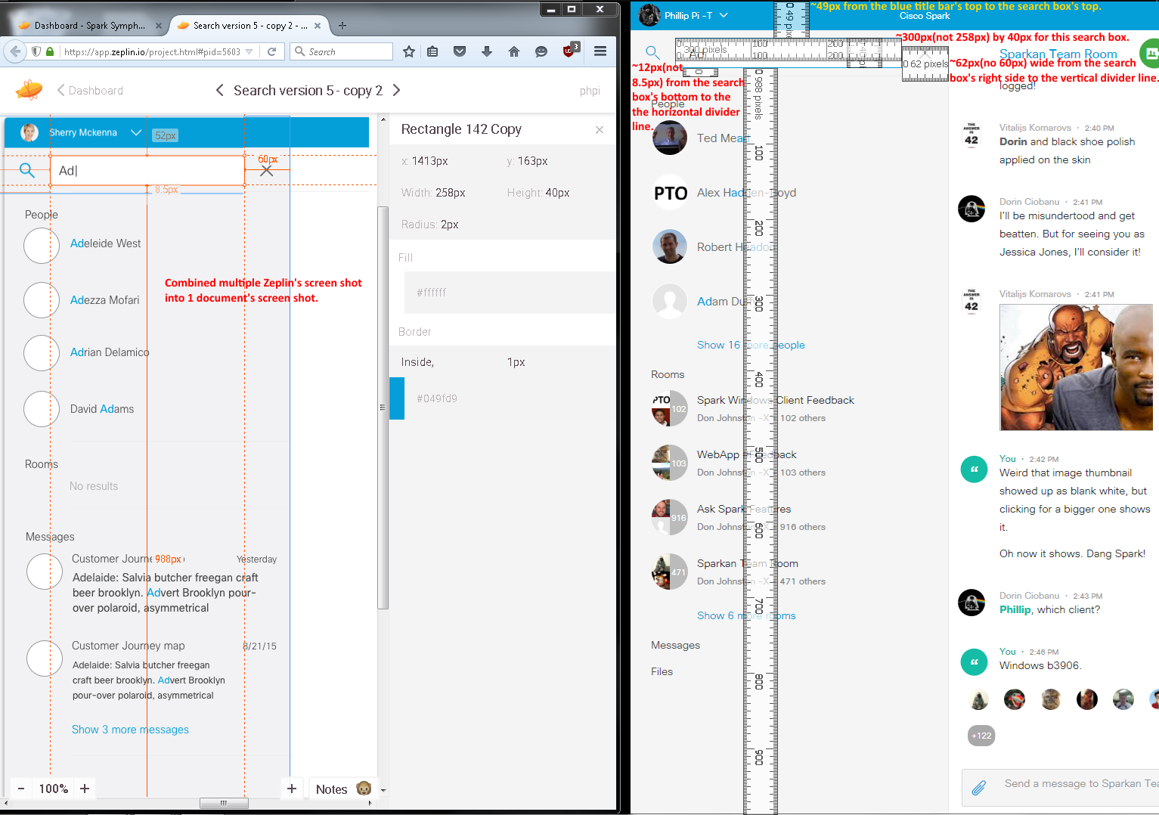
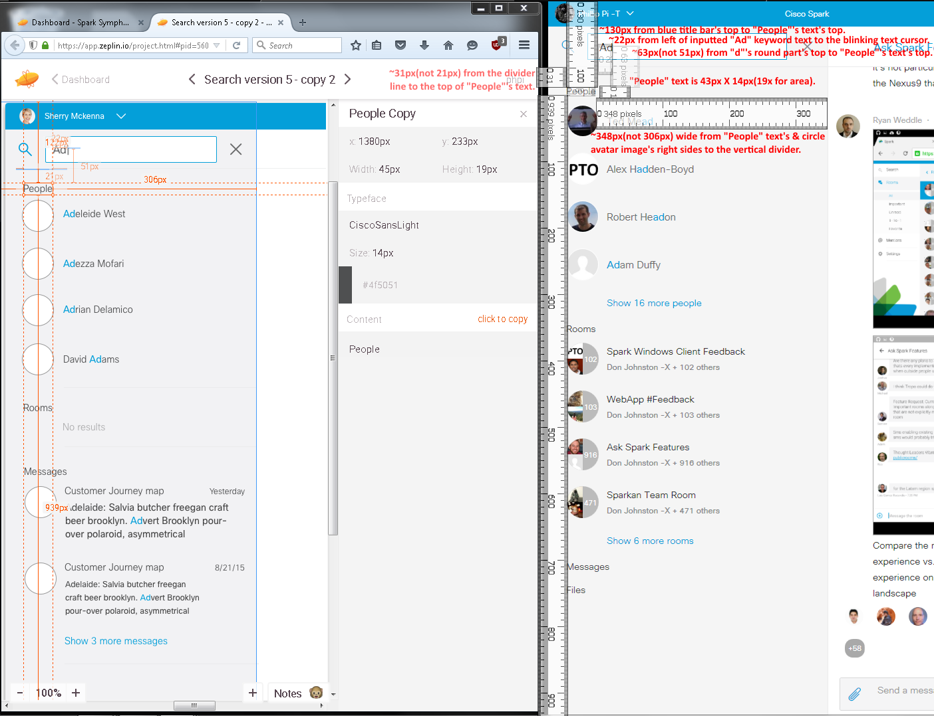
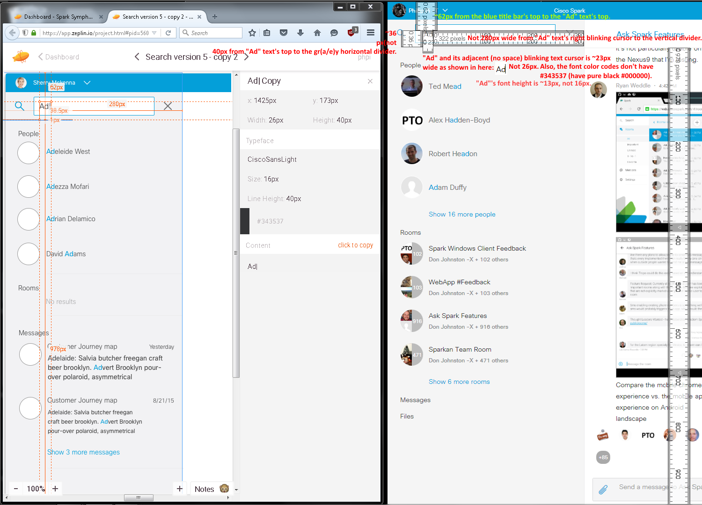

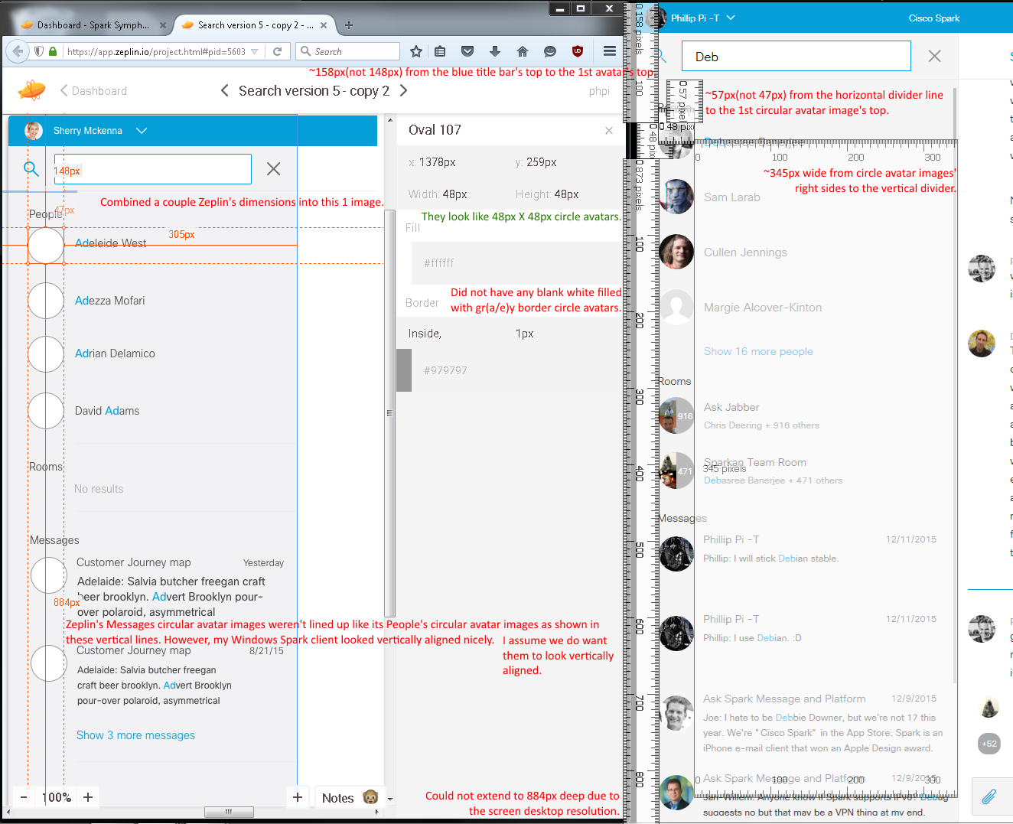
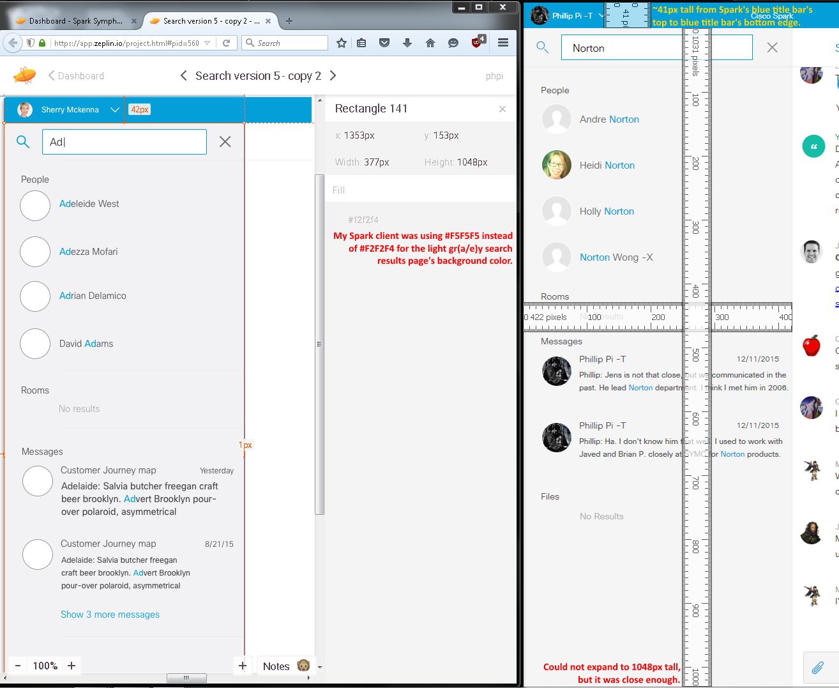From build 3125 on Dec. 14th, 2015.
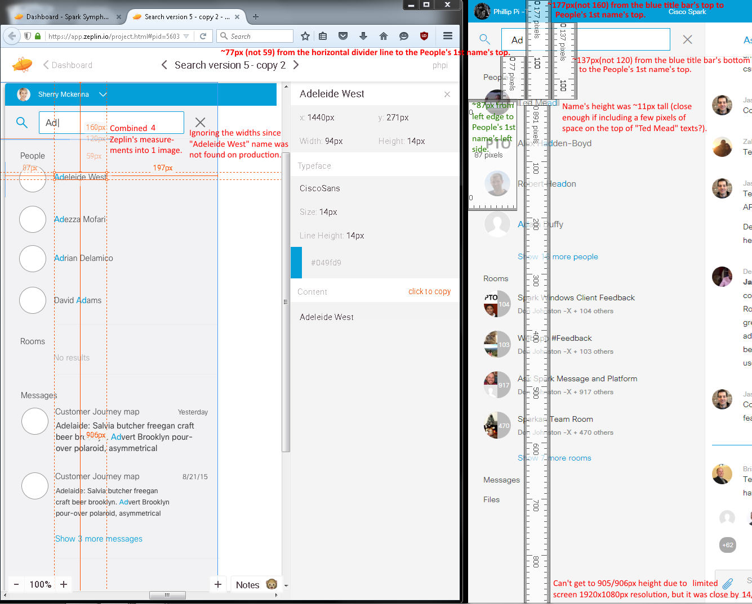
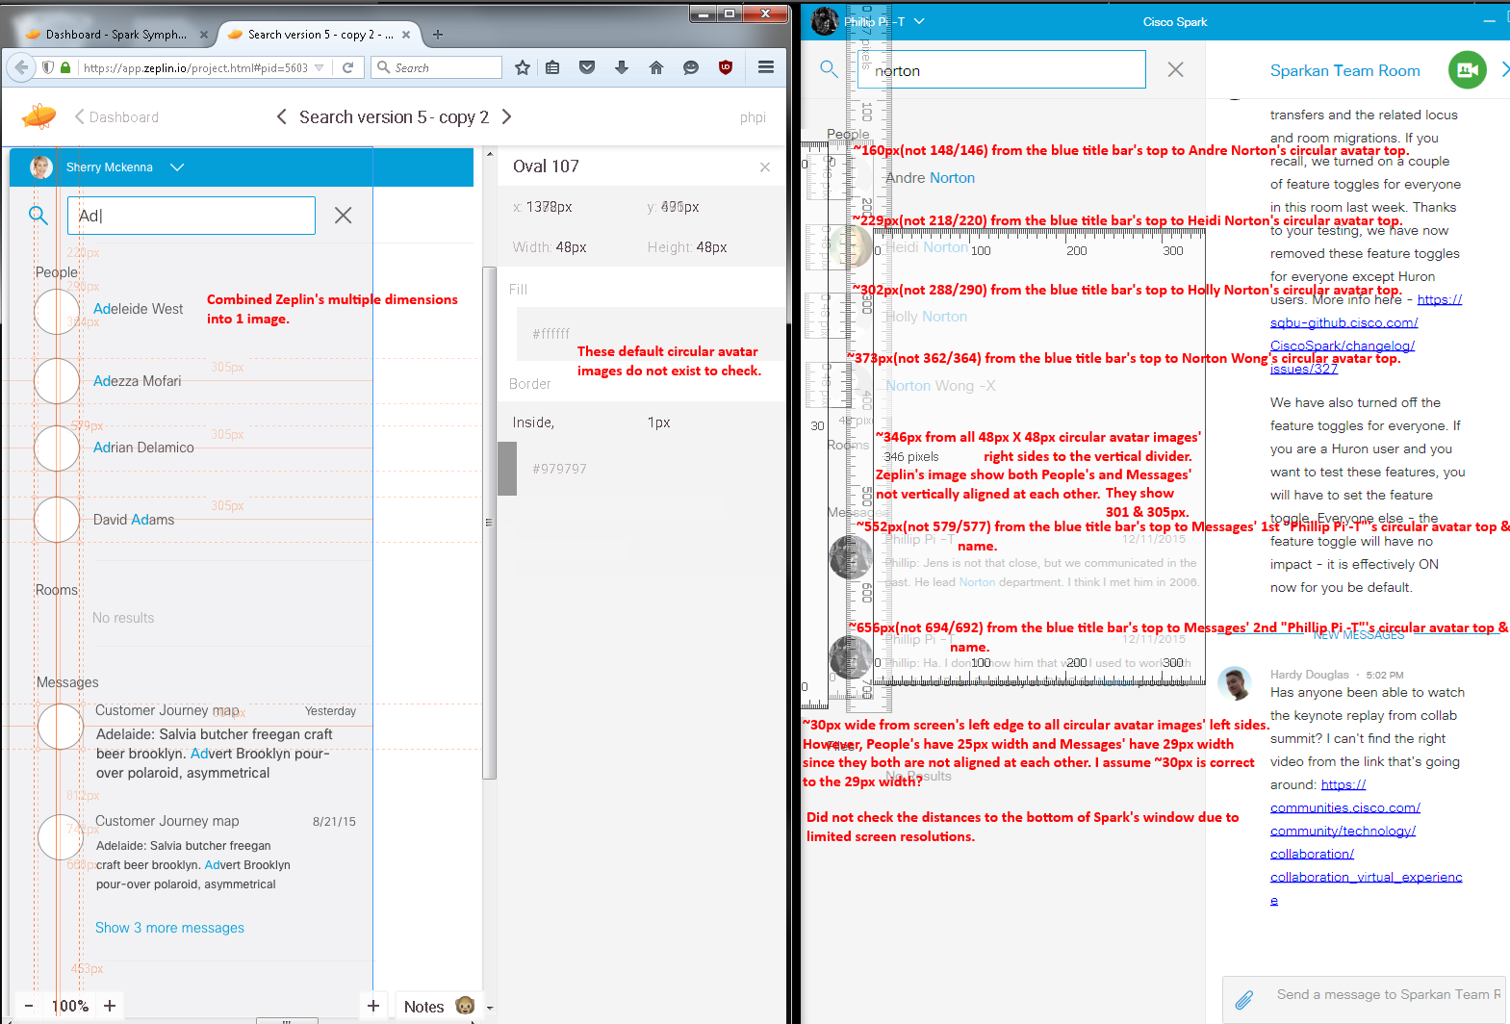
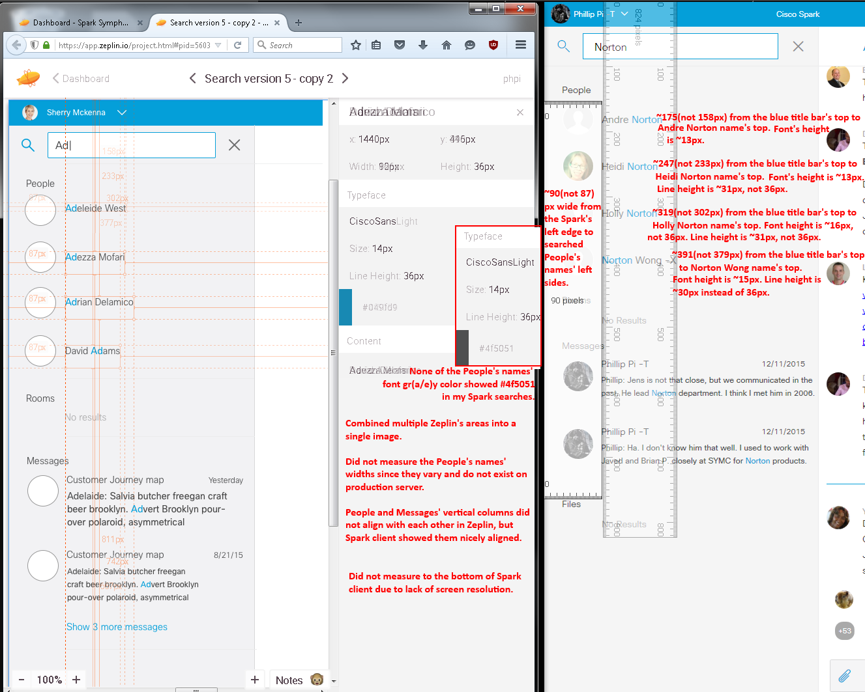
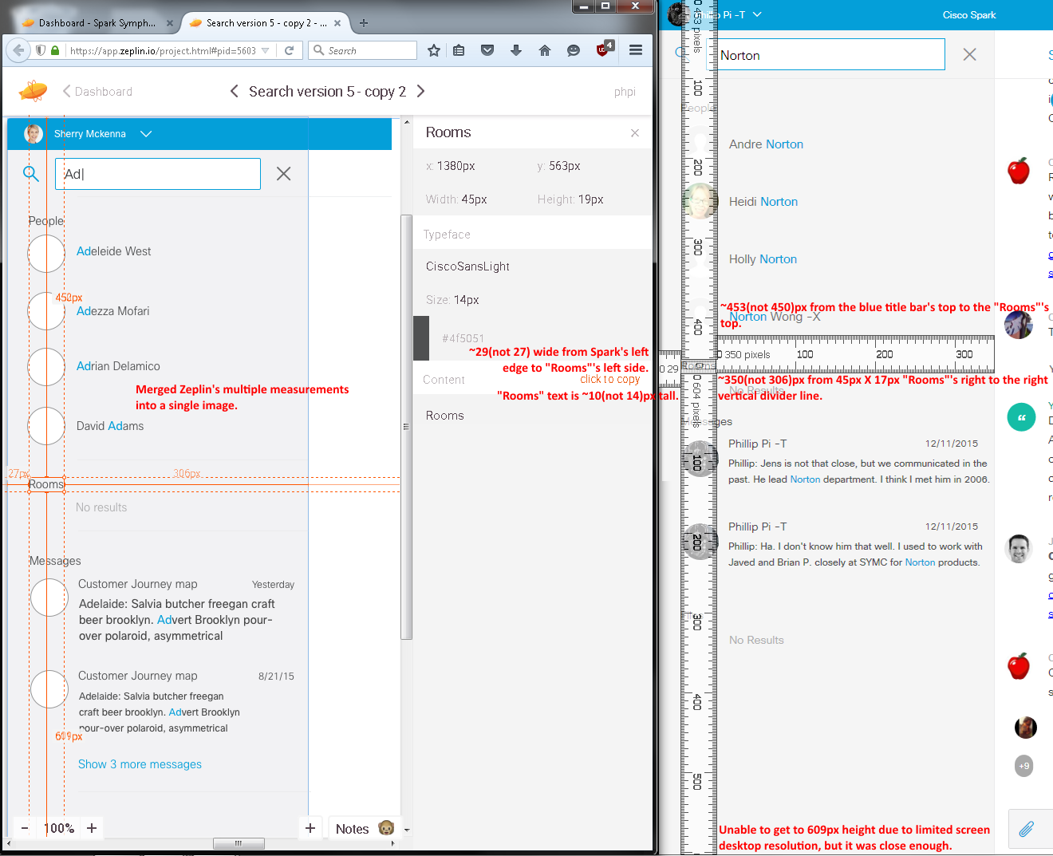
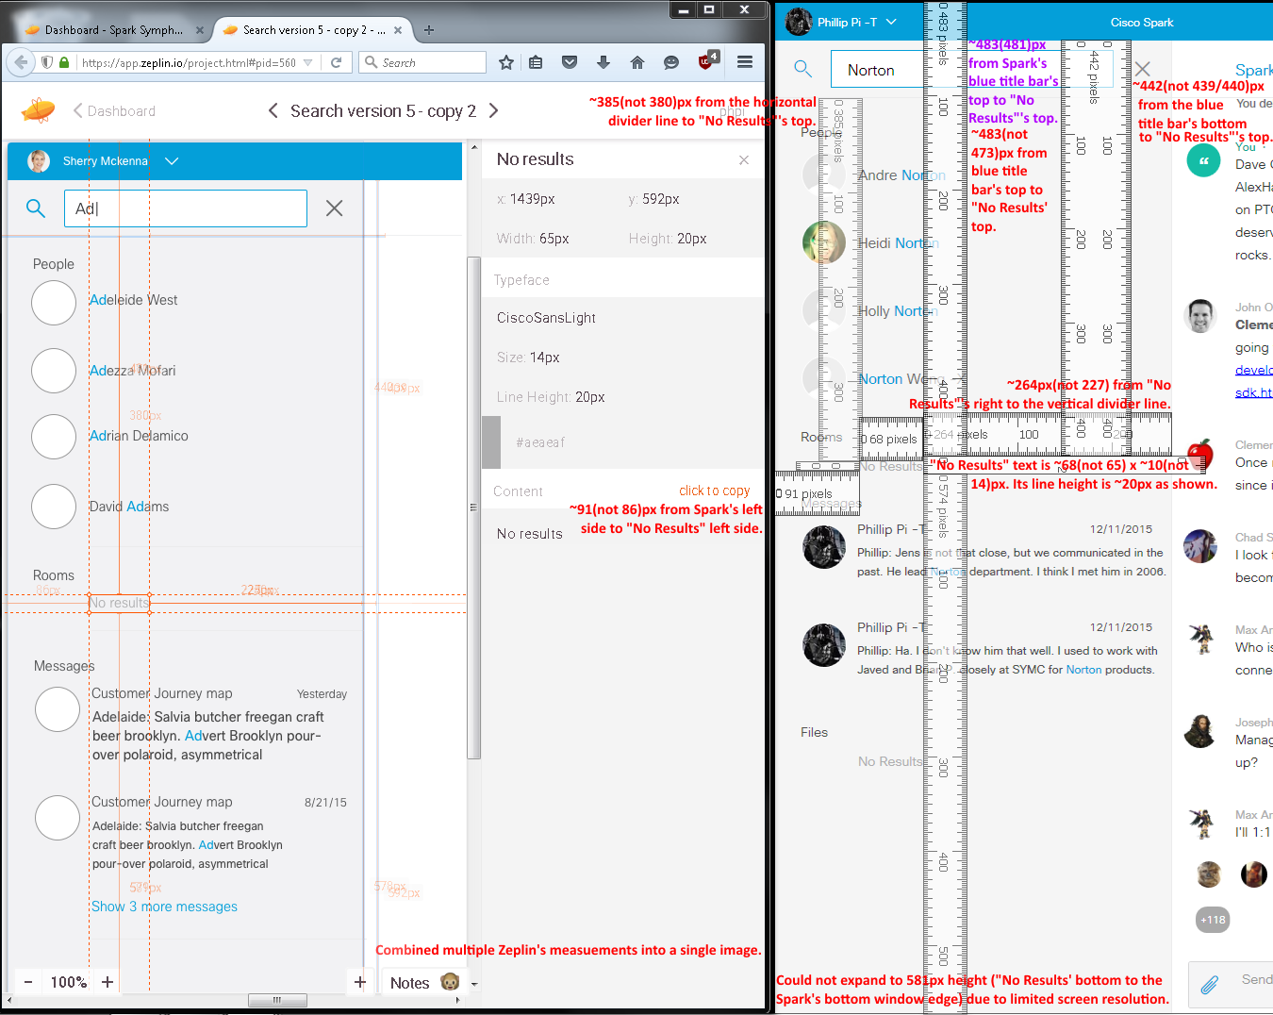
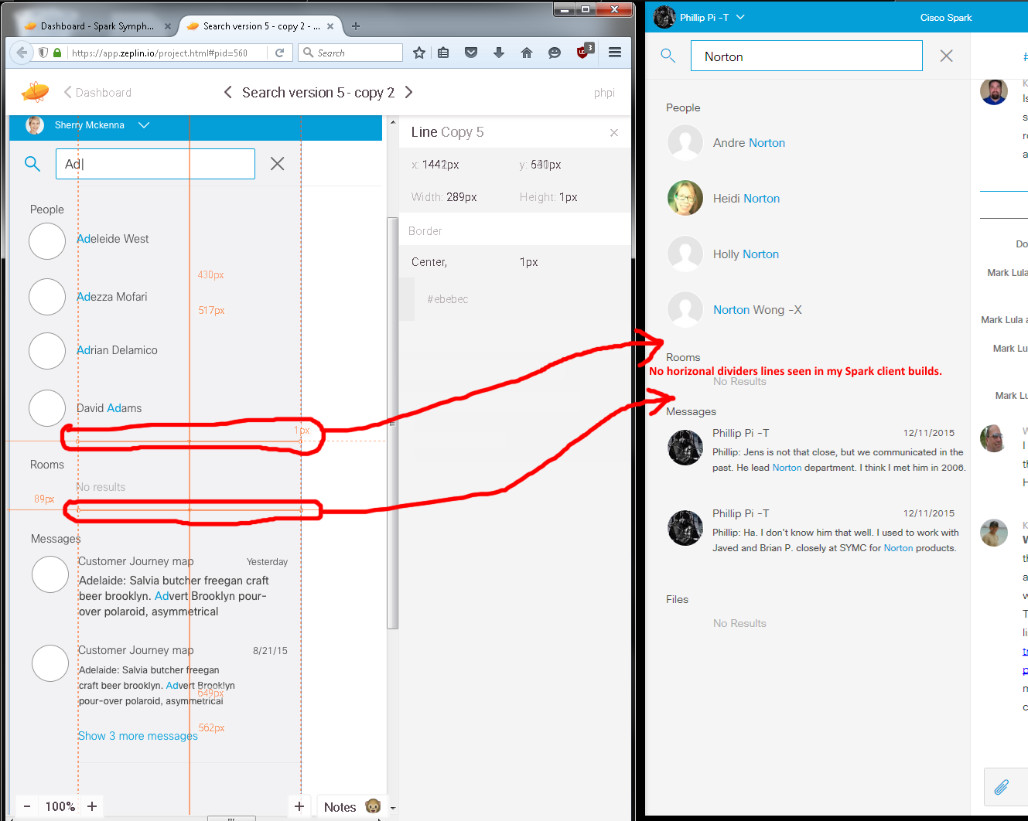
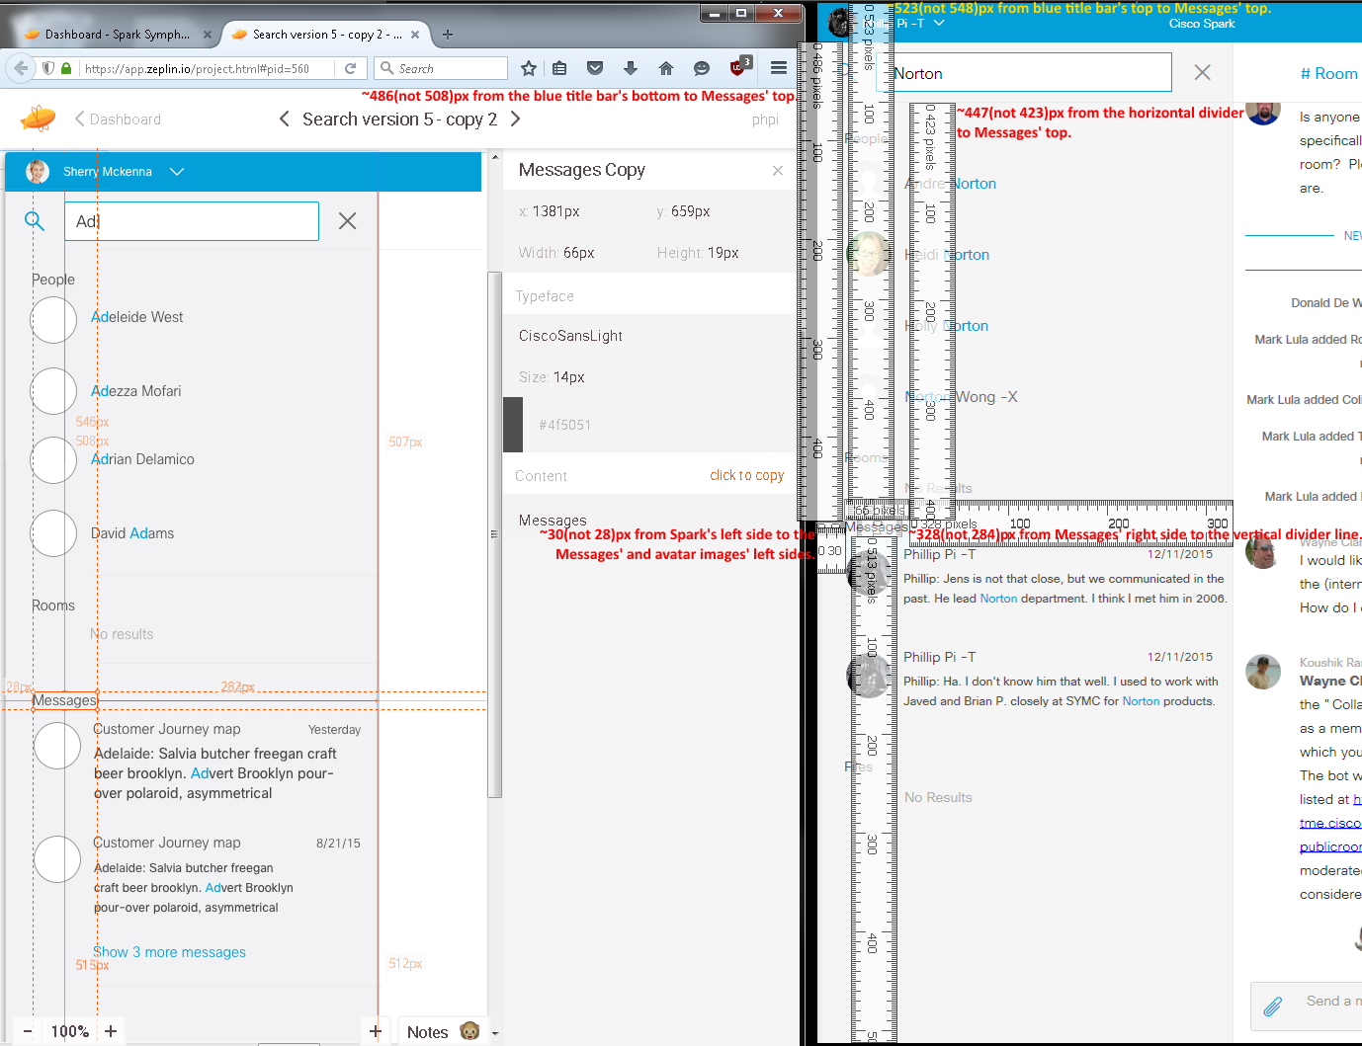
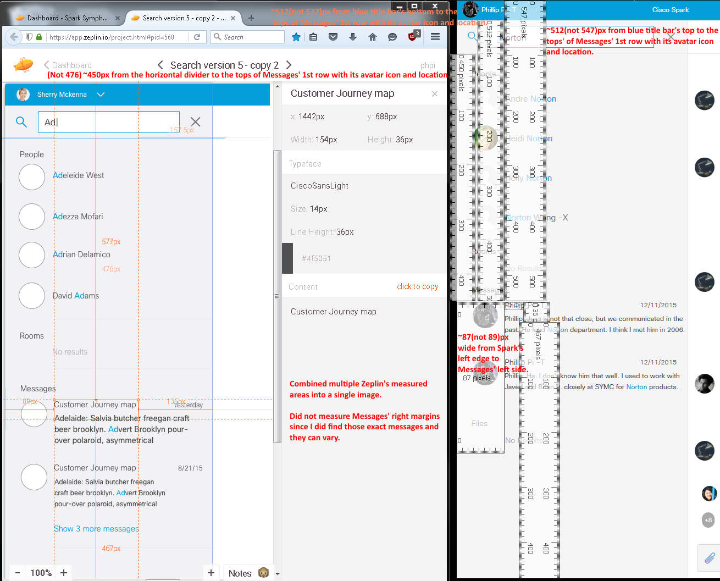
From build 3146:
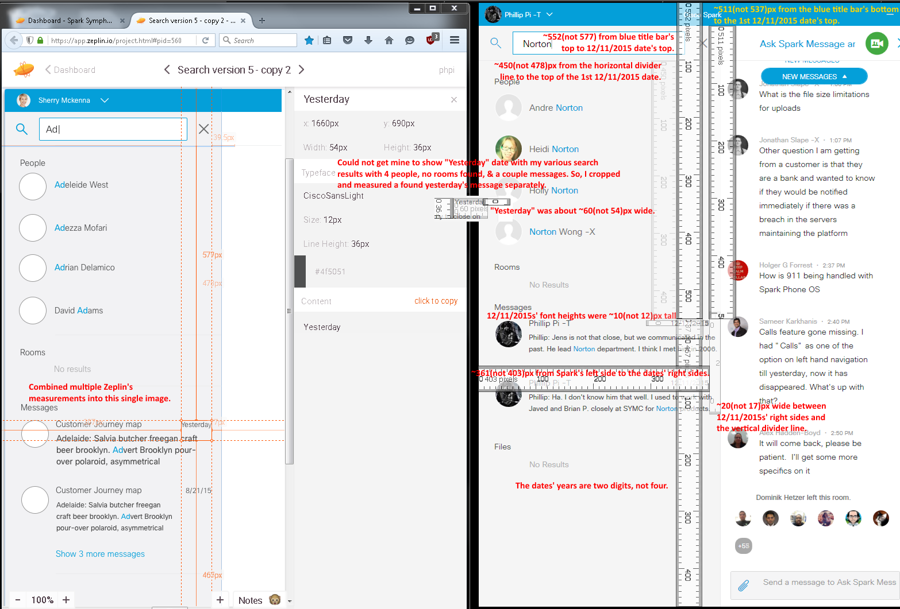
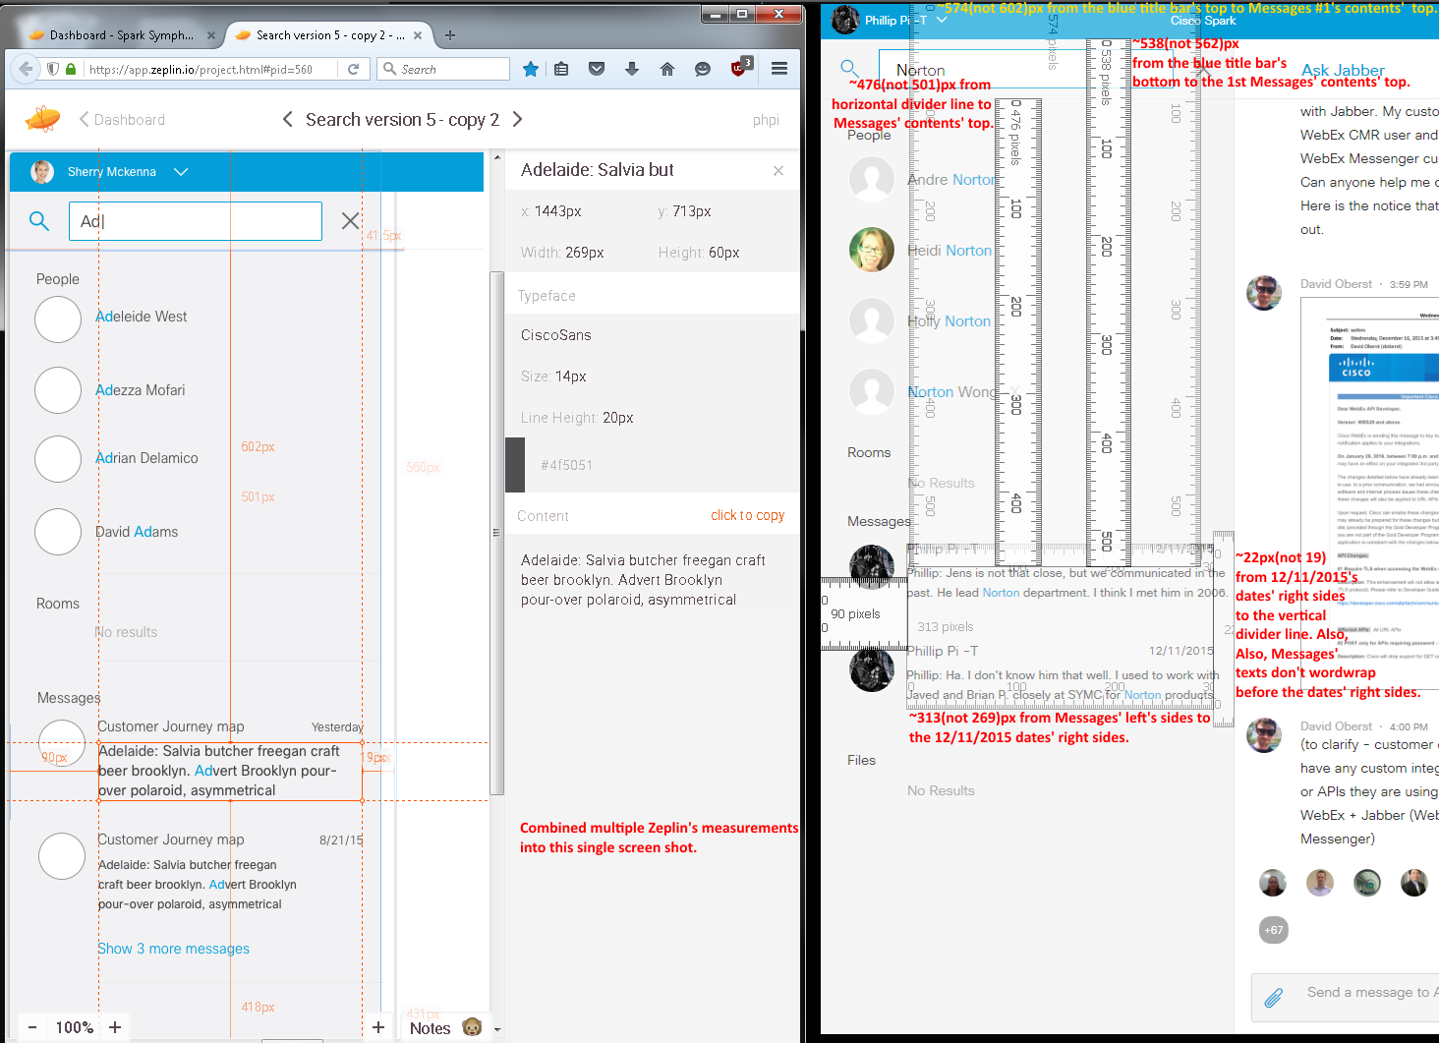
Did not check Messages’ 2nd contents’s vertical distances since they have different texts. Its horizontal measurements looked mostly the same as above (1st).
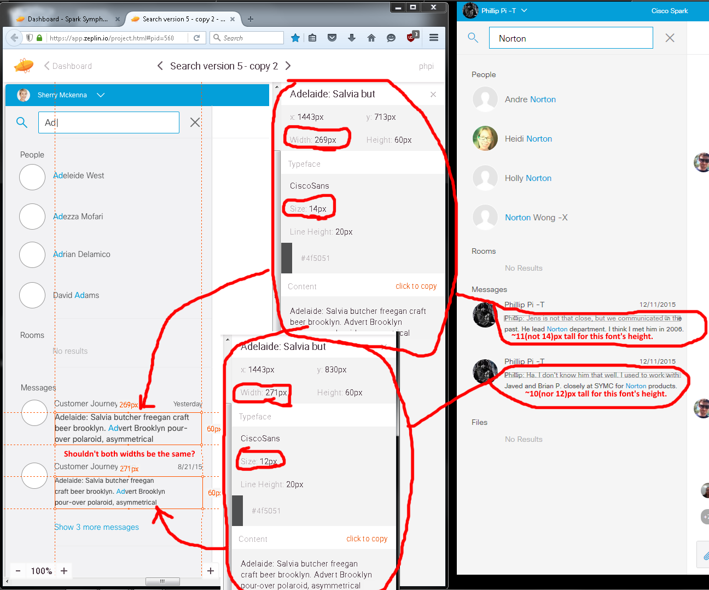
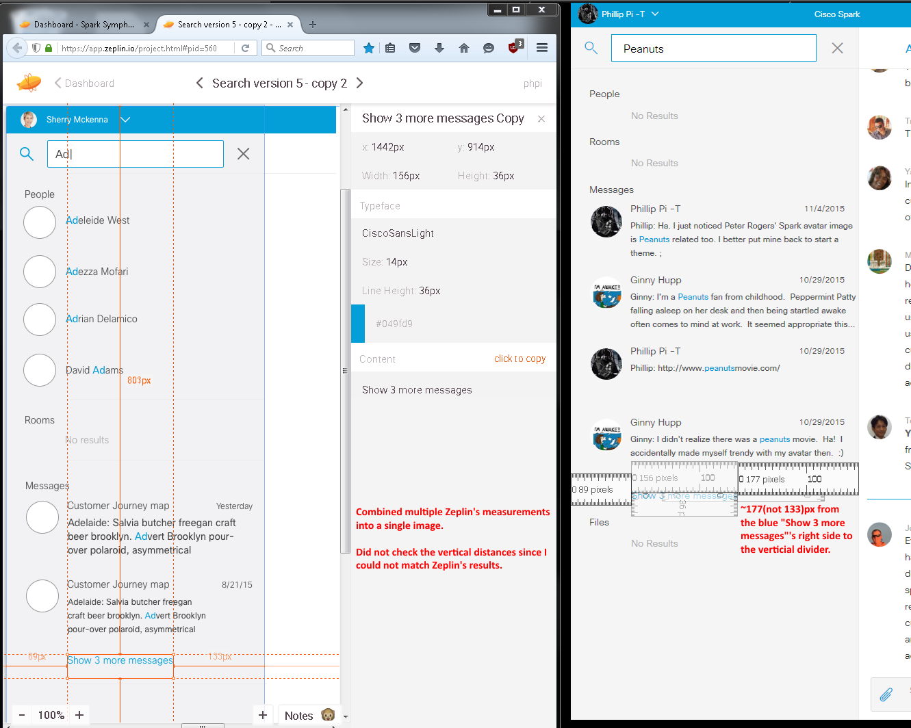
Third Image’s Issues:
- Wrong/Incorrect sizes.
- Incorrect/Wrong gr(a/e)y color codes.
- Blinking text cursor right of “Ad” (and any inputs) was adjacent and had no space between like shown in Zeplin’s screen (shot/captures).
- People’s and Messages’ circular avatar images do not line up each other in Zeplin’s screen shot, but Spark’s client is nicely aligned (assuming this is correct?).
- Mine shows its Messages’ contents not wordwrapping before the dates’ right sides.
- Missing horizontal divider lines.
- Dates’ years are four digits instead of two.

Fourth Image With No Search Input:
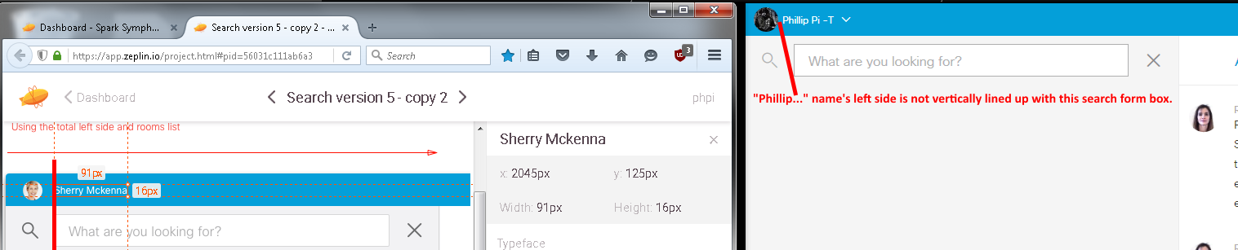
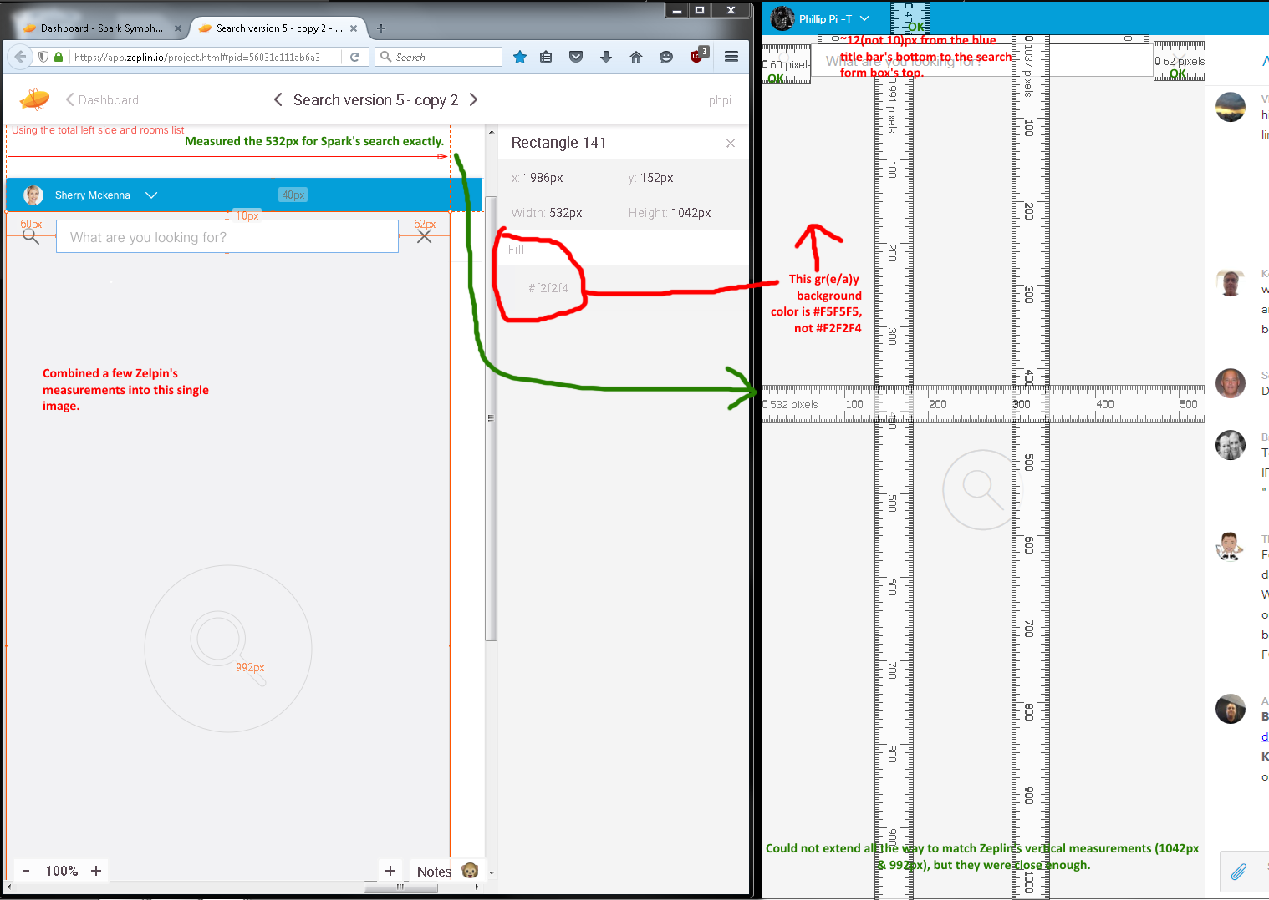
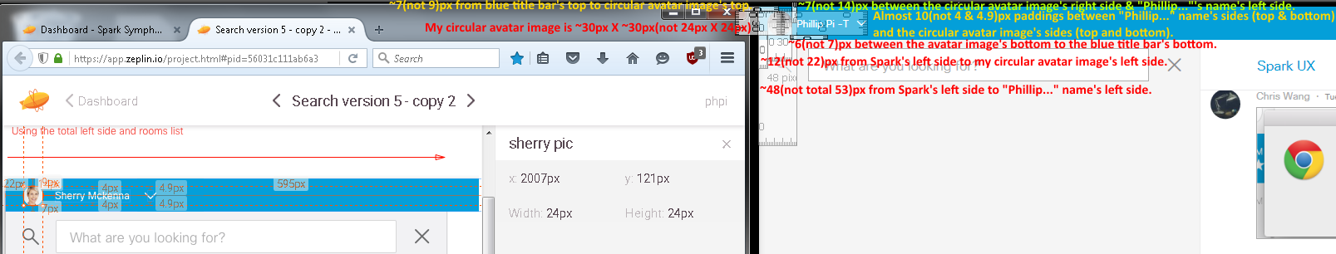
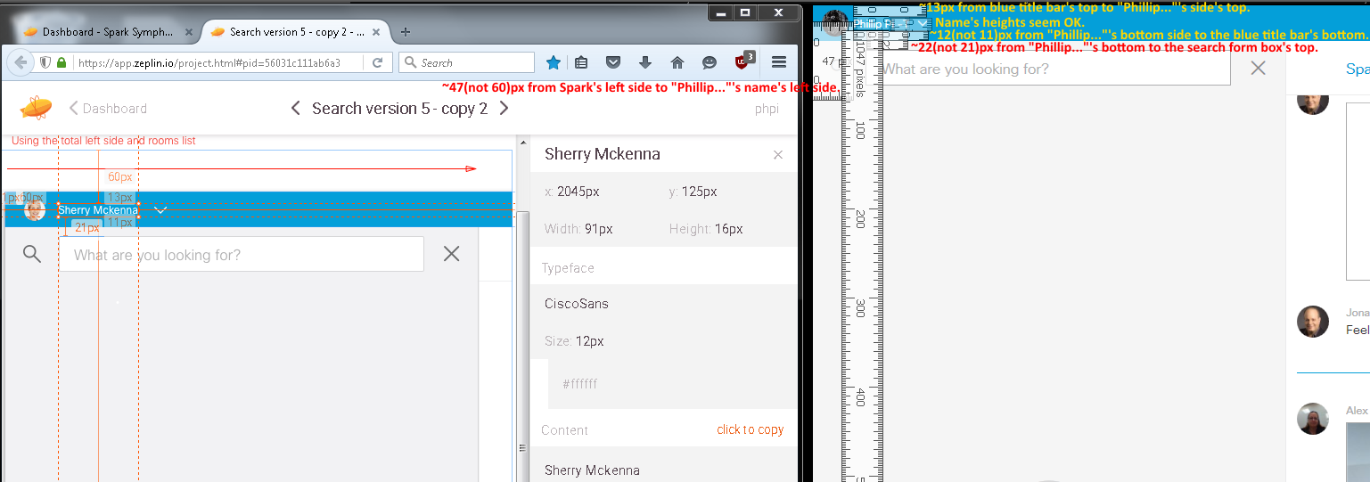
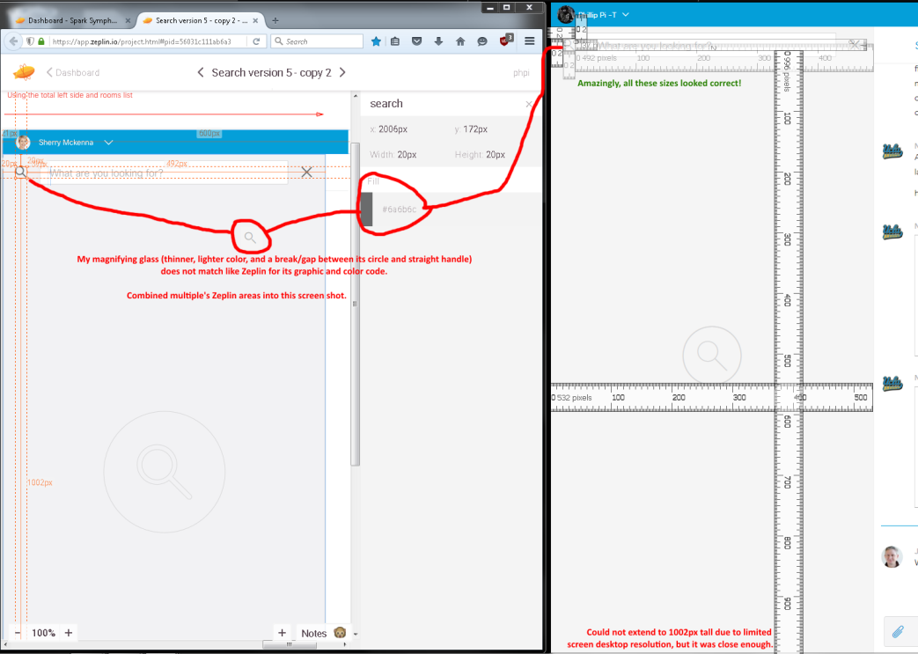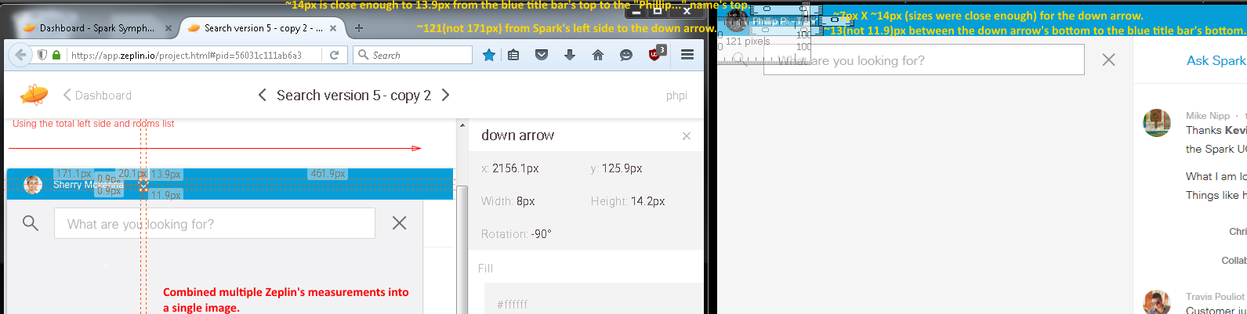
Left and below few screen (shot/capture)s were from build 3155 on 12/18/2015.
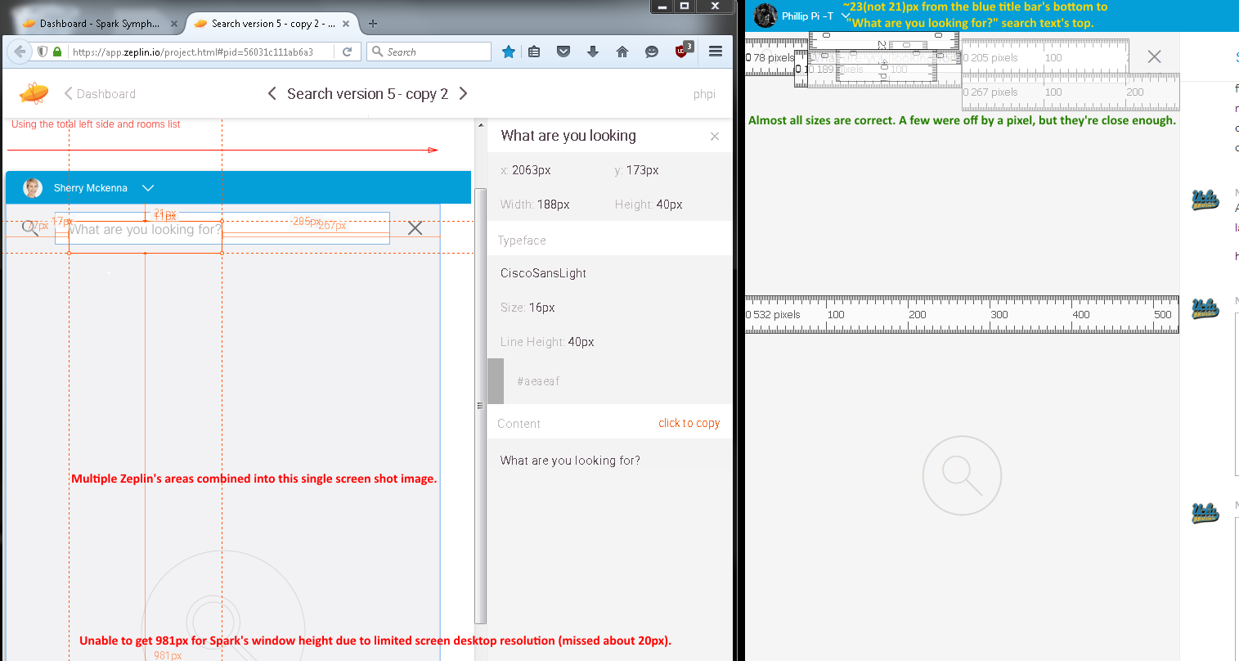
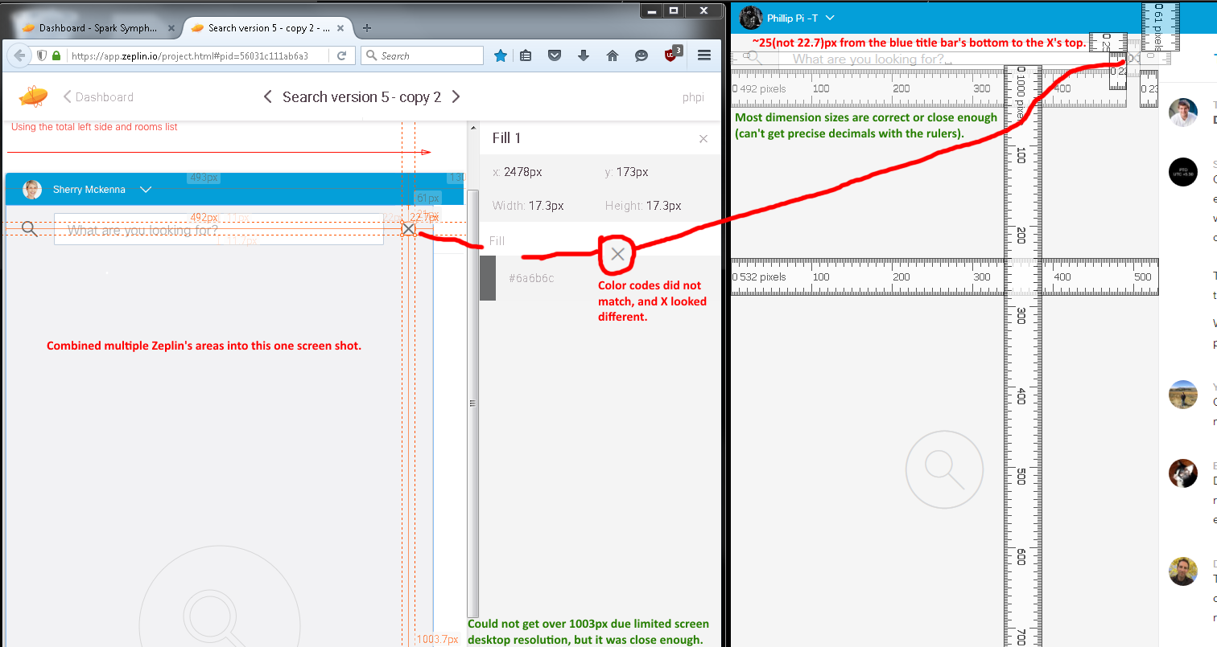
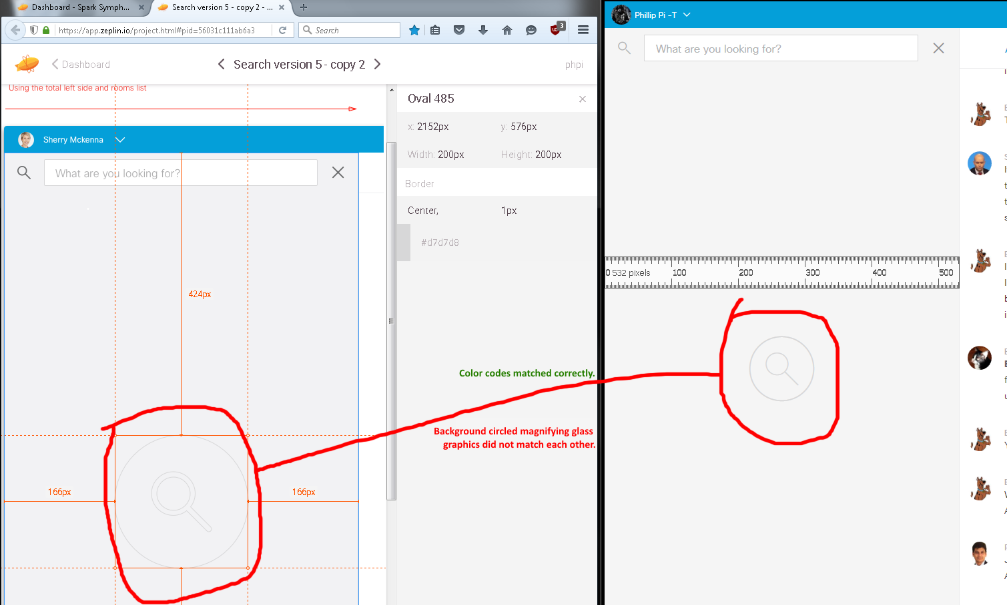
Fourth Image’s Issues:
- Background circled magniying glass graphics did match.
- Wrong sizes.
- Incorrect gr(a/e)y color in the search’s background and magnifying glass icon (also looks different).
- Name’s left side not vertically lined up with the search form box’s left side.

