**Phillip Pi’s QA UX UI Results With Windows v1.0.0.3155 Desktop Client’s Search (Redlines) in an Updated 64-bit W7 EE SP1 (smaller - 100% DPI).**

Notes: All redline specifications were from web browsers’ online Zeplin’s “Spark Symphony Windows Native” project (<https://app.zeplin.io/project.html#pid=56031c111ab6a3262dc395b8&dashboard>)’s dashboard for its <https://app.zeplin.io/project.html#pid=56031c111ab6a3262dc395b8&dashboard&sid=566077eaee1c2c173c87a3fc> “Search version 5 – redlines”’s 12/3/2015 screens and compared between Dec. 18th to 21st, 2015 (USA’s PST). Also, Spark’s left menu was not collapsed into its icons only (should say “< Rooms / All”) before clicking on its search. Only looked at the human’s redline overlays and not Zeplin’s (see the “WindowsDesktopClientSearchQAuxIn64w7eeSP1 - Search version 5 - copy 2.docx” file for Zeplin’s markups).

**Image #1:**

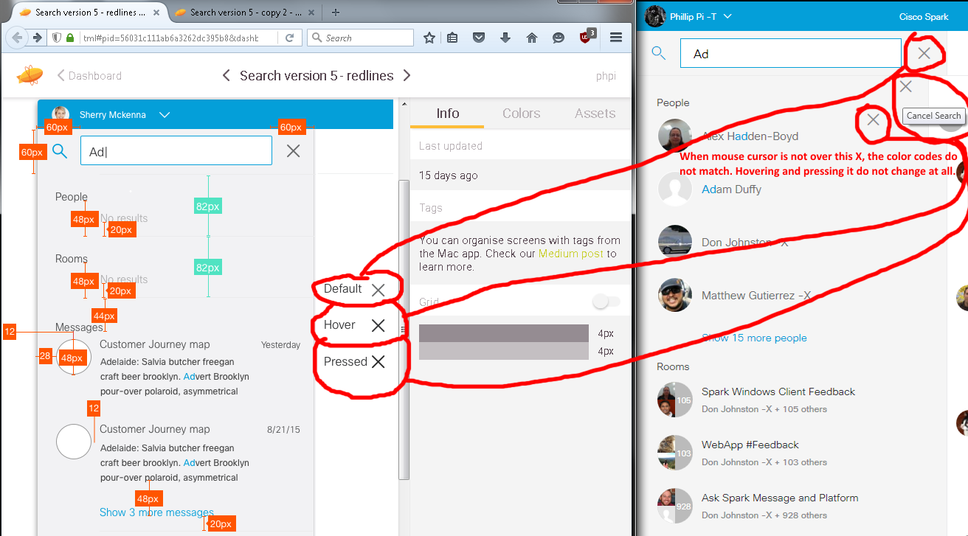

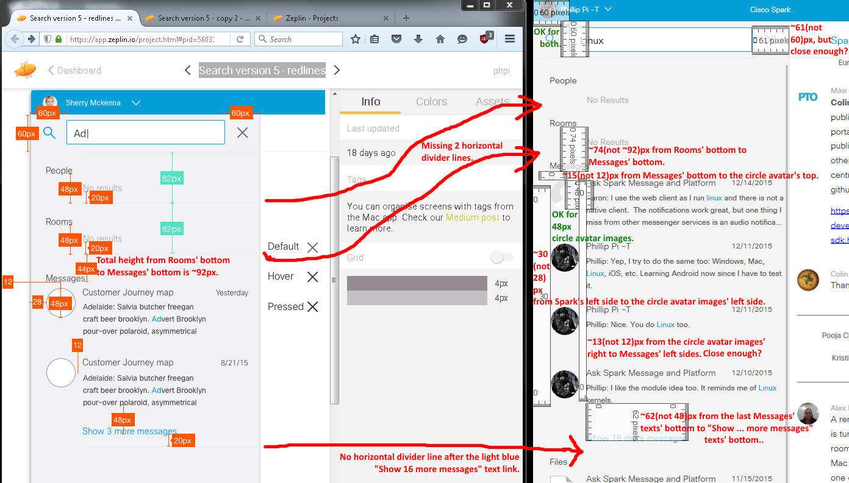

Image #1’s Issues:

1. Search’s “X” has the wrong gr(e/a)y colors and do not even change when hovered and pressed.
2. Incorrect/Wrong sizes.
3. Three missing horizontal divider lines.

**Image #2:**

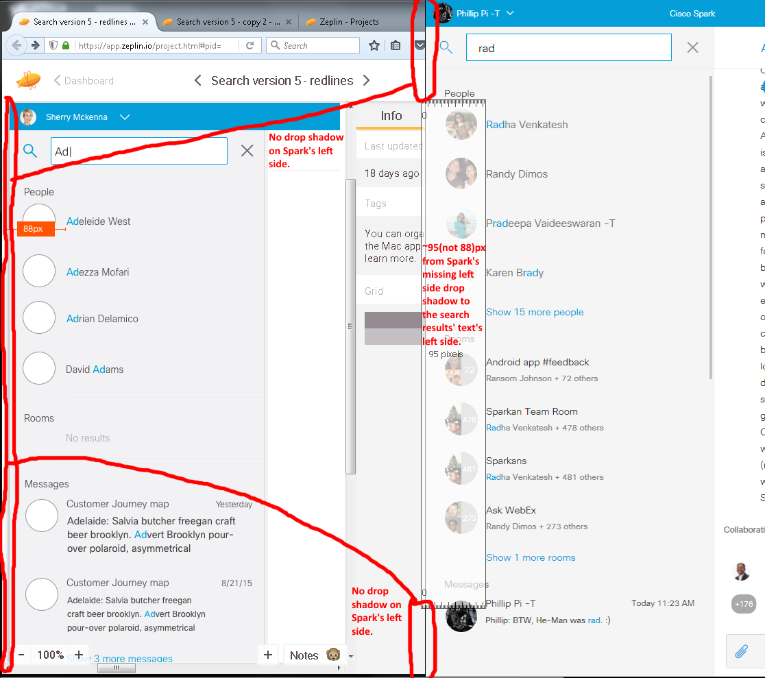Image #2’s Issues:

1. No drop shadow on Spark’s left side.

2. Not the correct distance from the left of estimated Spark’s left side’s missing drop shadow to the search results’ texts’ left side.

**Image #3:**

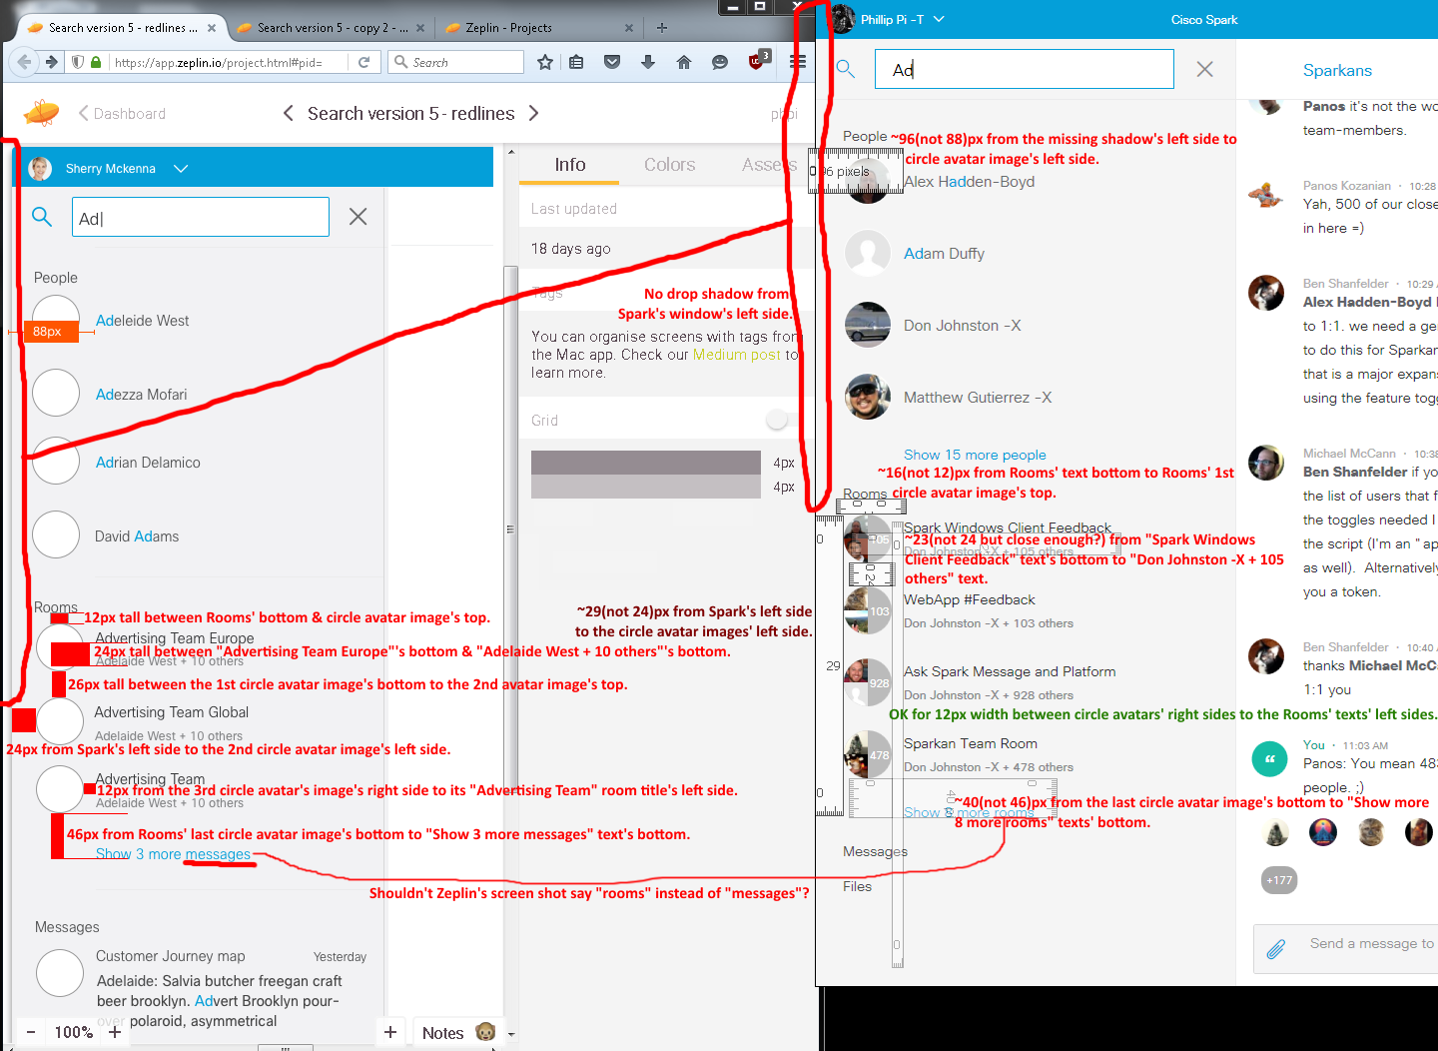

Image #3’s Issues:

1. No drop shadow on Spark’s left side.
2. Wrong/Incorrect sizes.

**Image #4:** There were no human’s redline mark ups. Since it looks the same as <https://app.zeplin.io/project.html#pid=56031c111ab6a3262dc395b8&sid=566077eaee0fadc42ae414f4> ’s “Search version 5 - copy 2”, please view/see my comparisons in “WindowsDesktopClientSearchQAuxIn64w7eeSP1 - Search version 5 - copy 2.docx” file for Zeplin’s redline markups from build 3155.