**Meeting Client’s WBX Spark interop (After Meeting Flow):**

**In 64-bit W7 EE SP1 with its IE11 web browser and logged In with my Cisco account on 6/24-25/2015 & 7/7/2015:**

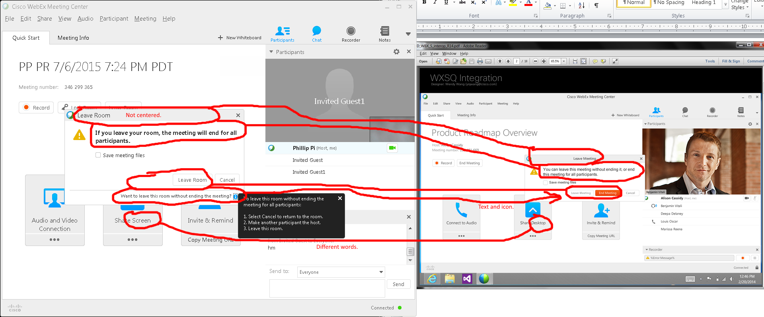

Issues:

1. “Leave Room” title justification.
2. Different texts for leaving the meeting room.
3. Orange “End Meeting” button option.
4. “Share …” texts.

End meeting (note: I never got its random survey):

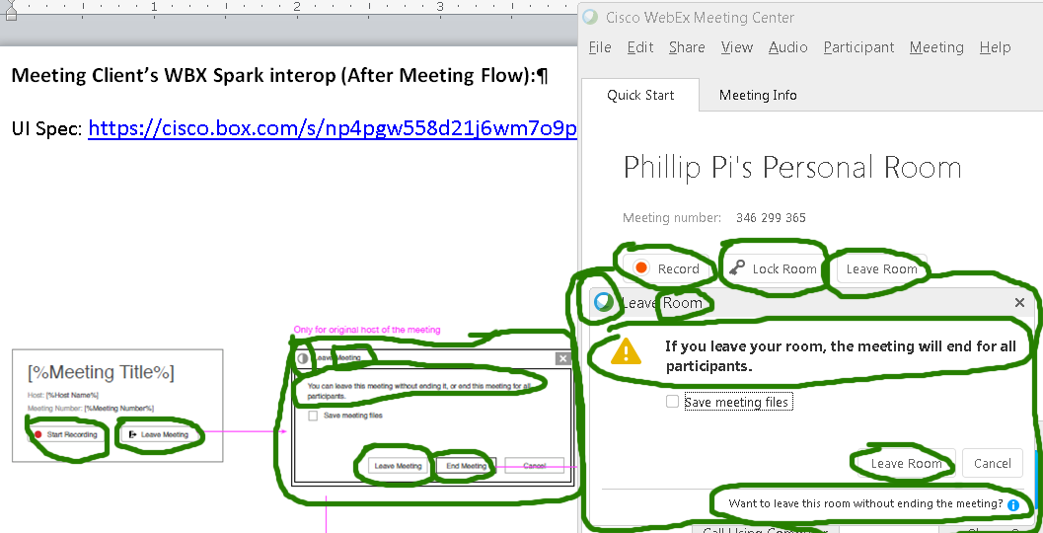

Issues:

1. Different dialog boxes, graphics (red record buttons, top left corner of the leave dialog boxes), and texts (Leave Meeting/Room, leaving warning message, record, etc.).
2. Missing graphics (yellow ! triangle and the red record) and texts (“Want to leave this room without ending the meeting?” with its blue i icon, “Lock Room” with its key logo, “Leaving Meeting” with its door arrow logo).
3. I never got its random survey.

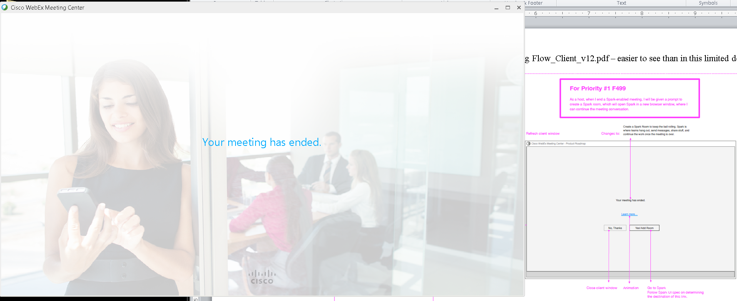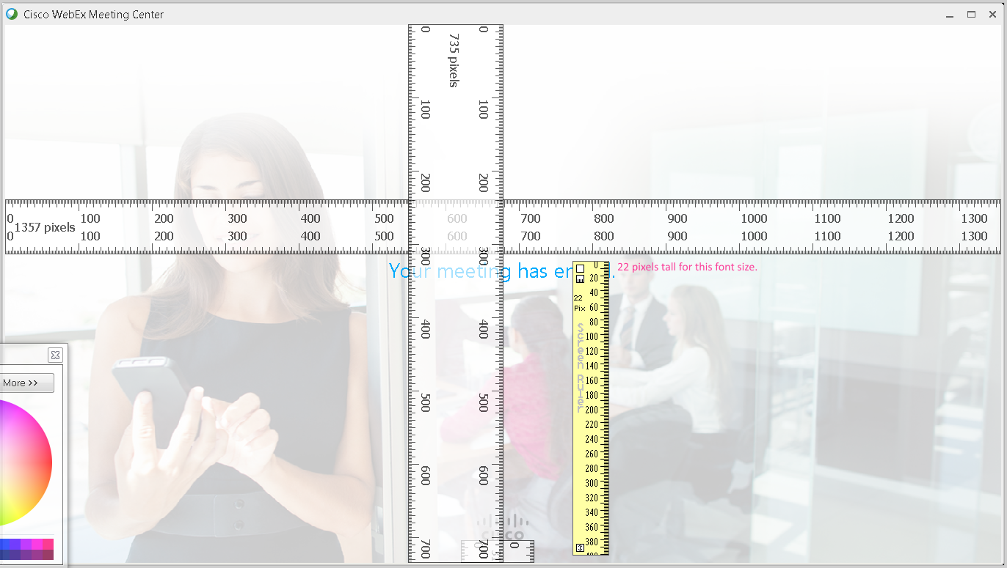

This “Your meeting has ended.” screen was up for about a second until the next screen below:

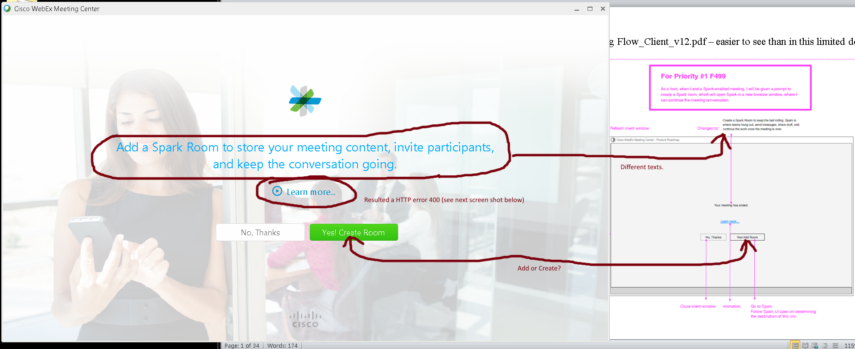

Clicking on “Learn more…” resulted a HTTP error 400 on 6/24/2015:

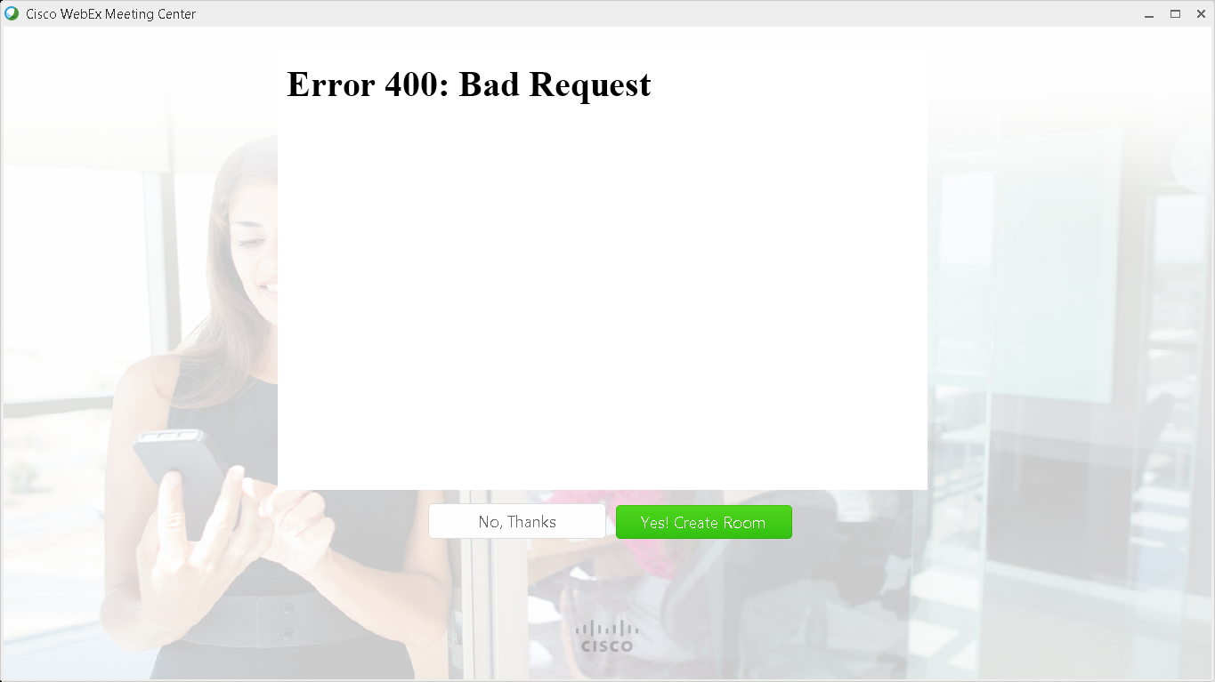

As of 6/25/2015 9 AM PDT hour, the error was gone and this Flash (using the same v18 b194 player) animation worked correctly:

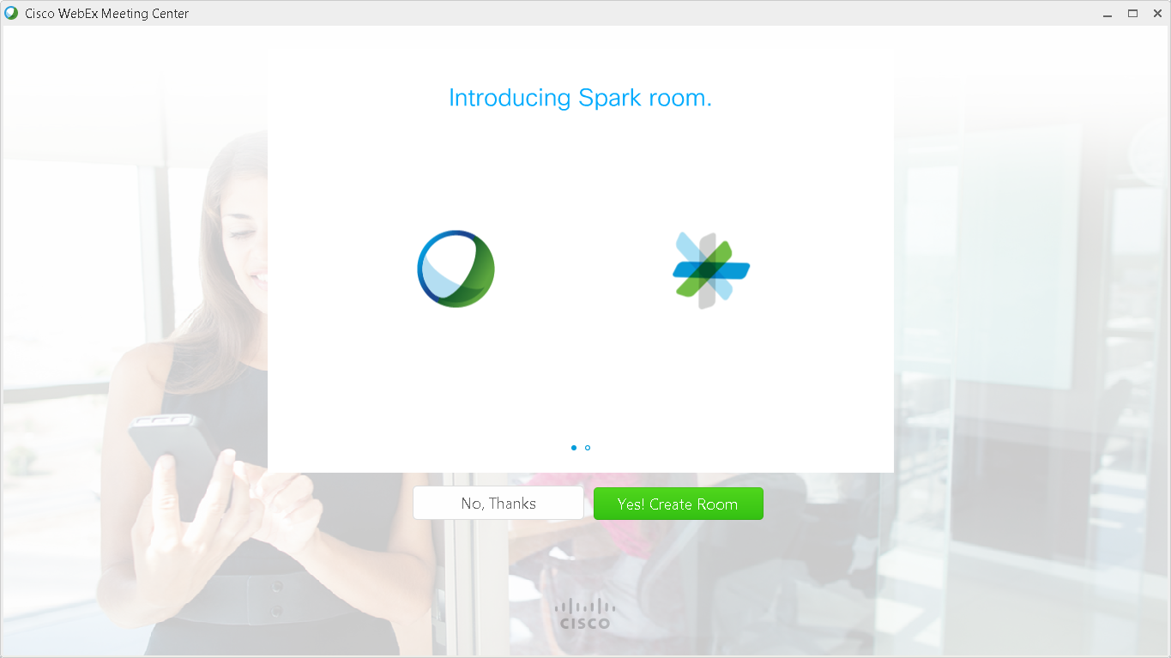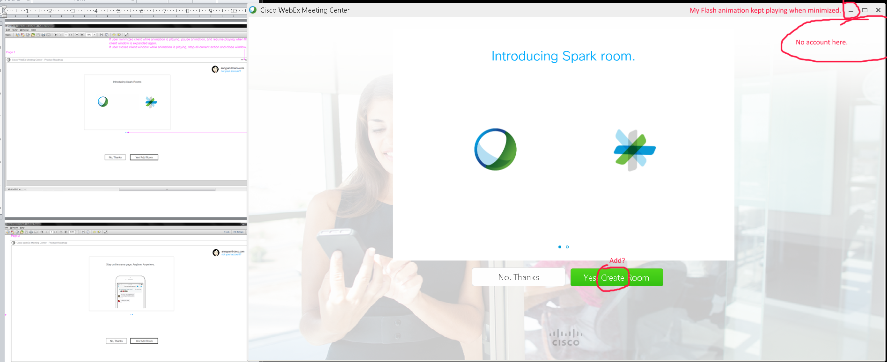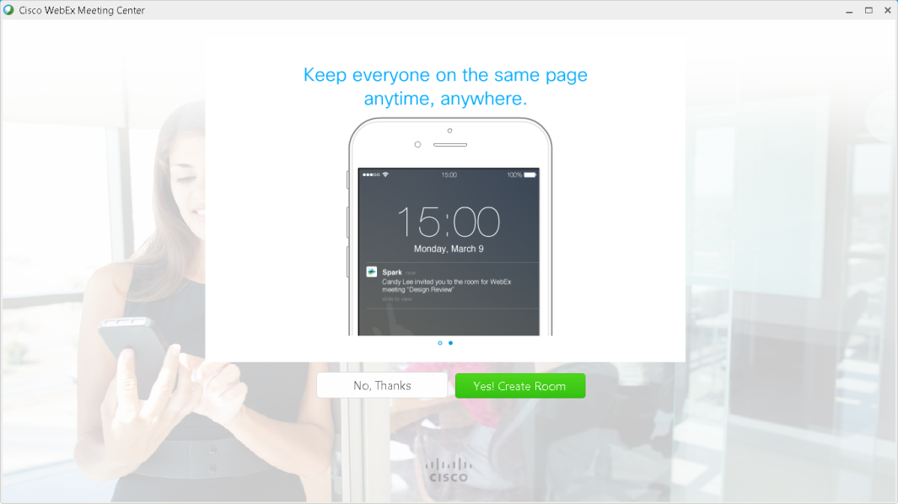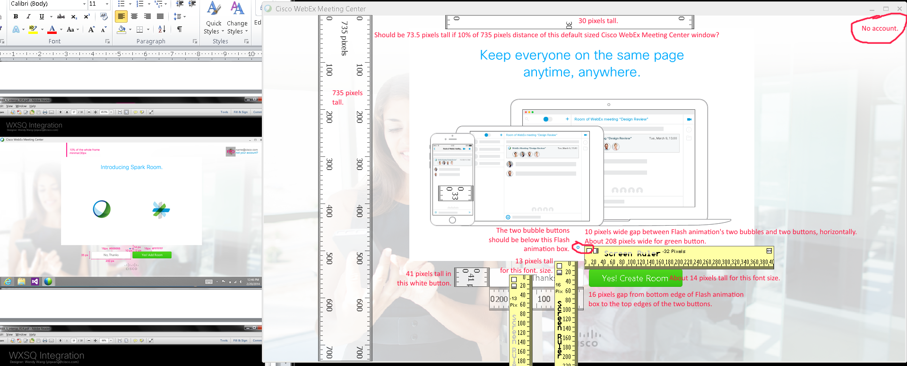

Issues:

1. Flash animation still plays when Cisco WebEx Meeting Center’s window is minimized.
2. Top right corner’s account area still does not show.
3. Different sizes seen with texts, gaps, and images.
4. Flash animation’s bubble buttons are not in the right area (should be below the Flash animation box?).
5. Alignment problems.

Clicking on “Yes! Create Room” button took me to Spark’s production server (already recognized my login from beta server):

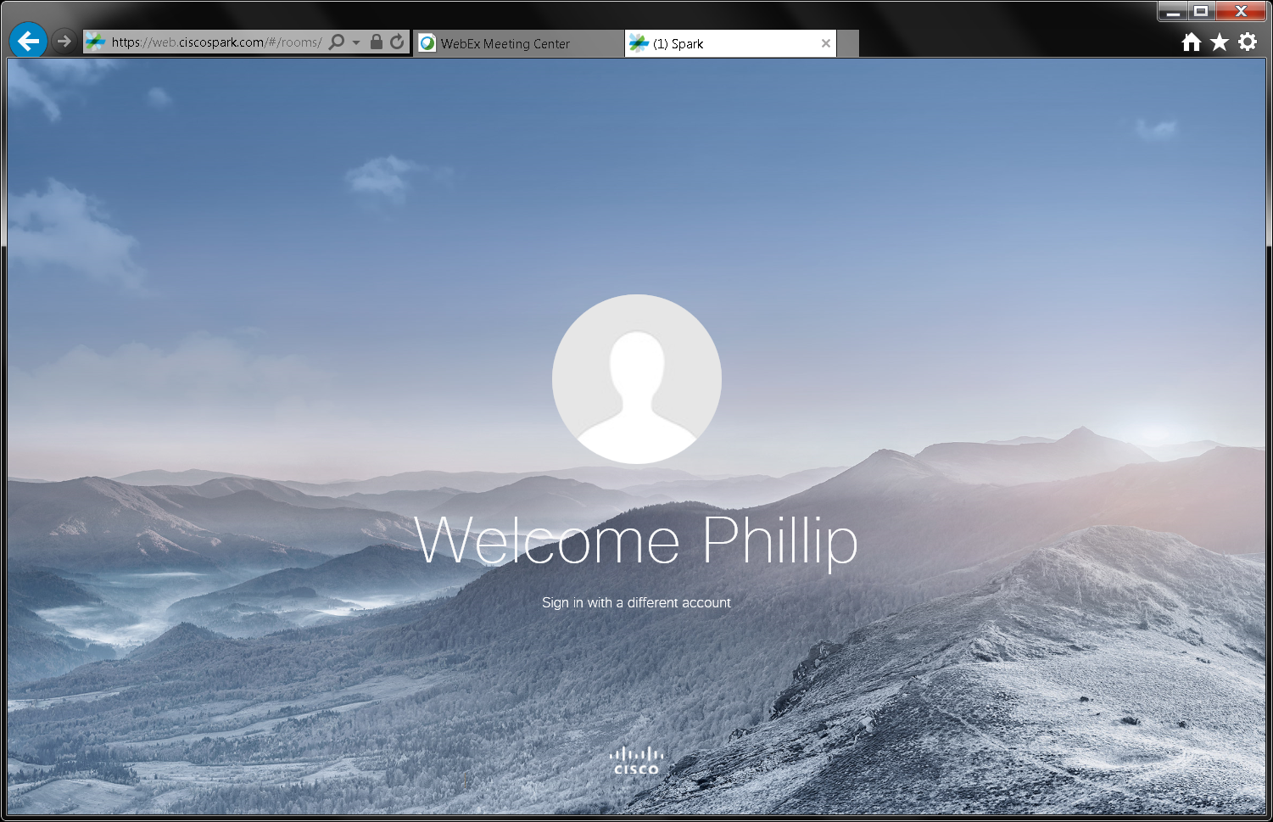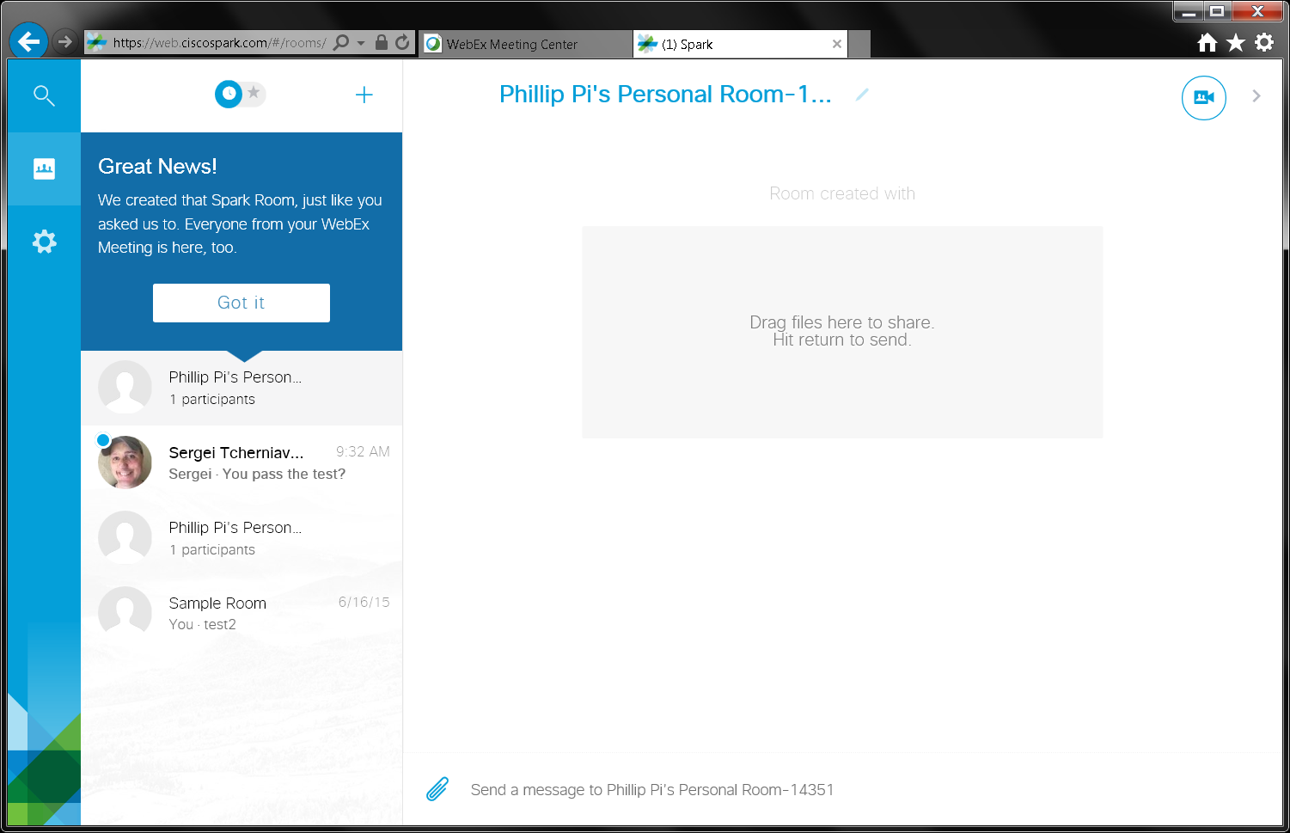

Issues:

1. Different texts.
2. Clicking on “Learn more…” link resulted a HTTP error 400 on 6/24/2015, but worked on the next day.
3. Unable to get a random survey to appear. I have never seen it before too since I started using gobeta.webex.com server on 6/17/2015.
4. Unable to figure how to create non-trusted users and hosts and using without logging in with an account.
5. Unable to recreate the error in failing to syncing participants as the only participant (host).

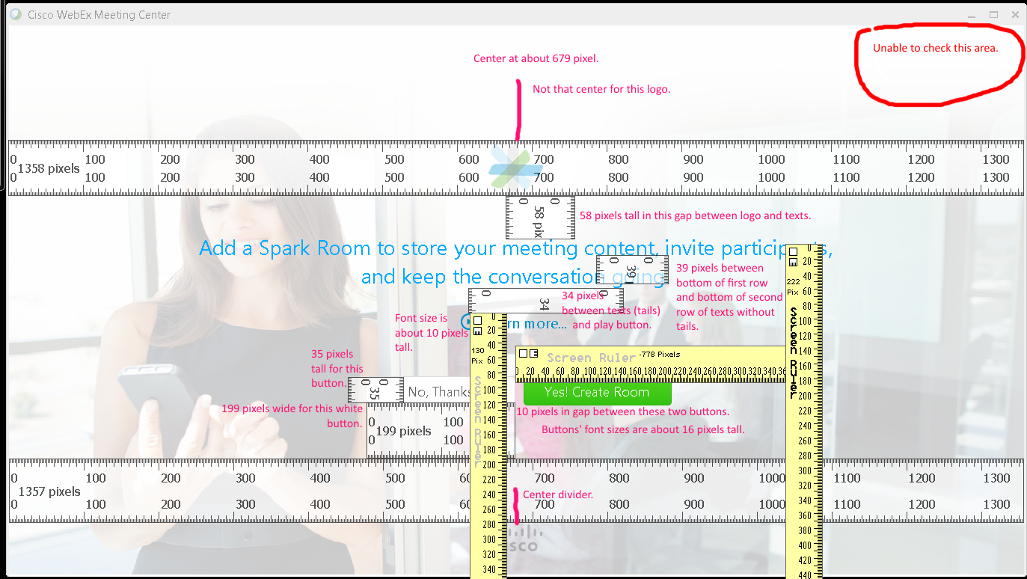

Issues:

1. Pixel lengths for texts, gaps, etc.
2. Spark’s logo isn’t totally center like Cisco’s logo.
3. I cannot seem to reproduce "We have added a Spark Room for your meeting." message from Cisco WebEx Meeting Center before going to Spark’s production server.

**OVERALL ISSUES:**

1. Pixel lengths/Different sizes for texts, gaps, images, etc.
2. Alignment problems (e.g., Spark’s logo isn’t totally center like Cisco’s logo and Flash animation’s bubble buttons are not in the right area (should be below the Flash animation box?).
3. I cannot seem to reproduce "We have added a Spark Room for your meeting." message from Cisco WebEx Meeting Center before going to Spark’s production server.

different texts.

1. Clicking on “Learn more…” link resulted a HTTP error 400 on 6/24/2015, but worked on the next day.
2. Unable to get a random survey to appear. I have never seen it before too since I started using gobeta.webex.com server on 6/17/2015.
3. Unable to figure how to create non-trusted users and hosts and using without logging in with an account.
4. Unable to recreate the error in failing to syncing participants as the only participant (host).
5. Flash animation still plays when Cisco WebEx Meeting Center’s window is minimized.
6. Top right corner’s account area does not show.
7. Unable to get the random survey.