**Web Pages – Audio Join Flow (no prototype and visual):**

<https://go.webex.com> in 64-bit W7 EE SP1 with Firefox v39 web browser and Cisco WebEx Meeting Center v30.0.2177 on 7/20/2015:

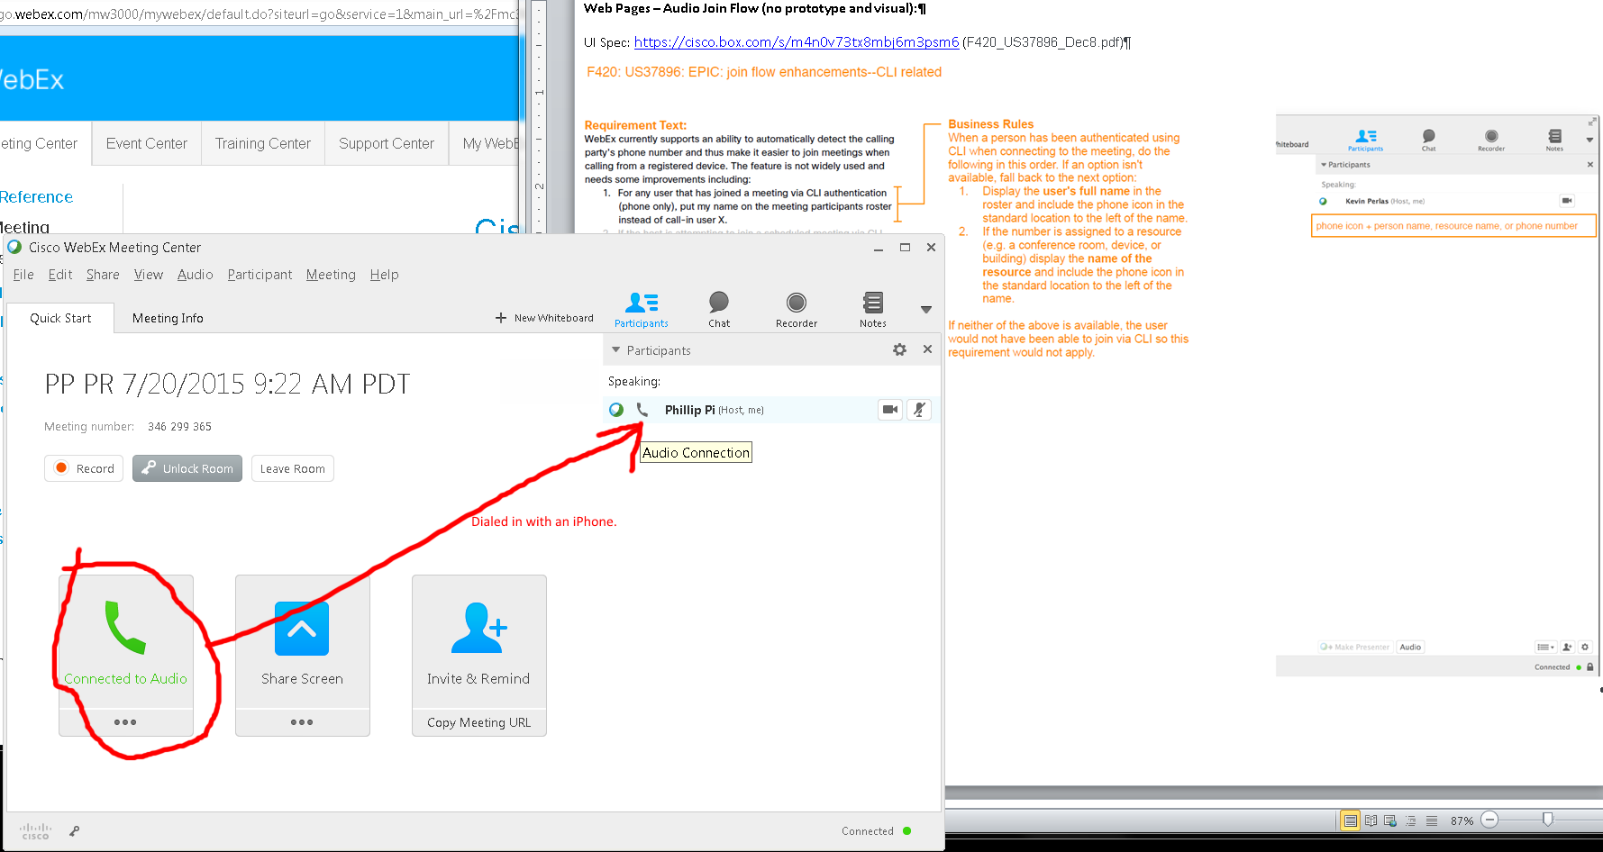

I assume this is correct when I dialed into my own meeting room with the provided phone number to call in from my iPhone.

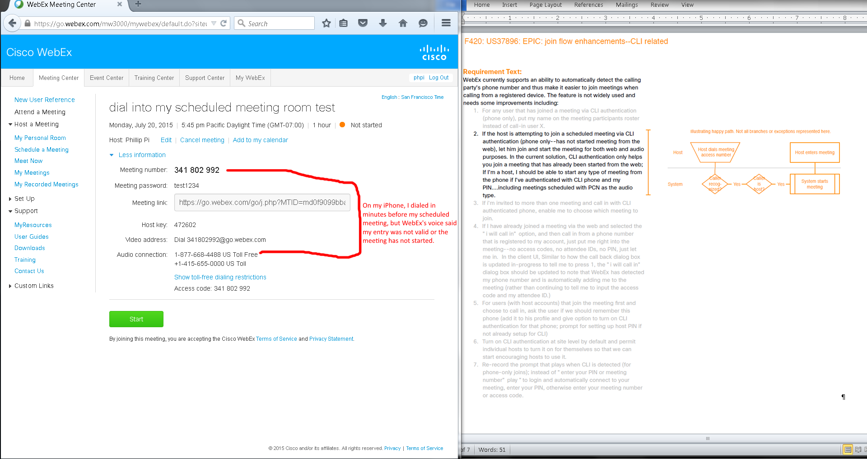

Issues: As a host, I was unable to get my scheduled meeting to start by joining into it by dialing from my iPhone. WebEx’s phone’s recording told me that my entry was invalid or my meeting has not started. I had to start my meeting manually from the web to launch Cisco WebEx Meeting Center software first before I could join in by phone.

3

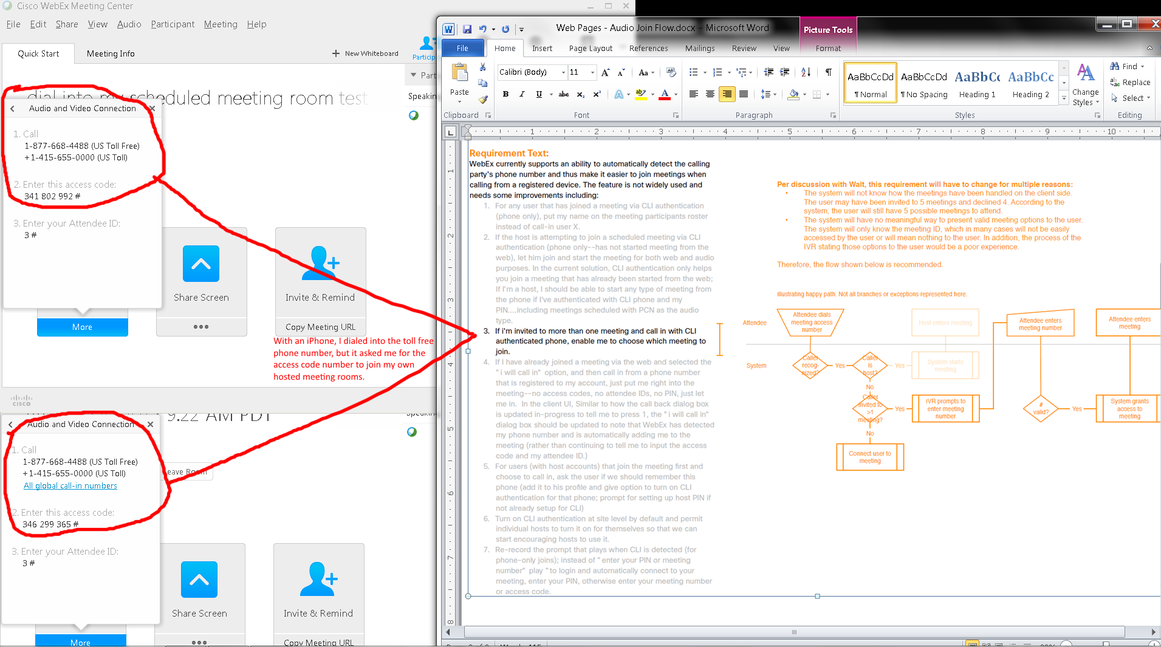

Issues: When I had two scheduled meetings started and launched with Cisco WebEx Meeting Centers, I dialed in the toll free phone number with my iPhone. It asked me to enter the access code for the specific meeting room.

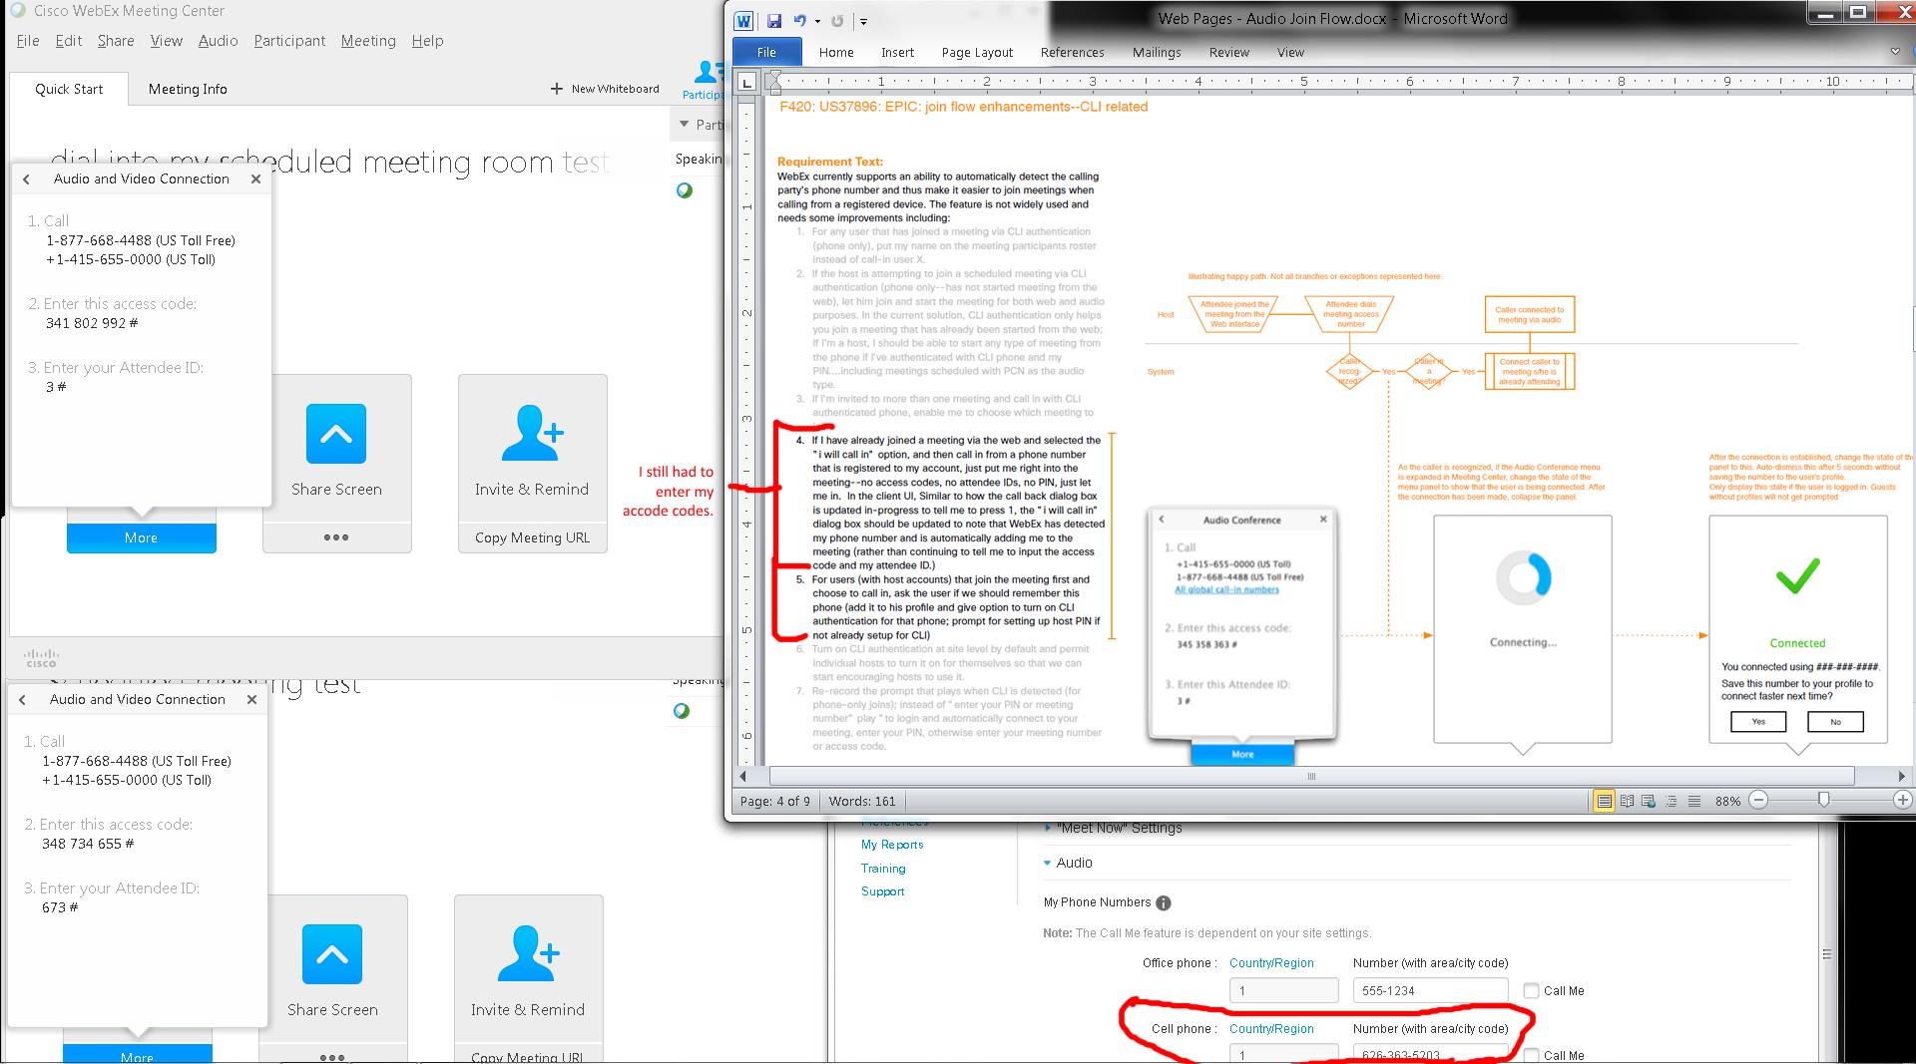

Issues: I still had to enter passcodes after adding my phone number to Preferences’ Audio’s Setup’s My Phone Numbers and dialing into the toll free phone number with my iPhone. I tried enabling “Call Me” and setting an audio PIN, but they made no differences.

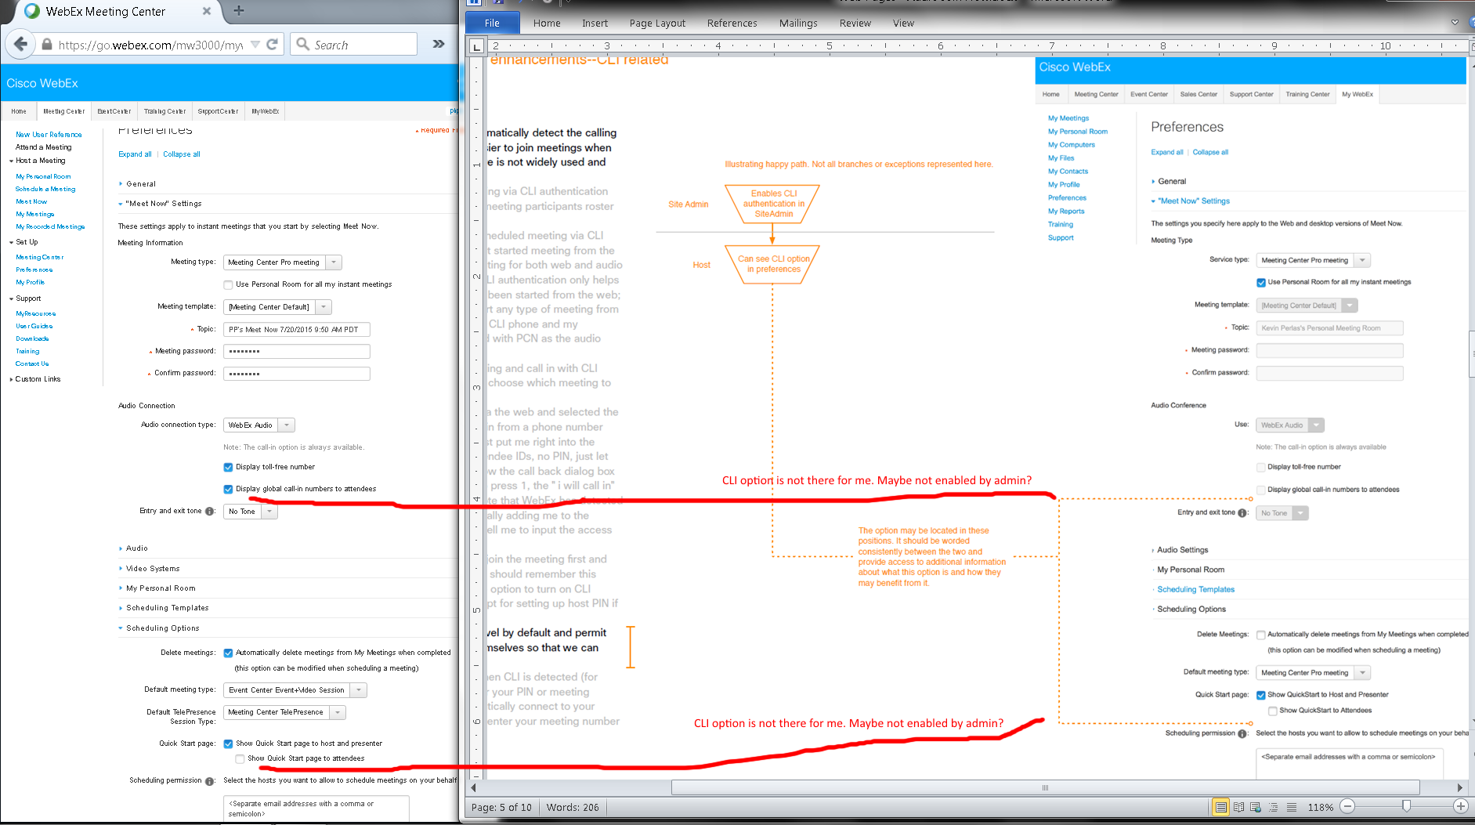

Issue: I don’t see any CLI options on my screen.

**OVERALL ISSUES:**

1. As a host, I was unable to get my scheduled meeting to start by joining into it by dialing from my iPhone. WebEx’s phone’s recording told me that my entry was invalid or my meeting has not started. I had to start my meeting manually from the web to launch Cisco WebEx Meeting Center software first before I could join in by phone.
2. When I had two scheduled meetings started and launched with Cisco WebEx Meeting Centers, I dialed in the toll free phone number with my iPhone. It asked me to enter the access code for the specific meeting room.
3. I still had to enter passcodes after adding my phone number to Preferences’ Audio’s Setup’s My Phone Numbers and dialing into the toll free phone number with my iPhone. I tried enabling “Call Me” and setting an audio PIN, but they made no differences.
4. I don’t see any CLI options on my screen.