**Web Pages - CI integration Flow (no prototype and visual):**

In 64-bit W7 EE SP1 (125% DPI (medium) and mostly no antialias) with its IE11 web browser on 7/21-22/2015:

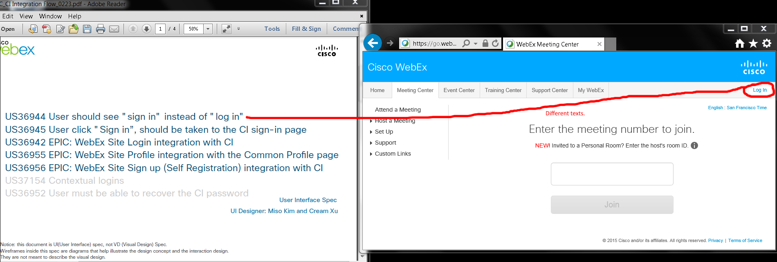

Issue: I saw “Log in” (lowercased “l”) link on <https://go.webex.com/mw3000/mywebex/default.do?siteurl=go> web page redirected from <http://go.webex.com> URL.

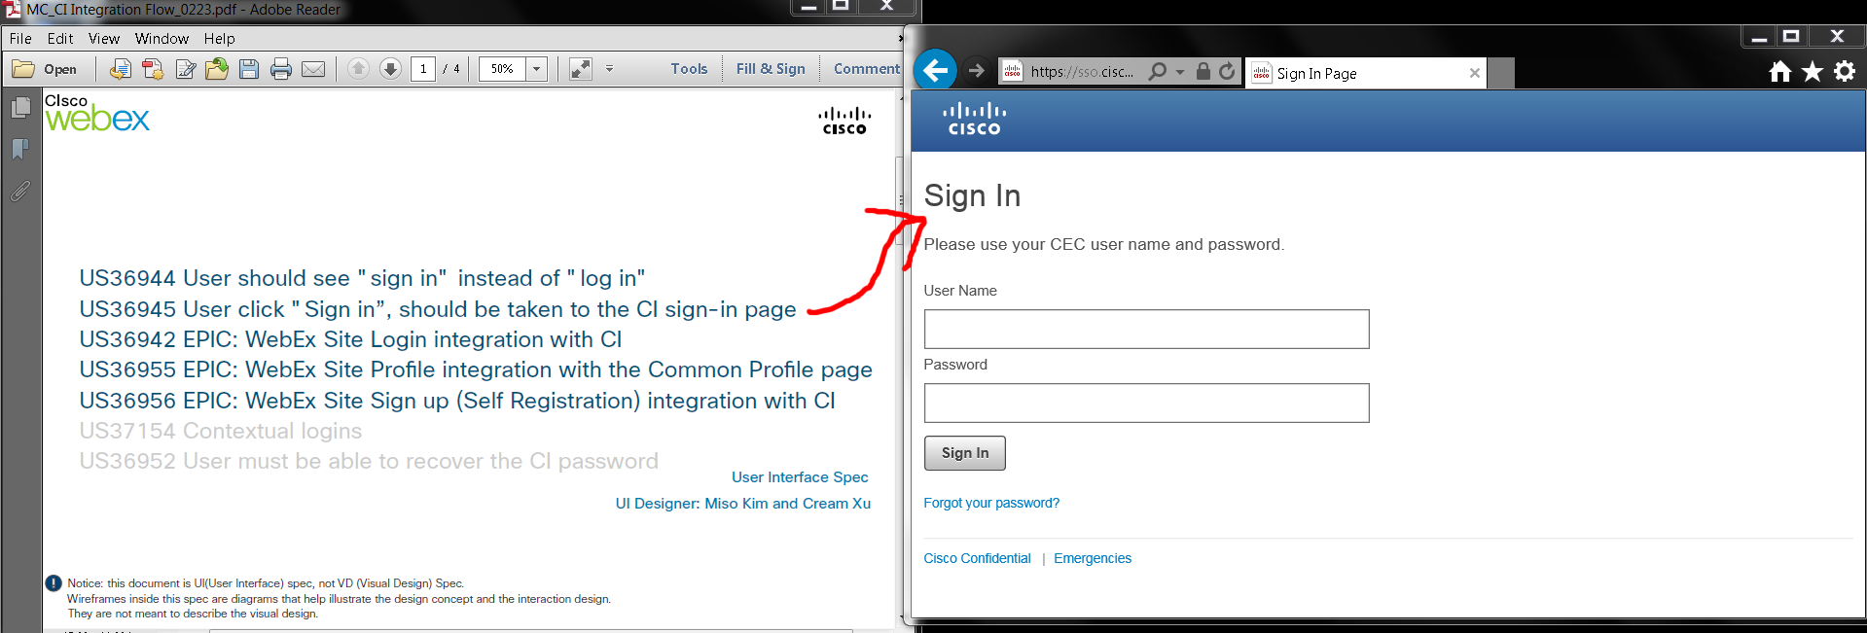

“Sign In” (capitalized “I”?) web page was at <https://sso.cisco.com/autho/forms/rCECLogin.html>.

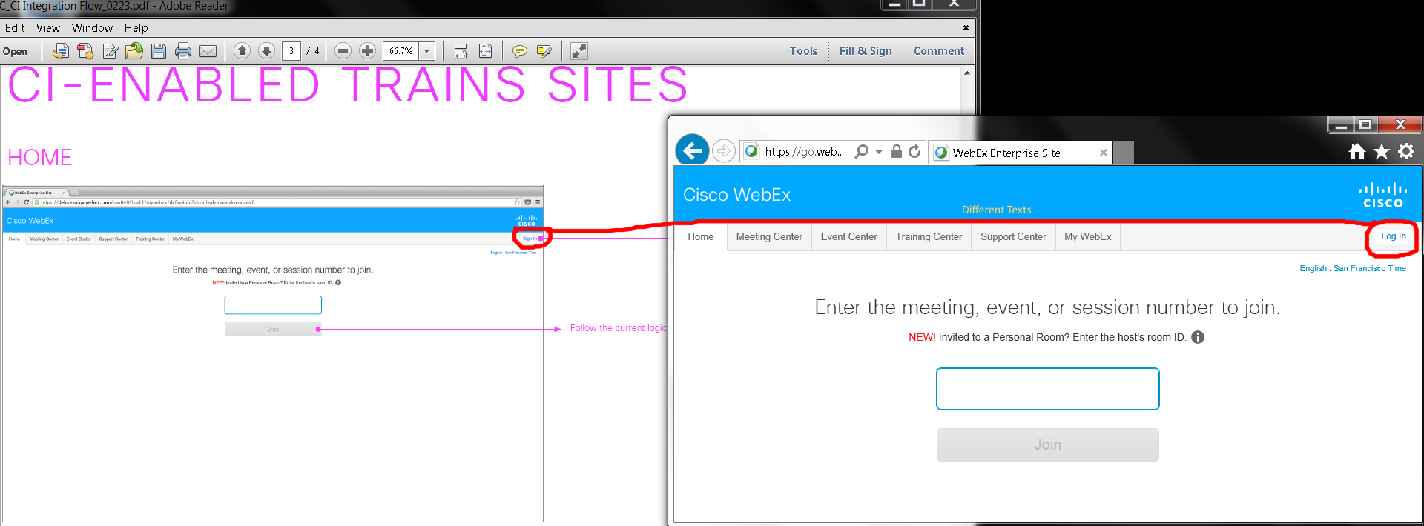

Issue: Home page’s “Sign in” and “Log In” buttons.

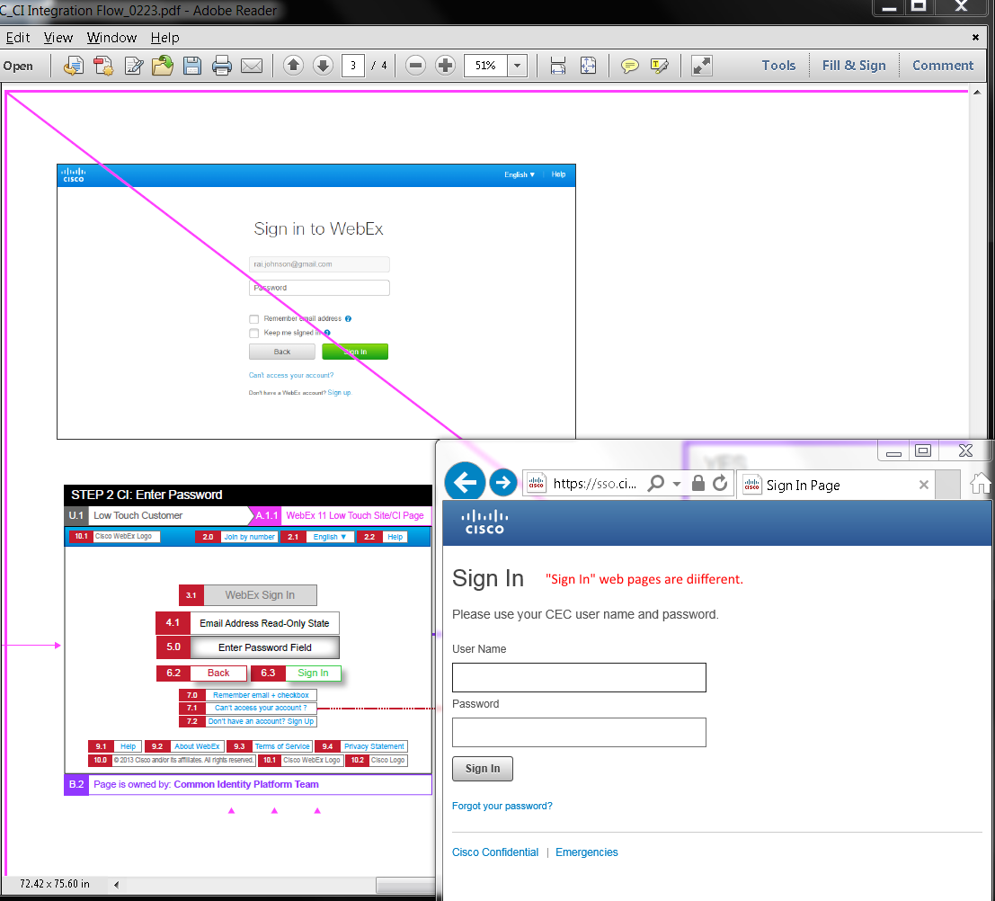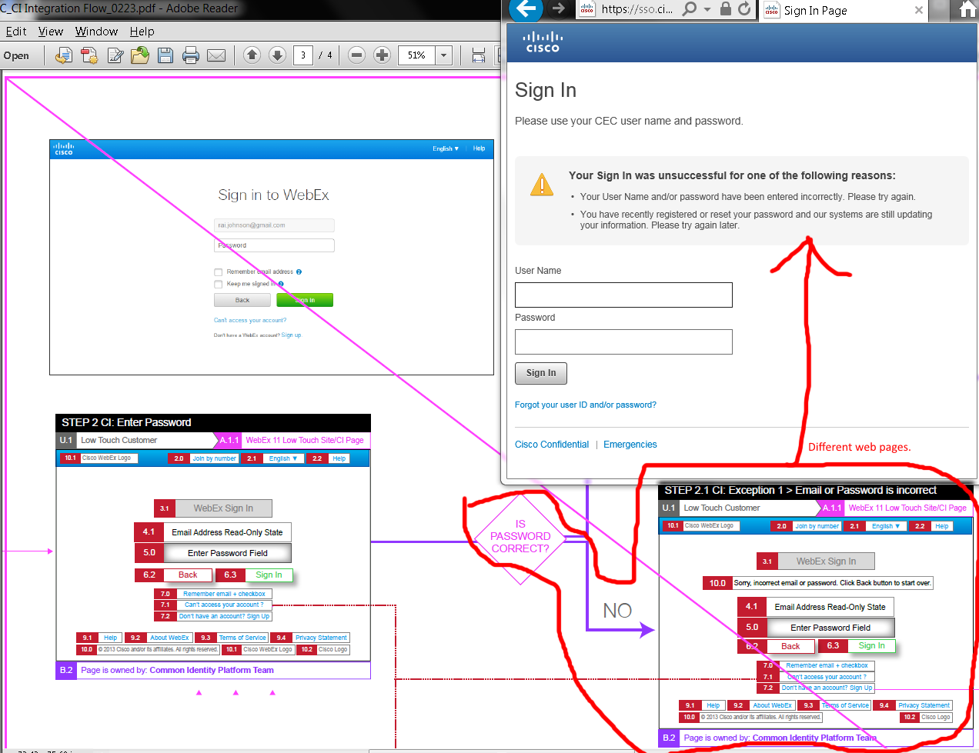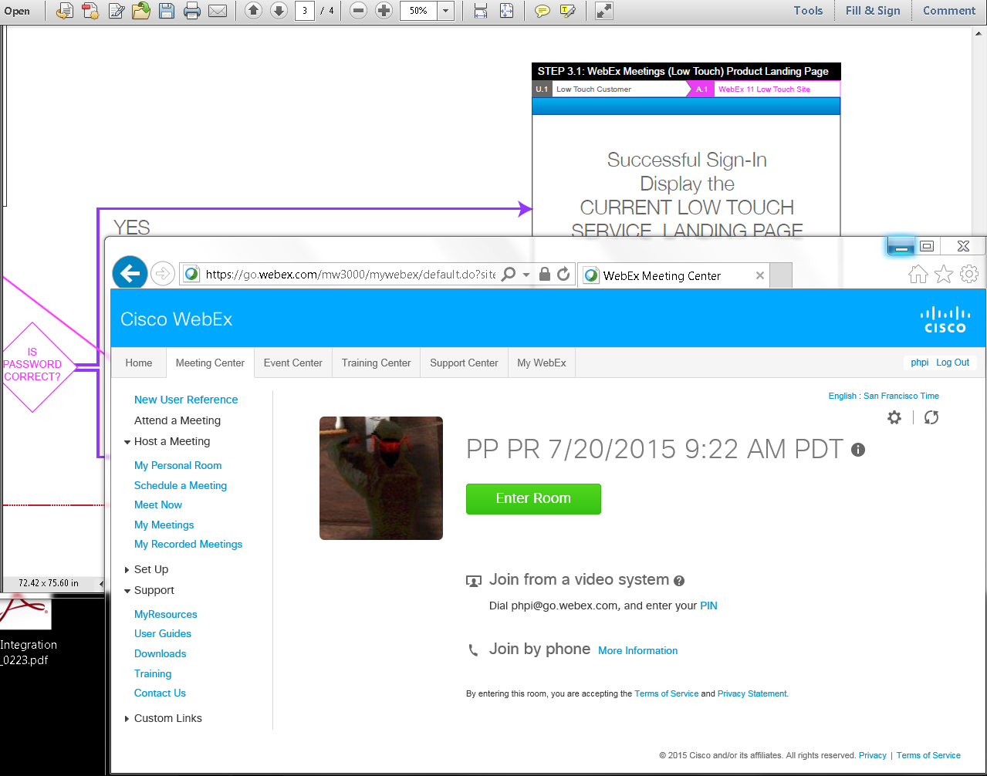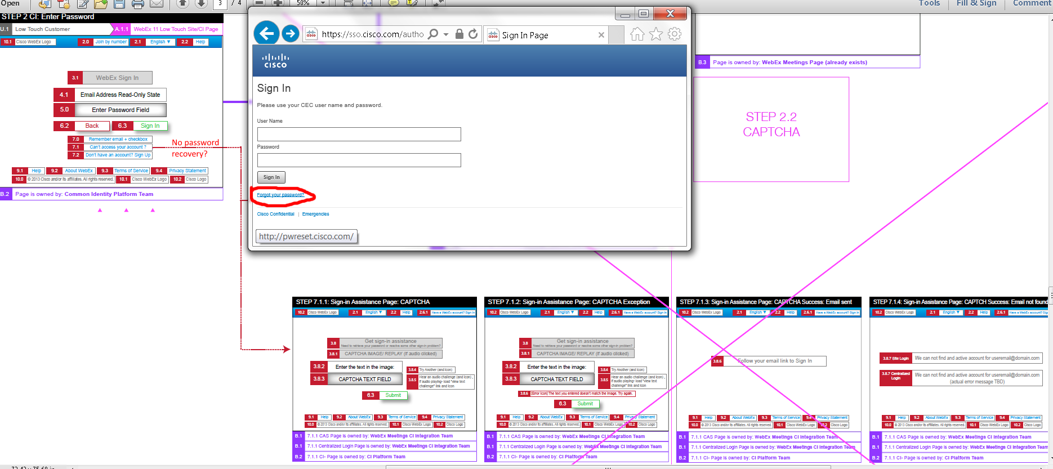

My “Forgot your password” link went to <http://pwreset.cisco.com/> to <https://pwreset.cisco.com/CISCO/psf.exe#2> web page:

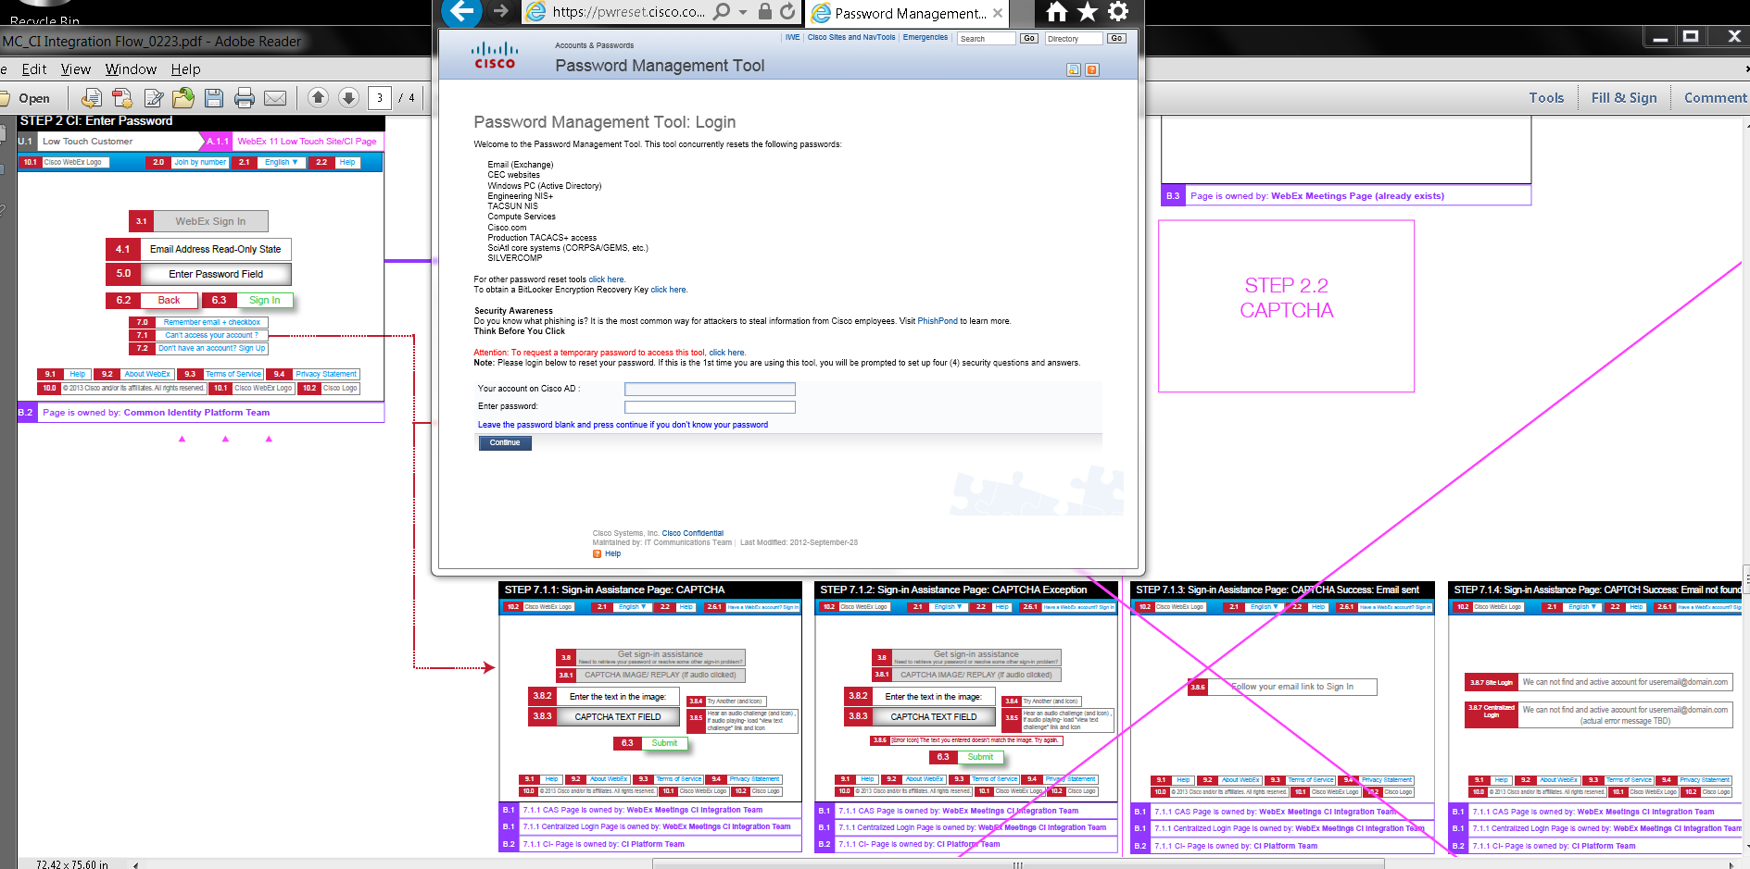

Issues: Results were different for password recovery.

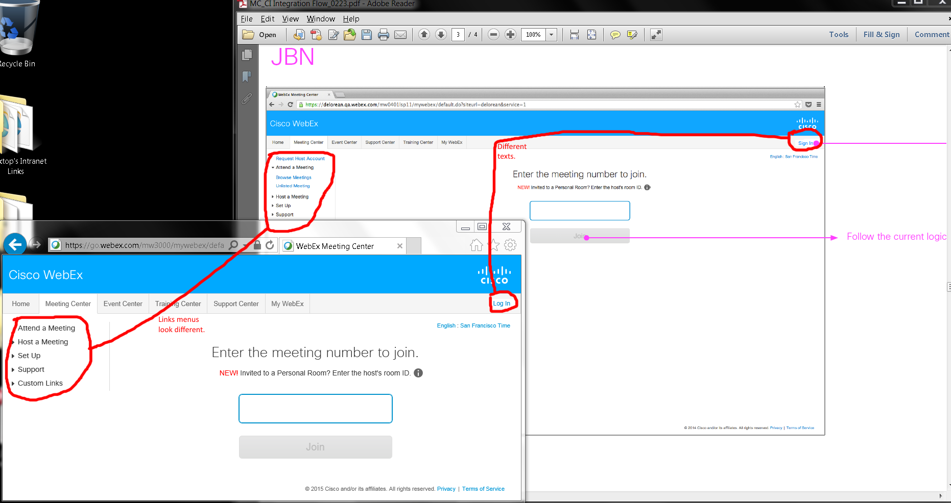

Issues:

1. Top right corners’ Sign/Log In links.
2. Log/Sign In links’ left menus are different.

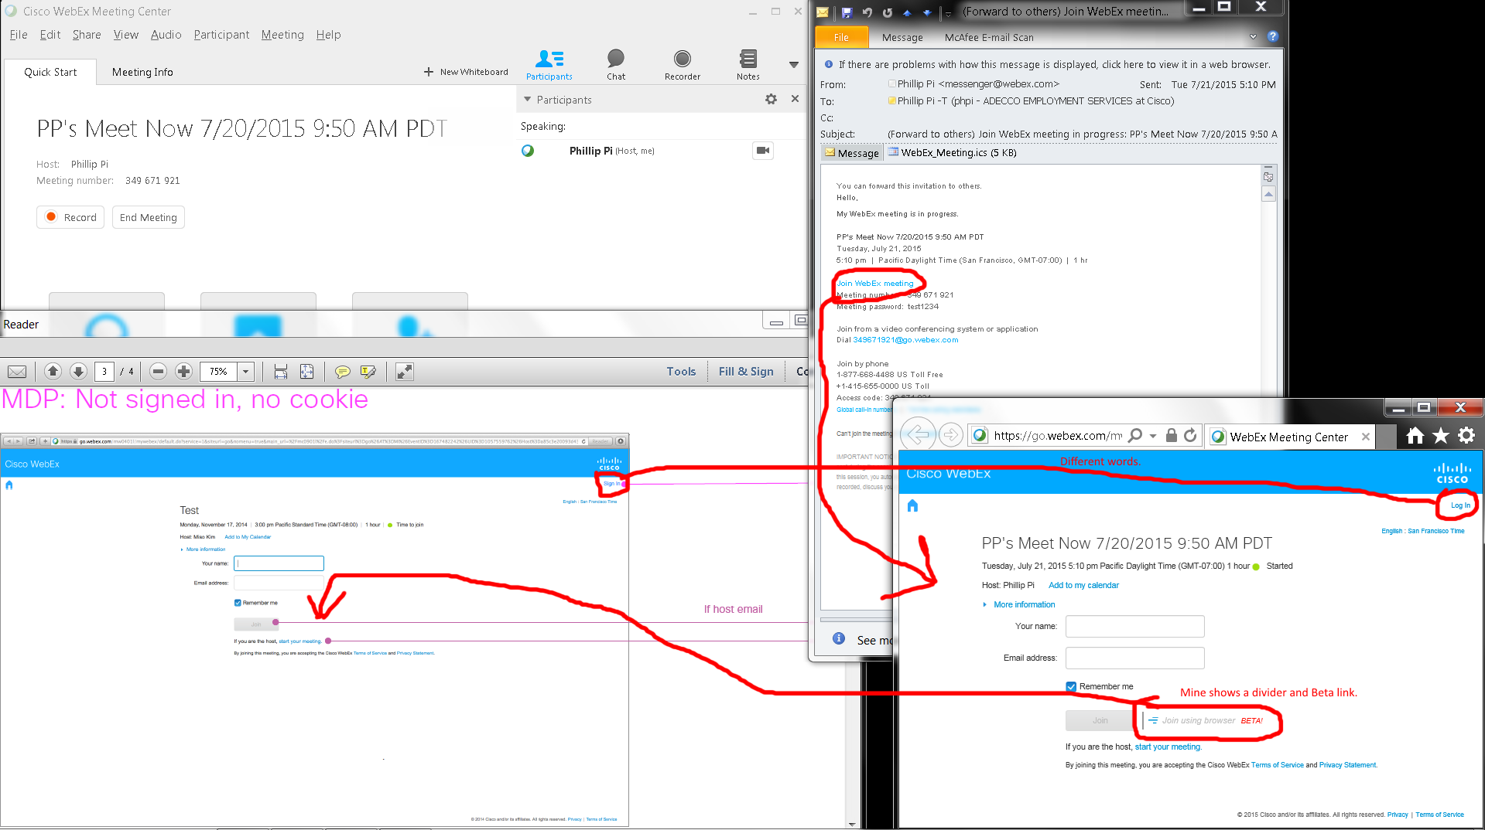

Issues:

1. Sign/Log In texts.
2. Mine shows “Join using browser *BETA!*” with its graphics and divider.

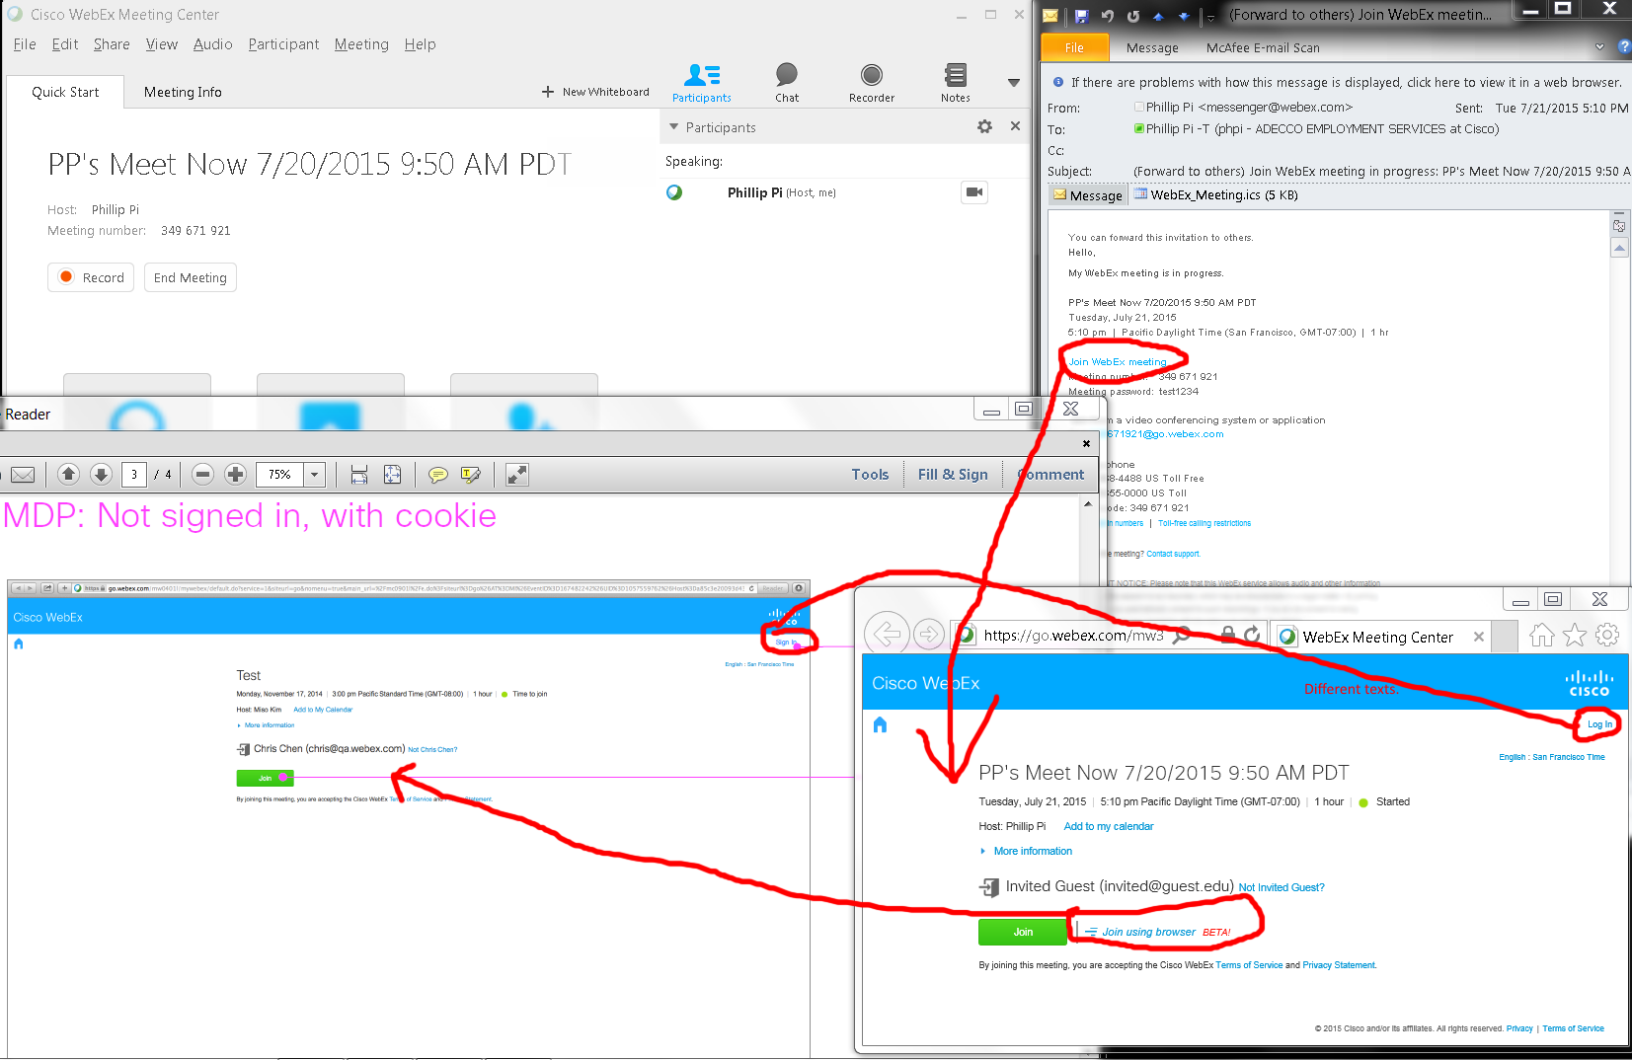

Issues:

1. Top right corner’s Sign/Log In links have different words.
2. Mine shows “Join using browser *BETA!*” with its graphics and divider.

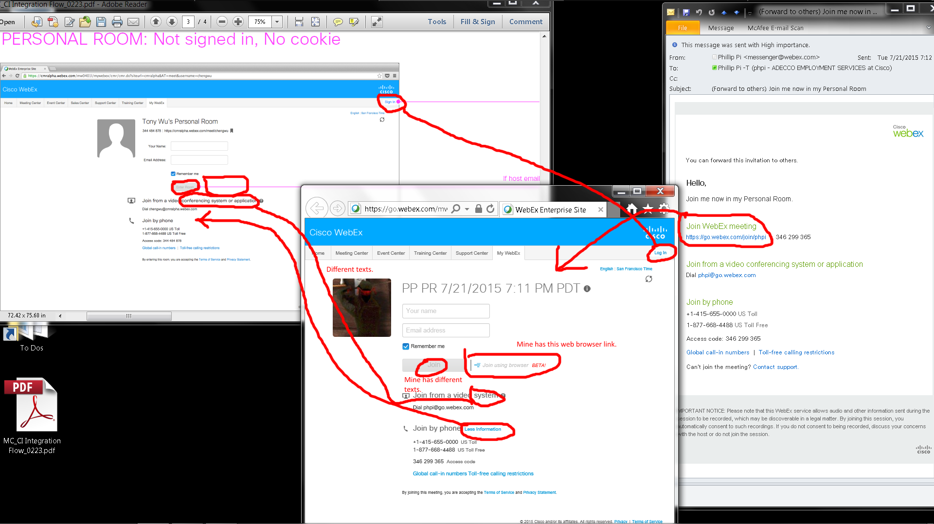

Issues:

1. Mine shows a “Join” gr(e/a)y button.
2. “Join by phone” information is expandable and collapsable on my screen.
3. Mine shows “Join using browser *BETA!*” with its graphics and divider.
4. “Join from a video…” texts are different.

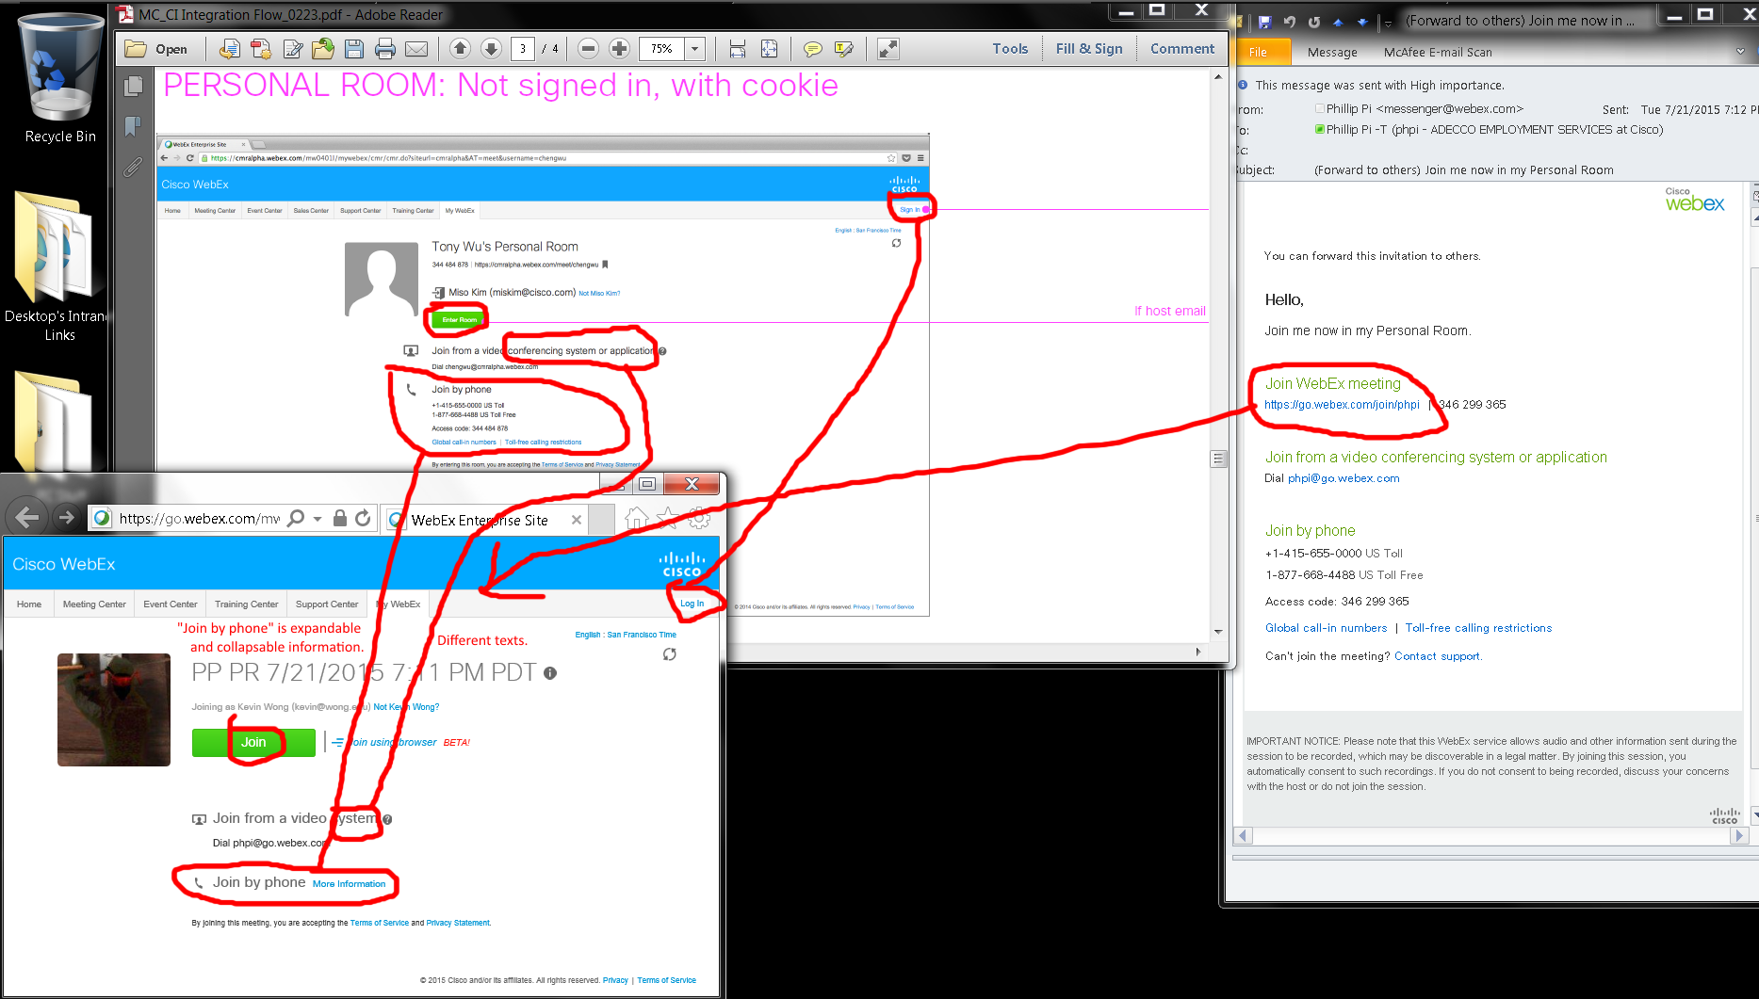

Issues:

1. Different texts in the green buttons.
2. “Join by phone” information is expandable and collapsable on my screen.
3. Mine shows “Join using browser *BETA!*” with its graphics and divider.
4. “Join from a video…” texts are different.

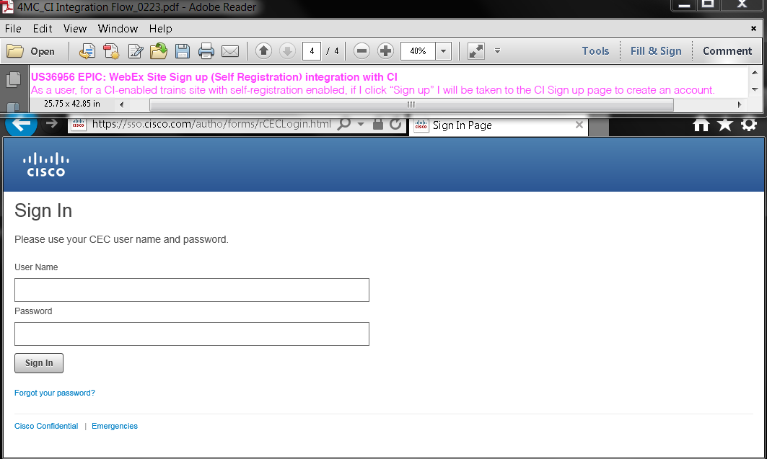

Issue: <http://go.webex.com>’s <https://sso.cisco.com/autho/forms/rCECLogin.html> does not have a sign up option. This web site uses my existing production Cisco Activedirectory account that is the same with other Cisco’s servers.

My Profiles:

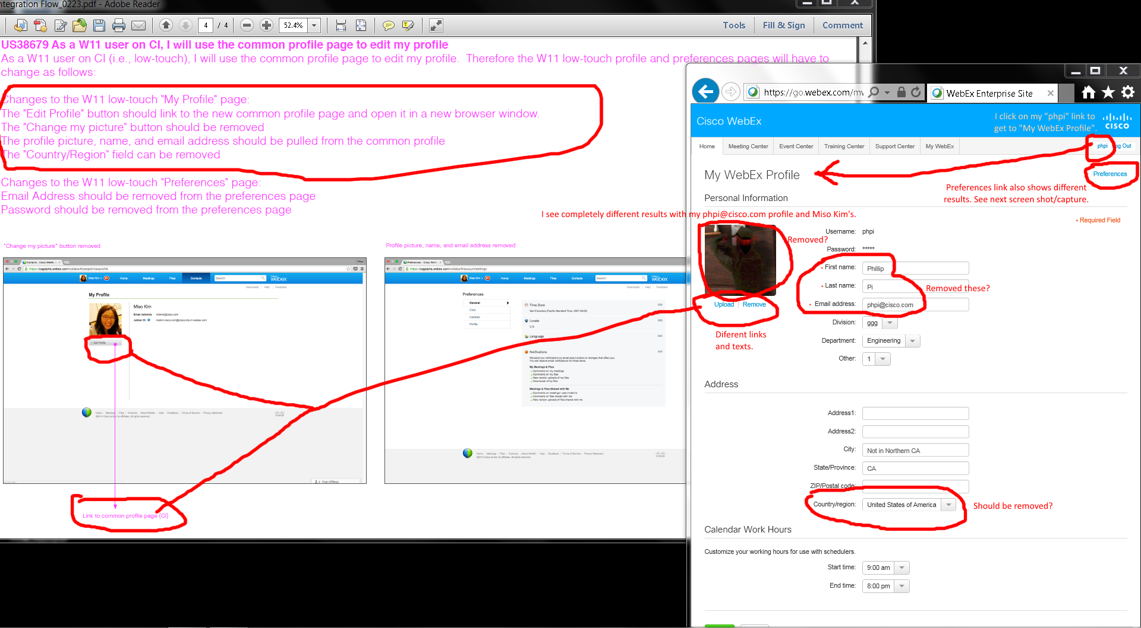

Preferences:

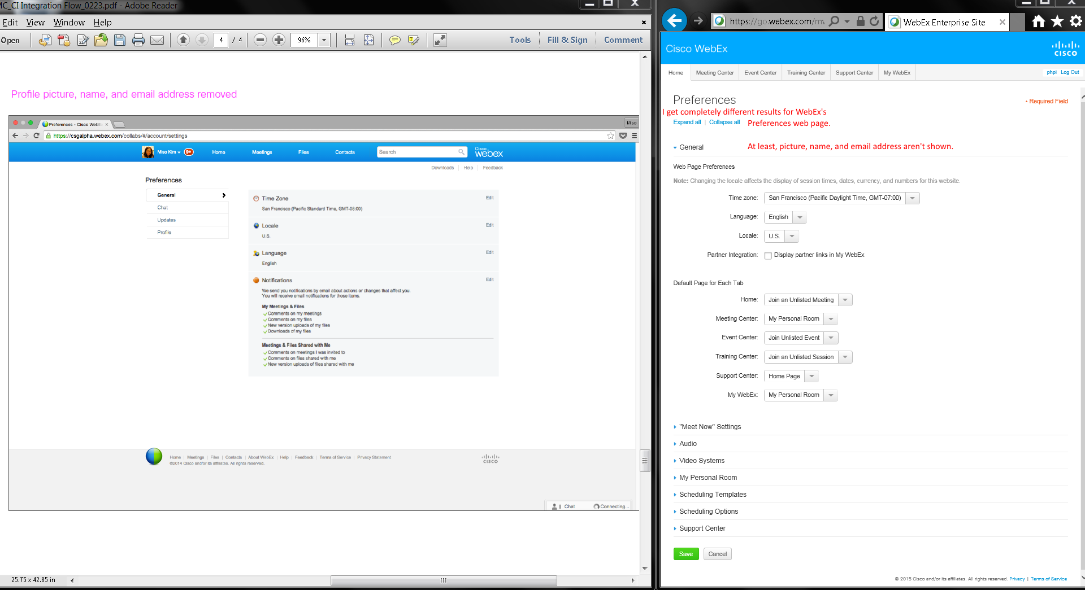

Issues:

1. Completely different web page design, layouts, results, texts, links, etc.
2. Many items remain and should be removed?
3. My “phpi” link goes to “My WebEx” profile.

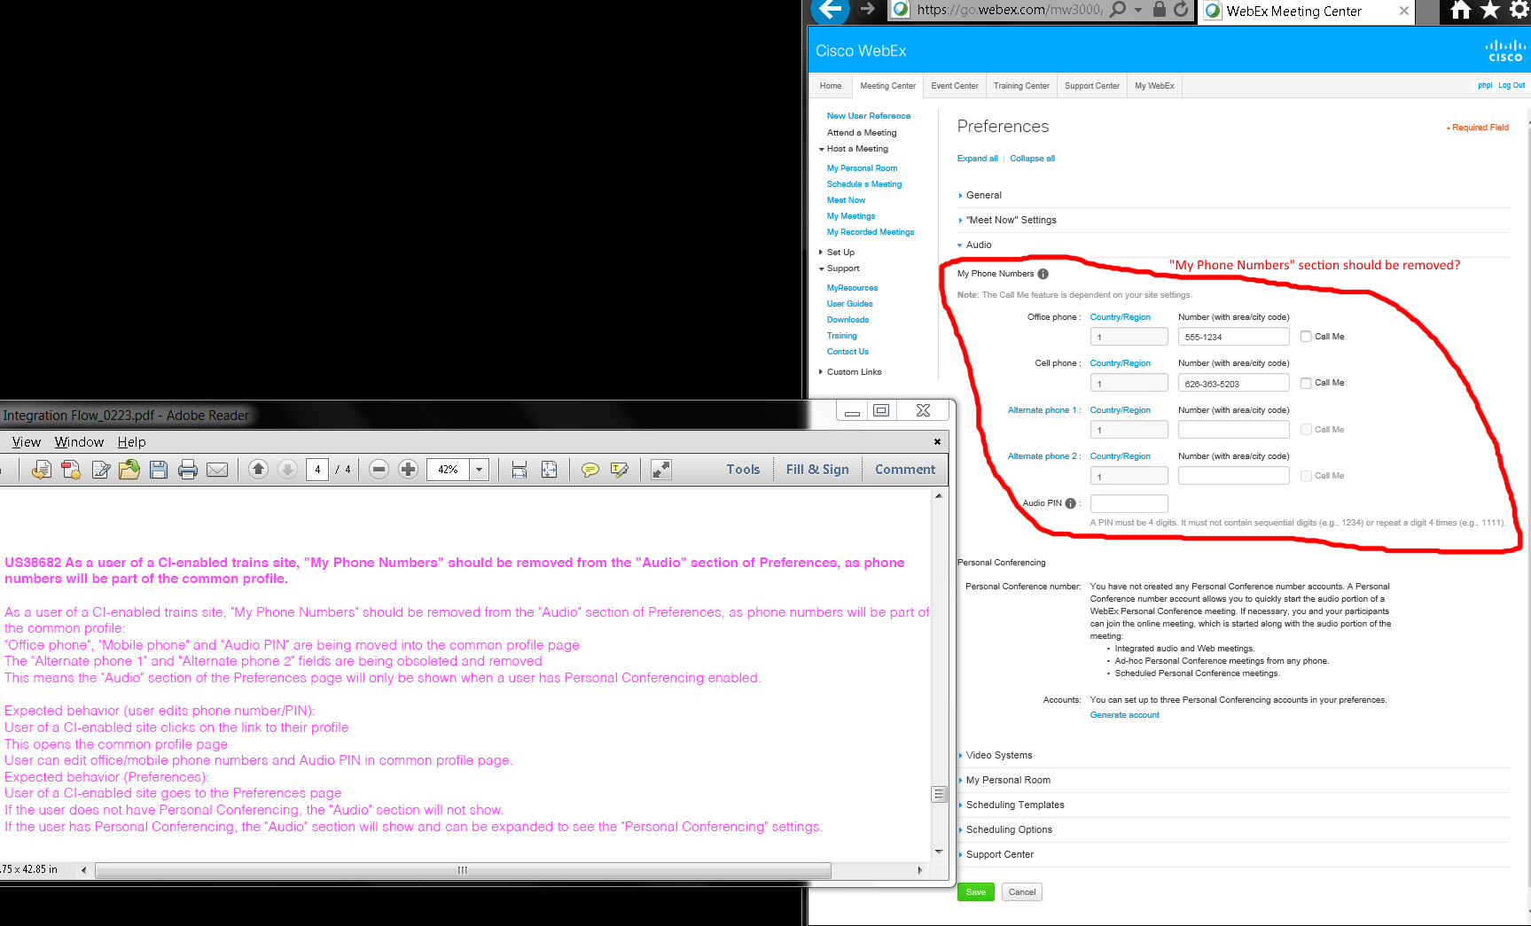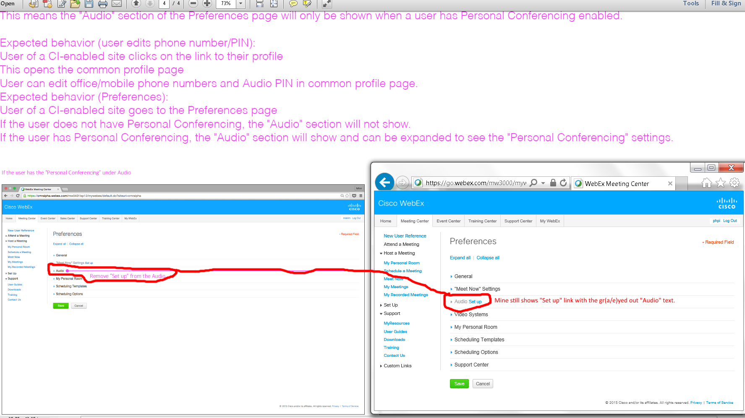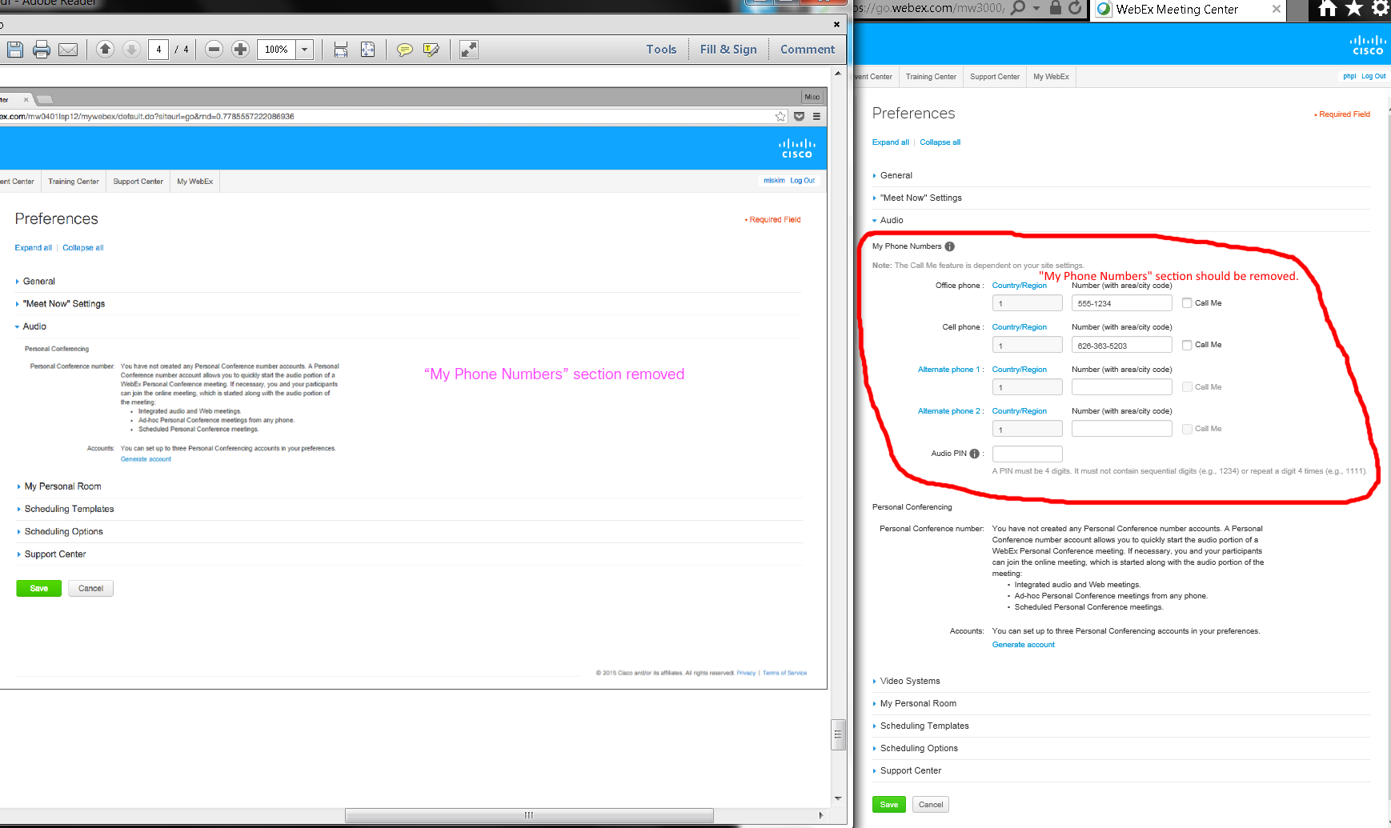

Issues:

1. Mine shows a gr(e/a)yed out “Audio” with its linked blue “Set up” link.
2. Audio’s phone number section should be removed?
3. I was unable to test without "Personal Conferencing" for Preferences' Audio settings.

OVERALL ISSUES:

1. I saw “Log in” (lowercased “l”) link on https://go.webex.com/mw3000/mywebex/default.do?siteurl=go web page redirected from http://go.webex.com URL.
2. Home page’s “Sign in” and “Log In” buttons.
3. Results were different for password recovery.
4. Top right corners’ Sign/Log In links.
5. Log/Sign In links’ left menus are different.
6. Mine shows “Join using browser BETA!” with its graphics and divider.
7. Mine shows a “Join” gr(e/a)y button.
8. “Join by phone” information is expandable and collapsable on my screen.
9. “Join from a video…” texts are different.
10. Different texts in the green buttons.
11. http://go.webex.com’s https://sso.cisco.com/autho/forms/rCECLogin.html does not have a sign up option. This web site uses my existing production Cisco Activedirectory account that is the same with other Cisco’s servers.
12. Completely different web page design, layouts, results, texts, links, etc.
13. Many items remain and should be removed?
14. My “phpi” link goes to “My WebEx” profile.
15. Mine shows a gr(e/a)yed out “Audio” with its linked blue “Set up” link.
16. Audio’s phone number section should be removed?
17. I was unable to test without "Personal Conferencing" for Preferences' Audio settings.