**Web Pages – Disclaimer (no prototype):**

In 64-bit W7 EE SP1 (no antialias/ClearType) with Firefox v39 web browser:

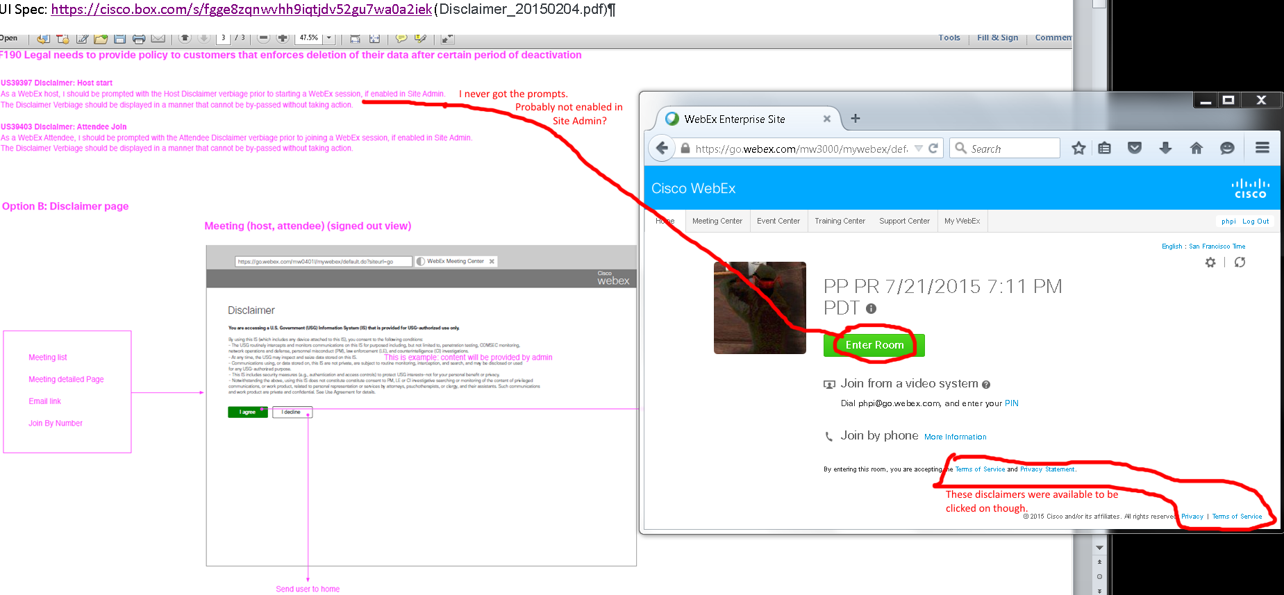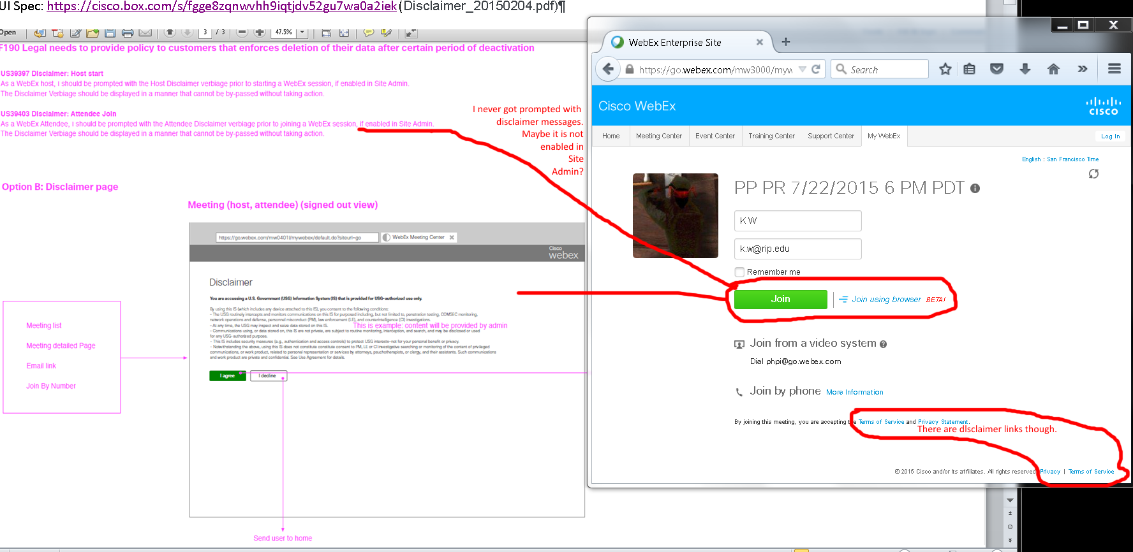

Issues: I never get the disclaimer prompts. It is probably disabled by site admin which I don’t have access to. It doesn't matter if I was signed in (phpi@cisco.com) or out.

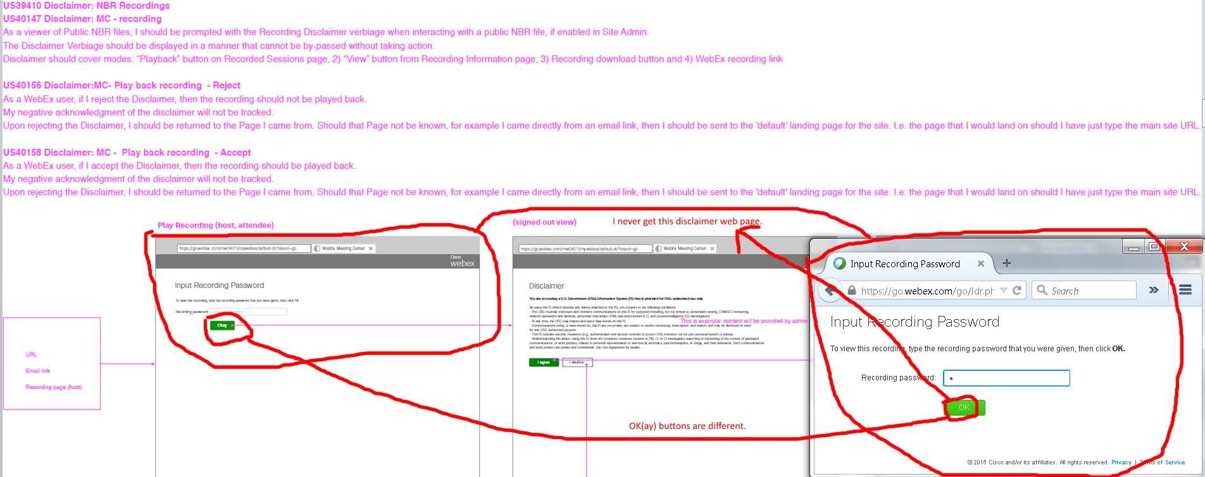

Issues:

1. I never see the Disclaimer web pages with my streaming and download recorded meetings’ URLs. I assume site admin didn’t enable the disclaimer feature which I don’t have access to. It didn’t matter if I was signed in (phpi@cisco.com) or out.
2. Green buttons have different green colors and texts.
3. Unable to check disclaimers template to compare.

OVERALL ISSUES:

1. I never get the disclaimer prompts. It is probably disabled by site admin which I don’t have access to. It doesn't matter if I was signed in (phpi@cisco.com) or out.
2. Green buttons have different green colors and texts.
3. Unable to check disclaimers template to compare.