**Web Page’ Personal Room auto lock (no prototype):**

<https://gobeta.webex.com> in 64-bit W7 EE SP1 with Firefox v38.0.5 web browser from June 29th to July 1st, 2015:

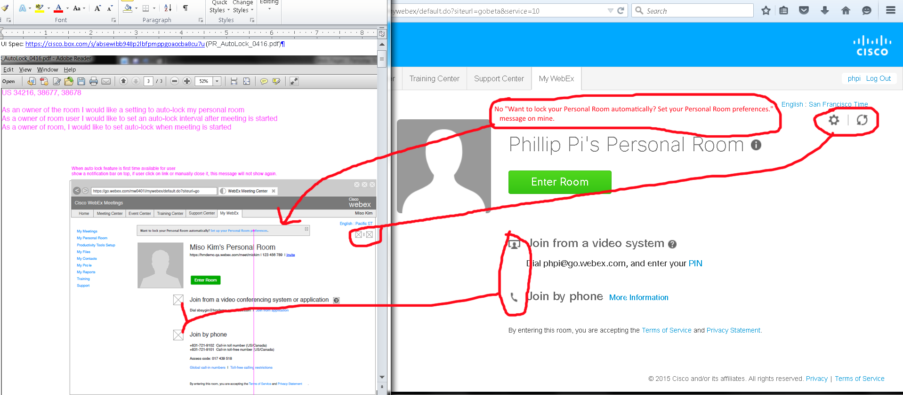

Issues: I never see this "Want to lock your Personal Room automatically? Set your Personal Room preferences." message on my gobeta.webex.com screens. I had to use its gear icon to get to my preferences web page. Also, document has missing icons (assuming the icons on gobeta server are correct).

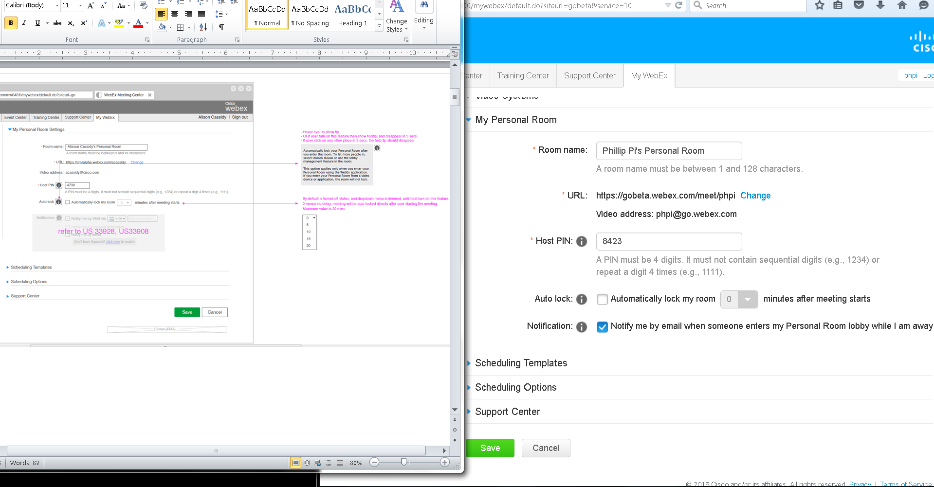

Issue: I need to reset my old or get a new gobeta.webex.com account to see the default settings.

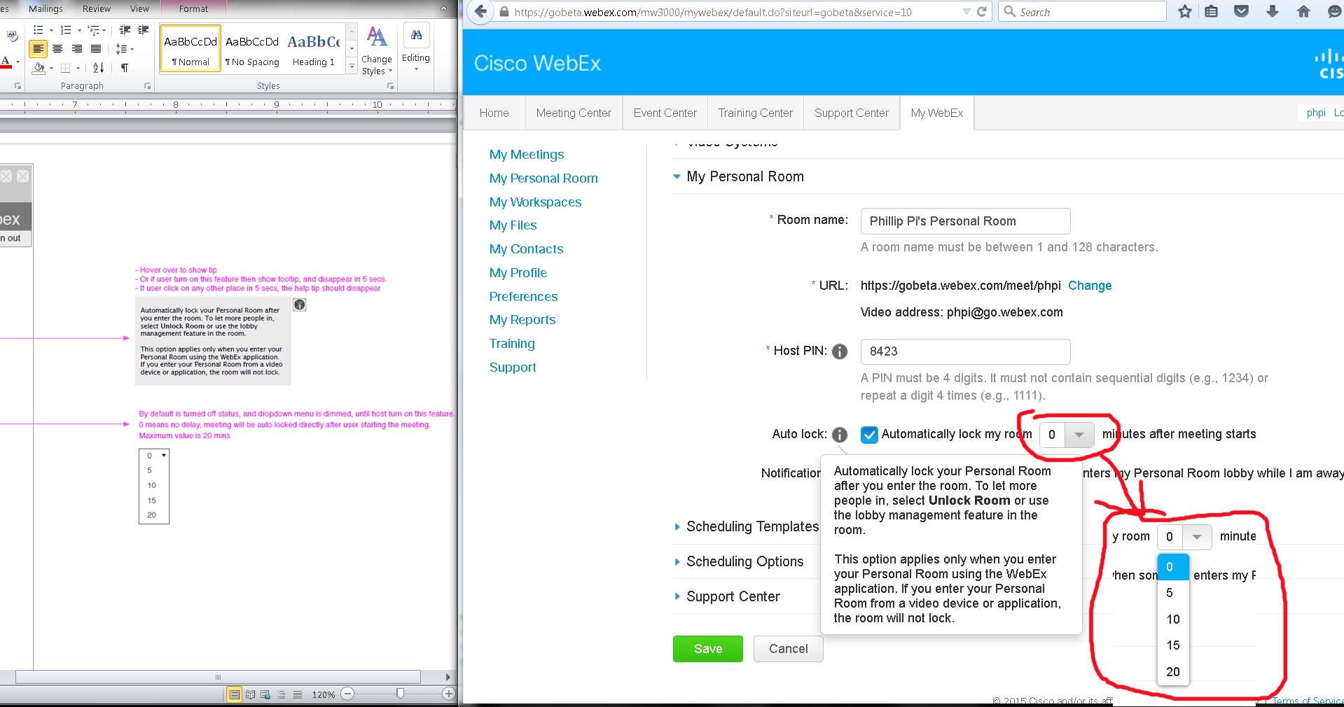

Everything looked fine and working to me.

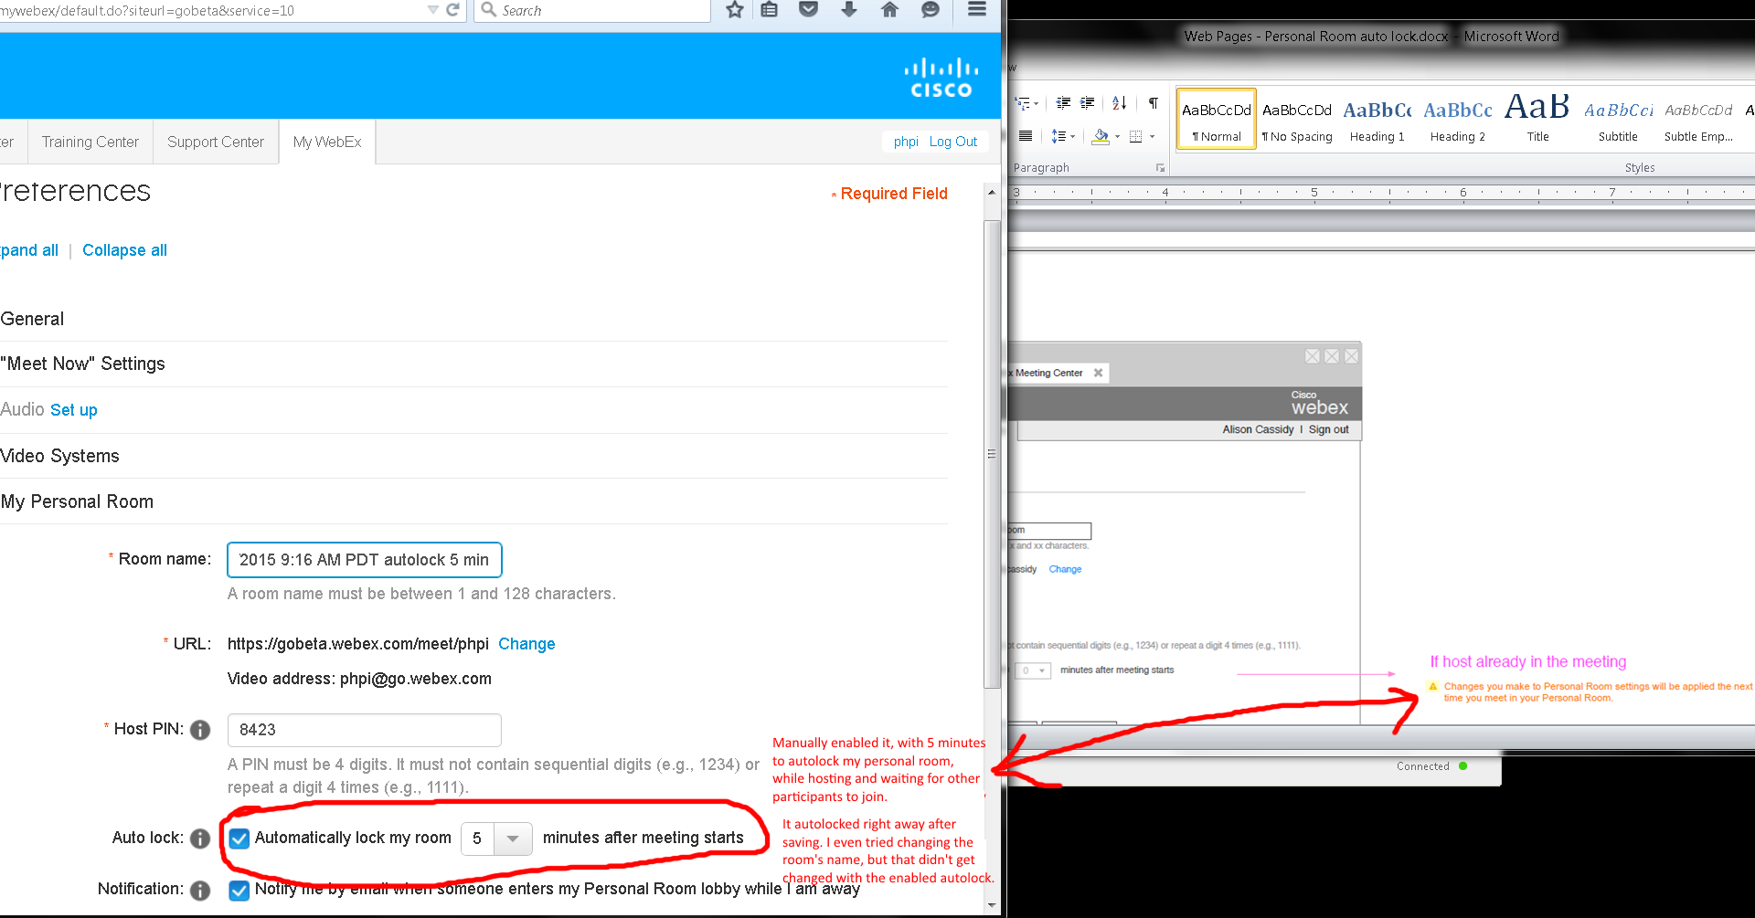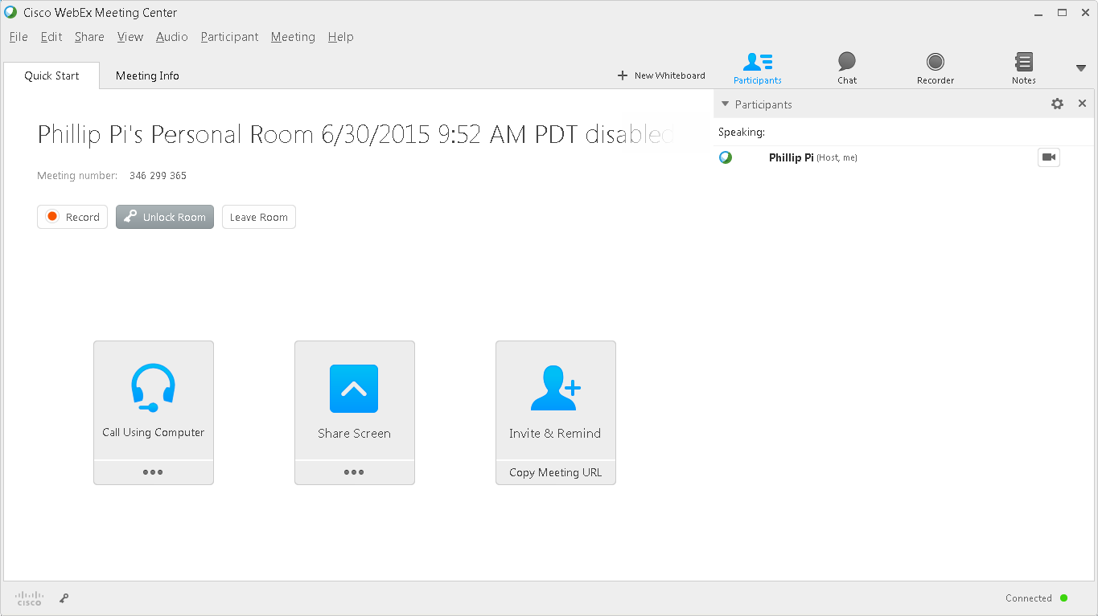

Issue: Autolock should not be changing in my current room that I started and in after I manually told it to autolock since I did not leave and rejoin. No one else came in too.

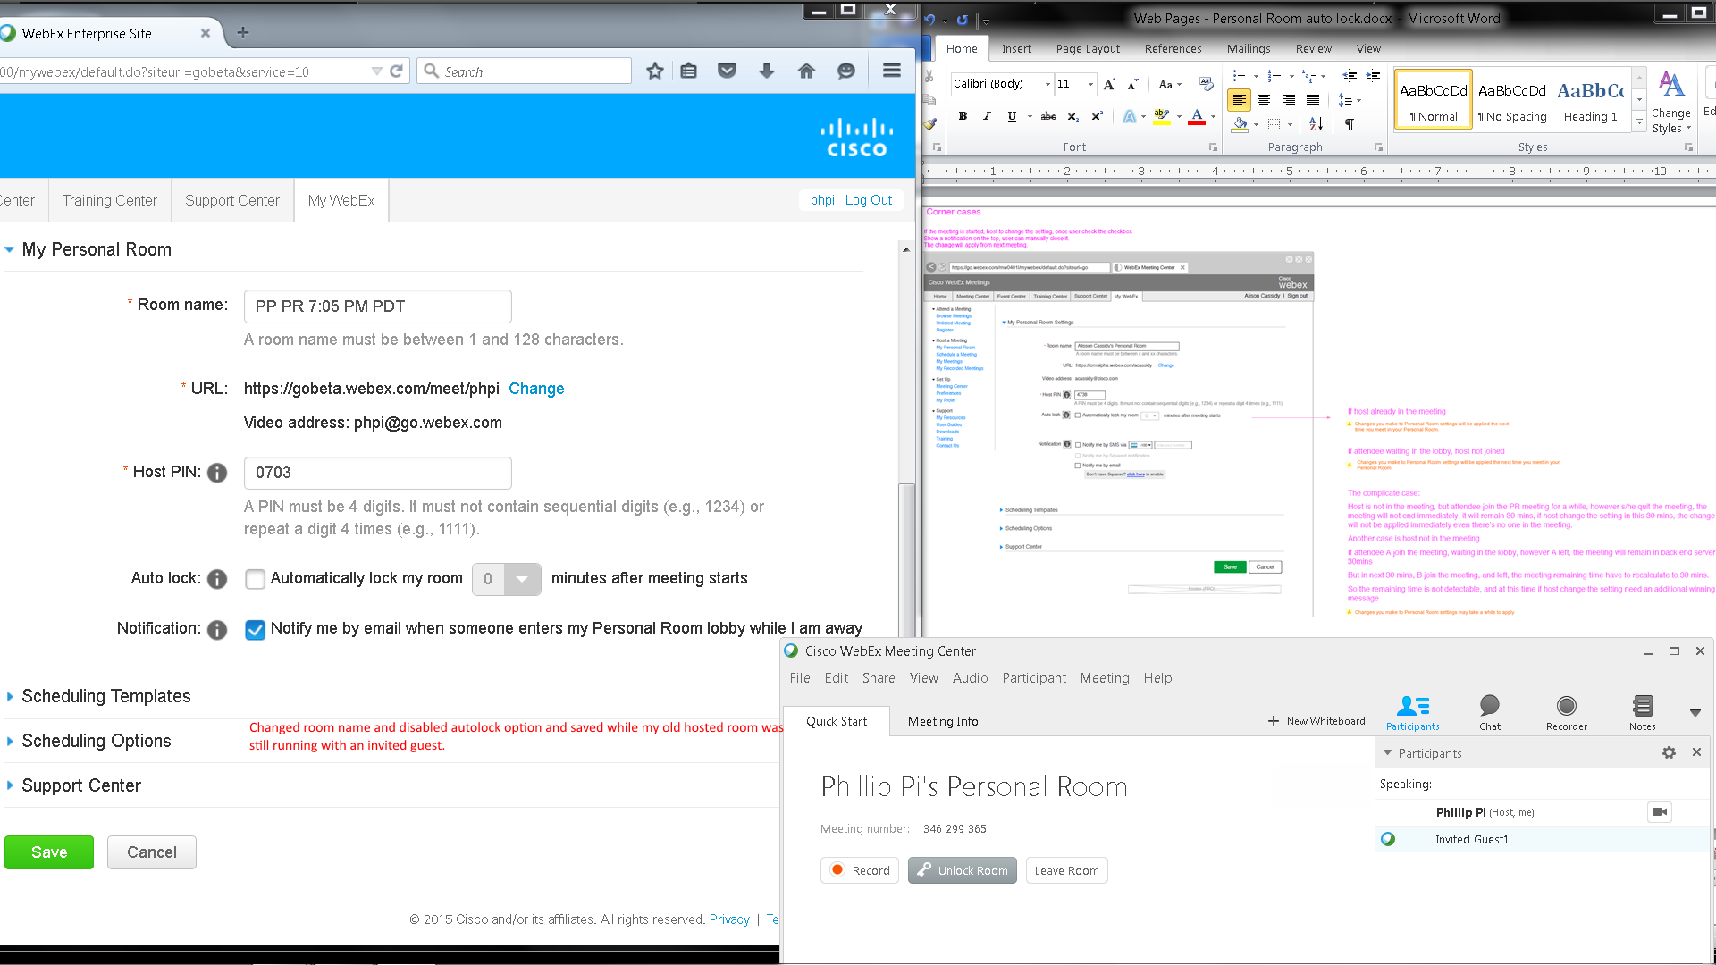

Issues: Unable to test the complicate case due to Cisco WebEx Meeting Center:

1. Host required for the meeting.
2. Wanting to dump all participants when host tries to leave the room.
3. Thinking the host is rejoining on the same machine when trying to pass presenter status to the guest.

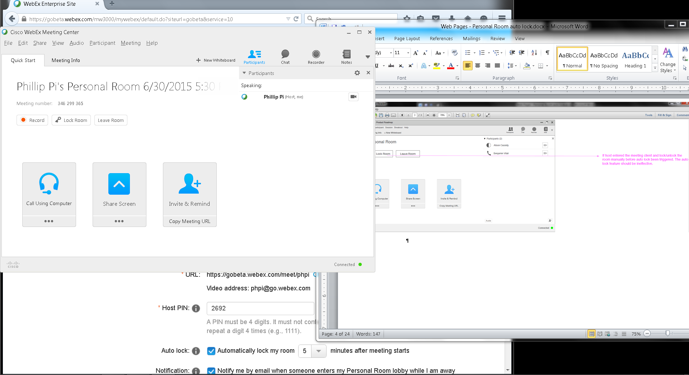

Waited over five minutes and no autolock occurred.

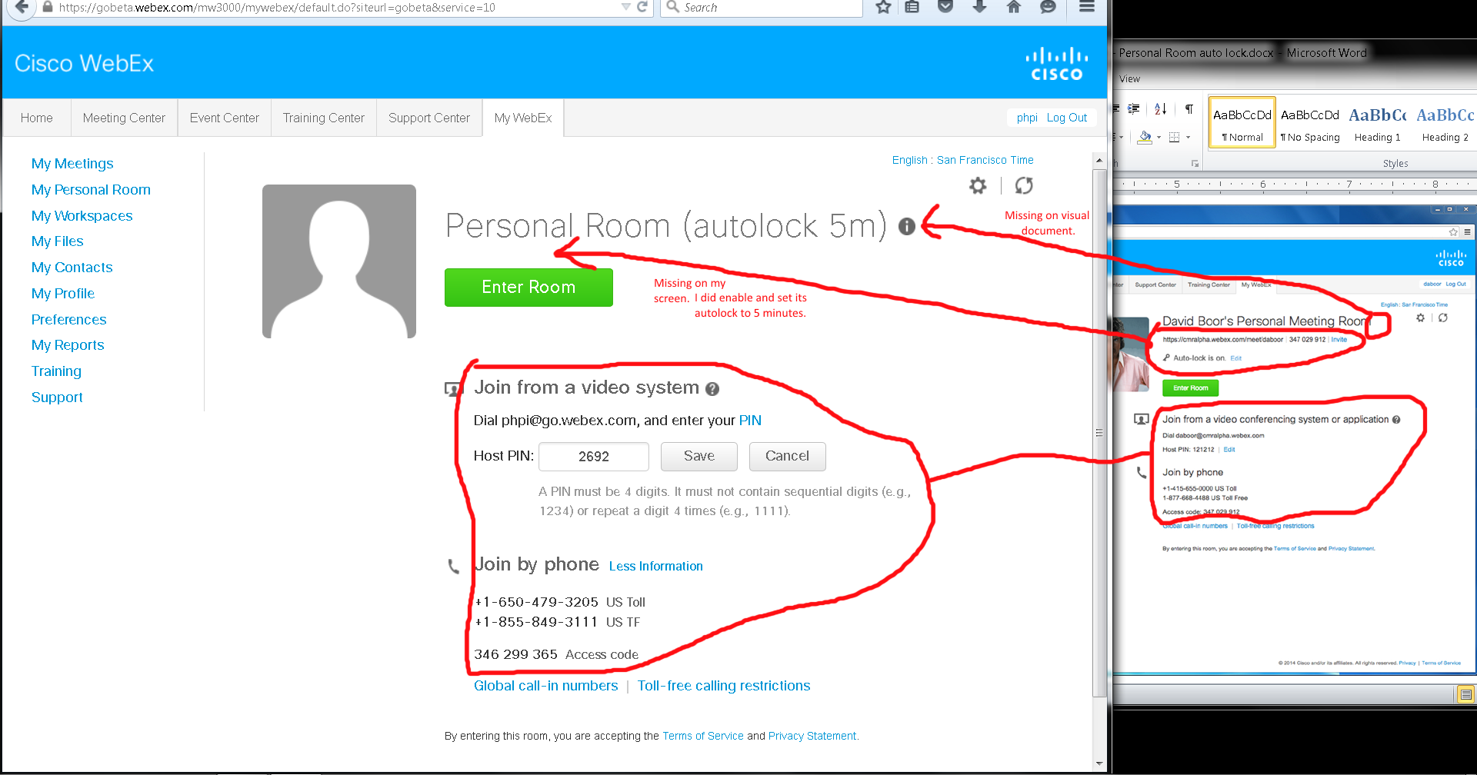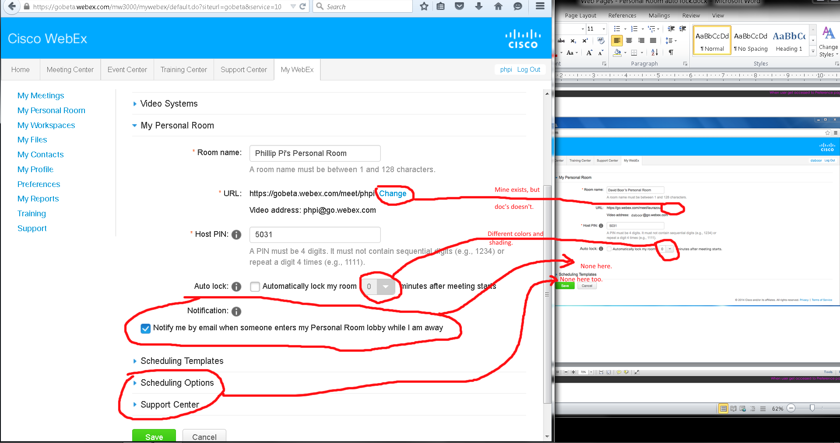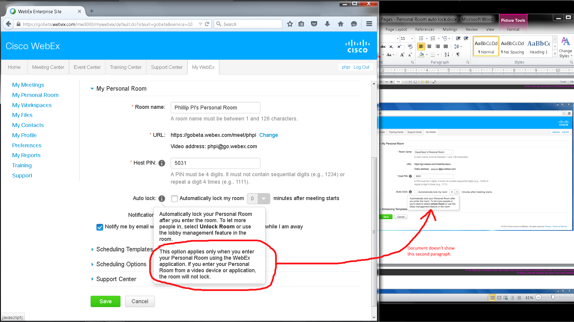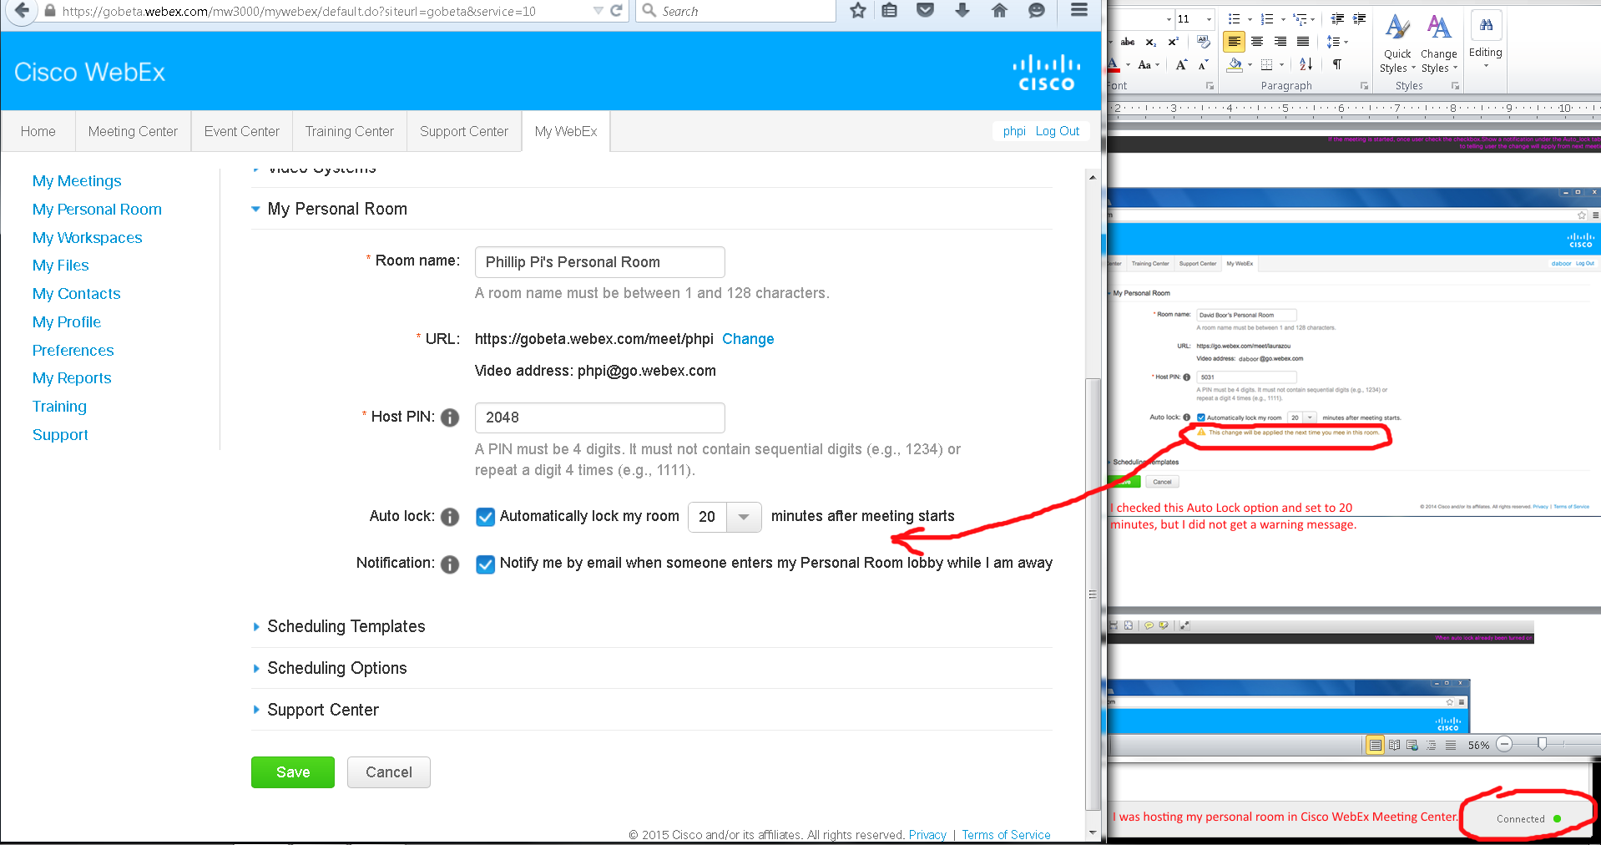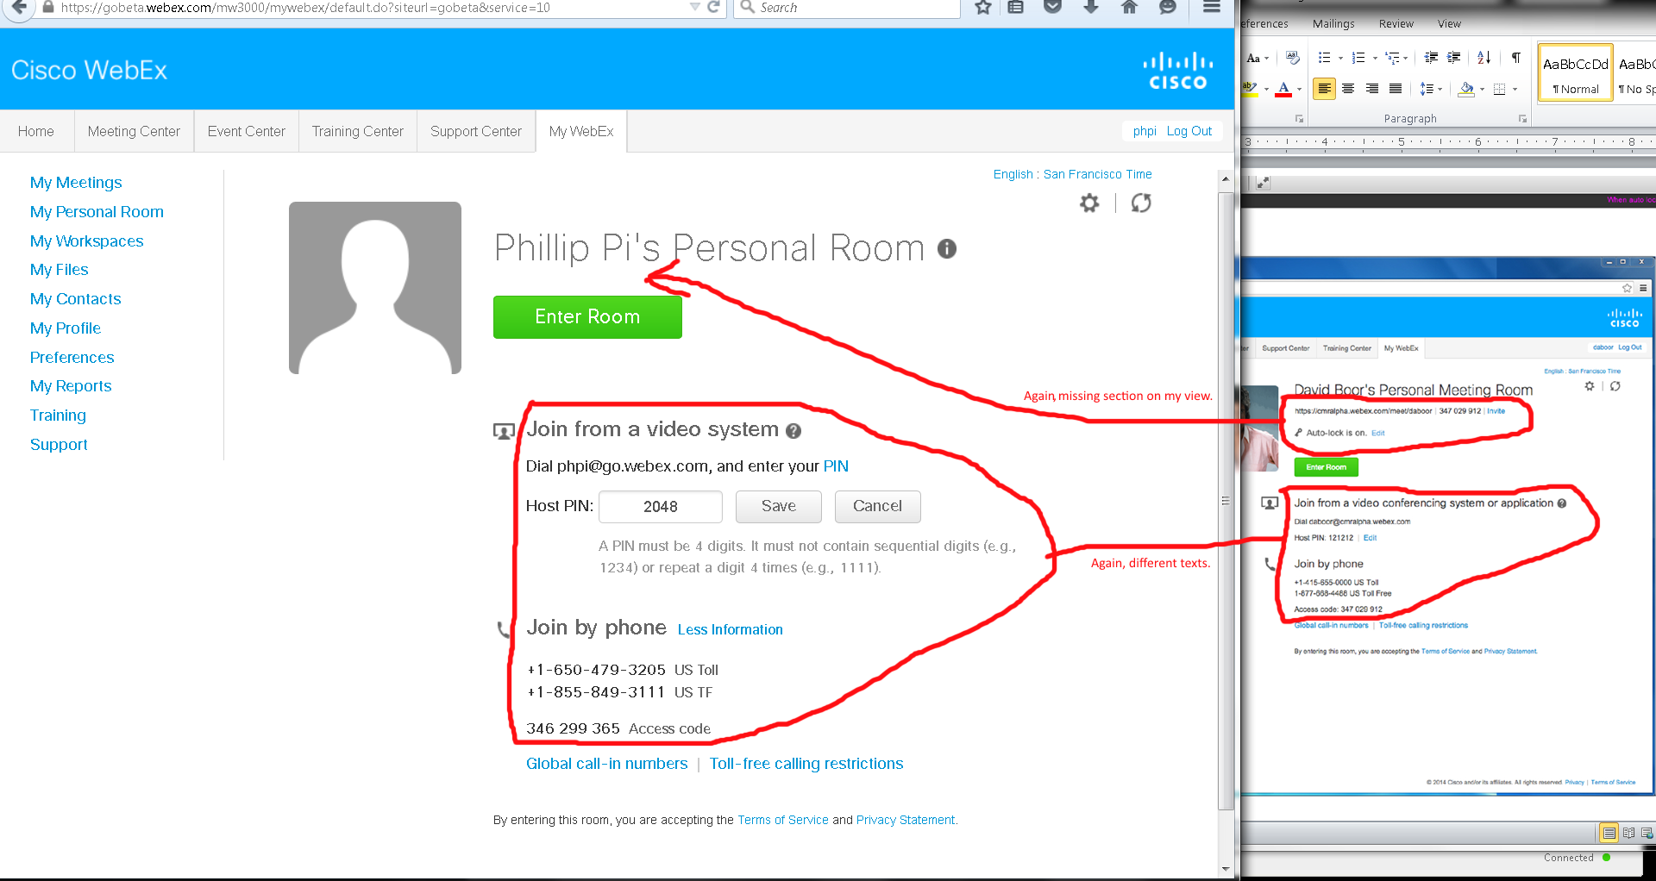

Issues from above images: Both my screen and the document’s show differences like missing texts, links, icon graphics, etc.

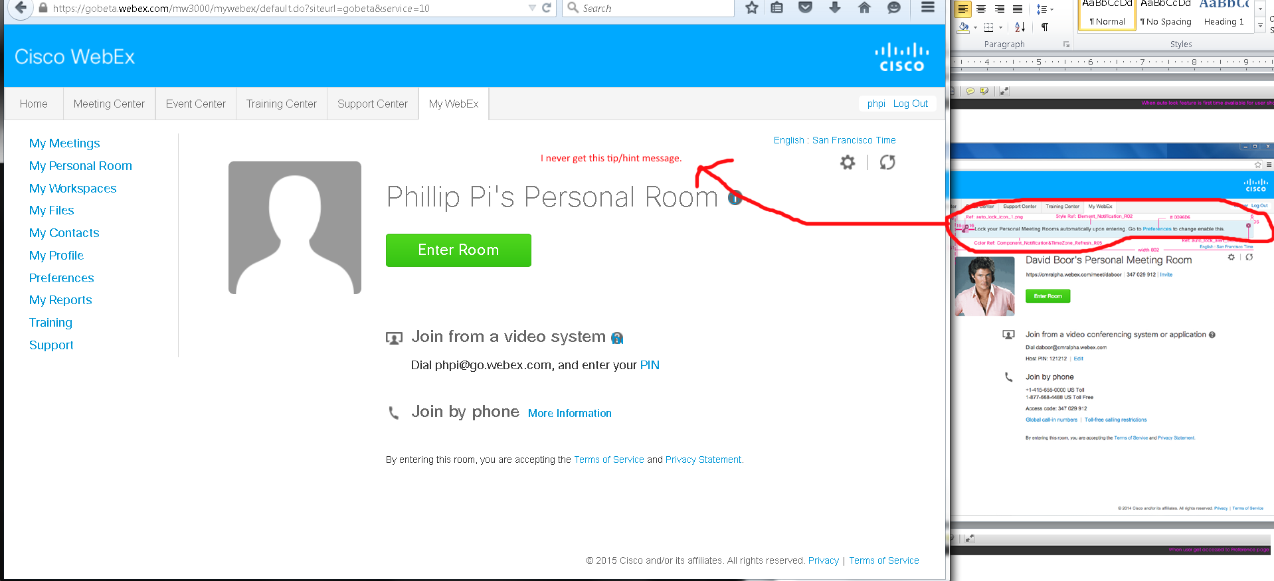

Issue: Missing hint/tip section. I have never seen it show up before too.

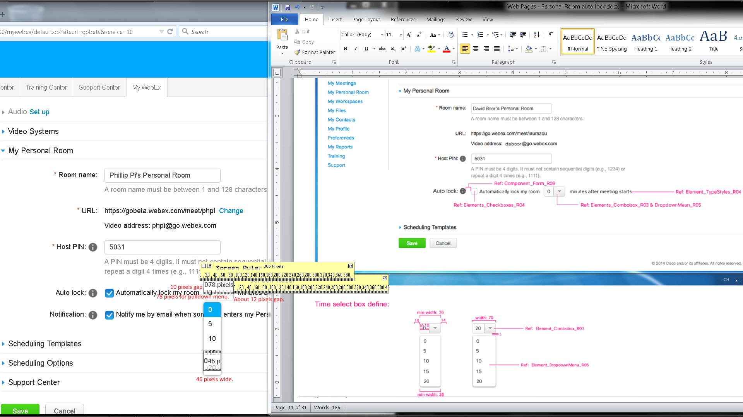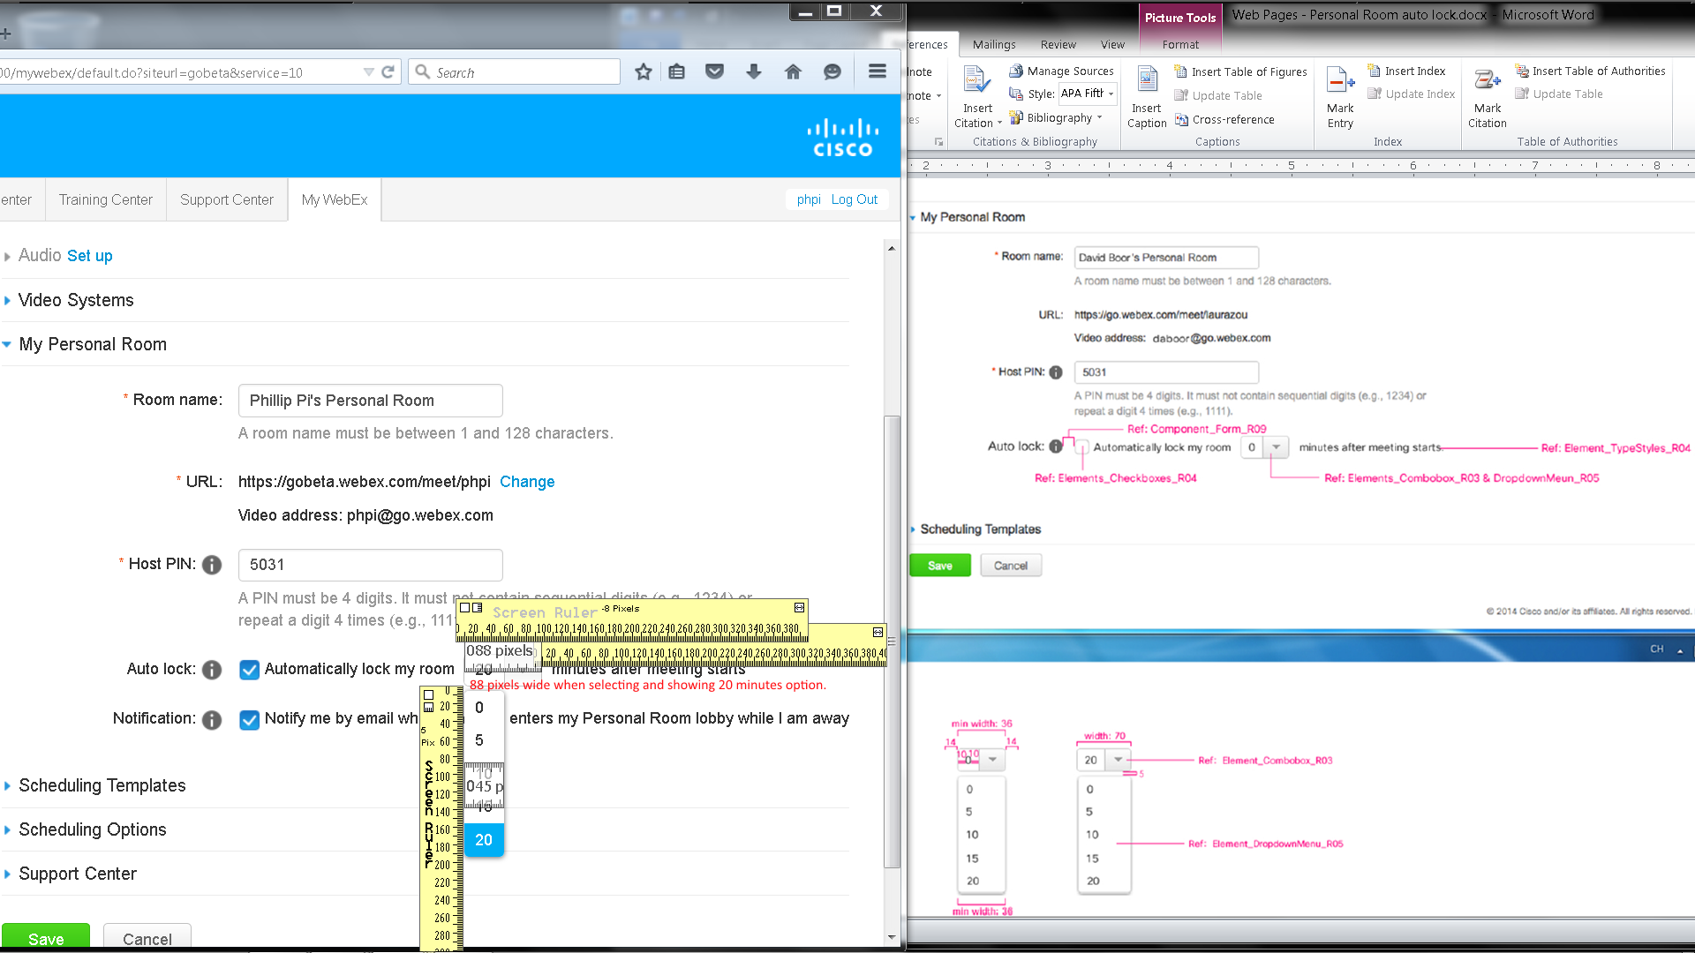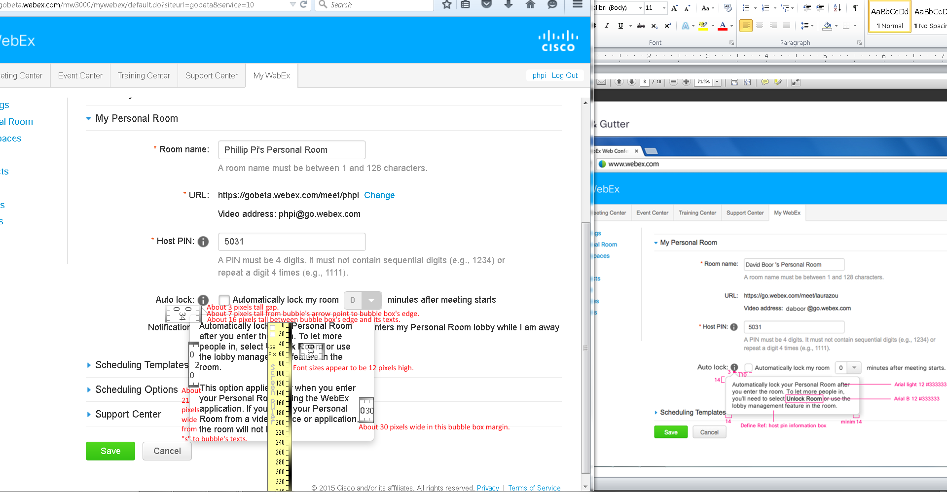

Issues:

1. Dimension sizes.
2. Need the sizes from “Ref …” texts. Asked for them.

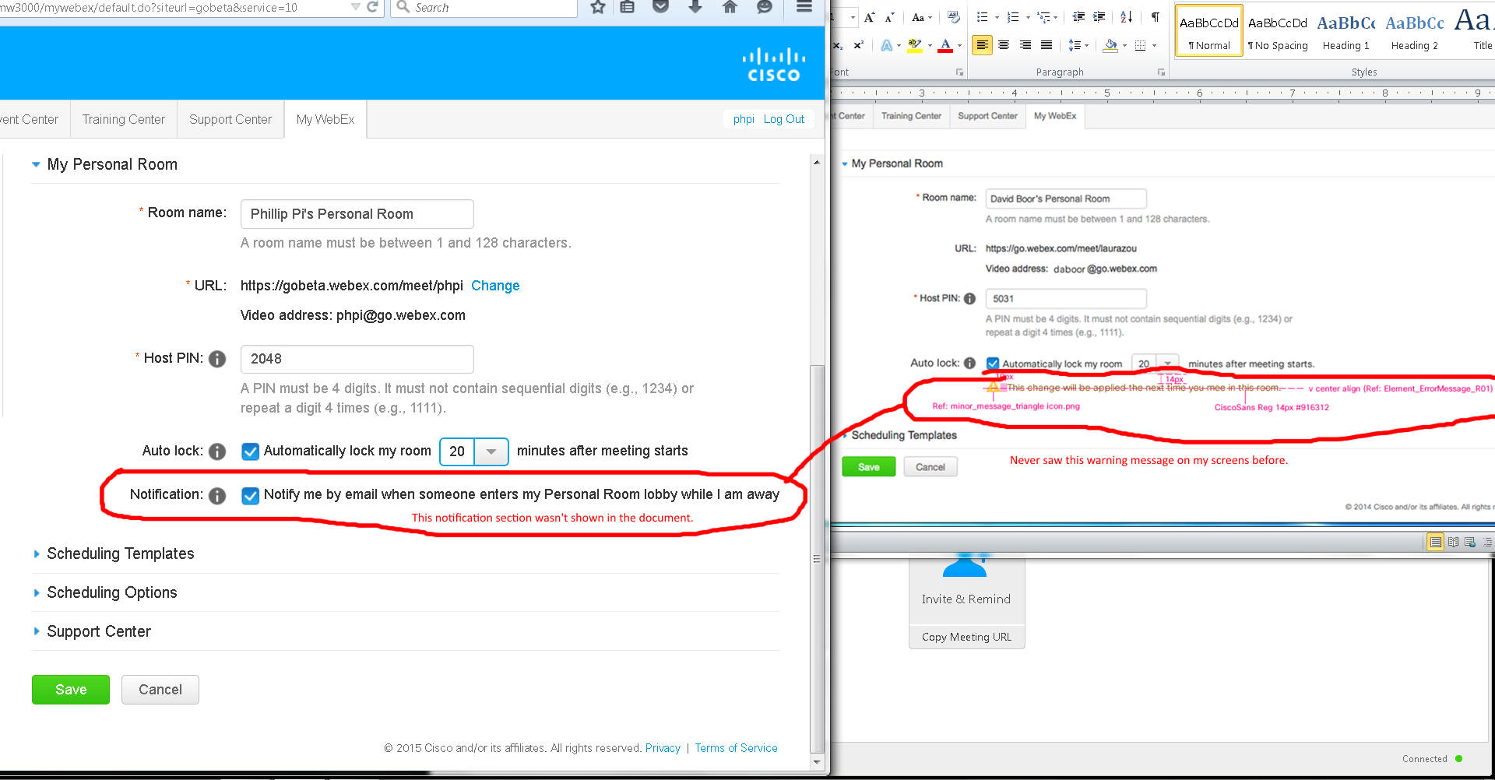

Issues:

1. I never see these warning messages when I have Cisco WebEx Meeting Center running as a host and changing my room’s settings in the web browser
2. I saw a Notification option on my screen, but not in the document’s.

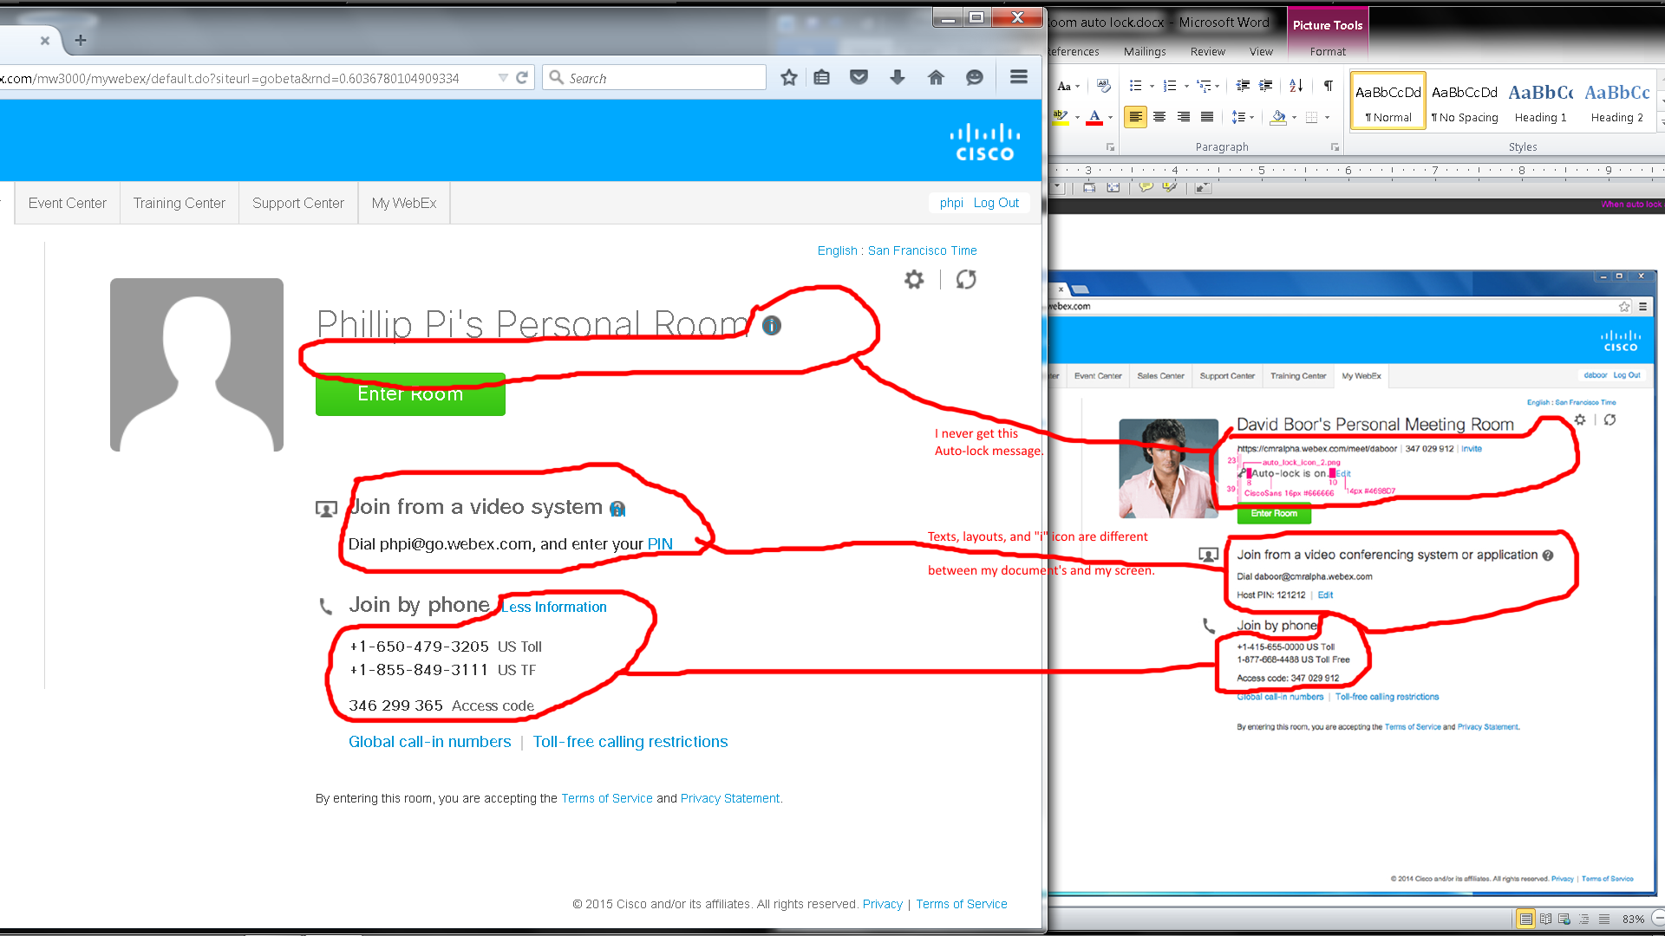

Issue: Many differences like texts, layouts, “i” icon between my screen and document’s.

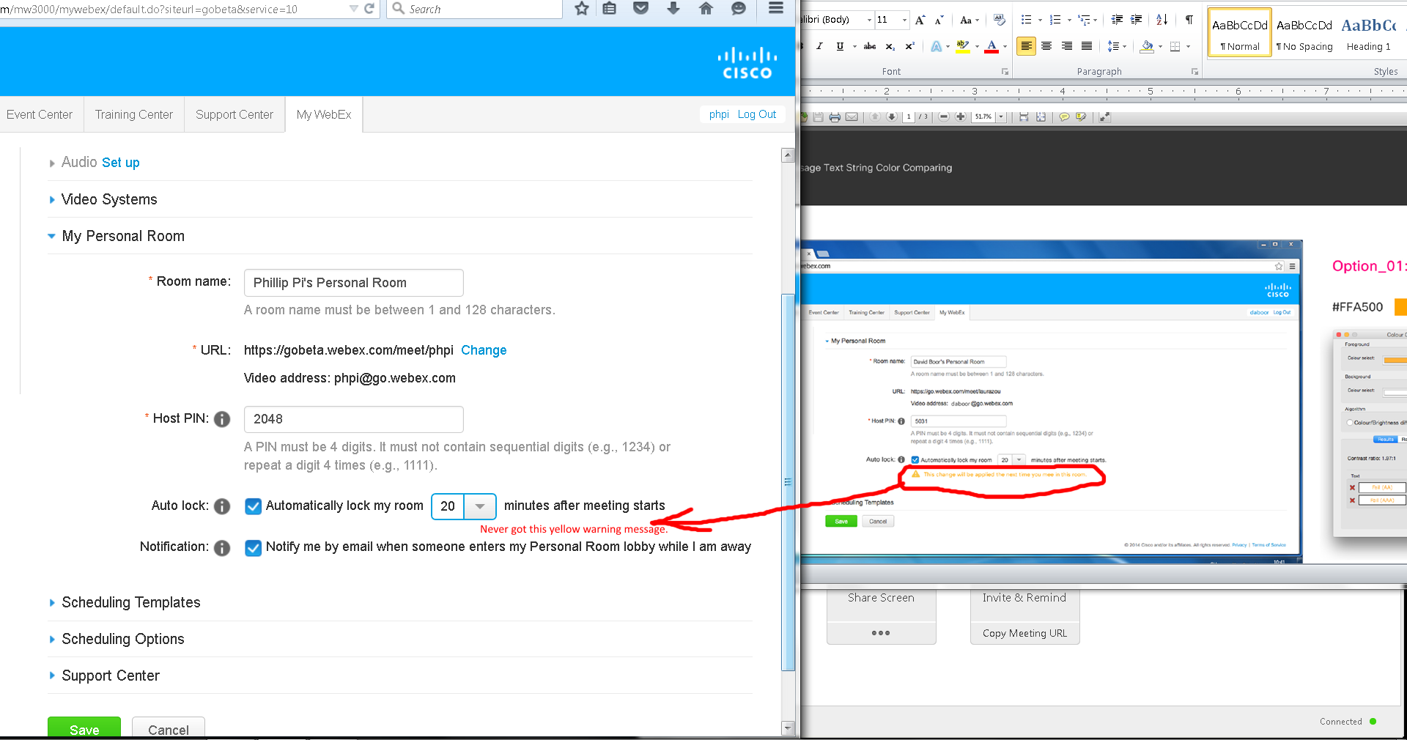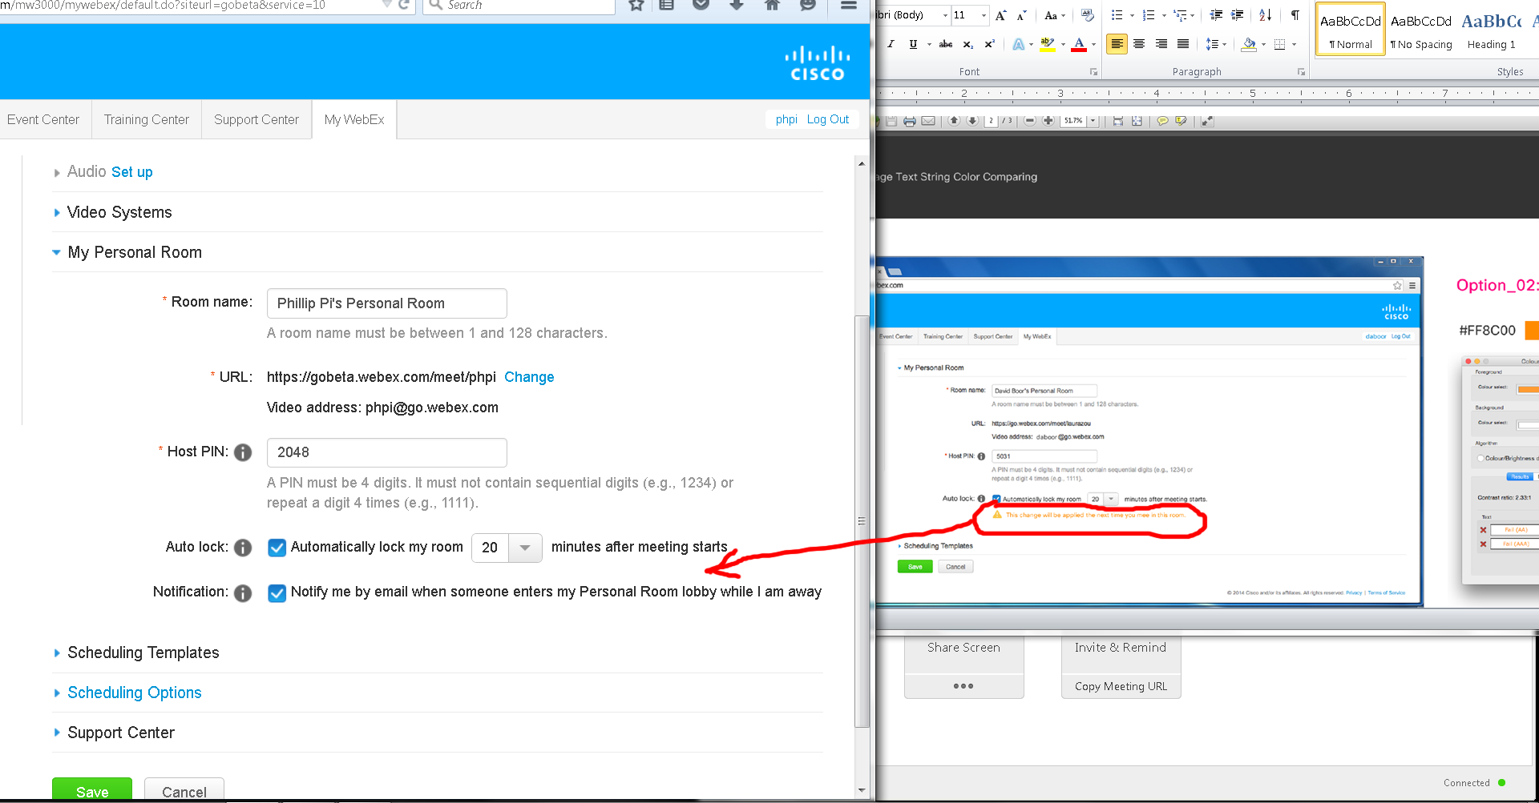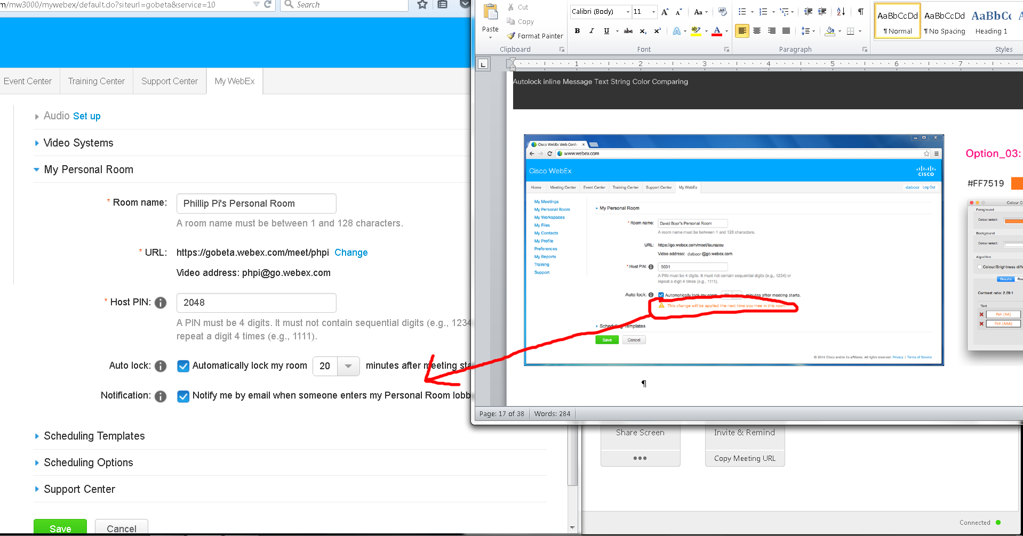

Issues: I never see these warning messages when I have Cisco WebEx Meeting Center running as a host and changing my room’s settings in the web browser.

**Overall Issues:**

1. I never see some of the messages, like "Want to lock your Personal Room automatically? Set your Personal Room preferences." I had to use its gear icon to get to my preferences web page on my <http://gobeta.webex.com> screens.
2. Autolock should not be changing in my current room that I started and in after I manually told it to autolock since I did not leave and rejoin. No one else came in too.
3. Unable to test the complicate case due to Cisco WebEx Meeting Center: Host required for the meeting; Wanting to dump all participants; Thinking the host is rejoining on the same machine when trying to pass presenter status to the guest. Need another account and work computer?
4. Both my screen and the documents' show differences like missing texts, links, icon graphics, etc.
5. Dimension sizes.
6. Need the sizes from “Ref …” texts. Asked for them.
7. I never see these warning messages when I have Cisco WebEx Meeting Center running as a host and changing my room’s settings in the web browsers.
8. I saw a Notification option on my screen, but not in the document’s.