**Web Pages – User Guide** (no prototype and visual)**:**

<https://gobeta.webex.com> in 64-bit W7 EE SP1 (no antialias/ClearType) with its IE11 web browser:

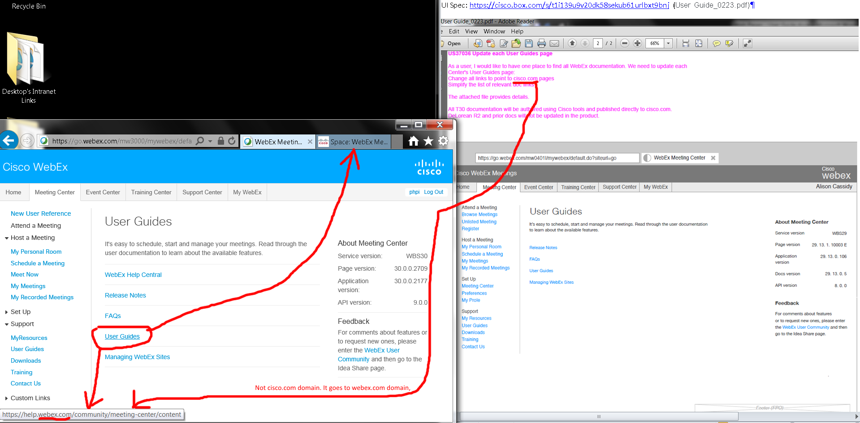

This URL shows:

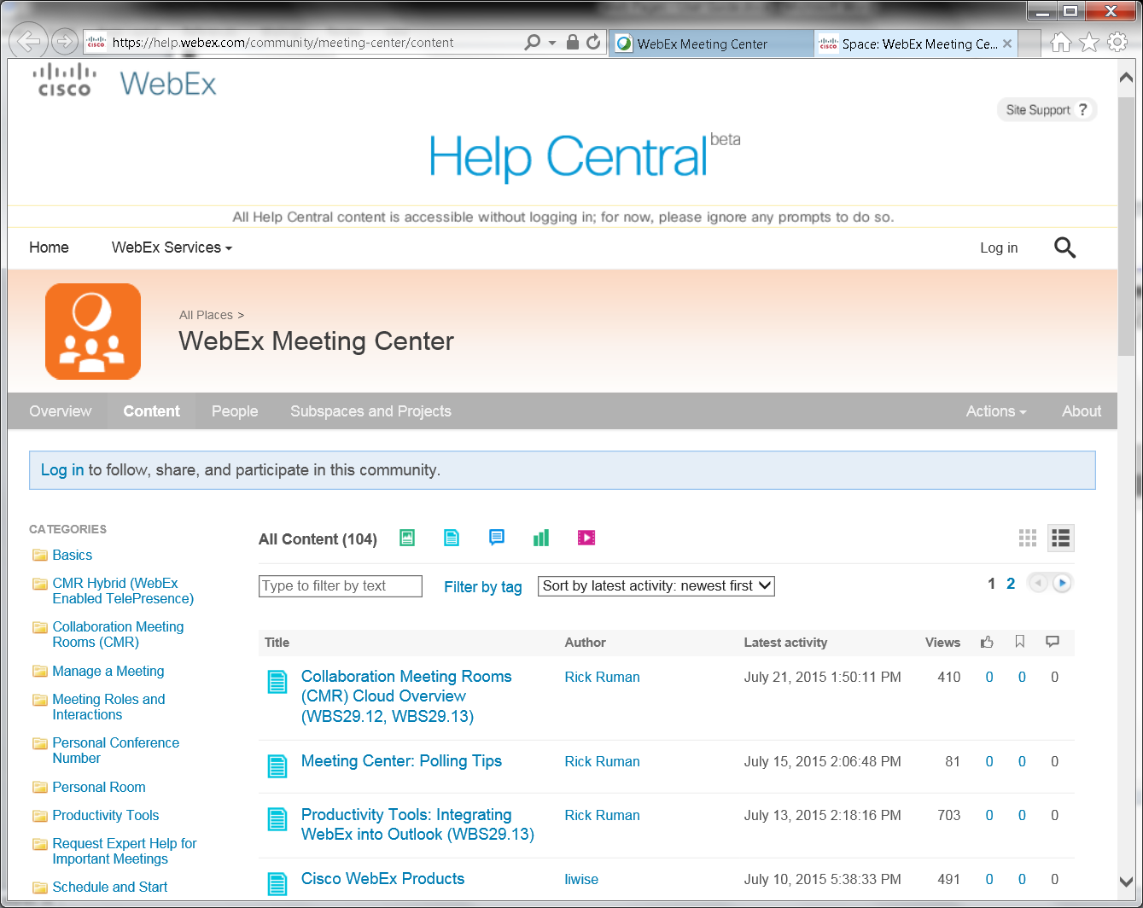

OVERALL ISSUES: User Guides” link did not go to cisco.com domain name, but webex.com domain name (Is this OK since Cisco owns both?).