**Web Pages - Video call back from CMR** (no Prototype and Visual):

<https://gobeta.webex.com> in 64-bit W7 EE SP1 with Firefox v39 web browser:

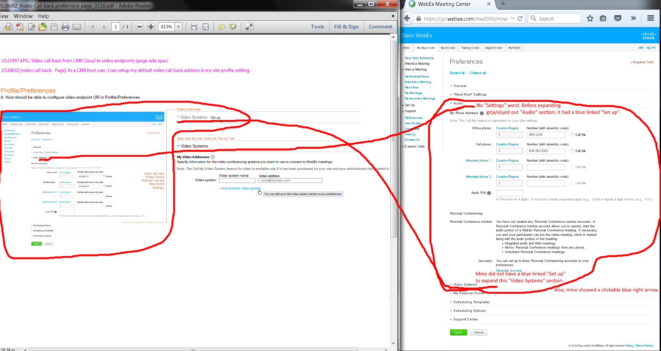

Issues:

1. My go.webex.com’s profile preferences show no “Settings” after “Audio” text after expanding “Audio” section.
2. My go.webex.com’s profile preferences show no blue “Set up” link after “Video Systems” text in collapsed “Video Systems” link. However, I did have a blue “Set up” link on the right of the gr(a/e)yed out “Audio” when it was collapsed before I clicked to expand it.

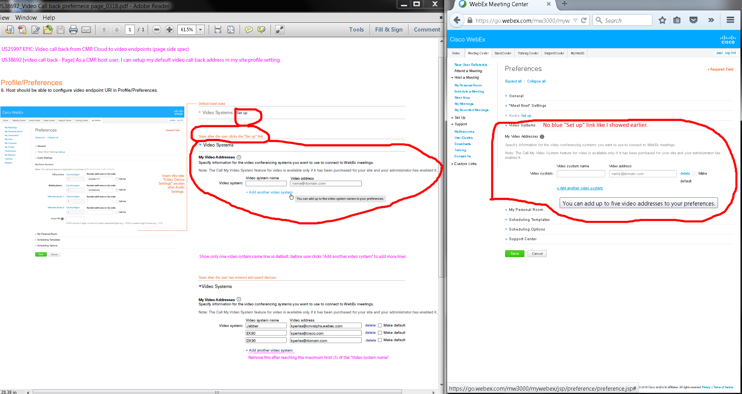

Issue: No blue “Set up” link in “Video Systems” section. Please ignore the "Make default" wordwrapping issue since I had to make everything smaller in sizes to screen capture. It was fine when not normal sizes.

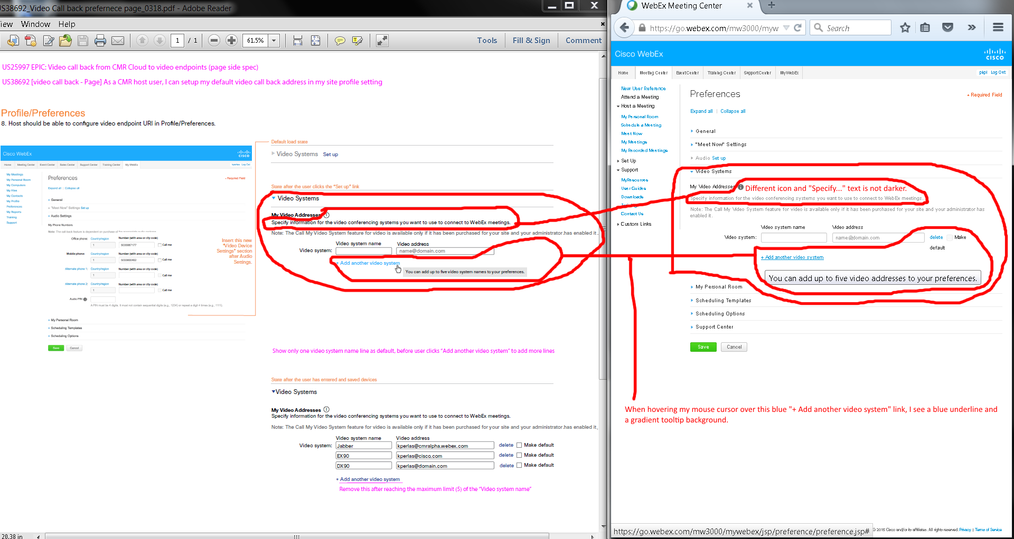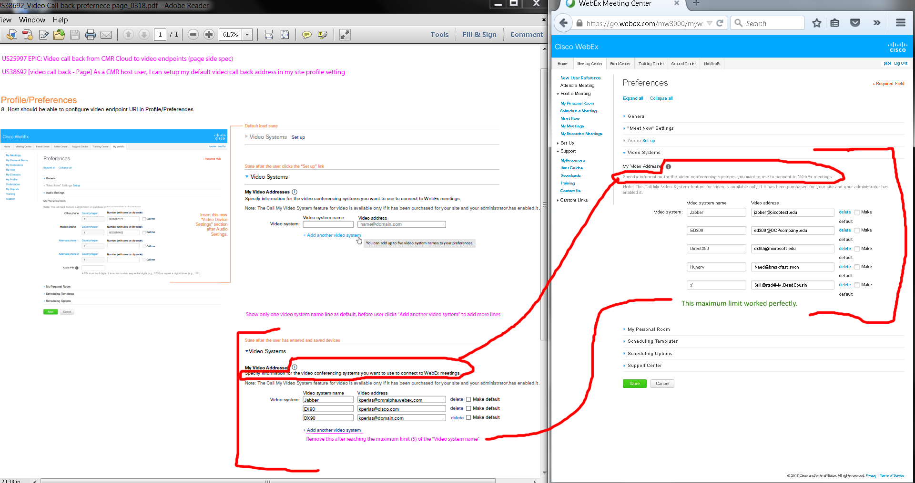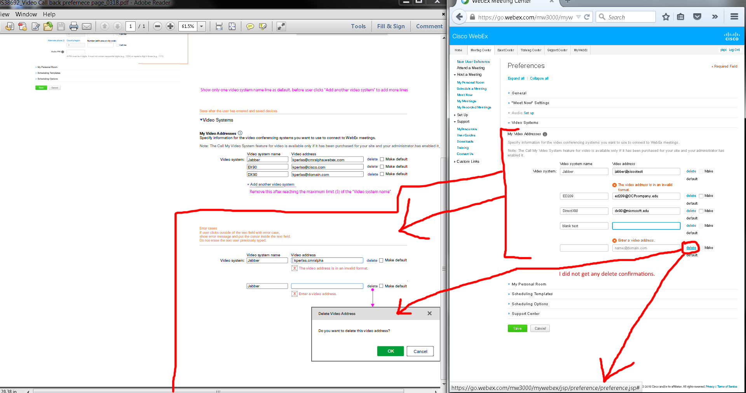

Issues:

1. My “Video Addresses” section shows a different “i” icon and its “Specify information for the video conference systems you want to use to connect to WebEx meetings.” is a lighter color.
2. I get a blue underline and a gradient tooltip background when I hover my mouse cursor over the blue “+ Add another video system” link.
3. Deleting my inputted video address did not ask me to confirm.

Notes: Please ignore the "Make default" wordwrapping issue since I had to make everything smaller in sizes to screen capture. It was fine when not normal sizes.

**OVERALL ISSUES:**

1. Please ignore the "Make default" wordwrapping issue since I had to make everything smaller in sizes to screen capture. It was fine when not normal sizes.
2. My “Video Addresses” section shows a different “i” icon and its “Specify information for the video conference systems you want to use to connect to WebEx meetings.” is a lighter color.
3. I get a blue underline and a gradient tooltip background when I hover my mouse cursor over the blue “+ Add another video system” link.
4. Deleting my inputted video address did not ask me to confirm.
5. My “Video Addresses” section shows a different “i” icon and its “Specify information for the video conference systems you want to use to connect to WebEx meetings.” is a lighter color.
6. I get a blue underline and a gradient tooltip background when I hover my mouse cursor over the blue “+ Add another video system” link.
7. Deleting my inputted video address did not ask me to confirm.