Client Mac OS X 10.7.x’s Network Setup for Proxy Testings
Created by Phillip Pi on 7/9/2012 1:46 PM PDT. Used an updated Mac OS X 10.7.4 VMware Fusion v4.1.3 image (bridge network setup) on a Mac Mini. This document assume you have a proxy server ready to connect and use. See the other two documents in //[deleted]/Symantec_Online_Services/Docs/ISP_2010/QA/Proxy_Information/ for those instructions and details.

By default, Mac OS X 10.7.x uses DHCP’s network settings like this example:
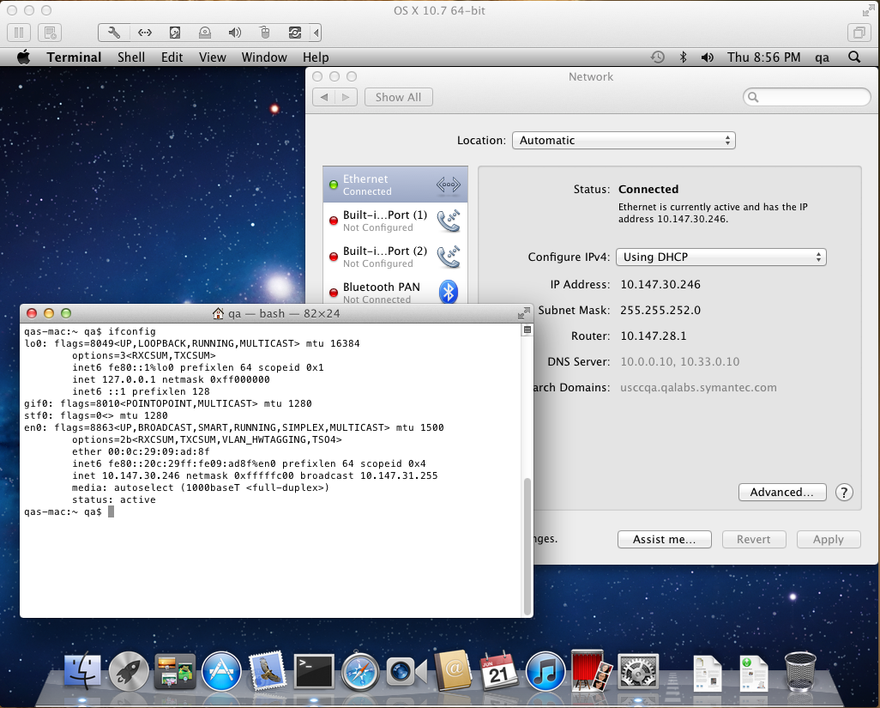
Note all this information through Terminal’s ifconfig command and/or Mac OS X’s System Preferences’ Network option.
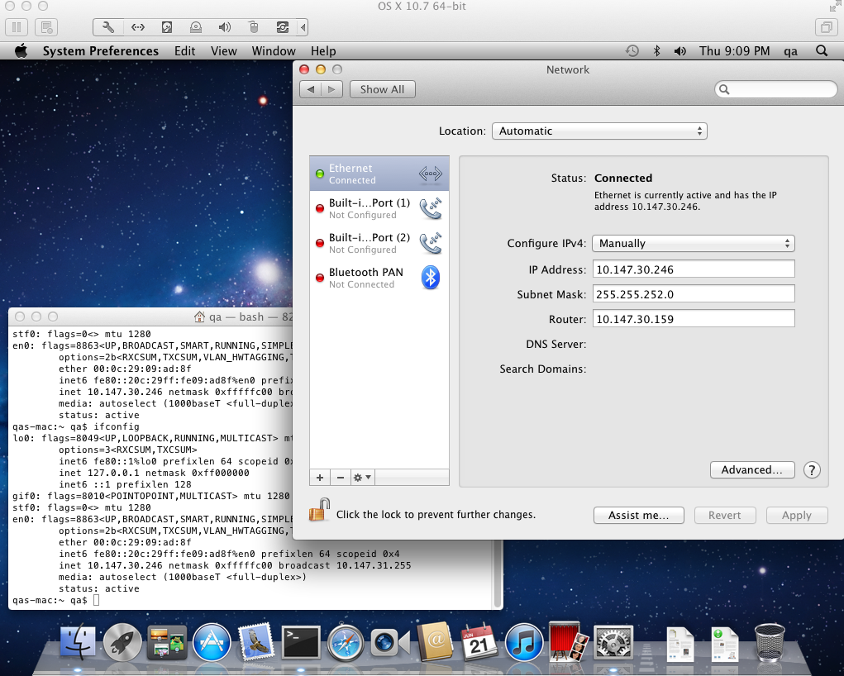
Manually change “Configure IPv4” to “Manually” value. Its IP Address and Subnet Mask IP addresses should be the same as “Using DHCP”. Router’s IP address would be the proxy server IP address (an example would be 10.147.30.159 when I tested with my Windows XP Pro. SP2 proxy server).
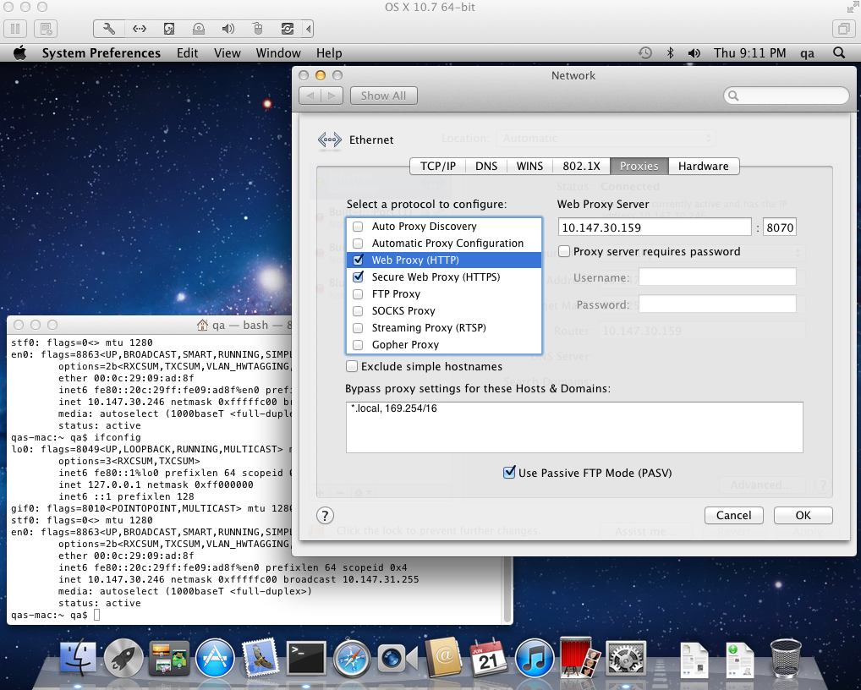
If you’re using proxy server without any PAC scripts, then check the necessary protocols (HTTP and HTTPS should be fine/enough) and enter their “web proxy server” address and its port number. As an example, 10.147.30.159:8070 was my CCproxy v7.2 server.
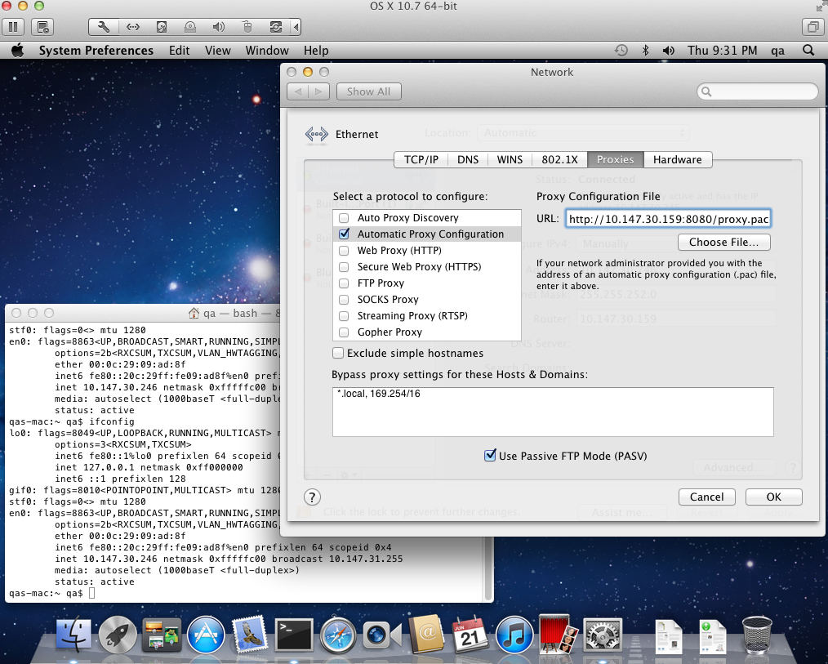
If testing with PAC script for proxy testings, then check “Automatic Proxy configuration” and enter its proxy configuration file URL. As an example for my Windows XP Pro. SP2’s IIS+Squid proxy server, it was at http://[deleted]:8080/proxy.pac.

After configuring the network with proxy setups, test the Internet to be sure it works. If using other Internet programs, they might need to be configured as well if they don’t recognize Apple’s network setup.

Also note that using Mac OS X 10.7.4’s guest and standard accounts, with parental controls, don’t seem to have network/Internet connection with IIS+Squid + PAC proxy setup. It only works without parental controls and administrator accounts (never have parental controls). Other proxies (e.g., Apache with its PAC script file) worked fine even with these low level access accounts.

