INSTRUCTIONS ON HOW TO SET UP POPULAR/COMMON WEB PROXY SERVERS (APACHE AND SQUID), WEB SERVERS (APACHE AND IIS TO HOST PAC FILES), AND CLIENT PCS’ PROXIES (MANUALLY).
Created by Phillip Pi. Last updated on 7/7/2011 11:41 AM PDT.

Read and understand //[deleted]/Symantec_Online_Services/Docs/ISP_2010/QA/Proxy_Information/Proxy Testings - Other non-CCproxy Servers Setups.doc first to learn how to test, setup, and understand the issues before trying this document since this replaces CCproxy and adds other things like web servers and scripts. These proxies (not CCproxy) and web servers are only for web browsers’ proxies, not for the network devices. If you want to manually have proxies for other Internet programs (type in via cmd.exe or Internet Explorer (IE)’s MANUAL settings) for whatever reasons (probably not needed for our testings), then see the end of this document. Also, these instructions were used in Culver City’s usccqa.qalabs.symantec.com network (third and fourth floors) and might not work on other networks.

Apache v2.2 Setup in Windows XP for Both Proxy and Web Server (PAC Files):

How to setup (used an updated and activated Dell OEM Windows XP Home SP2):
- Disable the PC's firewall or allow port 8080, so other computers can access its port 8080. You might want to open cmd.exe and ping the server’s IP address to see if it responds.
- Go to http://httpd.apache.org/download.cgi#apache22, download the latest Apache binary software for Windows (e.g., http://mirrors.ibiblio.org/apache//httpd/binaries/win32/httpd-2.2.19-win32-x86-openssl-0.9.8r.msi) and install it with defaults.
- Edit C:\Program Files\Apache Software Foundation\Apache2.2\conf\httpd.conf file.
- You can use the default port number (80) or change it. We will change its default number in "Listen 80" line to 8080.
- Remove pound signs/hashes (#s) from all "LoadModule proxy_..." lines to enable these *.so modules for Apache.
- Add this part to the bottom in this section:
<IfModule mod_proxy.c>

ProxyRequests On

<Proxy *>
Allow from all
</Proxy>

</IfModule>
- Also, add this line to the bottom of this section: AddType application/x-ns-proxy-autoconfig .pac
- Save httpd.conf file and start/restart Apache service (you can do it through its “Apache Service Monitor” system tray icon instead of control panel’s administrative tools method). If you get an error about starting, then recheck httpd.conf and be sure there are no typos, incorrect formattings, etc. Apache is picky! Whenever you change and save httpd.conf, you need to restart Apache service.
- If you need to upload files to the Apache server, then note its httpd.conf file where it says DocumentRoot "C:/Program Files/Apache Software Foundation/Apache2.2/htdocs" line. This is where your files goes like a proxy.pac file. Inside already is an index file (you can delete it if you want so seeing this http://localhost:8080/ shows a directory listing instead of “It works!” Web page). Ensure remote computers can connect to its IP address with its port 8080 like http://123.45.67.89:8080. See if it connects and shows results.
- Then, configure client PC(s) as shown in //[deleted]/Symantec_Online_Services/Docs/ISP_2010/QA/Proxy_Information/Proxy_Testing. Doc.doc before testing with the proxy server.
- When you need to download from a file from proxy server, just type in proxy server IP address and its port 8080 like http://[deleted]:8080/proxy.pac and the web browser (e.g., Internet Explorer/IE) should ask you to download it or not. It should NOT show the text contents inside proxy.pac. If it did, then you didn’t either restart Apache server and/or didn’t configure MIME settings correctly as shown in step #7.
- When confirmed working, go to the web browser for its network proxy settings and enter the URL to proxy.pac file for automatic proxy configuration. Save and test it. There is an Apache log folder/directory in its installation area to check for logs.

Sources/Reading Materials:
- http://www.devshed.com/c/a/Administration/Using-Apache-As-A-Proxy-Server/ article on how to set up an Apache server for proxy.
- http://httpd.apache.org/docs/2.2/mod/mod_proxy.html for proxy features.
- http://homepages.tesco.net/J.deBoynePollard/FGA/web-browser-auto-proxy-configuration.html for automatic configurations for proxies.
- alt.apache.configuration newsgroup.

XP Pro.’s Internet Information Services (IIS) v5.1 To Host PAC Script Files and Squid To Be A Proxy:

How to setup IIS (used an updated and activated Windows XP Professional/Pro. SP2):
- Ensure Windows XP is Pro. edition and not Home (does not have IIS option), and have its bootable CD. It is recommended to use the one provided from the operating system/OS and not the separate newer versions (e.g., downloaded) unless you are told to do so.
- Open up Windows’ Control Panel and go to its “Add/Remove Programs”. Then, click on “Add/Remove Components”. Check the box for “Internet Information Services (IIS)” to select the defaults and click Next button. Windows will ask for your bootable installer CD to add IIS to the system.
- Disable the PC's firewall.
- Check to see if IIS is working. On the same PC, go to http://localhost. It should say its Web service is running and give you help (will tell you its version number as well – should be v5.1 for updated XP Pro. SP2’s).
- Since its default port is 80, it should be changed to 8080 (or some other number, but we use 8080 as an example). Right click on “My Computer” and click on Manage for “Computer Management”. Expand “Services and Applications” -> IIS -> Web Sites -> highlight “Default Web Site” -> and click on its Properties. Go to its “Web Site” tab, and change its “TCP Port” value as shown in the screen shot below:
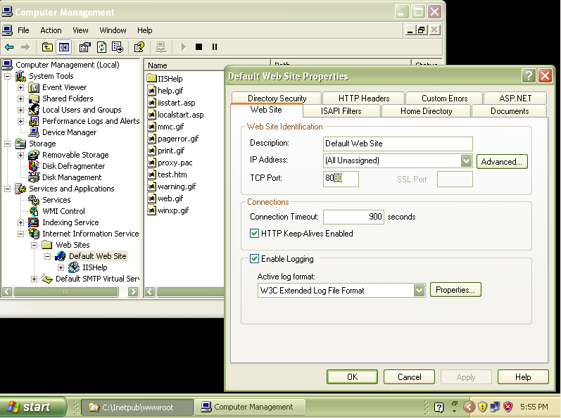
- In the same Properties screen, go to “HTTP Headers” tab and click on “File Types…” button in “MIME Map” tab. Click on “New Type…” button to add a new file type. Enter “.pac” (without quotation marks) for “Associated extension:” and “application/x-ns-proxy-autoconfig” (without quotation marks) for “Content type (MIME):”). See below screen shot of what the screen look like:
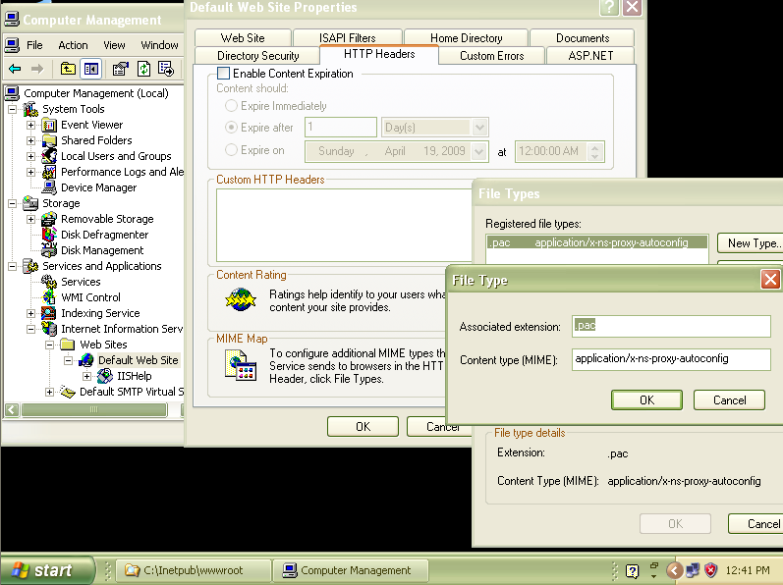
- IIS’ default location (can be changed in “Home Directory” tab’s “Local Path”, but not required for testings) for Web files for Web site is in c:\inetpub\wwwroot\, so proxy.pac file can be copied here for testings.
- Hit OK buttons to save everything.
- Then, IIS should be ready to be tested. You should be able to download proxy.pac like: http://localhost:8080/proxy.pac on the proxy server machine and http://10.147.27.242:8080/proxy.pac remotely. Try it with web browser’s download first before setting up a proxy server (e.g., Squid). If it doesn’t work, then try fixing the file(s) and/or folder(s) permissions as shown in http://www.eggheadcafe.com/conversation.aspx?messageid=31737359&threadid=31720254 (ran into this problem on an outdated XP Pro. VMware image [easier to set up on real machines]).

Sources/Reading Materials:
- http://homepages.tesco.net/J.deBoynePollard/FGA/web-browser-auto-proxy-configuration.html for automatic configurations for proxies.
- http://technet.microsoft.com/en-us/library/bb742440.aspx#EEAA for MIME Types setup in IIS.

Setting Up Squid On the Same Computer Server to Act Like a Proxy Server (note the reverse slashes and this will NOT work with hosts file (I tried to make it work, but couldn’t – if you can get it to work, then let us know!):
- Download the latest compiled standard Squid stable version for Windows from http://squid.acmeconsulting.it/ (e.g., http://squid.acmeconsulting.it/download/squid-2.7.STABLE8-bin.zip).
- Extract the downloaded binary zip archive in the desired directory (e.g., c:\squid). Note that paths with spaces (e.g., C:\Programs Files\Squid) are NOT supported by Squid.
- Rename the following three default configuration files in Squid's etc subfolder/subdirectory (e.g., c:\squid\etc) by removing their .default filename:
squid.conf.default to squid.conf
mime.conf.default to mime.conf
cachemgr.conf.default to cachemgr.conf
- If you are not using the default c:\squid directory/folder for extracted Squid location, then edit its squid.conf and replace its c:/squid paths (use path with '/' char, NOT '\') to the correct location.
- Manually create ALL the directories (only had to make c:\squid\var\cache) specified in squid.conf if they don't exist already, except the contents of the cache directory.
- In a cmd.exe session, go to squid.exe's path (Squid’s sbin subdirectory) and run this command and its parameters to install the servicename Squid service using the configuration file: squid -i [-f configfile] [-n servicename]. If it is successful (with defaults), then it should show something like this (ignore the starting service and editing squid.conf instructions part for now and note the reversed slashes, quotation marks, and the lack of brackets in the example):
C:\squid\sbin>squid -i -f "c:/squid/etc/squid.conf" -n "Squid"
Registry stored HKLM\SOFTWARE\GNU\Squid\2.6\Squid\ConfigFile value c:/squid/etc/squid.conf
Squid Cache version 2.7.STABLE6 for i686-pc-winnt installed successfully as Squid Windows System Service.
To run, start it from the Services Applet of Control Panel.
Don't forget to edit squid.conf before starting it.
- Also, need to create the cache directories with squid -z [-f configfile]
Example with defaults:
C:\squid\sbin>squid -z -f "c:/squid/etc/squid.conf"
2009/04/13 14:45:31| Creating Swap Directories
- Lastly, set in Windows Registry the Squid servicename service command line with: squid -O servicecommandline [-n servicename]
Example with defaults:
C:\squid\sbin>squid -O servicecommandline -n "Squid"
Registry stored HKLM\SOFTWARE\GNU\Squid\2.6\Squid\CommandLine value servicecommandline
- Through Windows' control panel’s Administrative -> Services, start "Squid" service to start the proxy server and service.
- Then, set up the proxies on the client PCs (e.g., use the Squid proxy server’s IP address with its port 3128 -- by default in squid.conf file since its port is on 3128). If using its PAC script (pointing to the same Squid proxy server address (e.g., 12.34.56.78:3128), then point client PC to this IIS web server and its filename (e.g., http://12.34.56.78:8080/proxy.pac) in web browser and Norton product.
- Test it. The best way to see if proxy is working watch the network card’s status watch download/stream videos to see if the file transfer increases a lot compare to idle times. Or you can check in Squid’s logs folder/directory (e.g., c:\squid\var\logs).

Sources:
http://squid.acmeconsulting.it (compiled Windows binaries).
http://wiki.squid-cache.org (documents, especially http://squid.acmeconsulting.it/SquidNT27.html and http://wiki.squid-cache.org/SquidFaq/ConfiguringBrowsers).
http://www.squid-cache.org (sources and documents).

Tips for other Proxy Softwares: You could probably do the same with other proxy servers (e.g., CCProxy with IIS and Apache web servers).
IF NEEDED FOR TESTING! SKIP THIS IF NOT NEEDED!
Setting Up Client PCs’ Proxies manually (will not work with PAC scripts) Through Cmd.exe (requires admin especially in Vista [run as admin]) for Some Internet Programs:
In XP (proxycfg.exe with its -h or -? parameters to see help.):
To display current settings: proxycfg
Example:
C:\>proxycfg
Microsoft (R) WinHTTP Default Proxy Configuration Tool
Copyright (c) Microsoft Corporation. All rights reserved.

Current WinHTTP proxy settings under:
HKEY_LOCAL_MACHINE\
SOFTWARE\Microsoft\Windows\CurrentVersion\Internet Settings\Connections\
WinHttpSettings :

Direct access (no proxy server).
To import proxy settings from current user's IE manual settings (in HKCU registry): proxycfg –u
Example with a configured proxy server setting in IE6’s LAN settings (this must be set correctly and enabled for it to work; if it is disabled, then proxy transmission cannot work):
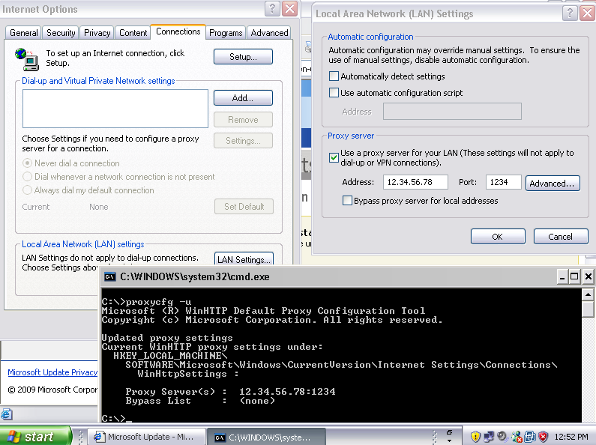
To manually set the proxy settings for network connection: proxycfg -p <ProxyServeIPaddress>:<port#> "<local>;localsite1;localsite2;..."
Example with a proxy server:
C:\>proxycfg -p 12.34.56.78:1234
Microsoft (R) WinHTTP Default Proxy Configuration Tool
Copyright (c) Microsoft Corporation. All rights reserved.

Updated proxy settings
Current WinHTTP proxy settings under:
HKEY_LOCAL_MACHINE\
SOFTWARE\Microsoft\Windows\CurrentVersion\Internet Settings\Connections\
WinHttpSettings :

Proxy Server(s) : 12.34.56.78:1234
Bypass List : (none)

In Vista (netsh winhttp /? for its help; MUST run as admin for cmd.exe):
To display current settings: netsh winhttp show proxy
Example:
C:\>netsh winhttp show proxy

Current WinHTTP proxy settings:

Direct access (no proxy server).
To import from current user's IE manual settings (in HKCU registry): netsh winhttp import proxy source=ie
Example:
C:\>netsh winhttp import proxy source=ie

Current WinHTTP proxy settings:

Proxy Server(s) : 12.12.34.22:8080
Bypass List : (none)
To manually set proxy settings for network connection: netsh winhttp set proxy <ProxyServerIPaddress:ItsPort#> "<local>;localsite1;localsite2;..."
Example:
C:\>netsh winhttp set proxy 12.12.34.22:8080

Current WinHTTP proxy settings:

Proxy Server(s) : 12.12.34.22:8080
Bypass List : (none)
To set back to direct: netsh winhttp reset proxy
Example:
C:\>netsh winhttp reset proxy

Current WinHTTP proxy settings:

Direct access (no proxy server).

Then, you can test these setups beside web browsers. Use Internet programs that knows Microsoft Windows HTTP Services (WinHTTP) [Mozilla Firefox (http://www.mozilla.com/firefox/) doesn’t use it since it doesn’t work and doesn’t have this WinHTTP API (application programming interface) according to http://bytes.com/groups/javascript/441634-xmlhttp-firefox] that will recognize proxies for Internet connection. Google Chrome (http://www.google.com/chrome) dropped it too according to http://www.linux-mag.com/id/7222.

CDBurnerXP (http://cdburnerxp.se) is an example of a free program that has WinHTTP since I downloaded an update for my outdated installation program and saw my proxy server network status transfer rate values go fast.

Sources:
proxycfg.exe: http://msdn.microsoft.com/en-us/library/aa384069.aspx
netsh winhttp …: http://technet.microsoft.com/en-us/library/cc731131.aspx

Phillip Pi’s Test Notes With Generic SOS 2009.x Products and Their Activations Through Proxies:
- NIS 2009.5 v16.5 b134 without LiveUpdates (LUs) in a Dell OEM XP Home SP2 (IE6) client machine connected to XP Pro. SP2 PC’s Squid proxy (port 3128) and IIS servers (port 8080 for a PAC script). Activated with a PAC script in IE6 and no network card properties changes.
- NIS 2009.0 v16.0 b125 (no LUs) and v16.5 b134 (all LUs) in a Dell OEM XP Home SP2 (IE6) client machine connected to Apache’s proxy mod (port 8080). Saw the “can’t activate” issue with v16.0 with IE’s manual LAN settings and network card properties to the proxy server. Upgraded to v16.5 and activated without problems.
- First installed NIS 2009.0 v16.0 b125 (no LUs) and overinstalled N360 v3.0 b134 (no LUs; couldn’t get v16.5 LUs for NIS) in a 64-bit Vista UE (IE8) client PC connected to an outdated XP Pro.’s IIS (port 8080) with Squid proxy (port 3128) in VMware v4.5.2. Saw the “can’t activate” issue with both products with IE’s PAC script and network card properties to the proxy server. However, activating N360 with IE manual settings worked. Reproduced BBSS saw with PAC script even though I can surf the Web in IE8.
- NIS 2009.0 v16.0 b125 without and with all LUs on an ASUS K8V SE client machine (512 MB of RAM) connected to a Dell OEM XP Home SP2 PC’s Apache (port 8080 for PAC script) with its proxy mod enabled. Activated with proxycfg -u (enabled IE LAN manual settings) in IE6, no network card properties changes, and updated NIS.
- N360 v3 b134 without LUs in an activated 64-bit Vista UE on an ASUS K8V SE client machine (512 MB of RAM) connected to a Dell OEM XP Home SP2 PC’s Apache (port 8080 for PAC script) with its proxy mod enabled. Activated with a PAC script and no network card properties changes.
- NAV 2009.0 v16.0 b125 without LUs on an ASUS K8V SE client machine (512 MB of RAM) with an updated and activated 32-bit Vista UE and connected to a Dell OEM XP Home SP2 PC’s Apache (port 8080 for PAC script) with its proxy mod enabled. Activated with “netsh winhttp set proxy 10.147.27.244:8080” proxy method in IE7, no network card properties changes, and updated NAV.
- Installed N360 v3.0 b134 (no LUs) in a Windows XP Pro. SP2 (IE6) client PC connected to an outdated XP Pro.’s IIS (port 8080) with Squid proxy (port 3128) in VMware v4.5.2. Saw the “can’t activate” issue with IE’s PAC script and network card properties to the proxy server. However, can activate with IE manual settings. Reproduced BBSS saw with PAC script even though I can surf the Web in IE8.

Also tested in 2010 products which worked even better. ☺

