Simple Exploit Examples With and Without Norton Internet Security (NIS) 2003 Products (Intrusion Detection and Personal Firewall) Presentation
by Phillip Pi (12/4/2002)

Introduction:
Intrusion Detection System (IDS) subsystem provides basic functionality for the NIS 2003 products in detection and protection. This allows the firewall the ability to inspect each packet (e.g., string patterns) targeted towards the Windows machine, looking for anomalies, and stopping such detected anomalous traffic. IDS subsystem maintains a list of attack signatures. Each such signature specifies operating system(s) and port number(s) to which it is applicable, e.g., WinNuke signature is only applicable to port 139 (the NetBIOS port) in Windows. Sources: Stanley’s IDS Subsystem documentations. In this presentation document, there are three ways to exploit unprotected Windows machines that script kiddies/hackers might use.

Using Nbtstat Command To Gain Computer Information and Data (Privacy):
Sources: http://www.emf.net/~ddonahue/NThacks/nbtstat.htm, http://astalavista.com/library/auditing/netbios/advantage.shtml, and http://www.mycgiserver.com/~ethicalhackers/netbios.html

Information about the Windows machine can be obtained easily from any Windows 9x and NT machines with Internet access that have no security. For example, I attacked from a Windows Me VMware v3.2.0 image (64 MB of RAM; IE6.0 SP1 and all updates) to 155.64.158.38 IP address (Pentium II 300 Mhz system with 64 MB of RAM and Windows 98 SE with no hot fixes). There are ways to get a target’s IP address (e.g., IRC lookup, e-mail header, etc.).

With Windows without a firewall protection, a hacker could access computer information (e.g., computer name, login name(s), password(s), MAC address, shared file(s) without passwords, shared printer(s) without passwords, etc.):

C:\>nbtstat -A 155.64.158.38

Lana # 0:
Node IpAddress: [155.64.158.162] Scope Id: []

NetBIOS Remote Machine Name Table

Name Type Status
---------------------------------------------
ZIMBABWE98 <00> UNIQUE Registered
ANTS <00> GROUP Registered
ZIMBABWE98 <03> UNIQUE Registered
ZIMBABWE98 <20> UNIQUE Registered
ANTS <1E> GROUP Registered
ANTS <1D> UNIQUE Registered
..__MSBROWSE__.<01> GROUP Registered

MAC Address = 00-A0-C9-72-89-59

The number <20> shows that the computer has enabled File and Printer Sharing feature in Windows.
Here’s an example of a hack on this machine with its file (C: drive) and printer sharing enabled and without passwords. Both machines were setup for “ants” workgroup (did not use domain login either):
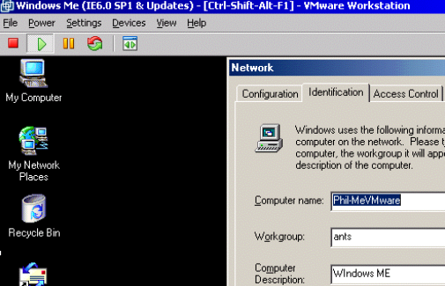

I edited and saved c:\windows\lmhosts.sam file to add the IP address that I wanted to access:
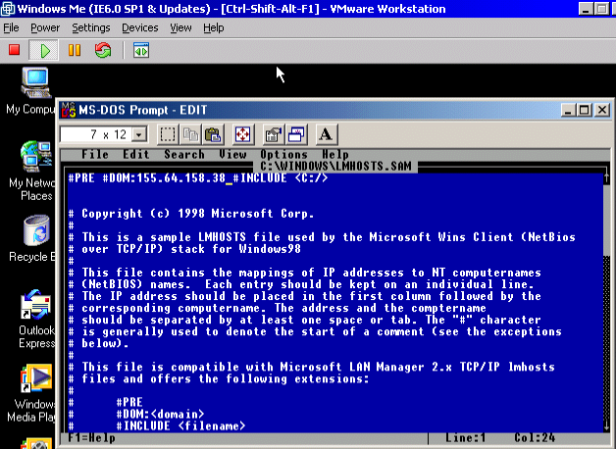
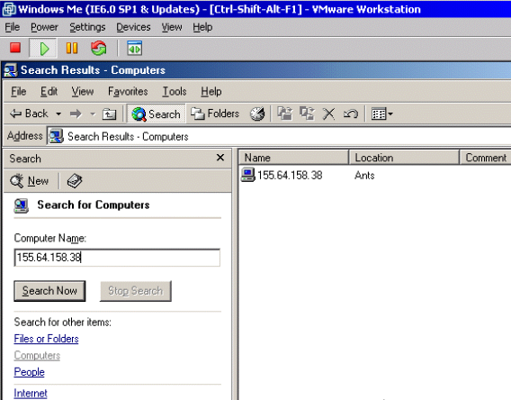
I made Windows Me searched for 155.64.158.38 computer and it found it. I was able to get into the C: drive without any issues (no protection). I was able add, remove, and change files and folders.

With Norton Personal Firewall 2003 enabled (everything enabled and with all LiveUpdates):
C:\>nbtstat -a 155.64.158.38

Lana # 0:
Node IpAddress: [155.64.158.162] Scope Id: []

Host not found.

The attacker was unable to get very far and get any information about the computer from this IP address.

Crashing a clean installation of Windows 98 OS’ with RFParalyze script from Linux:
Here’s a clean Windows 98 with IE6.0 without a firewall protection that I used for testing. I obtained the target’s IP address (155.64.158.65) and Computer name (PhilW98VM). I can use nbstat command to do this as well.
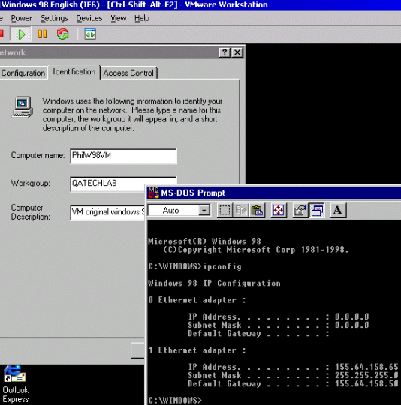
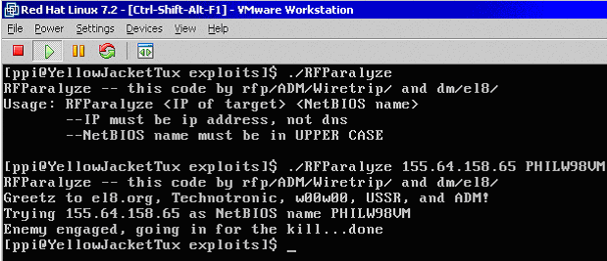
From Linux, I ran a compiled RFParalyze script (crashes Windows 98; Source: http://online.securityfocus.com/bid/1163/info/) and targeted the 98 VMware session and got:
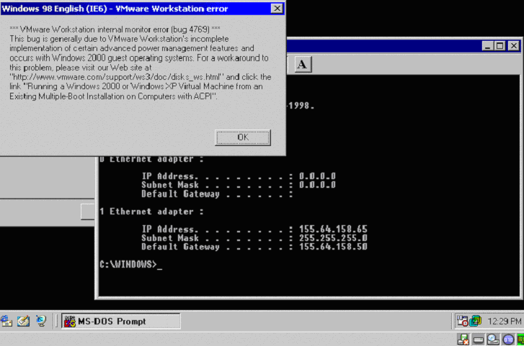
I also did two more similar tests on a Pentium II 300 Mhz system machine with 64 MB of RAM and Windows 98 SE (IE6.0 SP1). The first test gave me a blue screen and the second one gave the computer a reboot. As you can see this, this is a nasty and rude interruption for a user.

Now, let’s watch what happens if Norton Personal Firewall 2003 (retail build 141, with default settings, and without its LiveUpdates) was installed and I repeated the attack:
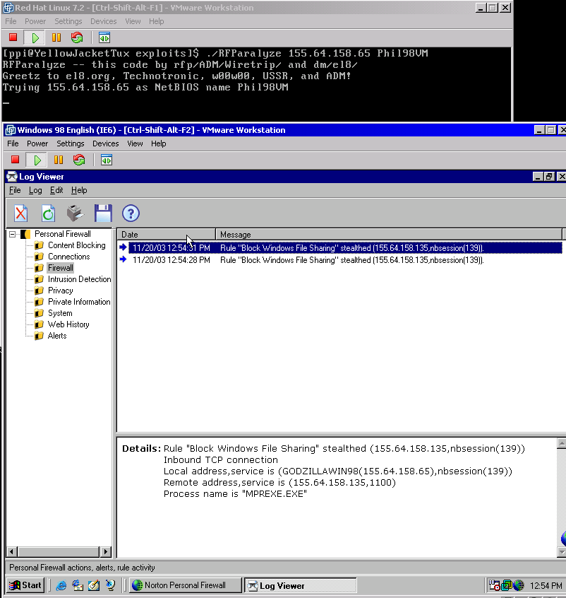
Windows 98 SE did not crash or reboot my computer. The attack was blocked according to Norton Personal Firewall’s log.
Back Orifice (BO) 2000:
Source: http://www.cultdeadcow.com/tools/bo.html
Notes: Used NPF 2003 because NIS’ NAV would clean up Back Orifice on the target computer.

Here is what happens if the unprotected Windows 98 target (VMware v3.2.0 with 64 MB of RAM) with all hotfixes and updates) is infected/running with Back Orifice (server). The attacker/hacker, with BO client, can do all kinds of stuff from his/her Windows 98 SE machine (P2 300 Mhz system with 64 MB of RAM). As shown in the screen shot below, he/she got system information about the targeted Windows 98 machine:
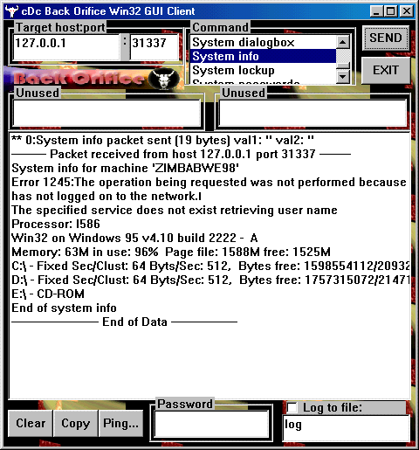

With a protected Windows 98 with Norton Personal Firewall 2003 (with LiveUpdates) and default settings, I tried to send a system lock up command but it was blocked:
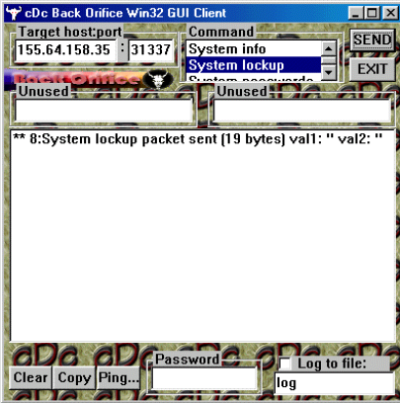
NPF 2003 alerted me about the Back Orifice 2000 Trojan horse attack and protected the Windows 98 computer:
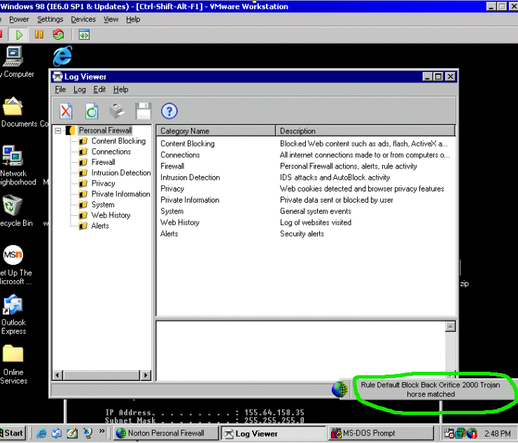
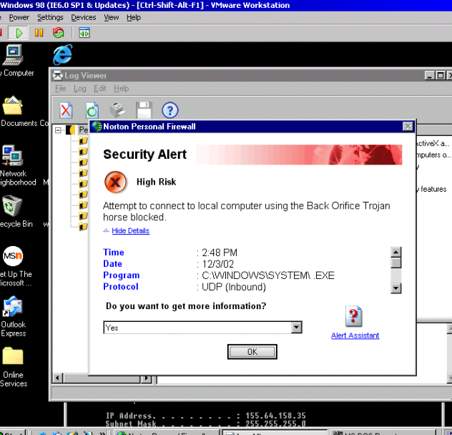
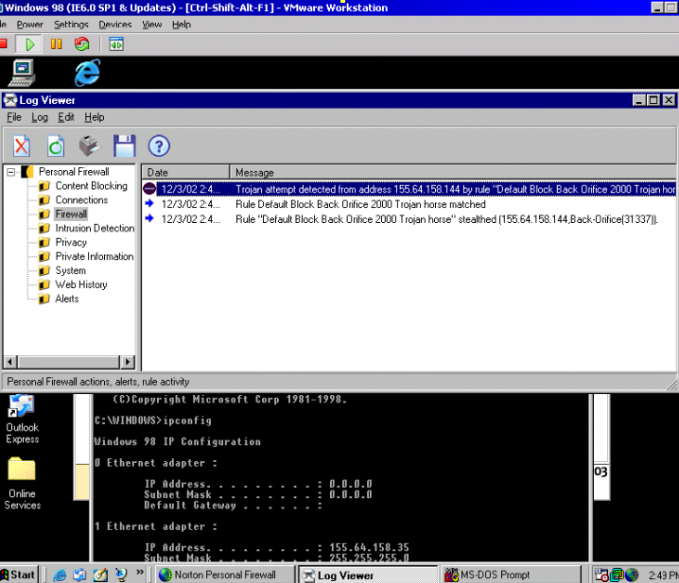

Conclusion:
As you can see, NIS products can provide protection from all kinds of unrequested network attacks and interruptions.

